TRƯỜNG TIỂU HỌC NGỌC LÂM
REVIEW – GRADE 3 Nội dung ôn tập học kì 1 môn Tiếng Anh 3
- Học sinh ôn kĩ cột mẫu câu, từ vựng, ngữ âm từ Unit 6 đến 10. Cụ thể:
+ Phần mẫu câu: HS luyện nói thuộc và vận dụng được trong giao tiếp, viết lại các mẫu câu ra vở ôn luyện.
+ Phần từ vựng: Hs luyện đọc thuộc lòng và viết ra vở ôn luyện những từ còn chưa thuộc.
+ Phần ngữ âm: HS học thuộc lòng cách phát âm các âm in đậm đã học và tìm thêm 5-10 từ mỗi âm đó ra vở luyện
- Các dạng bài tập có trong đề thi: HS tham khảo đề mẫu đính kèm và các dạng bài trong sách bài tập Tiếng Anh 3 Unit 6-10
- 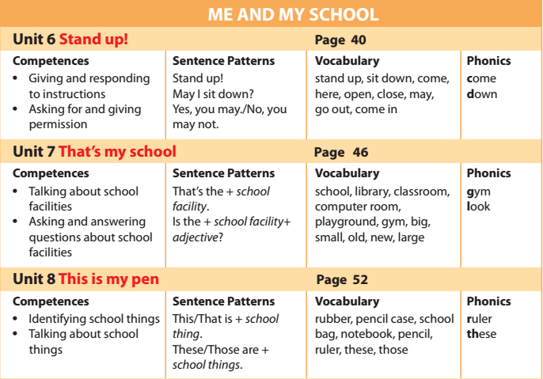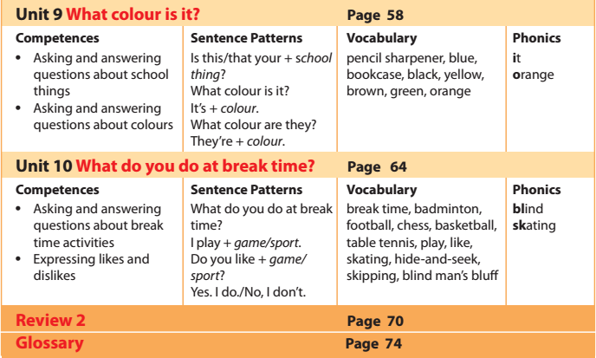
Từ vựng
Mẫu câu
Ngữ âm
*** CÁC DẠNG BÀI TẬP
- Điền 1 chữ cái thích hợp vào chỗ trống:
1. S__hool |  | 9. O__t
2. Li__rar__ |  | 10. Cl__se
3. Cl__s__room |  | 11. O__en
4. __ayg__ound |  | 12. Co__p__ter
5. G__m |  | 13. Do__n
6. __ig |  | 14. M__y
7. S__all |  | 15. C__n
8. La__ge |  | 16. L__ok
- Sắp xếp các từ xáo trộn thành câu có nghĩa:
- is/ that/ computer/ the/ room/. |  |  | ………………………………………….
- the/ library/ that/ is/. |  |  | ………………………………………….
- my/ that/ is/ school/. |  |  | ………………………………………….
- that/ music/ the/ room/ is/. |  |  | ………………………………………….
- the/ is/ big/ gym/ ? – is/ it/ yes/. |  |  | ………………………………………….
- my/ is/ this/ friend/ new/. |  |  | ………………………………………….
- friends/ they/ your/ are/? – no/ not/ are/ they/. |  |  | ………………………………………….  ………………………………………….
- the/ playground/ is/ large/? – is/ not/ it/ no/. |  |  | …………………………………………  …………………………………………..
- her/ is/ school/ small/? – it/ is/ not/ no/. big/ is/ it/. |  |  | ………………………………………….  ………………………………………….
- is/ book/ your/ old? – it/ is/ not/ no. new/ is/ it/. |  |  | ………………………………………….  ………………………………………….
- Viết tên các đồ vật:
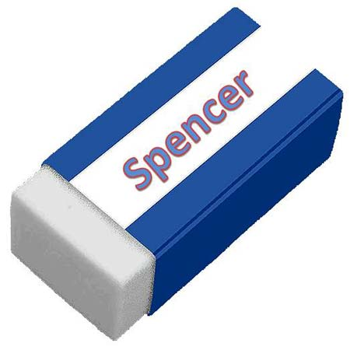 | 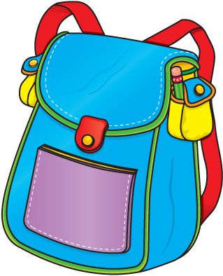 |  |  | 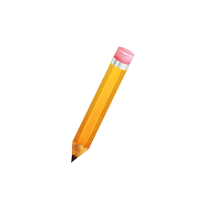
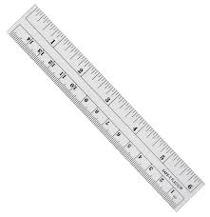 | 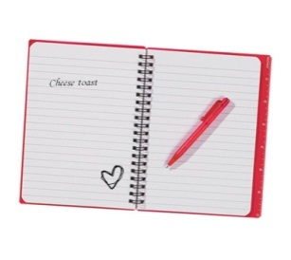 |  |  | 
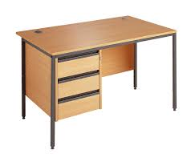 |  |  |  | 
- Chọn đáp án đúng:
- This is my ............................ (rubbers/ pencils/ notebook).
- Those are my ............................ (ruler/ rubber/ pencils).
- ............................ are my books. (these/ the/ that).
- That is my ............................ . (pencils/ pencil sharpener/ pens).
- This is my ............................ . (cases/ new/ desk).
- Is the ............................ new? (small/ classroom/ new).
- Đọc và trả lời câu hỏi:
Hello, I’m Linh. I’m eight years old. I’m in class 3A at Quang Trung Primary School. My school is big and new. My class is big and new, too. This is my desk. It is brown. These are my books. They are yellow. This is my notebook. It’s pink. These are my pens. They are black and white. This is my rubber. It’s orange and white. And this is my school bag. It’s blue, green and red.
- What’s her name? | ………………………………………….
- How old is she? | ………………………………………….
- Is her school big and new? | ………………………………………….
- What colour is her desk? | ………………………………………….
- What colour is her school bag? | ………………………………………….
- What colour are her books? | ………………………………………….
- What colour are her pens? | ………………………………………….
- Is her rubber red? | ………………………………………….
- Cho các từ dưới đây vào cột thích hợp:
Black, one, stand, classroom, notebook, ask, gym, rubber, three, brown, ruler, music room, open, nine, white, sit, pencil sharpener, eight, red, pen, green, library, playground, eleven, close, orange, twelve, computer room, desk, write
Colour | School thing | School facility | Number | Action

ĐỀ LUYỆN
Task 1. Listen and tick () or cross (X). There are two examples(A,B).
Examples: |  | 
  A.
  B.

 |  | 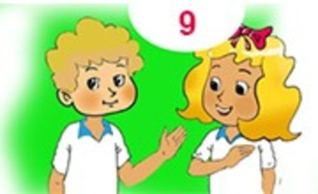
  1.
  2.
  3.
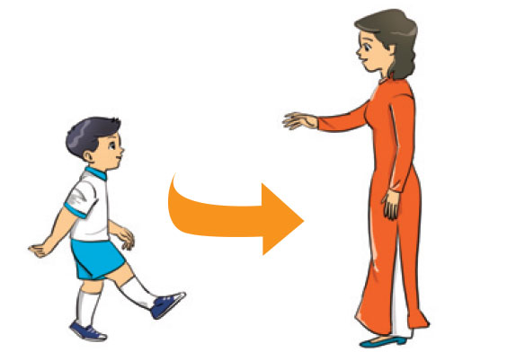 | 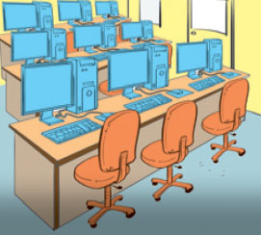
  4.
  5.

Task 2: Listen and match. The first picture is done for you.

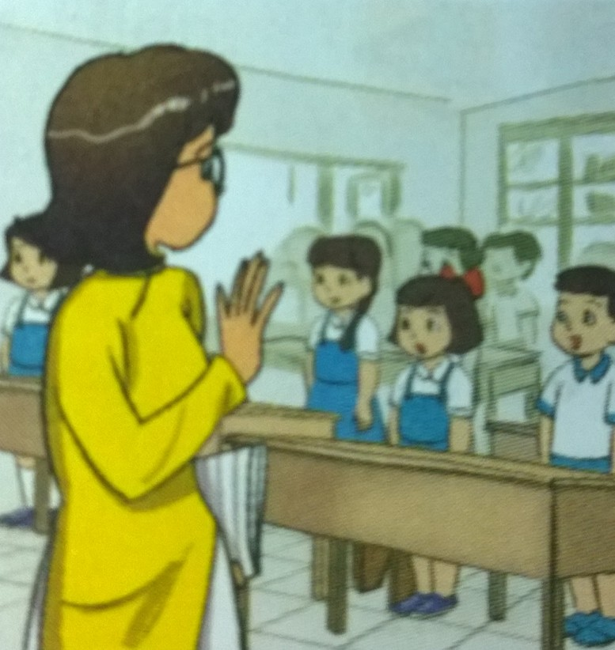
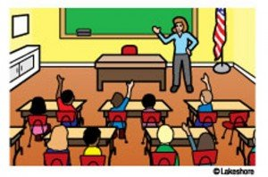
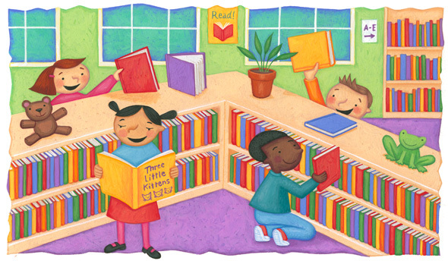
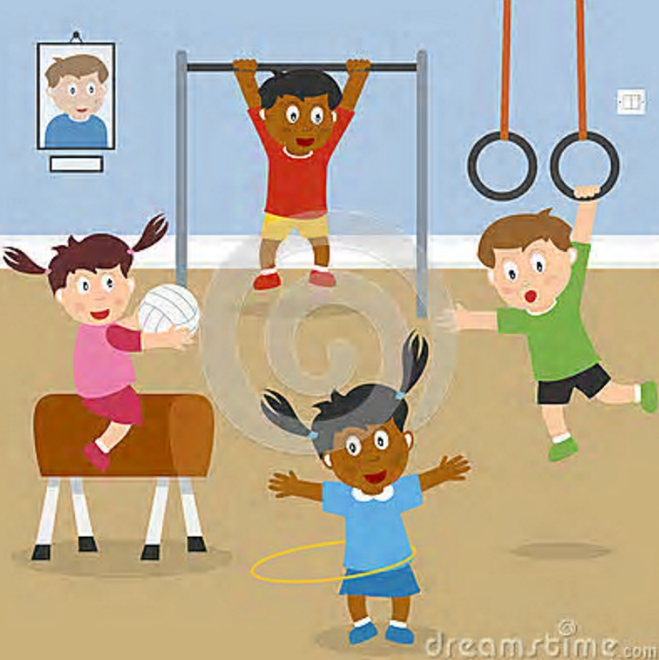

E
D
C
B
A

1
5
4
3
2

Task 3. Look and write. There is one example.
  0. y m g → gym | 
  3. l l s m a  → s_ _ _ _ | 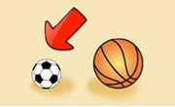
  1. e c n p l i c s a e → p_ _ _ _ _ c_ _ _
  4.e c n p l i h s e e r r n p a → p_ _ _ _ _ sh _ _ _ _ _ _ r | 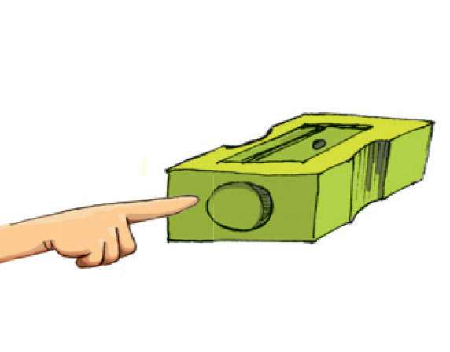
  2. r l b a y i r  → l_ _ _ _ _ _ | 
  5. i s t d n o w  → s_ _ d_ _ _ | 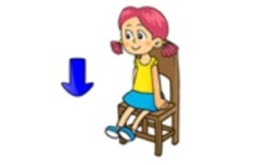

Task 4. Look and read. Tick () or cross (X) the box. There are two examples.
Examples: |  |  I'm Mai. |  | 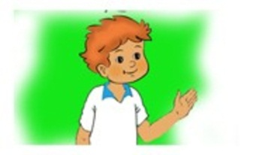 I'm Quan.
  A.
  B.
  1.These are my school things. | 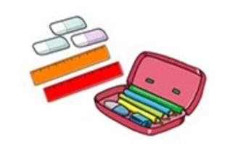
    1.
  2. Those are my books.
  2.
 |  |  | 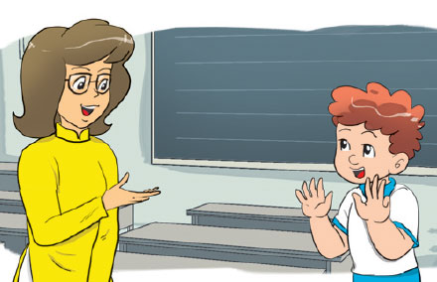
  3. Miss Hien: How old are you, Tom?
  Tom: I’m 9 years old.
  3.
  4. Don’t talk, please! | 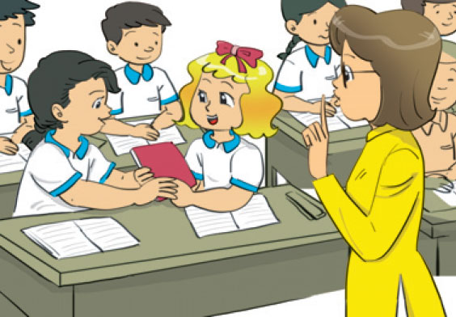
    4.
  5. The gym isn’t big. It’s small.
  5.

Task 5. Read and complete. There is one example.
Hi nice this no that nice

 | 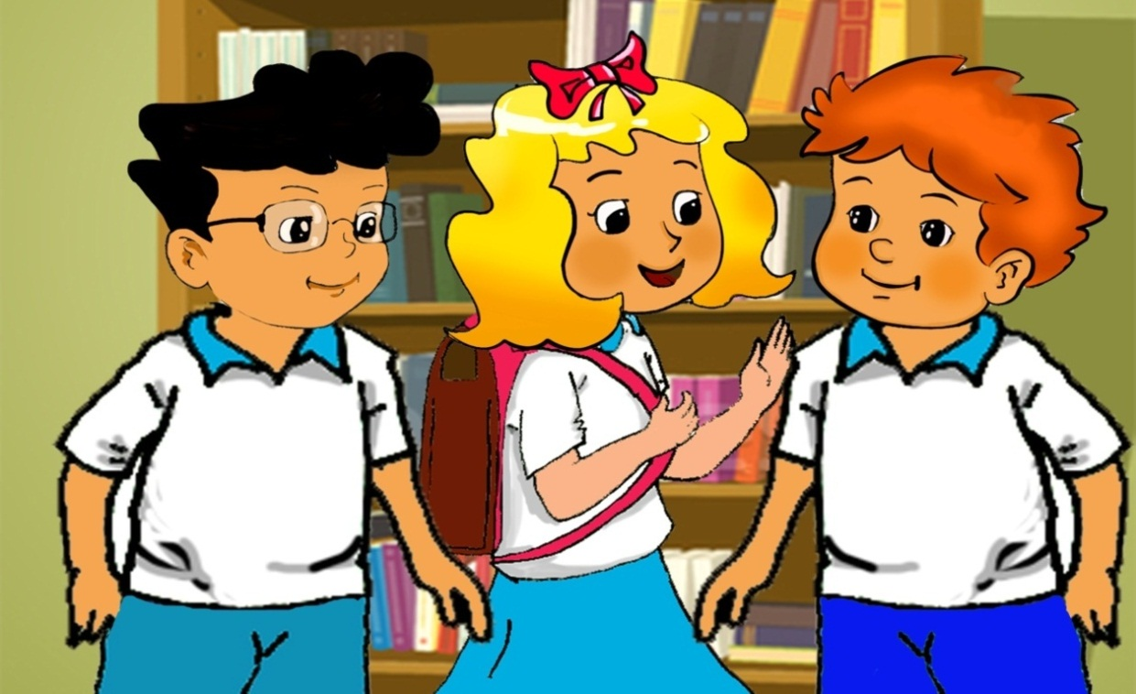
  Phong: (0) Hi, Linda.
  Linda: Hello, Phong. (1) _________ is Tony.
  Phong: (2) __________ to meet you.
  Tony: Hello, Phong. (3) _________ to meet you, too.
  Linda: Is (4) _____________ Mai?
  Phong: (5) _________, it isn't. It's Hoa.

Task 6. Odd one out.
0. | A. hello | B. I | C. you | D. he
1. | A. green | B. friend | C. pink | D. purple
2. | A. five | B.eight | C. these | D. three
3. | A. pencil | B. ruler | C. big | D. rubber
4. | A. how | B.spell | C. open | D. close
5. | A. Mai | B.Tony | C. Linda | D. Mary
Task 7 . Which word is differently pronounced.

0. | A. it | B. ice-cream | C. is | D. in
1. | A. this | B. that | C. three | D. these
2. | A. come | B. cat | C. computer | D. circle
3. | A. close | B. frog | C.dog | C. orange
4. | A. listen | B. this | C. five | D. fish
5. | A. that | B. cat | C. hat | D. name

Task 8 . Write the answers.

- What’s your name?………………………………………………………
- How old are you? ……………………………………………
- What colour are your pens? ……………………………………………
- What is the name of your school? ……………………………………………
- Is your classroom big? ……………………………………………
PART III. SPEAKING
- Respond the questions in task 6.
- Talk about the pictures .

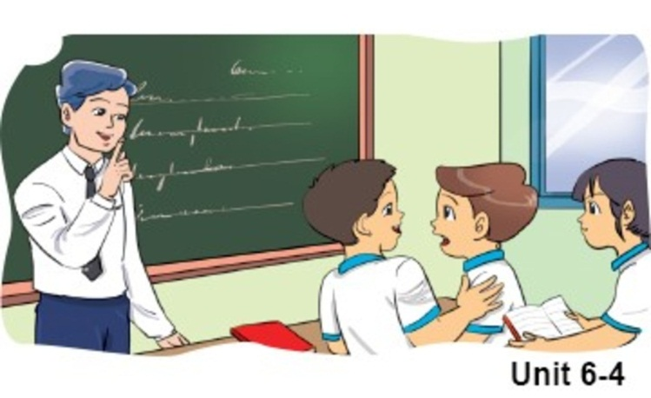 | 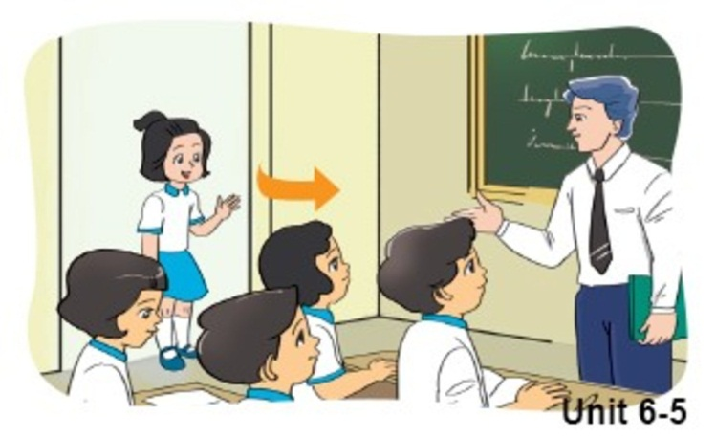
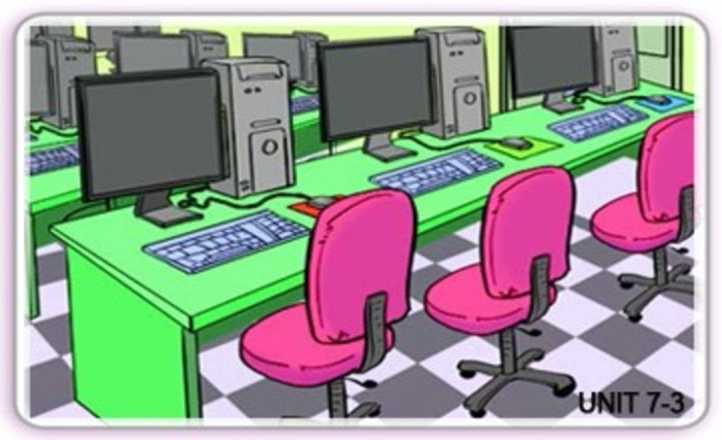 | 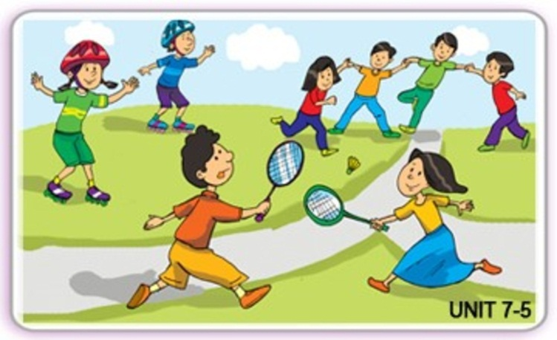
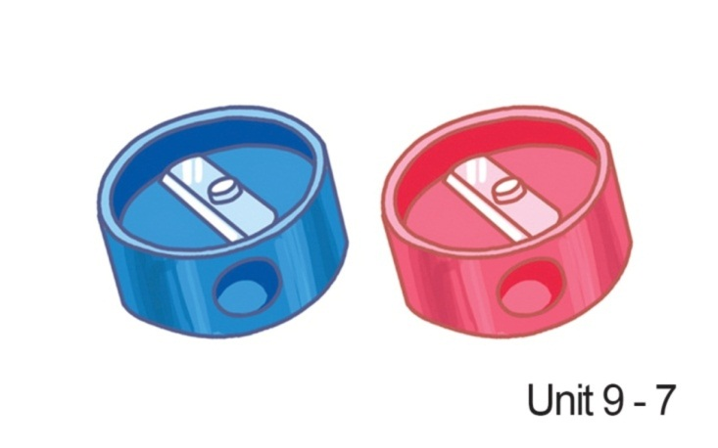 | 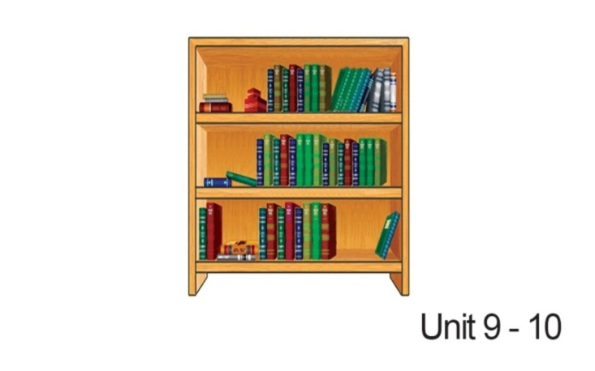

-THE END-

Tổ trưởng tổ Tiếng Anh  Lê Thị Hậu | BAN GIÁM HIỆU  Đỗ Thanh Huyền

IV. Exercises (Bài tập)
- Nhìn tranh và viết từ tương ứng:
1. They are playing_______________ | 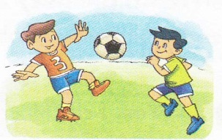

2.She plays __________________.

3. Linda likes ___________________ . | 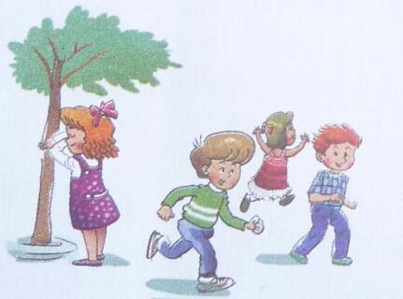

4. I like_________________.

5. He likes __________________.
6. They play ___________________ . | 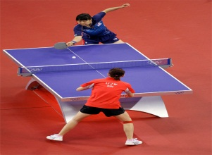

2. Đọc và trả lời câu hỏi:
Hi. My name is Quan. I am a pupil at Ngoc Lam Primary School. At break time some of my friends and I play football. Nam and Tony do not like football. They like basketball. Mai and Linda do not play basketball. They play blind man’s bluff.

1. What is his name? | ………………………………………………..
2. What is the name of his school? | ………………………………………………..
3. Do Quan and his friends play football at break time? | ………………………………………………..
4. What do Nam and Tony like? | ………………………………………………..
5. What do Mai and Linda play at break time? | ………………………………………………..

U1
IV. Exercises (Bài tập)
1. Sắp xếp thứ tự các chữ cái cho đúng
1. HOLLE | .......................... | 4. GEYBOOD | ..........................
2. IH | .......................... | 5. EMET | ..........................
3. NEFI | .......................... | 6. OHW | ..........................
2. Điền từ còn thiếu vào các câu sau:
Lan: Hello. I __________ Lan.
Nam: ______. I am ________
Lan: Nice_________ _______ you.
Nam: _______ to ________ _______, too.
Lan: How ______ you?
Nam: I am _________, Thank _______. And _______?
Lan: ___________, thank.
Nam: Goodbye.
Lan: Bye. See _____ ______.
3. Nối câu cột A với cột B:
A | B | Đáp án
1. How are you? | a. Hi! | 1. ________
2. Hi! I’m Mai | b. Bye. See you later. | 2. ________
3. Goodbye! | c. Hello. I am Thuy. | 3. ________
4. Hello. | d. Nice to meet you, too! | 4. ________
5. Nice to meet you! | e. Fine, thanks. | 5. ________
U2
2. Sắp xếp câu theo thứ tự:
________ I’m fine.
________ How are you?
________ Nice to meet you.
________ My name’s Alan.
________ What’s your name?
3. Nối các câu hỏi cột A với các câu trả lời cột B:
A | B | Đáp án
1. What ’s your name?  2. How are you?  3. Goodbye.  4. Hello, I am Linda.  5. Nice to meet you.  6. How do you spell your name? | a. Bye. See you later.  b. L-I-N-D-A.  c. My name is Nga.  d. I’m fine, thank you.  e. Nice to meet you, too  f. Hi. I’m Alan. | 1--  2--  3--  4--  5--  6-

U3.
2. Khoanh đáp án đúng:
1. .............is Peter.  A. I B. She C. He  2. The girl is Mai. ............is my friend.  A. He B. They C. She  3. Hi. My.............is Tony. | A. How B. name C. Fine  4. ................ I’m Linda.  A. Hello B. Goodbye C. Am  5. Is Linda …………. Friend?  A. my B. yours C. your

U4
2. Em hãy chọn từ thích hợp để hoàn thành các câu sau:
name Who how old sister
A: (1)……………… is that ?
B: That’s my sister.
A: What’s her (2)…………. ?
B: Her name is Lien. She is my (3) ……………….
A: How (4)…………….. is she ?
B: She is six .
A: And (5)………… old are you ?
3. Sắp xếp các từ xáo trộn thành câu có nghĩa:
- you/ old/ How/ are/ ? | ……………………………………
- am/ years/ eight/ old/ . | ……………………………………
- do/ spell/ How/ you/ name/ your/ ? | ……………………………………
- name/ your/ is/ What/ ? | ……………………………………
- thanks./ am/ I/ fine, | ……………………………………
B: I am ten years old.
4. Khoanh đáp án đúng:
1. Is this Linda? | 2. Is that Mary?
A: Yes, she is. | A: Yes, she is.
B: No, she not is. | B: Yes, he is
3. Is Peter your friend? | 4. Is Tony your friend?
A. Yes, he is. | A. Yes, she is.
B. Yes, she is. | B. No, he isn’t.
5. Khoanh đáp án đúng:
1. .............is Peter.
A. I B. She C. He
2. The girl is Mai. ............is my friend.
A. He B. They C. She
3. Hi. My.............is Tony.
A. How B. name C. Fine
4. ................ I’m Linda.
A. Hello B. Goodbye C. Am
5. Is Linda …………. Friend?
A. my B. yours C. your

U5.
2.Điền từ vào chỗ trống:
1.______ thatMr. Tuan? – Yes, it is.
2.How________ you spell your name? – P – H – U – O – N – G
3.This_______ my friend.
4.Thoes________ my friends.
5.Are these Linda and Phong? – Yes, _____ are.

3.Sắp xếp thành bài hội thoại hợp lí:
A.  1. It’s Thang Long School.  2. This is my school.  3. Oh, it’s big.  4. What’s its name? | B.  - Nice to meet you too.  - Miss Chi, this is Li Li. She’s my fiend.  - Good morning. Miss Chi.  - Nice to meet you. LiLi.  - Good morning, Nam.
4. Vẽ và tả 2 người bạn thân ở trường của em:
Name: ……………………. Class: …….
U7.
IV. Exercises (Bài tập)
- Sắp xếp các từ xáo trộn thành câu có nghĩa:
1. may/ Sir/ come/ in/ I
………………………………………………..
2. please/ quite/ be
………………………………………………..
3. Miss/ I/ a/ ask/ question/ may/ Hien
………………………………………………..
4. out/ may/ go/ I
………………………………………………..

- Em hãy chọn từ thích hợp để hoàn thành các câu sau

come | yes | don't | book

A. Miss Hien: | Mai, open your (3)_________, please.
Mai: | Yes, Miss Hien.
Miss Hien: | (4) ________ here, Quan
Quan: | Yes, Miss Hien.

B.Tom: | May I come in, Mr Loc?
Mr Loc: | (1)________ , you can.
Mr Loc: | (2) ________ talk, Nam.
Nam: | Sorry, Mr Loc.

U8
IV. Exercises (Bài tập)
- Điền 1 chữ cái thích hợp vào chỗ trống:
1. S__hool | 9. O__t
2. Li__rar__ | 10. Cl__se
3. Cl__s__room | 11. O__en
4. __ayg__ound | 12. Co__p__ter
5. G__m | 13. Do__n
6. __ig | 14. M__y
7. S__all | 15. C__n
8. La__ge | 16. L__ok

2.Sắp xếp các từ xáo trộn thành câu có nghĩa:
- is/ that/ computer/ the/ room/. | ………………………………………….
- the/ library/ that/ is/. | ………………………………………….
- my/ that/ is/ school/. | ………………………………………….
- that/ music/ the/ room/ is/. | ………………………………………….
- the/ is/ big/ gym/ ? – is/ it/ yes/. | ………………………………………….
- my/ is/ this/ friend/ new/. | ………………………………………….
- friends/ they/ your/ are/? – no/ not/ are/ they/. | ………………………………………….  ………………………………………….
- the/ playground/ is/ large/? – is/ not/ it/ no/. | …………………………………………  …………………………………………..
- her/ is/ school/ small/? – it/ is/ not/ no/. big/ is/ it/. | ………………………………………….  ………………………………………….
- is/ book/ your/ old? – it/ is/ not/ no. new/ is/ it/. | ………………………………………….  ………………………………………….

U9
IV. Exercises (Bài tập)
- Viết tên các đồ vật:
- Chọn đáp án đúng:
- This is my ............................ (rubbers/ pencils/ notebook).
- Those are my ............................ (ruler/ rubber/ pencils).
- ............................ are my books. (these/ the/ that).
- That is my ............................ . (pencils/ pencil sharpener/ pens).
- This is my ............................ . (cases/ new/ desk).
- Is the ............................ new? (small/ classroom/ new).

IV. Exercises (Bài tập)
- Cho các từ dưới đây vào cột thích hợp:
Black, one, stand, classroom, notebook, ask, gym, rubber, three, brown, ruler, music room, open, nine, white, sit, pencil sharpener, eight, red, pen, green, library, playground, eleven, close, orange, twelve, computer room, desk, write
Colour | School thing | School facility | Number | Action

- Đọc và trả lời câu hỏi:
Hello, I’m Linh. I’m eight years old. I’m in class 3A at Quang Trung Primary School. My school is big and new. My class is big and new, too. This is my desk. It is brown. These are my books. They are yellow. This is my notebook. It’s pink. These are my pens. They are black and white. This is my rubber. It’s orange and white. And this is my school bag. It’s blue, green and red.
- What’s her name? | ………………………………………….
- How old is she? | ………………………………………….
- Is her school big and new? | ………………………………………….
- What colour is her desk? | ………………………………………….
- What colour is her school bag? | ………………………………………….
- What colour are her books? | ………………………………………….
- What colour are her pens? | ………………………………………….
- Is her rubber red? | ………………………………………….

Name: ……………………. Class: …….
Name: ……………………. Class: …….

