TRƯỜNG TIỂU HỌC NGỌC LÂM
REVIEW – GRADE 5 Nội dung ôn tập học kì 1 môn Tiếng Anh 5
- Học sinh ôn kĩ cột mẫu câu, từ vựng, ngữ âm từ Unit 6 đến 10. Cụ thể:
+ Phần mẫu câu: HS luyện nói thuộc và vận dụng được trong giao tiếp, viết lại các mẫu câu ra vở ôn luyện.
+ Phần từ vựng: HS luyện đọc thuộc lòng và viết ra vở ôn luyện những từ còn chưa thuộc.
+ Phần ngữ âm: HS phân biệt được âm nhấn trong câu. Tìm thêm 10 câu ra vở.
- Các dạng bài tập có trong đề thi: HS tham khảo đề mẫu đính kèm và các dạng bài trong sách bài tập Tiếng Anh 5 Unit 6-10.
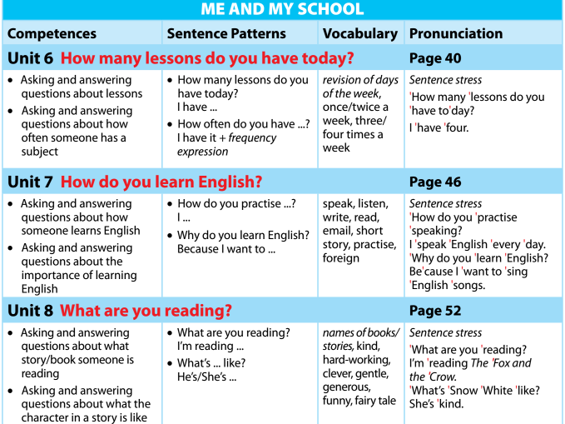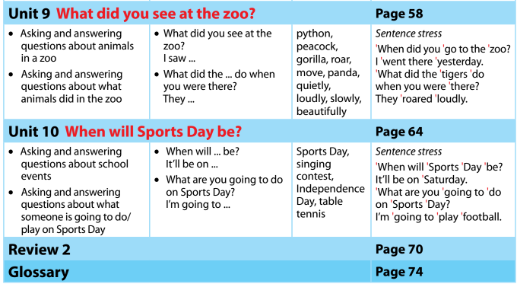
Từ vựng
Ngữ âm
Mẫu câu

*** CÁC DẠNG BÀI TẬP
Exercise 1: Chọn từ có phần gạch chân được phát âm khác so với các từ còn lại:
1/ A. early B. my C. usually D. city
2/ A. always B. play C. have D. face
3/ A. like B. evening C. dinner D. film
4/ A. study B. surf C. up D. bus
5/ A. kind B. ride C. twice D. fishing
6/ A. come B. once C. bicycle D. centre
Exercise 2: Chọn từ có trọng âm khác:
7/ A. after B. morning C. often D. before
8/ A. homework B. afternoon C. exercise D. centre
9/ A. library B. Internet C. cinema D. information
10/ A. partner B. swimming C. november D. island
Exercise 3: Chọn đáp án đúng để hoàn thành câu:
6/ They usually ……… early and do morning exercise.
- gets on B. get up C. get on D. gets up
7/ What ……… you do after school? – I usually do my homework.
- do B. are C. does D. x
8/ Mary often ……… TV after dinner with her parents.
- watch B. to watch C. watches D. watchs
9/ What does your mother …….. in the evening? – She ……… me with my homework.
- do – help B. do – helps C. does – helps D. does – help
10/ I sometimes go to the sports centre with my friends ……… the afternoon.
- on B. at C. with D. in
Exercise 4: Chia các động từ sau:
11/ The children often (ride) ………………. a bike in the afternoon.
12/ Her mother always (cook) ………..…….… dinner after work.
13/ My brother sometimes (talk) ………………..… with friends online in the evening.
14/ Lily (like – listen) ……………………………….. to music after dinner.
15/ Tam and her friend always (go) ……………. to school early.

Exercise 5: Sắp xếp từ thành câu hoàn chỉnh:
16/ is/ food/ This/ we/ the/ eat/ way/ our/ . …………………………………………………
7/ do/ What/ after/ she/ does/ school/ ? ……………………………………………………
18/ breakfast/ have/ I / always/ big/ a/ .………………………………………………
19/you/ school/ Who/ with/ to/ do/ go/ ?…………………………………………………
20/likes/ Tim/ badminton/ playing/ . ……………………………………………………
Exercise 6: Viết câu hỏi và trả lời theo mẫu:
Eg: How often/ you/ go to the library? – twice a month.
- How often do you go to the library? – I go to the library twice a month.
6/ How often/ you/ study with a partner? – twice a week.
……………………………………………………………………………………………………
7/ How often/ Linda/ go to the cinema? – once a month.
……………………………………………………………………………………………………
8/ How often/ your mother/ go shopping? – every day.
……………………………………………………………………………………………………
9/ How often/ you/ surf the Internet? – once a week.
……………………………………………………………………………………………………
Exercise 7: Hoàn thành đoạn hội thoại sau với các từ đã cho:
twice after cooking often late are
Adam: What (10)……… you doing, Susan?
Susan: I’m (11) …………… dinner.
Adam: Do you like cooking?
Susan: Yes, I do. I usually cook (12) ………….. school because my mother always comes home (13) ………... I help my mother with shopping too.
Adam: How (14) ……………. do you go shopping?
Susan: (15) ……………. a week.
Exercise 8: Dịch câu sau sang tiếng Anh:
16/ Bạn đi câu cá bao lâu một lần? – 1 tháng 1 lần……………………………………………
17/ Tom đến rạp chiếu phim 2 lần 1 tháng. ……………………………………………………
18/ Hàng ngày tớ đi xe đạp đến trường. ………………………………………………………
19/ Bố bạn làm gì vào buổi tối? - Ông ấy thỉnh thoảng lên mạng.
…………………………………………………………………………………………………
Exercise 9: Đọc đoạn văn rồi trả lời câu hỏi:
My name is Mai. I get up very early in the morning. I do morning exercise with my father. After breakfast, my brother and I ride a bicycle to school. We come home at 11 o’clock and then I have lunch with my family. In the afternoon, I study with my partner. Her name is Linh. Sometimes, I go to the library to look for some information. My family go to the cinema once a month.
20/ What’s her name? ……………………………………………………………
21/ Does she get up late in the morning? ………………………………………………………………………….
22/ Who does she go to school with? ………………………………………………………………
23/ What’s her partner’s name? …………………………………………………………………………………………
24/ How often do her family go to the cinema? …………………………………………………………………
Exercise 10: Mỗi dòng trong đoạn văn dưới dây có 1 lỗi sai, em hãy tìm và sửa lỗi sai đó:
Thanh and his parents go back to their hometown to visit 5/ ………………
his uncle last weekend. He live in a small village in Nam Dinh 6/ …………
Province. They went to Ha Noi Railway Station with taxi. Then 7/ …………
they took a plane to their hometown. His uncle took them to 8/ ………………
Vi Xuyen Lake, Rong Market and Thinh Long Beach. They has 9………
a wonderful time in their hometower. 10/..........
Trả lời các câu hỏi sau dựa vào nội dung đoạn văn trên:
11/ Where’s Thanh’s hometown? ………………………………………………….
12/ How did they get to Ha Noi Railway Station? ……………………………………………………………………………
13/ Did they go to their hometown by coach? ……………………………………………………………………
14/ Where did they go in Nam Dinh Province? …………………………………
15/ What was the trip like? ………………………………………………………………………………

Exercise 11. Fill in the gap with “What, Where, When, Who, Why, How, What time”:
  - . will they do tomorrow? - I will do my homework.
  - . will go camping next Sunday? - Nam and Quang will.
  - . will we meet? - We will meet at Lan’s house.
  - . .will you be back? - I will be back at 8 O’clock.
  - . will she go to the zoo? - She will go by bus.
  - . will your father travel to Ha noi ? - He will travel next week.
  - . will Nam go to bed early tonight? - Because he will have a test tomorrow.
Exercise 12. Fill in the gap with “from, to, on, in, at”:
- They often go swimming ……….. Sunday.
- The meeting will last ………..7a.m ………..5p.m.
- She will be 13 ………..her next birthday.
- We are playing chess ………..the moment.
- It often rains ………..July.
- My birthday is ………..September 3rd.
- The party will start ………..seven o’clock ………..the evening.
- He was born ………..April 2002.
Exercise 13. Read the text and answer the questions
We go to school (1)………..days a week, from Monday to Friday, and we have a lot of subjects at school such as math, Literature, English, Geography, and so on. I always try my best to study all, especially English because it’s my (2)……………. subject .Math is a little difficult but (3)………… However, I don’t like Literature very much (4)…... the teacher gives us so many exercises. I’m not very good at Computer Science, so I’m really afraid (5)……………. this subject. Physics, Geography and History are the most useful subjects to me. We learn about the world, about life and nature. I’m rather interested in these subjects.
1. A. seven B. four C. five D. six
2. A. lovely B. likely C. favorite D. interesting
3. A. easy B. good C. lovely D. interesting
4. A. because B. but C. then D. and
5. A. for B. at C. of D. on
Exercise 14. Fill in the blank with suitable preposition (in, on, at, by, from, with, to…)
- I often go to school …………… bus.
- Their grandparents live …………… 34 Hang Da street.
- Bob and I come …………… the same town but my accent is different …………… his.
- At present, John is staying ………… his brother’s family ………… the city center, very far …………… his parents.
- Thanh is a newcomer …………… class 5A5. She sits next …………… my cousin.

ĐỀ LUYỆN
Task 1. Look and write the correct words. There is one example.
 |  |  |  | 
crocodiles | peacocks | white bears | elephants | kangaroos

1.They live in rivers and eat people and animals in the water. | _________
2. They have two long and two short legs. | _________
3. They live in the Polar regions. | _________
4. They have a long trunk and two tusks. | _________
5. These birds have long and colourful tails. | _________

Task 2. Read and tick () True or False. There is one example (0).
Hello, I’m Quan. I have a friend Akiko. She is from Japan. Her favoutite subject is English. She practises listening by watching English cartoons on TV every day. She learns to read by reading English short stories. She writes emails to me every evening. We are both happy because we can understand each other. She says that she learns English because she wants to become a tourist guide.
 | True | False
1. Akiko comes from Japan.
2. Akiko watches English cartoons on TV to practise listening.
3. She reads detective stories in English to practise reading.
4. She can’t understand Quan’s emails.
5. She learns English to be a tourist guide.
Task 3. Look and read. Fill each gap with one word from the box. Write the word next to the number. There is one word that you do not need.
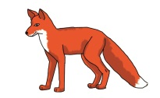 |  | 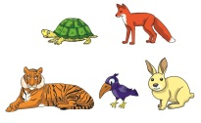 |  |  | 
fox | schoolboy | animals | meat | library | reading

Bill is a (1) _____________ . His hobby is (2) _ ___________ . He often goes to the
(3) _______________ to read books after school. He likes reading short stories about (4) ________________ He is reading The Fox and the Crow now. The Fox is clever. He gets a piece of (5) __________ from the Crow. Bill likes the story very much because he can learn a lesson from it.
Task 4. Look at the pictures. Read and write one word for each gap.
1.We sang and danced at the _____________ party. | 
 | 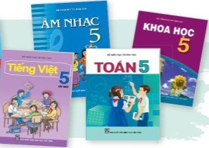
  2. | I have Music, Vietnamese, Maths and _____________ today.
 | 
  3. | We saw beautiful ________________ at the zoo.
4. He will visit his grandparents by c ______________next Sunday. | 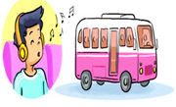
5. I learn to listen by________________videos everyday. | 
Task 5. Odd one out.
1. A. PE | B. Maths | C. Science | D. Subject
2. A. Tuesday | B. May | C. Friday | D. Saturday
3. A. Japanese | B. Australia | C. America | D. Malaysia
4. A. running | B. sitting | C. cooking | D. shopping
5. A. village | B. address | C. street | D. road

Task 6 . Order the words.
1. the / quietly / slowly / elephants / and / moved/ . | ………………………………………………………
2. how / speaking / you / practise / do/ English/ ? | ………………………………………………………
3. character / like / is / main / what / the/ ? | ………………………………………………………
4. go / who / did / you / the / with / zoo / to/ ? | ………………………………………………………
5. will/ this / be / where / weekend/ you / ? | ………………………………………………………
Task 7. Choose and circle the best answer.
1. How did you go to your hometown?
A. I go there by train. | C. I went there by train.
B. We went there by train. | D. All B and C are correct.
2. What are Hoa and Nga doing?
A. She is reading funny stories. | C. They are reading funny stories.
B. She can read funny stories. | D. They likes reading funny stories.
3. Why do you learn English?
A. Because it fun and easy. | C. But it’s difficult.
B. Because I want to sing English song. | D. Because he wants to sing English song
4. How …………… lessons do you have today?
A. much | C. many
B. old | D. often
5. Did you enjoy the party?
A. Yes, I do. | C. Yes, I am.
B. Yes, I did. | D. No, I don’t.
Task 8. Write the answer.
1.What do you usually do in the morning? | ………………………………………………
2. How often do you have English? | ………………………………………………
3. How do you practice speaking English? | ………………………………………………
4. Is An Tiem hard-worrking? | ………………………………………………
5. Where did you go on your holiday? | ………………………………………………
PART III. SPEAKING
1) Response the question in Task 8.
2) Point and say.
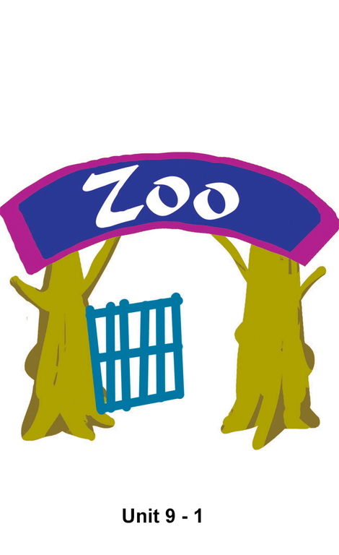 | 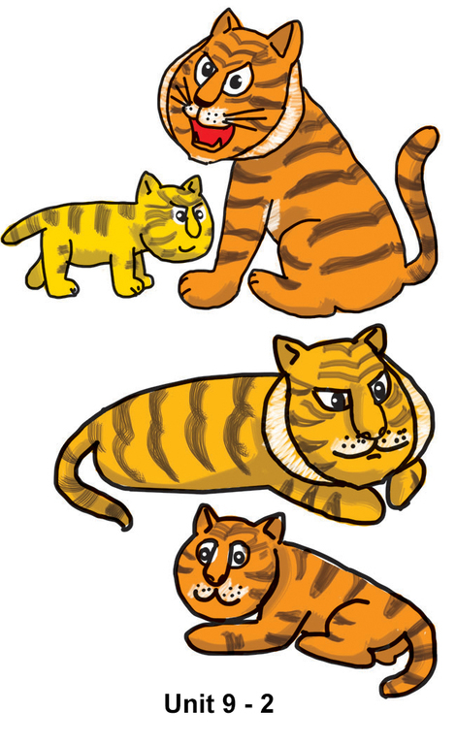
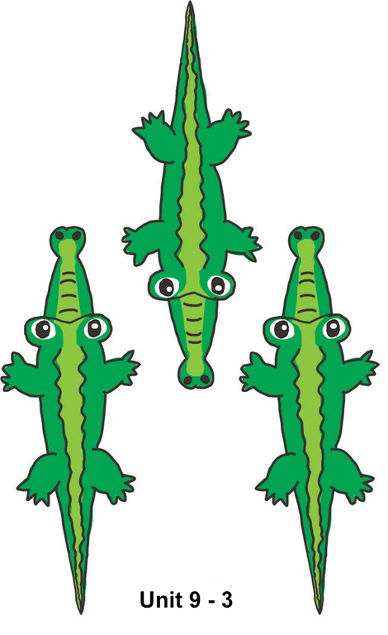 | 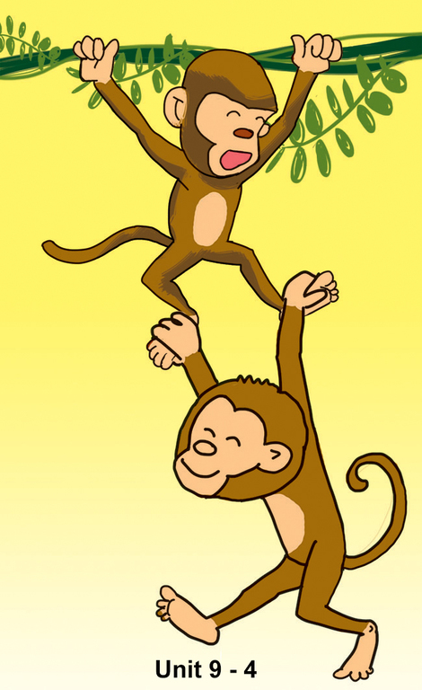
-The end-

Tổ trưởng tổ Tiếng Anh  Lê Thị Hậu | BAN GIÁM HIỆU  Đỗ Thanh Huyền

