BÀI TẬP ÔN TẬP TIẾNG ANH KHỐI 1
PHIẾU SỐ 4
Unit 4: My body
 Exercise 1: Look and write.
head – leg – arm - nose

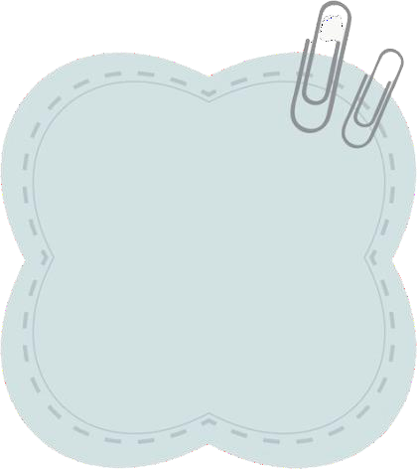
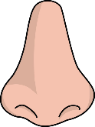
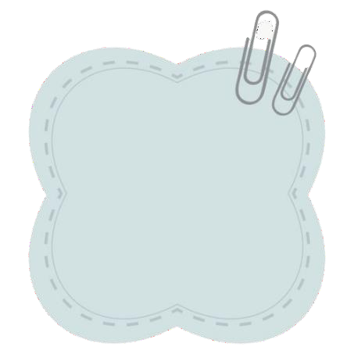
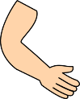
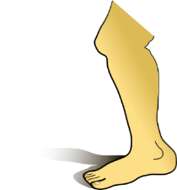
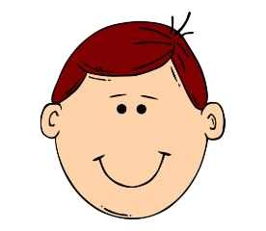
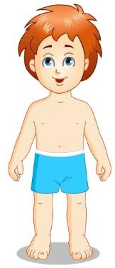
Exercise 2 : Look and write the missing letters.

l g r m

s
h
d
I-Learn Smart Start 1


Exercise 3: Look, read and number.




Exercise 4: Read, look and circle.
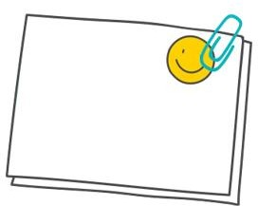
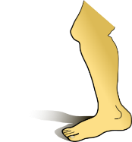
This is my ……
- leg
- arm

1) Touch you nose.
2) Touch your leg.
3) Touch your head.
4) Touch your arm.


This is my ……
- arm
- head

This is my ……
  - arm
  - leg
This is my ……
- head
- nose

