BÀI TẬP ÔN TẬP TIẾNG ANH KHỐI 1
PHIẾU SỐ 2
UNIT 2: SCHOOL
Exercise 1: Look and write.
1- pencil 2- cap 3- book 4- bag
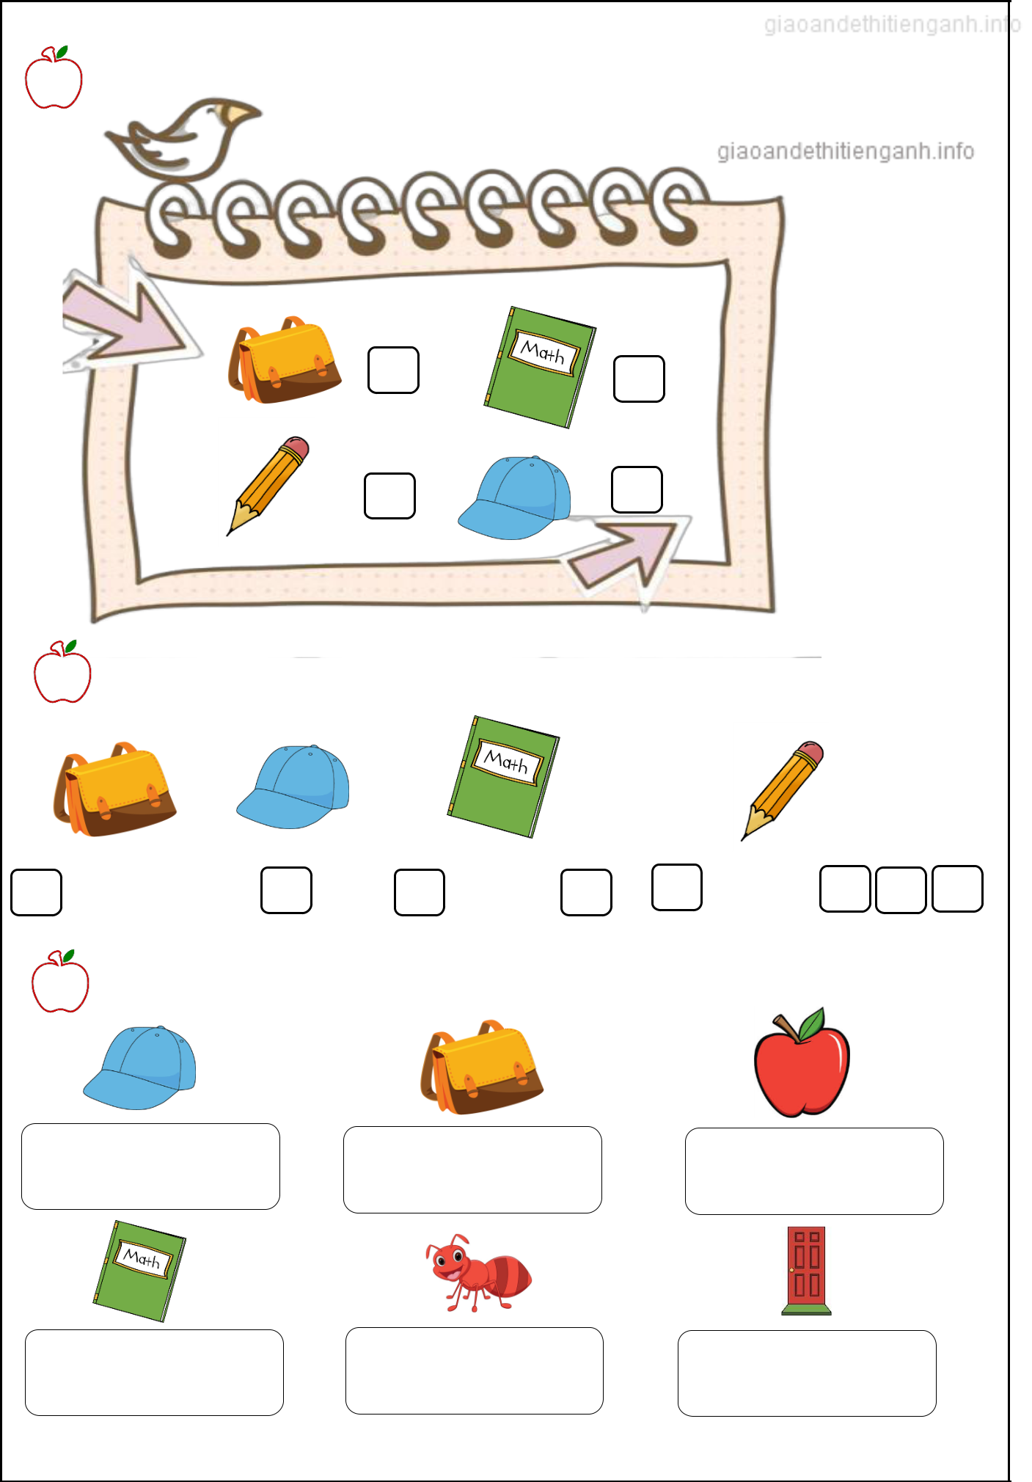

Exercise 2: Look and write the missing letters.


c
e
c
o
a

Exercise 3: Look and circle.

a) cap b) bag a) pencil b) bag a) apple b) ant

a) bag b) book a) ant b) apple a) cap b) door

I-Learn Smart Start 1

Exercise 4: Look and put a tick ()

This is my……..

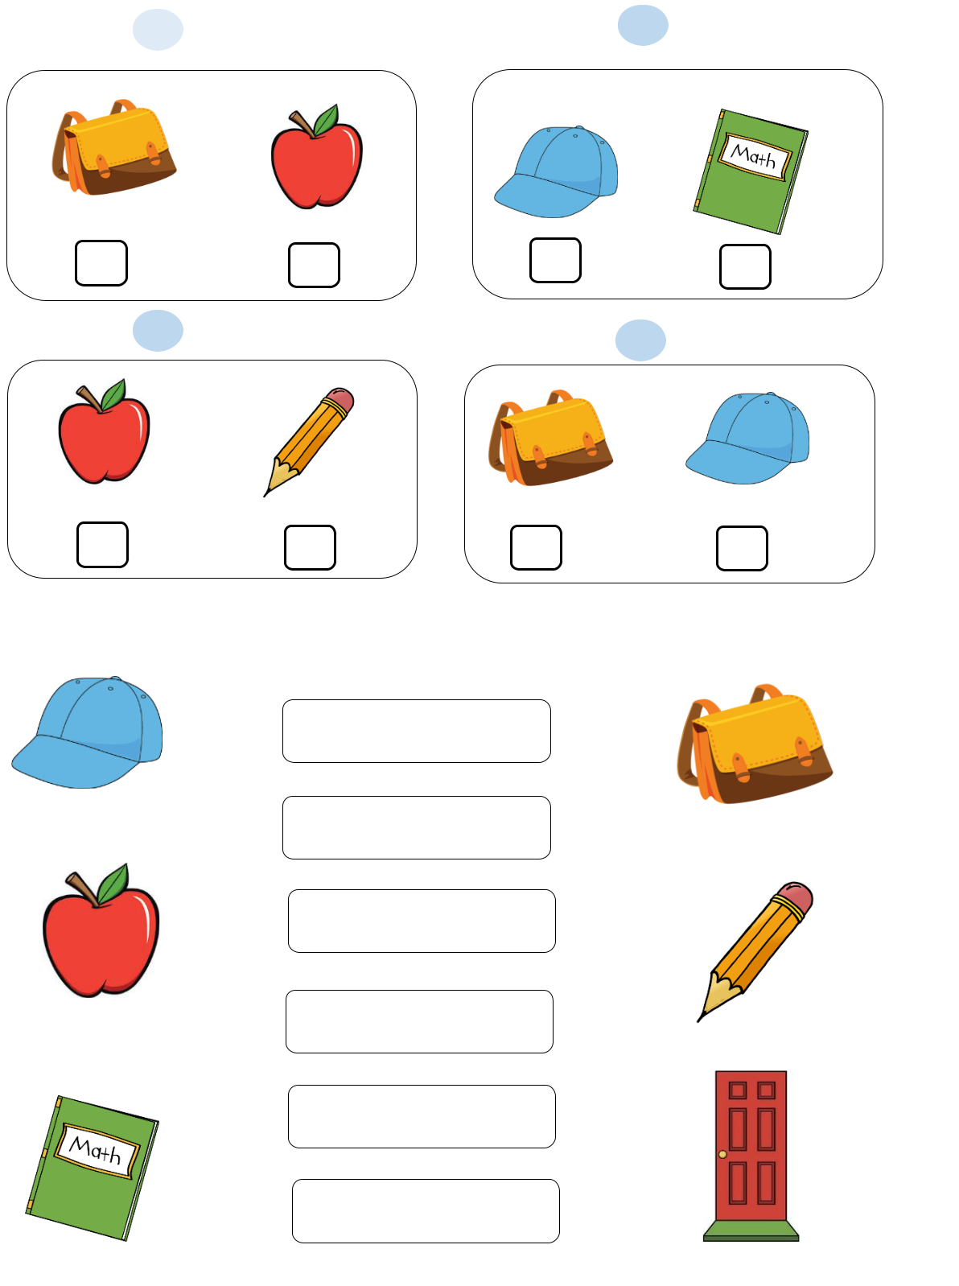
₁ bag 2 book

3 | pencil | 4 | cap

Exercise 5: Look, read and match.

. It’s a pencil.

.

.

It’s a book.

It’s a cap.

It’s a bag.

It’s a door.

.

. It’s an apple.

I-Learn Smart Start 1

