Gia Thuy Primary School  Full name: ………………………………………..  Class: 3A… | ENGLISH PRACTICE TEST 2  GRADE 3  Time: 40 minutes

I. LISTENING
Task 1. Listen and tick . There is one example.

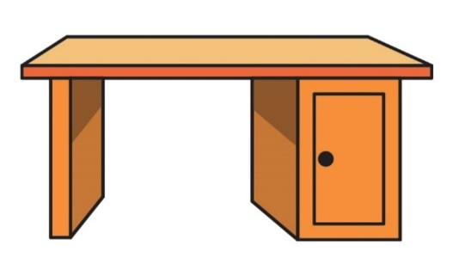  A | 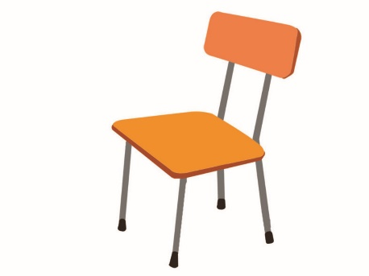  B 

  1. A. |   B.
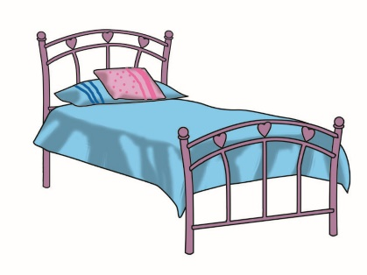  2. A. |   B.
  3. A. | 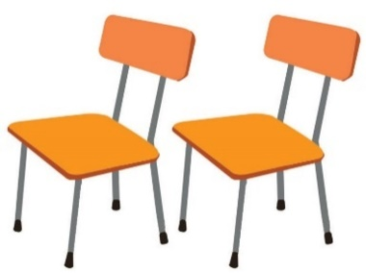  B.
  4. A. | 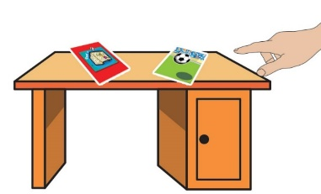  B.
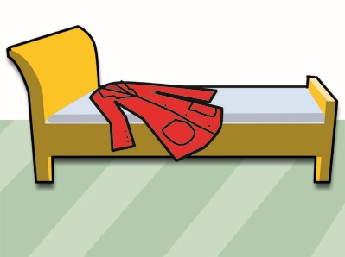  5. A. | 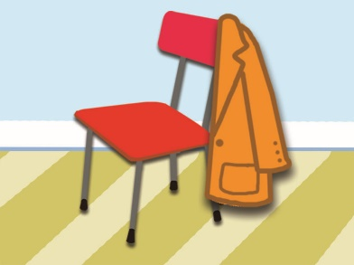  B.

Task 2. Listen and tick or cross . There are two examples.
Examples:
  A. | 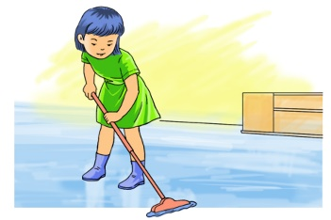  B.

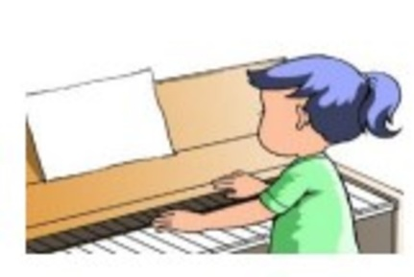  1. | 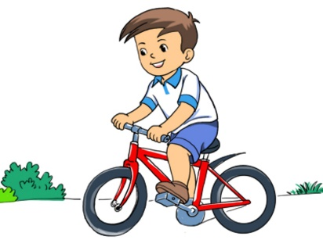  2. | 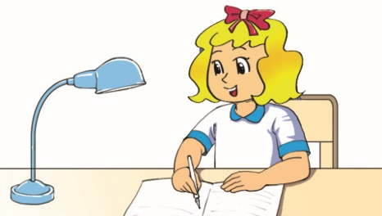  3.
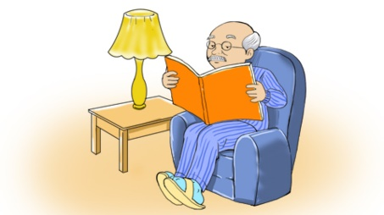  4. | 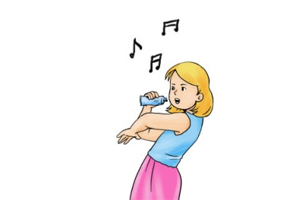  5.

Task 3. Listen and number the pictures. The first picture is done for you.
  A.  |   B. 3 | 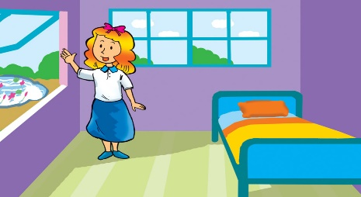  C. 1
  D. 5 |   E. 2 |   F. 4

II. READING AND WRITING
Task 1. Look and write. There is one example.
Example:
botro→ r o b o t | 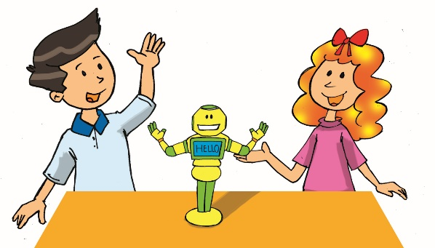

1. btolofal → football | 2. yots → toys | 3. tike → kite
 | 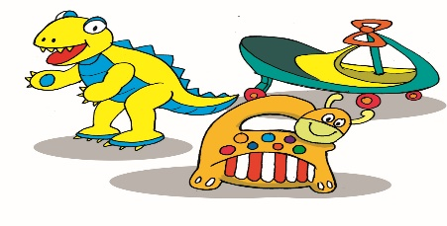 | 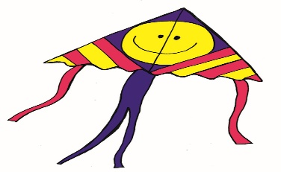
4. arc → car | 5. uzlzep → puzzle
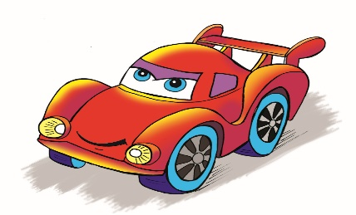 | 
Task 2. Look and read. or cross the box. There are two examples.
Examples:
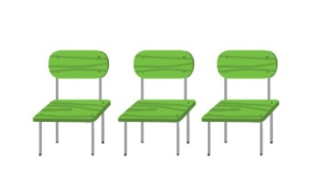  A. She has three chairs. | 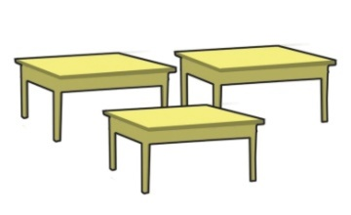  B. She has three beds.

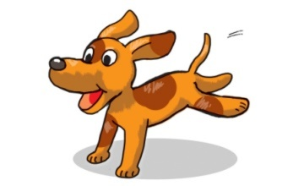  1. I have a dog. |   2. I have three cats. |  | 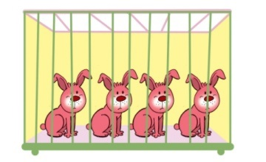  3. The rabbits are in the garden.
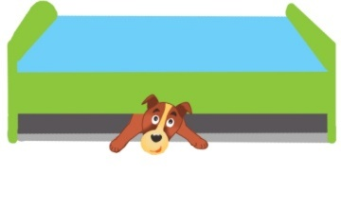  4. The dog is under the table. |  | 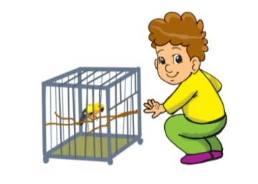  5. He has a small parrot.

Task 3. Read and complete. There is one example (0).
garden | cat | has | pets | two | likes

Hoa and her brother, Minh are in the (0) garden. They are playing with pets.
Hoa likes fish and birds. She (1)____has_____ ten goldfish and three parrots. Minh (2)_____likes____ dogs and cats. He has (3)_____two___ dogs and a small (4)__cat_______.
They like (5)___pets______ very much.

