Gia Thuy Primary School  Full name: ………………………………………..  Class: 4A… | ENGLISH PRACTICE TEST 2  GRADE 4  Time: 40 minutes

I. LISTENING
Task 1. Listen and tick . There is one example.
Example:
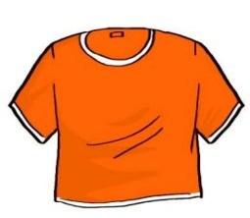  A. | 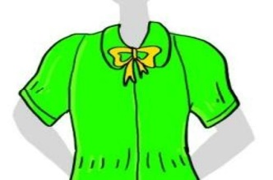  B. 

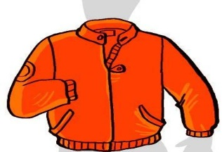  1. A. | 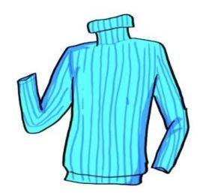  B.
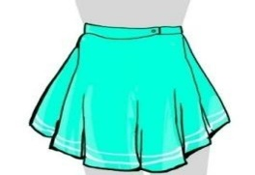  2. A. | 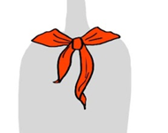  B.
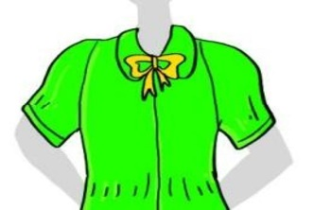  3. A. | 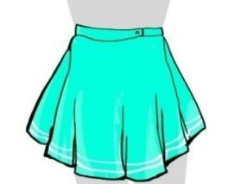  B.
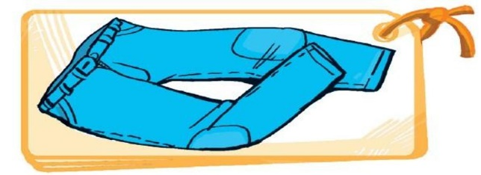  4. A. | 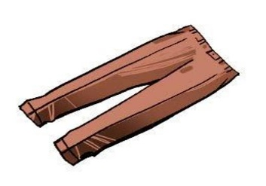  B.
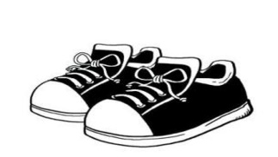  5. A. | 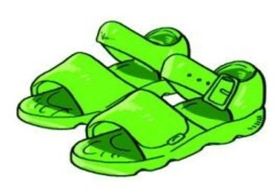  B.
Task 2. Listen and tick or cross . There are two examples.
Examples:
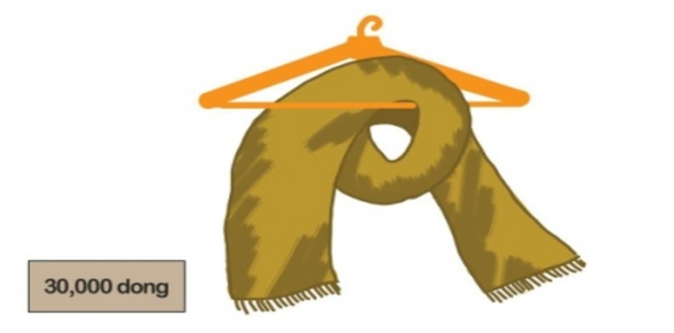  A. | 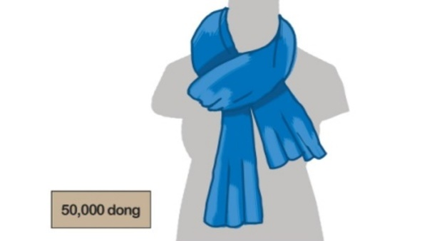  B.

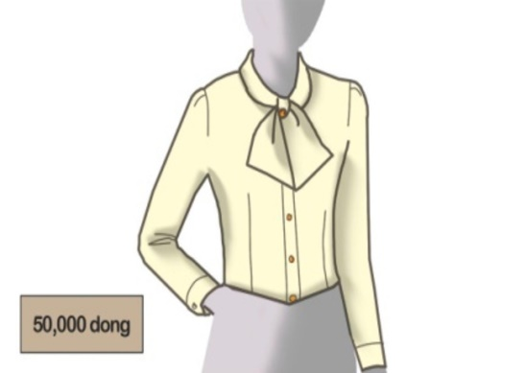  1. | 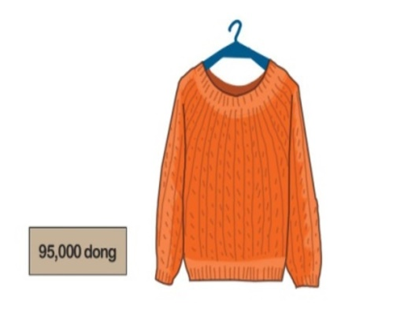  2. | 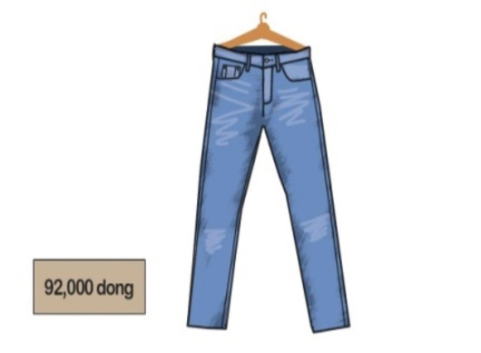  3.
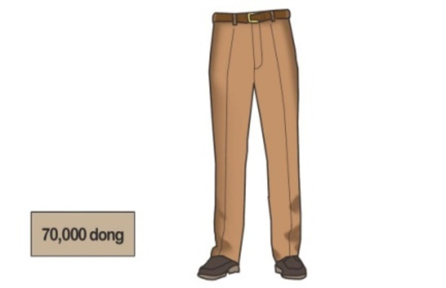  4. | 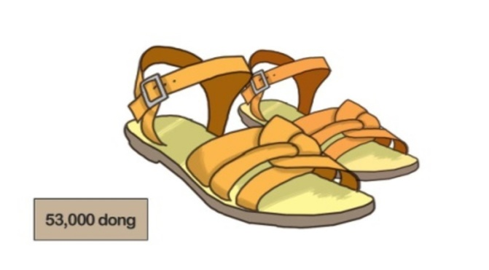  5.
Task 3. Listen and tick the correct pictures. There is one example (0).
0. Where does Jane go with her friends at weekends?
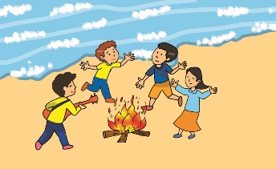  A. | 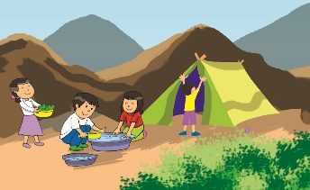  B. | 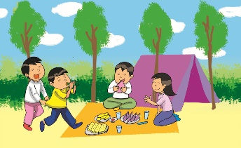  C.
1. What do the girls like doing?
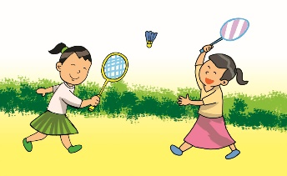  A. | 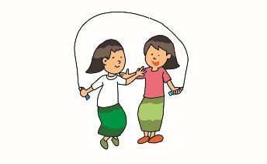  B. | 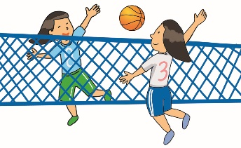  C.
2. What do the boys love doing?
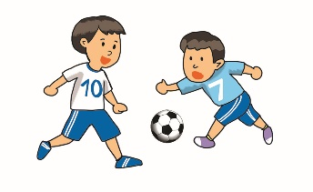  A. | 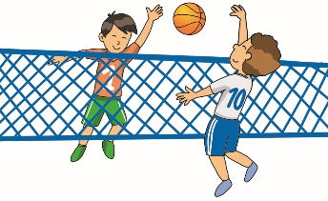  B. | 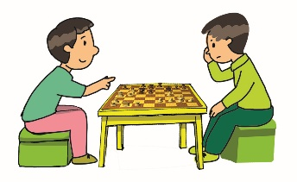  C.
3. What do some boys and girls like doing?
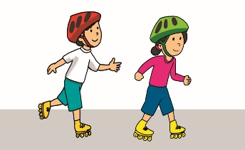  A. | 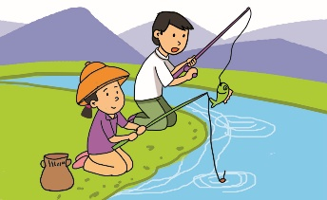  B. | 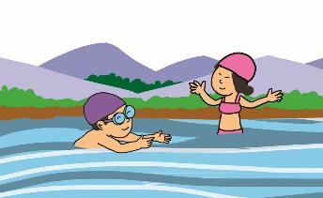  C.
4. How does Jane love taking photographs?
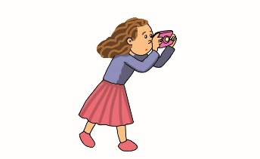  A. |   B. |   C.
5. What does Jane also enjoy doing?
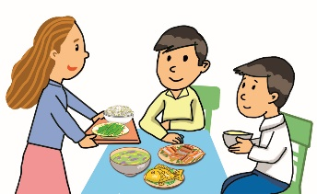  A. | 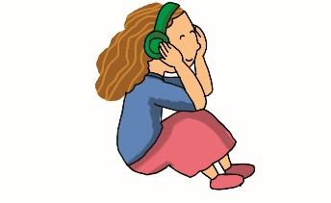  B. |   C.
II. READING AND WRITING
Task 1A. Look and write. There is one example.
Example:
pkis → s k i p | 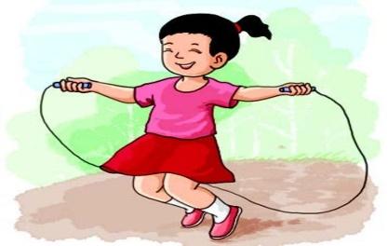

1. smiw → _ _ _ _ | 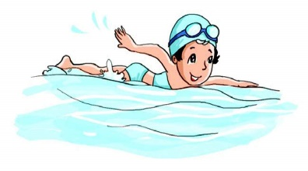
2. fotbolal → _ _ _ _ _ _ _ _ | 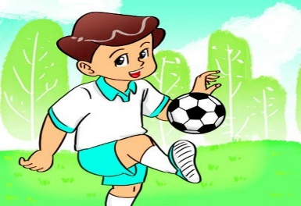
3. wen eary → _ _ _ _ _ _ _ | 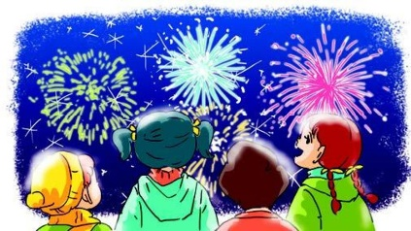
4. ibmadonnt → _ _ _ _ _ _ _ _ _ | 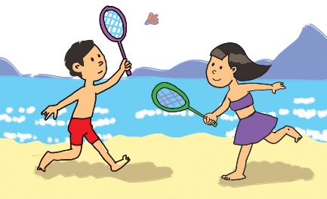
5. trossh → _ _ _ _ _ _ | 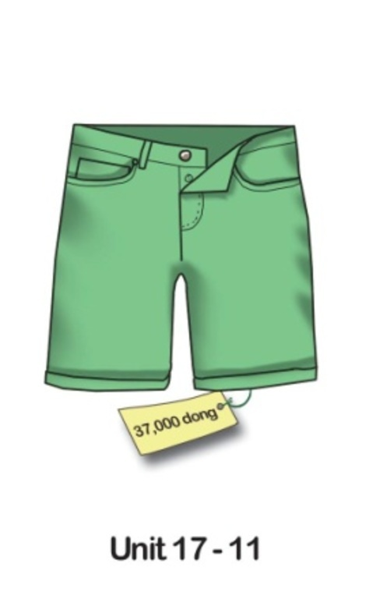
Task 2. Order the words. There is one example.

Example: my / sister / is / this
This is my sister.
1. my / young / is / mother
________________________________.
2. does / like / what / he / look
________________________________?
3. old / he / tall / is / and
________________________________.
4. is / stronger / who
_________________________________?
5. is / brother / than / stronger / me / my
_________________________________.
Task 3. Read and write YES or NO. There is one example (0).
Hi, my name is Quan. I wear different kinds of clothes for schooldays. On hot days at school, I often wear a cap, a T-shirt, a pair of shorts, a red scarf and a pair of sandals. On cold days, I usually wear a cap, a jacket over a jumper, a pair of trousers, a red scarf, a pair of socks and shoes. I like hot days because I can wear light clothes to school.
0. Quan wears different kinds of clothes for schooldays. | YES
1. He wears wear a cap, a T-shirt, a pair of shorts on hot days. | ______
2. He also wears a pair of socks and shoes on hot days. | ______
3. He wears a jacket over a jumper, a pair of trousers on cold days. | ______
4. He usually wears a pair of sandals on cold days, too. | ______
5. He likes hot days because he can wear light clothes at home. | ______

