Gia Thuy Primary School  Full name: ………………………………………..  Class: 3A… | ENGLISH PRACTICE TEST 1  GRADE 3  Time: 40 minutes

I. LISTENING
Task 1. Listen and tick . There is one example.
Example:
  - A.  |   B.

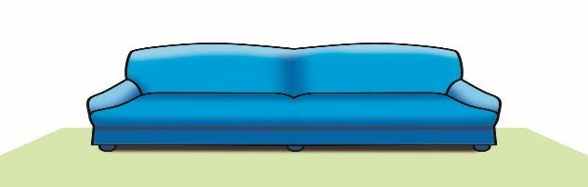  1. A. | 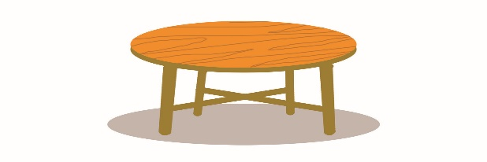  B.
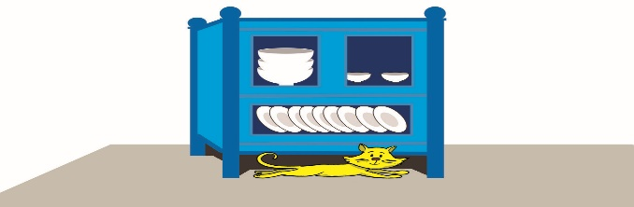  2. A. |   B.
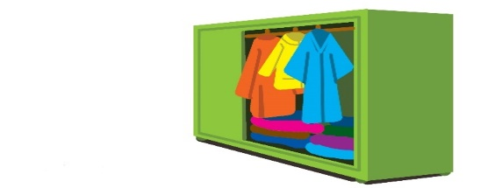  3. A. |   B.
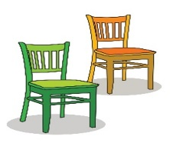  4. A. | 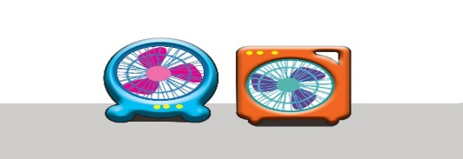  B.
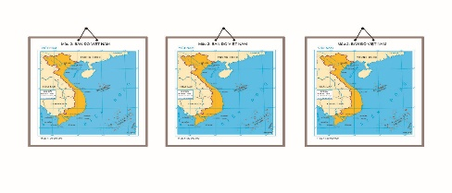  5. A. |   B.

Task 2. Listen and tick or cross . There are two examples.
Examples:
  A. |   B.

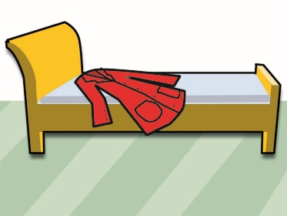  1. | 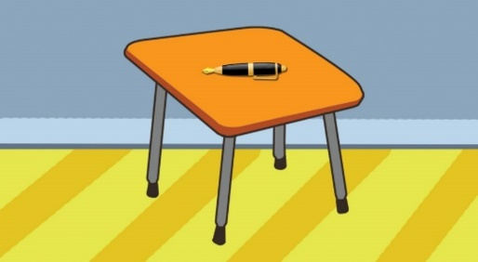  2. | 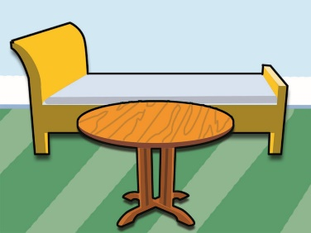  3.
  4. | 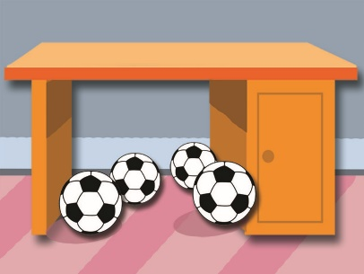  5.

Task 3. Listen and number the pictures. The first picture is done for you.
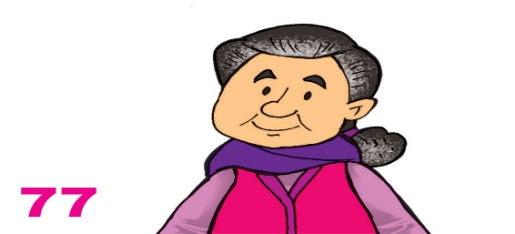  A.  | 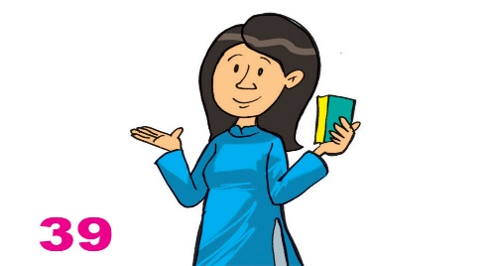  B. | 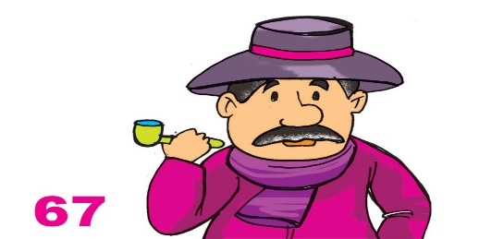  C.
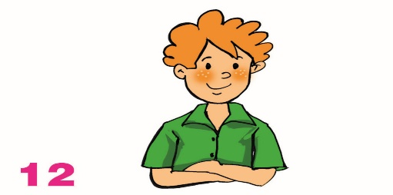  D. | 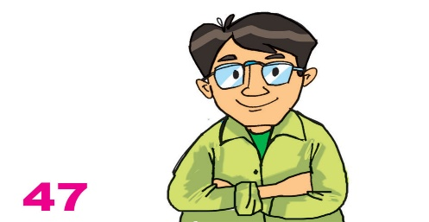  E. | 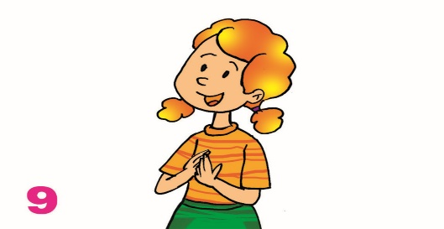  F.

II. READING AND WRITING
Task 1. Look and write. There is one example.
Example:  osaf → s o f a | 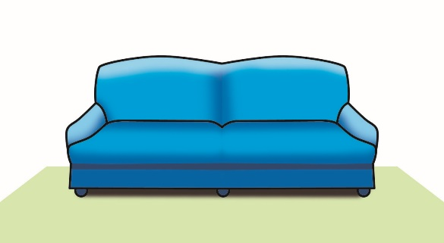

1. irormr → m __ __ __ __ __ | 2. aucpdobr → c __ __ __ __ __ __ __ | 3. nowdwi → w __ __ __ __ __
 | 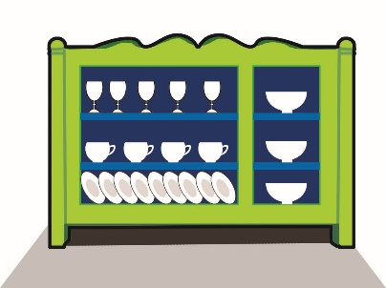 | 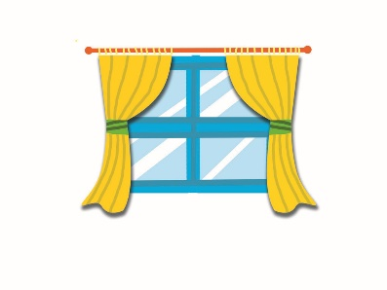
4. fna → f __ __ | 5. rawerobd → w __ __ __ __ __ __ __
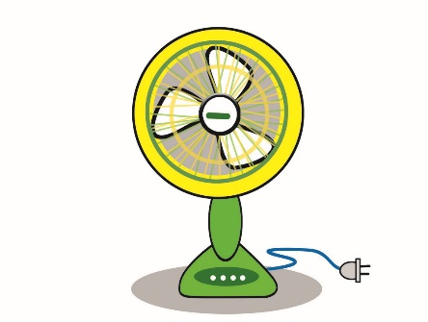 | 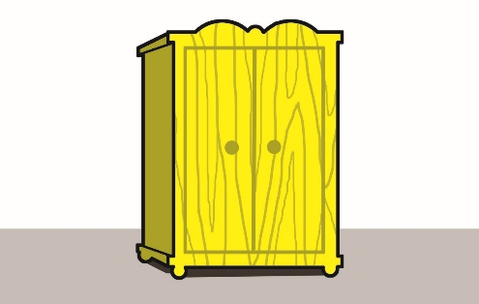

Task 2. Look and read. Tick or cross the box. There are two examples.
Examples:
  A. It’s a poster. | 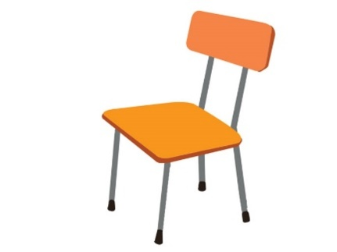  B. It’s a table.

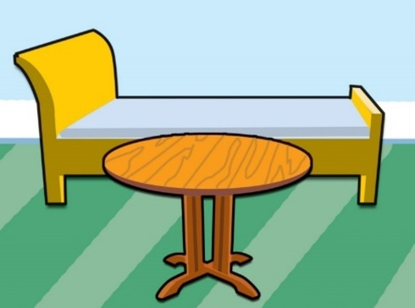  1. The bed is behind the table. | 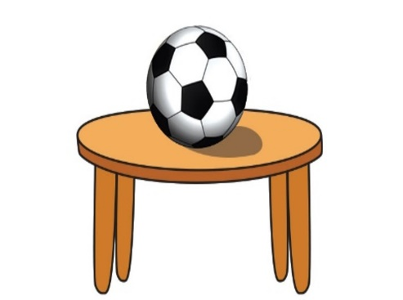  2. My ball is under the table. | 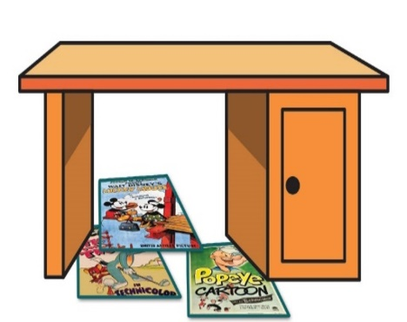  3. My posters are on the desk.
  4. The pictures are on the bed. |   5. My coats are on the wall.

Task 3. Read and complete. There is one example (0).
h | isn’t | it | garden | nice | there

A: This is my (0) house.
B: Wow. It's very (1) ________!
A: Yes, (2) ________ is. And this is my bedroom.
B: It's so big! Is there a (3) ________?
A: Yes, (4)________ is. Come and see it.
B: Is there a pond in the garden?
A: No, there (5)________.

