UNIT 20
WHICH ONE IS MORE INTERESTING, LIFE IN THE CITY OR LIFE IN THE COUNTRYSIDE
I.Listen and match.

a

b.

c.

d
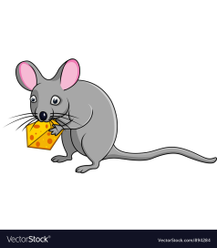
e

II. Listen and complete the paragraph.
Hello. My name’s Thien. It is not easy to answer the question: “ Which one is more exciting, life in the city ( 1)………………… life in the countryside? ” but I enjoy living in the countryside very much because life is ( 2)………………………... and the people are friendly. The villages are normally small and quiet.The fields are green, windy and beautiful with flowers in the ( 3)…………………………..and the birds singing in the summer. There are not many people, shops and traffic here . Sometimes I go to the Hanoi with my parents. I see a lot of people there so the streets are always so crowded and ( 4)…………………………, things are more( 5)………….………….. I think It’s more (6)……………….………. and exciting to live in countryside.

