UNIT 15
WHAT WOULD YOU LIKE TO BE IN THE FUTURE?
I.Listen and write.
Ben lives in a (0)__________ in a busy area. There are a lot of cars, (1) __________ and lorries in the street. Ben often goes shopping at a big and crowded (2) __________ opposite his house. There’s a bookshop on the corner of the street. Ben can (3) __________ there in ten minutes. He likes (4) __________ very much, so he goes to the bookshop every weekend. He would like to be a (5) __________ in the future. Ben likes the neighbourhood because he loves to see people and the busy life in the city.
 | 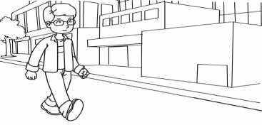 | 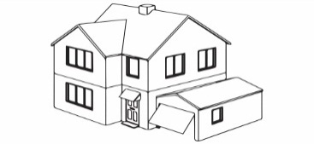 | 
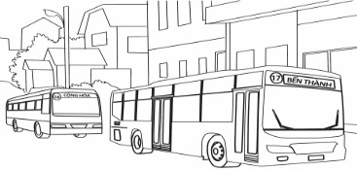 |  | 