UNI 19
WHICH PLACE WOULD YOU LIKE TO VISIT
I.Listen and tick .
0. |   A. | 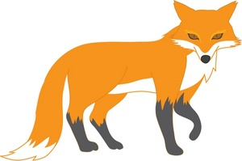  B. |   C.
1. |   A. | 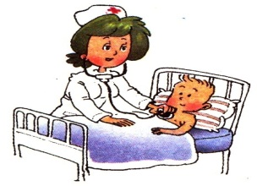  B. |   C.
2. |   A. | 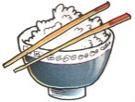  B. | 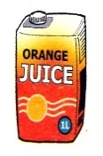  C.
3. | 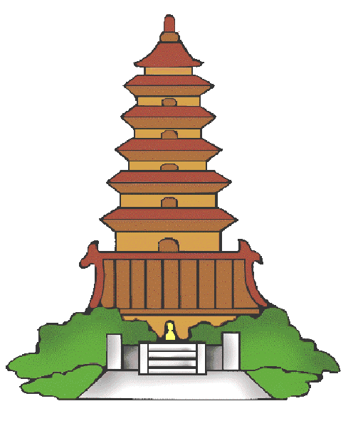  A. |   B. | 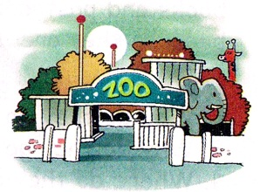  C.
4. |   A. |   B. |   C.
5. |   A. |   B. |   C.
II.Listen and complete with ONE word .
0. Tony shouldn’t play with the knife because it’s very sharp .
1. Tom shouldn’t ride too fast because he may fall off his _____________ and break his arm.
2. The post office is between the __________________ and the cinema.
3. Akiko can take a ___________ to get Phu Quoc Island from Ho Chi Minh City.
4. The ________________ is usually hot and there is a lot of rain.
5. Da Lat is more ________________ than London.

