ĐỀ KIỂM TRA GIỮA HỌC KÌ I
Môn: Tiếng Anh - Lớp 6
Thời gian làm bài: 60 phút, không tính thời gian phát đề
SECTION A: LISTENING (2 points)
Part I. Listen and write the missing information in the numbered blanks. (1.0p)
DANCE LESSONS FOR DAISY
Where? At ….school………..
- In which classroom? ………………….. -> Nhận biết
- On which day? ………………….. -> Nhận biết
- With which teacher? ………………….. -> Nhận biết
- Take to first lesson: ………………….. -> Nhận biết
- Come home by ………………….. -> Nhận biết

Part II. Listen and choose the correct answer by putting the tick (√) in the box A, B or C (1.0p)
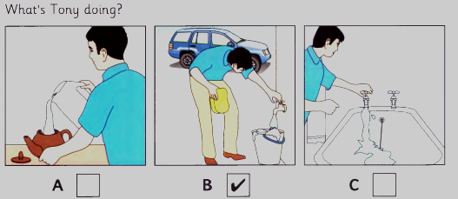
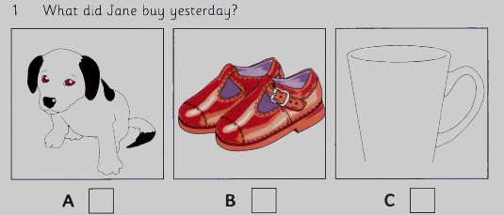
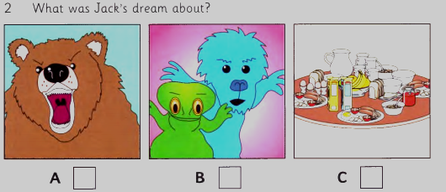
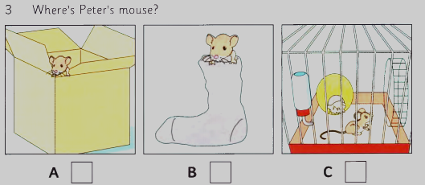
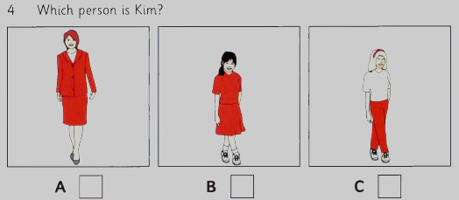
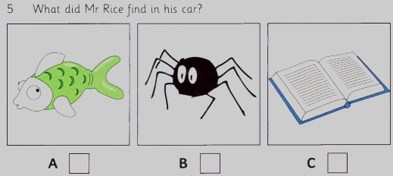
1 -> Thông hiểu
2 -> Thông hiểu
3 -> Vận dụng (có thông tin làm nhiễu nhiều)
4 -> Vận dụng (có thông tin làm nhiễu nhiều)
5 -> Thông hiểu
SECTION B: LANGUAGE FOCUS - READING – WRITING (7,5 points)
I/ Choose the word (A, B, C, or D) whose underlined part is pronounced differently. (0,4 point)
1. A. lamps B. sinks C. sofas D. flats (NB)
2. A. hard B. love C. above D. study (NB)
II. Choose the best word and phrase (A, B, C, or D) to complete the sentences below. (2 points)
1. My teacher has a house ________ to our house (NB)
A. near B. next C. on D. behind
2. ________ rooms are there in your house? - 5 rooms (NB)
A. How much B. How often C. How many D. How far
3. John goes to a/an__________ school. His classmates are from many countries. (TH)
A. boarding B. international C. local D. national
4. My mother is cooking in the ___________.(NB)
A. sink B. kitchen C. living room D. dinning room
5. My father has ___________ beard. (TH)
A. a long grey B. long a grey C. a grey long D. long grey
6. Nam: Would you like to have meals with us now? – Hoa: “____________” (VD)
A. Yes, I do B. No, I don’t
C. Oh sorry. I can’t. I must go home now. D. No, please
7. Mary is always _________. She studies hours a day and never misses homework before going to school. (TH)
A. smart B. active C. studious D. curious
8. ___________ school is small. (TH)
A. Tom of B. Toms C. Tom’s D. of Tom
9. John : “Can you tell me the way to the nearest cathedral?” (VD)
Nam: “____________________”
- It opens at nine o’clock.
- Turn left and then right
- You can go there by taxi.
- No, I can’t.
10. My brother can wait hours for his friends without getting angry. He is really ________ . (TH)
A. patient B. friendly C. lovely D. beautiful
III. Give the correct form of the verbs in the bracket. (0,6 point)
1. She (walk) ___________ to school every morning. (TH)
2. Look! Those people ________ (climb) the mountain so fast. (TH)
3. There are many clouds. It (rain) ____________ (TH)
V. Read and choose the correct word marked A, B, or C to fill each blank in the following email.(1,25 points)
From: mai@gmail.com
To: Mary@yahoo.com
Subject: My bedroom
Hi Mary,
How are you? Now I’ll tell you about my bedroom.
My bedroom is very(1) ________. There are two (2) _________, a bed, a wardrobe and a table in my bedroom. The table is near the window.
There are some books and an English-Vietnamese dictionary on the table. There are also some pens and (3) _________ on it.
The bed is on the (4) _________ of the room. There are some stories and magazines on the bed. The wardrobe is near the bed. I have many clothes. My clothes are all in the wardrobe. The bookshelf is on the (5) _________. There are many books on it. What about you? Tell me about your bedroom.
Write to me soon.
Best wishes,
Mai
1. A. near B. large C. light D. far (TH)
2. A. stool B. desk C. chairs D. sofa (NB)
3. A. pen B. pencils C. eraser D. ruler (NB)
4. A. right B. down C. up D. to (NB)
5. A. wardrobe B. wall C. door D. window (TH)
V. Read the passage and choose the correct answer for each question (1, 25 points)
Jack is my best friend. He is a teacher. He is teaching in a school in London. Every morning, he gets up at about 7 o’clock, has breakfast and a cup of coffee. Then he leaves for work. The school is far from his home, so he can’t walk there. He must go by bus. He has lunch at a restaurant nearby. In the afternoon he works until 5 or 5.30 and then he goes home. He doesn’t work on Saturdays or Sundays. He goes to the cinema or theatre. He is married and he has a son. He loves his family. They are very happy.
1. What is Jack’s job? (NB)
A. a student B. a teacher C. a writer D. a doctor
2. What does “leaves for” mean? (TH)
A. go to B. swim to C. run to D. play to
3. What’s his favorite drink? (NB)
A. milk B. tea C. coffee D. wine
4. According to the passage, which of the following statements is NOT TRUE? (TH)
A. He doesn’t have lunch at home
B. He doesn’t have any son
C. He works in a school
D. He loves his family
5. What is the passage about? (TH)
A. My friend B. Jack’s family C. My teacher D. my school
VI. Find out the mistake in each OF THE following sentenceS. (0,5 point)
1. Janet study English two hours a week. (NB)
A B C D
2. Jimmy is very sport and he likes playing football. (NB)
A B C D
VII. Rewrite the sentences, using the words given. (0,5 point)
1. There are many flowers in our garden. (VD)
=> Our garden ……………………………………………..
2. The police station is behind my school. (VD)
=> My school ……………………………………………….
VIII. Complete the sentences using the clues given. (0,5 point)
1. My close friend/ Mai/ always go/ school/ on time. (VD)
=> ……………………………..……………………………
2. There/not/bookshelf/ my bedroom. (VD)
=> ………………………………………………………………
IX. (1 point). Write an e-mail to your friend and tell him/her about your best friend. (From 60-80words) You can use the following cues: (vận dụng cao)
-His/her name/ Where he/she lives?  -What does he/she look like? (Describe his/her appearance: tall/short/ fat/thin/….) | - What is he/she like? (Describe his/her personality: kind/ creative/funny/friendly….)  - His/her hobby; What you and your best friend often do together….
From: Lucy@fastmail.com
To: David@gmail.com
Subject: ………………………
………………………………………………………………………………………………………………………………………………………………………………………………………………………………………………………………………………………………………………………………………………………………………………………………………………………………………………………………………………………………………………………………………………………………………………………………………………………………………………………………………………………………………………………………………………………………………………………………………………………………………………………………………………………………………………………/
- THE END -

ĐÁP ÁN VÀ HƯỚNG DẪN CHẤM ĐỀ KIỂM TRA GIỪA KÌ I
MÔN: TIẾNG ANH – LỚP 6
SECTION A: LISTENING (2 points)
Part I. Mỗi câu đúng được 0,2 điểm
1. ten/10 (years) | 2. (on) Monday(s) | 3. CARIS | 4. (some)(new) shoes | 5. (Daisy’s/my/your/her) bike
Part II. Mỗi câu đúng được 0,2 điểm
1. C | 2. A | 3. B | 4. B | 5. A
SECTION B: LANGUAGE FOCUS - READING – WRITING (7,5 points
I. Mỗi câu đúng được 0,2 điểm
1. C | 2. A

II. Mỗi câu đúng được 0,2 điểm
- B | - C | - B | - B | - A
- C | - C | - C | - B | - A

III. Mỗi câu đúng được 0,2 điểm

1. walks | 2. are climbing | 3. is raining

IV. Mỗi câu đúng được 0,25 điểm

- B | - C | - B | - A | 5.B

V. Mỗi câu đúng được 0,25 điểm
1. B | 2. A | 3. C | 4. B | 5. A

VI. Mỗi câu đúng được 0,25 điểm
- A | - B

VII. Mỗi câu đúng được 0,25 điểm
1. Our garden has many flowers.
2. My school is in front of the police station
VIII. Mỗi câu đúng được 0,25 điểm
1. My close friend, Mai always goes to school on time.
2. There isn’t/ is not a bookshelf in my bedroom
IX. ( 1 điểm)
- form : 0,2
- vocabulary : 0,2
- grammar : 0,2
- content: 0,4

