WORKSHEET 01 – Unit 1
Phrasal verbs; complex sentences
Ex1. Find the word which has a different sound in the part underlined.

1. A. layer
2. A. museum
3. A. tablecloth
B. frame
B. cultural
B. authenticity
C. artisans
C. drum
C. through
D. place
D. sculpture
D. although
Ex2. Choose the word which has a different stress pattern from the others.

4. A. artifact
5. A. complicated
B. embroider
B. experience
C. carpentry
C. prosperity
D. conical
D. traditional
Ex3. Choose the best answer A, B, C or D to complete the sentences.
6. In the past, local _______________ were chosen to make sophisticated embroidered costumes for the Vietnamese King, Queen and other Royal family members.
A. skill workers B. skillfully works C. skillful artists D. skilled artisans
7. Craft villages are becoming popular _____________ in Viet Nam.
A. tourism attractions B. tourist attractions
C. tour attractiveness D. physical attraction
8. Situated on the bank of the Duong River, the village was famous for the ________________ of making Dong Ho paintings.
A. craft B. production C. manufacture D. activity
9. Vietnamese traditional ____________ is done with a simple hammer and chisel.
A. sculptural pieces B. sculpture C. sculptured D. sculptor feature
10. Now, at the age of over 80, the artisan is leaving the craft to his descendants with a desire to ______________ this ancient craft.
A. preserve B. reserve C. change D. consider
11. For that artisan, making the paintings is a career _____________ its supports the life of many generations of the family.
A. so that B. because C. because of D. although
12. The Van Phuc silk produces have expanded their silk garment goods _____________ they can satisfy the varied demand for their silk.
A. in order to B. despite C. because D. so that
13. Weaving mats in Dinh Yen, Dong Thap used to be sold in the “ghost” markets set up at night and operated up to early morning _________ the government built a new market five years ago.
A. when B. until C. after D. as soon as
14. The traditional craft has ___________ from generation to generation.
A. passed down B. passed C. been passed D. been passed by down
15. Craftsmen have to ____________ the domestic and international markets so that they needn’t depend on the middlemen for their sales.
A. find B. find about C. find out D. find out about
IV. Fill in each blank in the passage with the correct word from the box. There are some extra words.
materials | tasks | individual | respects | craft | handicrafts | master | attractions
For generations throughout history, the Vietnamese people gathered in communal villages surrounded by the rice fields. However, many famers also learned to produce useful (16) __________________ for their daily lives from clay, bamboo, and other natural (17) __________________. A number of villages developed a certain (18) _____________________ for the local market or to bring into local towns or capital cities for sale. This was the origin of the Vietnamese handicraft trade villages.
These craft villages have undergone periods of varying success and failure throughout the 20th century. Some craft villages have developed and preserved their best skills and designs. In the craft village hall, the trade villagers often worship and periodically pay their (19) _________________ to the sacred craft (20) _____________________ of handicraft, who has exploits in founding, teaching or preserving the particular designs that the villages produce
V. Make a complex sentence from each pair of sentences. Use the subordinator provided and make any necessary changes.
21. Viet Nam’s current labor costs are lower compared to other countries. It brings advantages to both medium and small handicraft manufacturers. (since)
……………………………………………………………………………………………..

22. Giang got the loans from the project. Then he opened a small enterprise of ceramics. (when)
……………………………………………………………………………………………..

23. Green Craft has a lot of difficulties. It continually works to improve its productivity, designs and samples. (although)
……………………………………………………………………………………………..
24. The government carried out a job training programme in rural areas. The government wanted young people to find jobs in their own villages. (so that)
……………………………………………………………………………………………..

25. Some heads of the businesses had problems to find market. They have not been trained in management. (for) ……………………………………………………………………………………………..
VI. Choose the word or phrase among A, B, C or D that best fits blank space in the following passage.
Bau Truc pottery village of Cham ethnic minority is one of the oldest pottery villages in Southeast Asia. It is located about 10 kilometres in the South of Phan Rang town. The small village is (26) __________________ to more than 400 families, (27) ______________ 85% are in the traditional pottery business. The style is said to be handed (28) ______________ from Po Klong Chan, one of their ancestors from the immemorial time.
People in Bau Truc use their skillful hands, bamboo-made circles and shells to create priceless works. It is (29) _________________ that while the Kinh people have switched to using wheel as an indispensable (30) _________________, their Cham counterparts, on the contrary, still (31) ________________ talent hands and simple tools. To create a pottery product, a Cham craftsman only needs an anvil, not a pottery’s wheel, and other simple equipment and moulds and then uses hands to (32) _______________ pieces of clay into the works he wants.
The clay is taken from the banks of the Quao River and is very flexible, durable when (33) _______________. The skills needed to mix sand with the clay are also various. The amount of sand mixed with the plastic material is dependent on what the pottery used for and the sizes. For these reasons, Bau Truc pottery is quite different from pottery elsewhere. For example, water jars made in Bau Truc are always favoured by people in dry and sunny areas (34) _____________ the temperature of the water in the jars is always one centigrade cooler than (35) _____________ outside.

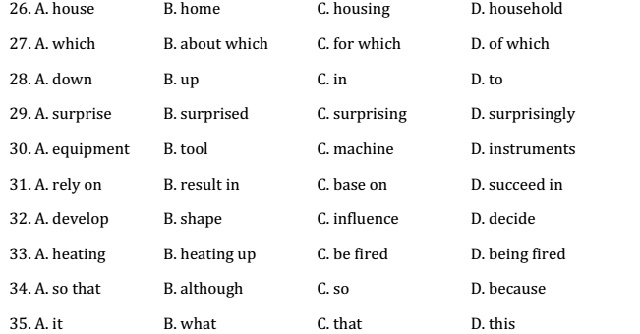
VII. Complete the second sentences so that it has a similar meaning to the first one, using the word given in brackets in the correct form.
36. The traditional handicraft villages used to accept the fact that there was a shortage of investments and human resources. (face)
……………………………………………………………………………………………..
37. Farmers can earn enough money from traditional handicrafts as they are free between harvests. (live)
……………………………………………………………………………………………..
38. People in the community often have a friendly relationship with one another so that they can follow the same craft. (get)
……………………………………………………………………………………………..
39. In the future, some traditional handicraft cooperatives will have no more wood to make wooden furniture. (run)
……………………………………………………………………………………………..
40. After trip, you return to the harbor to take a boat trip to Hoi An. (come)

WORKSHEET 02 – Unit 1
I. Find the word which has a different sound in the part underlined.
1. A. attraction B. surface C. lacqueware D. artisan
2. A. weave B. treat C. deal D. drumhead
3. A. sculpture B. lantern C. pottery D. treat
II. Choose the word which has a different pattern from the others.
4. A. handicraft B. lacquerware C. artisan D. pottery
5. A. historical B. embroidery C. authority D. architecture
III. Choose the best answer A, B, C or D to complete the sentences.
6. The four-ton statue of hero Tran Vu, ______ in 1667, still stands in Quan Thanh Temple.
A. cast B. casting C. to cast D. to be cast
7. In 1990, due to the change of the economic situation, Dong Ho paintings were difficult to sell and many ___________ quit their job.
A. craftsmanship B. craft unions C. craftsmen D. crafts
8. Making rice paper ____________ jobs and income for many locals, help many families out of poverty and become well-off.
A. keeps B. gets C. applies for D. creates
9. Since changing the way of production, many craftsmen have voluntarily joined together to form ______________.
A. cooperates B. cooperation C. cooperatives D. cooperative
10. The artisan is delighted to __________ to you the craft of creating prints in an old-age style.
A. demonstrate B. explain C. express D. provide
11. ___________ a majority of Vietnamese small and medium enterprises do not have in-house designers or specialized design staff, they have to hire freelance designers.
A. While B. Since C. Due to D. Despite the fact
12. __________ a large number of the country’s craft villages are suffering from a shortage of human resources and difficulties in building brand recognition, many international organizations have had projects to help them.
A. However B. But C. Even D. Although
13. Nowadays, Tan Chau artisans can produce silk of multiple colours _________they can meet customers’ demands.
A. so B. so that C. but D. in order
14. The bronze casting craft in Viet Nam dated back from the age of King An Duong Vuong _________ ancient bronze arrowheads were made.
A. because B. although C. so D. when
15. In 1990, due to the change of the economic situation, many Dong Ho cooperatives had to ________.
A. close B. close in C. close down D. shut
IV. Fill in each blank in the passage with the correct word from the box. There are some extra words.

handicrafts costumes | design skills | quality appearance | return history

There are many embroidery villages in Viet Nam. But Quat Dong village in Ha Noi is widely known for its products of high (16) _________________.
Embroidery has been developing around here since the 17th century. In the past, local skilled artisans were chosen to make sophisticated embroidered (17)______________ for the Vietnamese King, Queen and other Royal family members.
The first man who taught the local people how to embroider was Dr. Le Cong Hanh, who lived during the Le dynasty. He learned how to embroider while on a trip to China as an envoy, and taught the villagers of Quat Dong upon his (18)_____________. Although these (19) _____________ eventually spread across the country, the Quat Dong’s artisans’ creations are still the most appreciated.
In order to create beautiful embroideries, an artisans must be patient, careful and have an eye for (20) _____________, along with clever hands. Nowadays, Quat Dong products may range from clothes, bags, pillowcases, to paintings and decorations, which are exported to many countries.
V. Complete the second sentences so that it has a similar meaning to the first one, using the word given in brackets in the correct form.
21. Labourers in the Mekong Delta can earn enough money from their crafts during the flood seasons. (live)
……………………………………………………………………………………………..
22. The method of producing handcrafted paper flowers in Thanh Tien village in Hue were transferred from generation to keep the craft alive. (pass)
……………………………………………………………………………………………..
23. The tour guide gave a short speech so that foreign visitors could get information about the process of making fish sauce in Phu Quoc. (find)
……………………………………………………………………………………………..
24. Craft village development is now a good way to solve the poverty in rural areas. (deal)
……………………………………………………………………………………………..
25. We are thinking with pleasure about the trip in order to discover the traditional craft villager round Hue. (forward)
……………………………………………………………………………………………..

VI. Choose the word or phrase among A, B, C or D that best fits the blank space in the following passage.
Marble Mountains is a group of five smaller mountains (26) ____________ Metal, Wood, Water, Fire and Earth. It is also a travel itinerary linking Da Nang City to the ancient town of Hoi An and Hue City. As the name suggests, the Marbel Mountains used to be a place providing input (27) _____________ for craftsmen in the village, but the local government banned marble exploitation for (28)_______________ that the five mountains could disappear.
Most of the marble for the village now comes from northern provinces such as Ninh Binh, Thanh Hoa and Thai Nguyen. As a further step to diversify products, the marble fine arts village has (29) _____________ marble from Pakistan.
As far as I know, the man who (30) _____________ marble craftsmanship to the region came from Thanh Hoa, and most craftsmen in the village had handed down the craft from generation to generation. There are some 3,000 handicraft workers in Non Nuoc village. (31) ___________, there are only 70 skillful craftsmen who can (32) ______________ souls into marble sculptures after other workers have finished (33) _____________ the products.
In the shops along highway, you can see different marble products in all shapes and sizes, from contemporary (34) _____________ to religious sculptures. And of course you will have a chance to see craftsmen (35) ____________ their art turning soulless marble into sophisticated sculptured products.
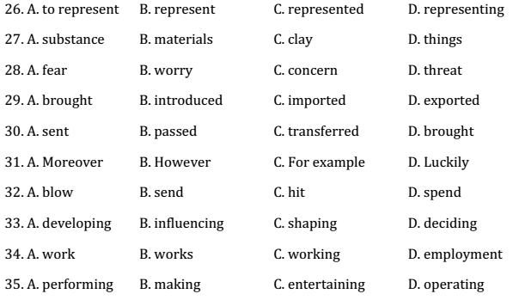
VII. Read the passage, and choose the correct answer A, B, C or D for each question.
Recently, we made a trip to visit Dong Ho village with a desire to meet the old artisan – Nguyen Huu Sam. Just when we arrived at the dyke in the village and talked with the villagers about the artisan, they immediately told about him.
The old house owned by the artisan is situated in a long alley of the village. On the walls of the house there are many folk paintings in different genres, from daily life paintings to landscape paintings shown in a set of “four seasons”.
Mr. Sam told us about his past. When he was three years old, he was instructed in the craft of makAing Dong Ho paintings by his father. At five, he could help his father apply the Dong Ho paintings, and learn how to print the paper with proper colours. At seven, he was able to draw with a pen and make the most difficult samples. Years went by and the soul of Dong Ho folk paintings has kept seashell powder paint to the poonah-paper.
In the 1940s, this craft flourished. At the time, he was assigned by his parents to take the paintings to the market for sale. Mr. Sam said that 17 families in the village have been engaged in making Dong Ho Paintings.
Artisan Sam has always been devoted to the making of Dong Ho paintings and has waited for opportunities to restore this traditional craft. In 1967, when the local authorities assigned him to restore the traditional genre of Dong Ho folk paintings, he gathered 50 villagers with professional skills and collected hundreds of woodblocks to establish the Dong Ho Painting Cooperative. Thanks to his efforts, such famous paintings as “Rat’s wedding”, “Rooster”, “Scene of jealousy” and “Writing verses about precious flowers” have been revived. Dong Ho paintings have been available in many parts of the world such as Jaoan, France, Germany, Singapore and the United States.
36. The themes of Dong Ho paintings are about _____________.
A. landscapes B. weddings C. various aspects of life D. animals and flowers
37. In order to make Dong Ho paintings, we need seashell powder paint, the poonah-paper and _______.
A. proper colours B. water C. markets D. woodblocks
38. From paragraph 3, we can infer that when Mr. Sam was very young, he mostly people parents by ____________.
A. applying the woodblocks with proper paints and pressing them on the sheets of paper
B. applying seashell powder to make various paints for painting making
C. drawing with a pen and using proper paints to make many copies of paintings
D. collecting and talking the paintings to the market for sale
39. All of the following can be inferred about the artisan – Mr. Sam – EXCEPT that________.
A. he is popular in the village
B. he could paint when he was three
C. he keeps a collection of Dong Ho paintings in his house
D. the local authorities tried to revive the traditional craft
40. In the writer’s opinions, the future of Dong Ho paintings is ____
A. international B. concerning C. optimistic D. negative

