Date of preparing: ………………………………….
Date of teaching: ………………………………….
Period 16

UNIT 3: MY FRIENDS

Lesson 1: Getting started

I. Objectives
By the end of this lesson, students will be able to:
1. Knowledge
- Have an overview about the topic My friends
- Have vocabulary to talk about body parts and appearance to describe people’s appearance
2. Core competence
- Develop communication skills and creativity
- Be collaborative and supportive in pair work and teamwork
- Actively join in class activities
3. Personal qualities
- Be ready to describe classmates
- Develop self-study skills
II. Materials
- Grade 6 textbook, Unit 3, Getting started
- Computer connected to the internet
- Projector/ TV/ pictures and cards
- sachmem.vn

Language analysis
Form | Pronunciation | Meaning | Vietnamese equipvalent
1. glasses (n) | /ˈɡlɑːsɪz/ | things people wear when they have eyes’ problems | mắt kính
2. cheek (n) | /tʃiːk/ | the parts under people’s eyes | má
3. foot (n-s)/feet (n-p) | /fʊt/ - /fiːt/ | ​the body part we use to stand on | bàn chân

Anticipated difficulties | Solutions
1. Students may be lack knowledge and experiences about the topic. | - Prepare some handouts.
2. Students may have underdeveloped listening, speaking and co-operating skills. | - Play the recording many times if necessary.  - Encourage students to work in pairs, in groups so that they can help each other.  - Provide feedback and help if necessary.

III. Procedures:
Stage | Stage aim | Procedure | Interaction
Warm-up  (5 mins) | To review on people’s body parts, recall Ss vocabulary. | * Listen and do along  - Teacher plays the song on speakers.  - Teacher and students sing along and point at the mentioned body parts in the song lyrics. Do 2-3 times and make it faster each time.  Link: https://www.youtube.com/watch?v=YGi3f_fHIzg  Lyrics:  Body body bop bop!  Body bop bop!  Body body bop bop!  Body bop bop!  Wash your head.  Wash your shoulders.  Body body bop bop bop!  Wash your tummy.  Wash your bottom.  Body body body body bop!  Body body bop bop!  Body bop bop!  Touch your eyes.  Touch your nose.  Body body bop bop bop!  Touch your mouth.  Touch your ears.  Body body body body bop!  Body body bop bop!  Body bop bop!  Body body bop bop!  Body bop bop!  Wiggle your arms.  Wiggle your legs.  Body body bop bop bop!  Wiggle your fingers.  Wiggle your toes.  Body body body body bop!  Body body bop bop!  Body bop bop!  Shake your elbows.  Shake your knees.  Body body bop bop bop!  Shake your hands.  Shake your feet.  Body body body body bop!  Body body!  Body body body body!  Bop bop bop! | T-Ss
Lead-in  (3 mins) | To lead in the topic. | Task 1: Teacher draws students’ attention to the picture in the textbook and asks them questions about the picture:  - What are Phong and Nam doing?  - What is Phong favourite magazine?  - Who do Phong and Nam see?  - Where are the two girls going?  Suggested answers:  - They are having a picnic.  - It’s …  - They see …  4. They are going to … | T-Ss
Presentation  (Vocab-  pre-teach)  (5 mins) | To enrich student’s vocabulary | Vocabulary  - Teacher introduces the vocabulary by:  + showing the pictures illustrating the words  + providing the synonym or antonym of the words  + providing the definition of the words  1. glasses (n): [picture]  2. cheek (n): [picture]  3. foot-feet (n): [picture] | T-Ss
Practice  (20 mins) | To practice the targeted language (adjectives) and the background knowledge.  To practice using the targeted  vocabulary. | Task 2: Listen to the conversation and check the prediction. (p. 26)  - Teacher plays the recording, asks students to underline the words they have learnt in the vocabulary part.  - Teacher can play the recording more than once.  - Students listen and read.  Task 3: Listen to the conversations again and work in pairs to do Ex. 2.  - Students work in pairs.  - Teacher asks students to share their answers before discussing as a class.  - Teacher asks students to explain where they can find the answer.  Answer key:  1. picnic  2. favourite magazine  3. Mai and Chau  4. glasses; long black hair  5. are going to  Task 4: Show a picture – stickers do Ex. 3.  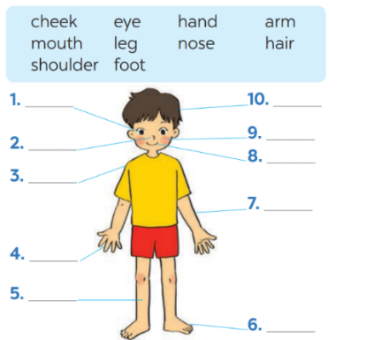  - Teacher has students go to the board to stick the right stickers with the body part names to the right place on the picture.  - Students work independently to do Ex. 3  - Teacher asks students to give out more names of body parts that they have known.  Answer key:  1. eye  2. nose  3. shoulder  4. hand  5. leg  6. foot  7. arm  8. mouth  9. cheek  10. hair  Task 5: Work in groups of 3-4 to do Ex. 4.  - Students can work in groups to complete this task.  - Teacher introduces examples and structures for students to make sentences to describe a friend.  Answer key:  1. Long/short: hair, arms, legs, fingers, …  Ex: She has long hair.  2. Big/small: nose, eye, hand, feet, mouth, …  Ex: She has big eyes.  3. Hair: blonde, curly, wavy, straight, short, long, dark, …  Ex: He has short curly hair. | T-Ss  Pair work  T-Ss  T- Ss  S  T-Ss  Group work
Production  (8 mins) | To use the vocaburaly and structure in real life context. | Task 6: Game: Describe and guess.  Work in groups, take turns to describe a classmate. Other group members guess who he/she is.  Suggested answers:  - She has glasses, she has long black hair.  - Is she Mai?  - No, she isn’t. She has a small nose.  - Is she Lan?  - Yes, she is. | Group work
Wrap-up  (3 mins) | To consolidate what students have learnt in the lesson. | Teacher asks students to talk about what they have learnt in the lesson. | T-Ss
Homework  (1 min) | To prepare vocabulary for the next lesson: A closer look 1. | Write some sentences to describe at least 3 classmates. | T-Ss

Date of preparing: ………………………………….
Date of teaching: ………………………………….
Period 17

UNIT 3: MY FRIENDS

Lesson 2: A closer look 1

I. Objectives
By the end of this lesson, students will be able to gain:
1. Knowledge
- Use vocabulary and structures about body parts, appearance and personality
- Correctly pronounce the sound /p/ and /b/ in isolation and in context.
2. Core competence
- Develop communication skills and creativity
- Be collaborative and supportive in pair work and team work
- Actively join in class activities
3. Personal qualities
- Be ready to make share ideas among classmates.
- Develop self-study skills

II. Materials
- Grade 6 textbook, Unit 3, A closer look 1
- Computer connected to the internet
- Projector/ TV/ pictures and cards
- sachmem.vn

Language analysis
Form | Pronunciation | Meaning | Vietnamese equivalent
1. confident (adj) | /ˈkɒnfɪd(ə)nt/ | believe in one’s self | tự tin
2. caring (adj) | /ˈkeərɪŋ/ | care about others | quan tâm
3. active (adj) | /ˈæktɪv/ | ​full of energy | năng động
4. careful (adj) | /ˈkeə(r)f(ə)l/ | always do things without mistakes | cẩn thận
5. creative (adj) | /kriˈeɪtɪv/ | have many interesting ideas | sáng tạo
6. shy (adj) | /ʃaɪ/ | = reserved >< confident | nhút nhát
7. kind (adj) | /kaɪnd/ | >< cruel/evil, = good, caring | tốt bụng
8. clever (adj) | /ˈklevə(r)/ | = intelligent/smart | thông minh

Anticipated difficulties | Solutions
1. Students may be lack of knowledge about personalities. | Prepare some antonyms so that students can guess correctly the meaning of the new vocabulary
2. Students may have  underdeveloped listening,  speaking and co-operating skills. | - Play the recording many times if necessary  - Encourage students to work in pairs, in groups so that they can help each other  - Provide feedback and help if necessary

III. Procedures:

Stage | Stage aim | Procedure | Interaction
Warm-up  (5 mins) | To review on people’s body parts, recall students’ vocabulary. | * “Simon says” game  - Teacher explains the game rules: Students have to touch the body parts that teacher calls out. Who gets wrong action is out of the game.  - Teacher starts all sentences with:  “Simon says Touch your … “ | T-Ss
Lead-in  (6 mins) | To lead in the topic. | Lead in: How can we describe our friends’ personalities?  Teacher asks students to say some personalities:  Suggested answers:  funny, active, lazy, hard-working, …  Task 1: Matching. Students work in pairs to match the words with the correct pictures: Check  (Teacher can help students by describing the pictures.)  Answer key:  1. c (caring)  2. e (active)  3. d (hard-working)  4. a (funny)  5. b (confident) | T-Ss
Presentation  (Vocab-  pre-teach)  (9 mins) |  | Vocabulary  - Teacher introduces the vocabulary by:  + providing the synonym or antonym of the words  + providing the definition of the words  1. confident (adj): [explanation]  2. caring (adj): [explanation]  3. active (adj): [explanation]  4. careful (adj): [explanation]  5. creative (adj): [explanation]  6. shy (adj): [antorym]  7. kind (adj): [explanation]  8. clever (adj): [synonym]  - Teacher asks students to repeat and practice pronouncing the words. | T-Ss
Practice  (10 mins) | To practice the targeted language (adjectives) and the background knowledge.  To practice the targeted  language (adjectives) and the background knowledge verbally | Task 2: Read the descriptions and match with the correct words. (p. 28)  - Teacher asks students to work individually.  - Then discuss with a partner.  - Teacher checks and corrects (if needed).  Answer key:  1. creative  2. kind  3. friendly  4. careful  5. clever  Task 3: Game: Why do I love my friends?  - Students work in groups.  - Teacher asks students to write at least 2-3 personalities to describe each members.  - Teacher asks students to read out, beginning with I love … because he/she is …, … and …  Suggested answer:  1. I love Trang because she is kind, creative and funny.  2. I love Minh because he is smart, caring and friendly.  3. … | S  Ss  T-Ss  Group work  T-Ss
Practice  (5 mins) | To help students  practice pronunciation the sound in words. | PRONUNCIATION  Task 4: Pronunciation: /b/ and /p/. Listen and repeat. Circle the words you hear.  - Teacher has students lister to the  recordings and stops to let students repeat each word.  - Students work independently to  circle the words they have listened.  Task 5: Listen. Practice the chant.  - Teacher plays the recording twice.  - Students practice with a partner.  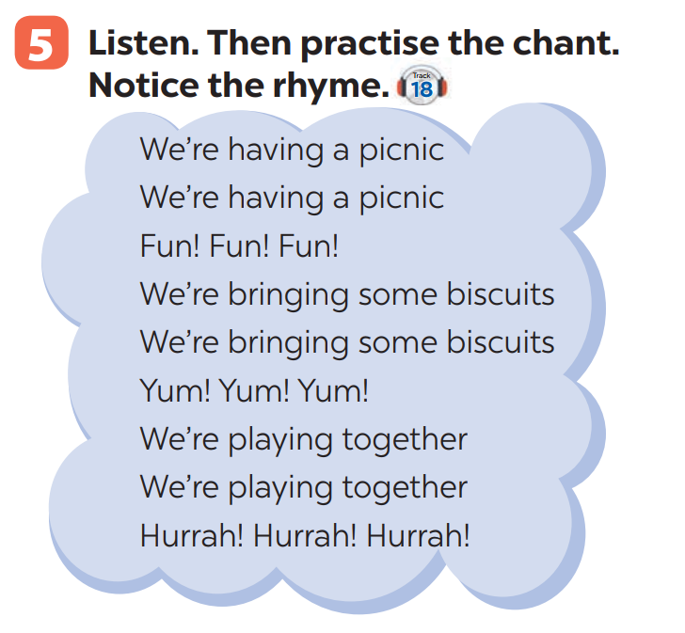 | T-Ss  S  T-Ss  Ss-Ss
Production  (7 mins) | To recognise the targeted vocabulary and sounds. | Task 6: Game: “Up and down”  - Teacher explains the rules:  - Round 1: Teacher says 1-15  personalities that students have learnt in the lesson. Students stand up for the positive ones, sit down for the negative ones.  - Round 2: Teacher says 1-15 words containing the sound /b/ and /p/. Students stand up for the ones with the “b” sound, sit down for “p” sound.  - Students plays on groups. | T-Ss  Group work
Wrap-up  (2 mins) | To consolidate what students have learnt in the lesson. | Teacher asks students to talk about what they have learnt in the lesson. | T-Ss
Homework  (1 mins) | To prepare vocabulary for the next lesson: A closer look 2. | Do the exercises in the workbook. | T-Ss

Date of preparing: ………………………………….
Date of teaching: ………………………………….
Period 18

UNIT 3: MY FRIENDS

Lesson 3: A closer look 2

I. Objectives
By the end of this lesson, students will be able to:
1. Knowledge
- Use the present continuous to talk about things happening now;
- Ask about appearance and personality
2. Core competence
- Develop communication skills and creativity
- Be collaborative and supportive in pair work and teamwork
- Actively join in class activities
3. Personal qualities
- Develop self-study skills

II. Materials
- Grade 6 textbook, Unit 3, A closer look 2
- Computer connected to the internet
- Projector/ TV/ pictures and set of word cards
- sachmem.vn

Language analysis
Form | Example
S + am/ is/ are + V-ing | She is playing basketball in the garden.
S + am not/ isn’t/ aren’t + V-ing | They are not going to school at the moment.
Am/ Is/ Are + S + V-ing? | Are you having lunch?
Wh + am/ is/ are + S + V-ing? | Why is he standing over there?

Anticipated difficulties | Solutions
1. Students may lack knowledge and experiences about the topic. | - Prepare some hand-outs in which key language of the key language of describing personalities.
2. Some students will excessively talk in the class. | - Define expectation in explicit detail.  - Have excessive talking students practise.  - Continue to define expectations in small chunks (before every activity).

III. Procedures:

Stage | Stage aim | Procedure | Interaction
Warm-up  (5 mins) | To activate students’ prior knowledge and  vocabulary related to the targeted grammar of present continuous and to increase students interest. | * Game: Sentence  puzzling  - Teacher divides the class into 4 groups.  - Teacher delivers a set of word cards which are jumble sentences in present continuous to each group.  - Students will have to work in groups to create as many correct sentences from the word cards as possible.  - The group with more correct sentences will be the winner.  Suggested answers: | Group work
  1. She |  |  | is | learning
  English |  |  | now.
  2. His |  |  | dog | is
  eating |  |  | dinner.
  3. Phong |  |  | and |  |  | Trang
  are |  | talking.
  4. Susan |  |  | isn’t | playing
  the |  |  | piano.
   | 5. My |  | parents |  |  | are
   | visiting |  | me.
Lead-in  (5 mins) | To introduce targeted grammar of present  continuous. | Task 1: Teacher explicits the forms.  - Teacher draws students’ attention to the form of the sentences created in the game ask them whether they know the target tense Teacher provides or confirms the answers and lead in the grammar focus of the lesson:  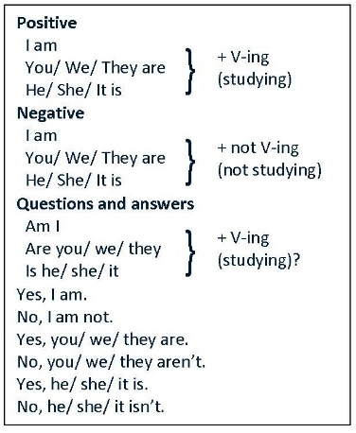 | T-Ss
Presentation  (10 mins) | To help students get to know the use of present continuous. | Task 2: Put the verbs in the brackets in the present continuous.  - Teacher has students complete Ex. 1 + 2 (p. 29).  - Teacher then asks students to exchange their textbooks to check their friends’ answers.  Answer key:  Ex. 1:  1. is reading  2. are playing  3. isn’t making  4. am going  5. are; talking  Ex. 2:  1. Nam and Ba are not / aren’t eating ice cream.  2. Lan and Trang are taking photos.  3. Ha is / Ha’s writing a letter.  4. Duong and Hung are not / aren’t playing badminton.  5. Phong is not / isn’t drawing a picture. | T-Ss  Ss-Ss
Practice  (12 mins) | To give students  opportunities to use present continuous correctly in context. | Task 3: Work in pairs. Make questions and answers from the given words and pictures. (p. 30)  - Teacher has students work on the exercise in pairs.  - Teacher gives feedback as a class discussion.  Answer key:  1. Is your friend swimming?  – Yes, he is.  2. Are they listening to music?  – No, they aren’t. (They’re / They are having a picnic.)  3. Is Mi playing the piano?  – No, she isn’t.  (She’s / She is doing karate.)  4. Are they learning English?  – Yes, they are.  5. Are your friends cycling to school?  – No, they aren’t. (They’re / They are walking to school.)  Task 4: Mime game:  Take turns to mime different actions. Others guess what you are doing. | Ss-Ss  T- Ss  Ss-Ss
Production  (10 mins) | To help students  distinguish and use correctly present simple and present continuous. | Task 5: Kahoot game. Choose the best option to complete the  questions in the game.  - Teacher prepares Ex. 4 (p. 30) to create questions in Kahoot game.  - Teacher allows students to use their mobile devices to answer and interact with the questions online.  - Teacher gives clear instructions for students to fully understand how to play Kahoot game online.  - Go to kahoot.it  - Enter the game PIN  - Type your nickname  - Choose the best option for each question appearing on the screen  - See who will be the winner  - Teacher provides the game PIN and allows students’ access to the game.  - Students choose the best option for each question appearing on the screen.  - Teacher gives complement or good mark to the winner of the game.  * Questions in the game:  1. My best friend (not walk) _______ to school every day. Sometimes she (cycle) _______.  A. does not/ doesn’t walk; cycles  B. isn’t/ isn’t walking cycles  2. Look! What _______ he (play) _______?  A. does he play B. is he playing  3. _______ your friends (study) _______ in the library every  afternoon?  A. Are your friends and you studying  B. Do your friends and you study  4. I (write) _______ an email to my friend now.  A. am writing B. write  5. He (not do) _______ his homework now. He (read) _______  A. doesn’t do/ reads  B. isn’t doing/ is reading  Answer key:  - A  - B  - B  - A  5. B | T-Ss
Wrap-up  (2 mins) | To consolidate what students have learnt in the lesson. | Teacher asks students to talk about what they have learnt in the lesson. | T-Ss
Homework  (1 min) | Reactivate the knowledge that students have gained in the Kahoot game. | Do Exercise 4, write the answers on your notebooks. | T-Ss

Date of preparing: ………………………………….
Date of teaching: ………………………………….
Period 19

UNIT 3: MY FRIENDS

Lesson 4: Communication

I. Objectives
By the end of this lesson, students will be able to:

1. Knowledge
- Ask and answer about people’s appearance and personalities
- Practice to talk about people’s appearance and personalities.
2. Core competence
- Develop communication skills and creativity
- Be collaborative and supportive in pair work and team work
- Actively join in class activities
3. Personal qualities
- Be ready to make share ideas among classmates.
- Develop self-study skills

II. Materials
- Grade 6 textbook, Unit 2, Communication
- Computer connected to the internet
- TV/ Pictures/ Projector
- sachmem.vn

Language analysis
How to ask about appearance and personality:

Form | Example
- The structure to ask about  appearance:  * What + do/does + S + look like? | What does your best friend look like?
- the structure to ask about  personality:  * What + be + S + like? | What’s she like?

Anticipated difficulties | Solutions
1. Students may lack knowledge of dates and months. | - Provide students with information about dates and months.
2. Students may have  underdeveloped reading, speaking and co-operating skills. | - Encourage students to work in pairs, in groups so that they can help each other.  Provide feedback and help if necessary.
3. Some students will excessively talk in the class. | - Define expectation in explicit detail.  Have excessive talking students practise.  - Continue to define expectations in small chunks (before every activity).

III. Procedures:

Stage | Stage aim | Procedure | Interaction
Warm-up  (5 mins) | To introduce the topic. | * BINGO  - Teacher asks students to make a table into their notebooks and fill in with different personalities.  - Teacher reads out loud 9 personalities. The student has a line of 3 can shout: BINGO.  - Teacher checks the answer. | T-Ss
  active | clever | kind
  …
Lead-in  (1 min) | To lead in the lesson. | - Teacher leads students into the lesson by telling about what they are going to learn: “How to ask and answer about people’s appearance and personalities”. | T-Ss
* EVERYDAY ENGLISH
Presentation  (15 mins) | To introduce question to ask about people  appearance and  personalities. | Task 1: Work in pairs to make similar dialogues about their best friend.  - Play the recording for students to listen and read the dialogue between Linda and Mi at the same time.  - Ask students to pay attention to the highlighted questions. Elicit the structure to ask about appearance:  * What does your best friend look like?  and the structure to ask about personality  * What’s she like?  as well as the language used to answer these two questions.  - Have students practise the dialogue in pairs.  Call some pairs to practise the dialogue in front of the class.  Audio script:  Linda: What does your best friend look like?  Mi: She’s short with long black hair. She has bright brown eyes.  Linda: What’s she like?  Mi: She’s very kind and creative.  - Teacher ask students to work in pairs to make similar  dialogues about their best friend, using the questions learnt.  - Teacher moves around to observe and provide help if needed.  Call on some pairs to practise in front of the class.  Suggested answer:  - What does A look like?  - He is tall and slim. He has short black hair. He has glasses.  - What is he like?  - He is hard-working and creative. He is kind, too. | T-Ss
Practice  (8 mins) | To practice talking about appearance and personalities. | Task 2: Puzzle reading. (Ex. 3, p. 31)  - Teacher ask students to work in groups. Each group reads about one friend only.  - Have students give their answers and give the reasons for their answers.  - Teacher writes the answers on the board to prepare for Activity 4.  Answer key:  - Vinh: clever,  hard-working  John: creative, kind | Ss-Ss  T-Ss
Production  (13 mins) | To apply the knowledge about asking for people’s appearance and  personalities. | Task 3: Read the descriptions in pairs and find out if they match your friend’s personalities.  - Teacher tell students that each person has a star sign, depending on his / her birthday, and the star sign may decide a person’s  personality.  - Ask students to read the descriptions and check if they match the friends in Ex. 3. Students can refer to the answers to Activity 3 that have been written on the board.  - Then teacher asks students to work in pairs and compare the descriptions. | T-Ss  Ss-Ss
Production  (13 mins) | To help students get used to talking about people’s  appearance and  personalities. | Task 4: Discussion: Read the descriptions in Ex. 4. Share your opinion within a group.  - Students work in groups and read the descriptions in 4. They write down their ideas to  complete the three sentences in the book.  - Students work in groups to share their answers.  - Teacher invites some students to share their opinion with the class. | Ss-Ss  T-Ss
Wrap-up  (2 mins) | To consolidate what students have learnt in the lesson. | - Teacher asks students to talk about what they have learnt in the lesson. | T-Ss
Homework  (1 min) | To prepare for the project of Lesson 7. | - Prepare a picture/ photo of your friend for Lesson 7. | T-Ss

Date of preparing: ………………………………….
Date of teaching: ………………………………….
Period 20

UNIT 3: MY FRIENDS

Lesson 5: Skills 1

I. Objectives
By the end of this lesson, students will be able to:
1. Knowledge
- Read for specific information about friends and summer camps;
- Talk about friends and summer camps;
2. Core competence
- Develop communication skills and creativity
- Be collaborative and supportive in pair work and teamwork
- Actively join in class activities
3. Personal qualities
- Develop self-study skills

II. Materials
- Grade 6 textbook, Unit 3, Skills 1
- Computer connected to the internet
- Projector/ TV
- sachmem.vn

Language analysis
Form | Pronunciation | Meaning | Vietnamese equivalent
1. superb (adj) | /sʊˈpɜː(r)b/ | the highest quality | siêu đẳng
2. perfect (adj) | /ˈpɜː(r)fekt/ | as good, correct, or accurate as it is possible to be | hoàn hảo
3. leadership (n) | /ˈliːdə(r)ʃɪp/ | ​the skill that allow a person to help and guide others | kĩ năng lãnh đạo
4. field trip (n) | /fiːld trɪp/ | a visit to a place that gives students the chance to study something in a real environment | chuyến tham quan

Anticipated difficulties | Solutions
1. Students may be lack of knowledge about body parts and structures to describe people’s appearance | Prepare some handouts on vocabulary and structures to describe people’s appearance.
2. Students may have underdeveloped listening,  speaking and co-operating skills. | - Encourage students to work in pairs, in groups so that they can help each other.  Provide feedback and help if necessary.

III. Procedures:

Stage | Stage aim | Procedure | Interaction
Warm-up  (5 mins) | To activate Ss’ knowledge of the topic in the reading text. | * Listen and do along  - Teacher plays the song on speakers.  - Teacher and students sing along and point at the mentioned body parts in the song lyrics. Do 2-3 times and make it faster each time. | T-Ss
Lead-in  (3 mins) | To lead in the topic. | Task 1: Lead in questions: Look at the advertisement, discuss in pairs and answer.  1. Who is the superb summer camp for?  2. What can people do at this summer camp?  Suggested answers:  1. It’s for kids between 10 and 15 years old.  2. They can play sports and games, draw pictures, play music, learn life skills, go on field trips, etc. | T-Ss
Presentation  (Vocab-  pre-teach)  (5 mins) | To provide students with some lexical items before reading the text. | Vocabulary  - Teacher introduces the vocabulary by:  + showing the pictures illustrating the words.  + providing the synonym or antonym of the words.  + providing the definition of the words.  1. superb (adj) [explanation]  2. perfect (adj) [explanation]  3. leadership (n) [explanation]  4. field trip (n) [explanation] | T-Ss
Pre-Reading  (4 mins)  While-Reading  (4 mins)  Post-Reading  (4 mins)  Pre-Speaking  (4 mins)  While-  Speaking  (4 mins) | To practice the targeted language  (adjectives) and the background knowledge. | Task 2: Explicit reading skills: Scan and Skim.  - Teacher explicits the targeted skills.  - Teacher explains how to scan and skim and ask students to practice with the advertisement.  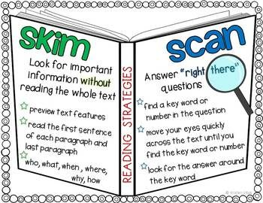  Task 3: Read the email and decide the sentences T or F.  - Ask students how to do the exercise. Instruct them to do the exercise if needed (e.g. reading the sentences,  underlining the key words, locating the key words in the text, deciding whether the sentences are true or false).  - Set a time limit for them to read the text and answer true or false. If it is false, ask them to correct it. Teacher ask students to note where they found the information that helped them complete the activity.  - Have students work in pairs and compare their answers before having them discuss as a class. Ask students to support their answers with  information from the text.  Answer key:  1. F (They speak English only.)  2. F (He has three.)  3. F (Jimmy likes taking photos.)  4. T  5. T  Task 4: Work in groups and do Ex. 3.  - Teacher has students look at the  advertisement for the Superb Summer Camp again and underline the requirements for the students if they want to join the camp (e.g. between 10 - 15 years old; ability to use English all the time, etc.) and the types of activity Ss can do at the camp.  - Teacher asks students to read the information about the three students Mi, An and Vy. Instruct students to underline the features of each student and compare these with the information stated in the advertisement.  - Teacher asks them to work in groups and decide if the Superb Summer Camp is suitable for these students and explain why. Invite students from different groups to share their answers.  Suggested answers:  1. The camp is suitable for her because it suits her age and she can use English. She can also practise her creativity at the camp.  2. The camp does not seem to suit An. He may be too old for the camp and he can’t speak English.  3. The camp suits Vy. It suits her age and it can help her improve her English. | T-Ss  T-Ss  S  Ss-Ss  T-Ss  Group work
Production  (Post-  Speaking)  (8 mins) | To provide an opportunity for students to practice speaking. | Task 5: Students to work in groups and share their opinions.  - Teacher has students think about themselves and decide if the camp suits them. Encourage them to give the reasons for their answers.  - Teacher asks students to work in groups and share their opinions. Move around to observe and provide help if needed.  - Call on some Ss to share their answers.  Suggested answers:  - I think Superb summer camp is suitable for me because I’m 12.  - Superb summer camp is good for me because I want to speak English all the time.  … | T-Ss  Ss-Ss  T-Ss
Wrap-up  (3 mins) | To consolidate what students have learnt in the lesson. | Teacher asks students to talk about what they have learnt in the lesson. | T-Ss
Homework  (1 min) | To prepare vocabulary for the next lesson: Skills 2. | Do exercises in the workbook. | T-Ss
Date of preparing: ………………………………….
Date of teaching: ………………………………….
Period 21

UNIT 3: MY FRIENDS

Lesson 6: Skills 2

I. Objectives
By the end of this lesson, students will be able to:
1. Knowledge
- Listen for specific information about best friends
- Write a diary entry about best friends
2. Core competence
- Develop communication skills and creativity
- Be collaborative and supportive in pair work and team work
- Actively join in class activities
3. Personal qualities
- Develop self-study skills

Anticipated difficulties | Solutions
1. Students may lack knowledge and experiences about the topic. | - Prepare some hand-outs in which key language of the key language of describing people.
2. Students may have  underdeveloped listening, writing and co-operating skills. | - Play the recording many times if necessary.  - Encourage students to work in pairs, in groups so that they can help each other.  Provide feedback and help if necessary.
3. Some students will excessively talk in the class. | - Define expectation in explicit detail.  Have excessive talking students practise.  - Continue to define expectations in small chunks (before every activity).

III. Procedures:

Stage | Stage aim | Procedure | Interaction
Warm-up  (5 mins) | To review the vocabulary. | * Game: Jumbled words  - Teacher sticks some jumbled words onto the board.  - Students raise hands to answer.  LFIEDRNY  TACIEV  UNFNY  RCUFEAL  TOFCNDITEN  Answer key:  - ACTIVE  - FRIENDLY  - FUNNY  - CAREFUL  5. CONFIDENT | T-Ss
Pre-Listening  (6 mins) | To help students  recall knowledge of present continuous. | Task 1: Look at the pictures. Guess the activity. Check as a class discussion.  - Teacher tells students to look at the pictures and guess what they are doing.  - Teacher plays the recording. Students listen and check their predictions.  Answer key:  a. They are talking.  b. They are playing football.  c. They are walking. | T-Ss
While-Listening  (10 mins) | - To develop students listening skills.  - To help students  develop listening skill for specific  information.  To help students  develop listening skill for specific information (gap-filling). | Task 2: Work in pairs. Note down to describe the two girls. Underline keywords. Listen and find out who is Lan and Chi.  *Descriptions  - Teacher asks students to look at the pictures and note down some descriptions about the 2 girls.  - Teacher asks students to underline the keywords Tell students to pay attention to the key words while listening.  * Listen and decide who is Lan and Chi  - Teacher plays the recording.  - Teacher asks students to listen and choose the answers.  - Teacher asks students to compare their answers with the  prediction made  previously.  - Teacher checks  students’ answers as a class.  Answer key:  - Lan is the girl wearing a red and white jacket and a red cap.  - Chi is the girl wearing a white T-shirt and a blue skirt.  Task 3: Listen again and fill in the blanks.  - Teacher asks students to read the questions carefully and determine what information they need to fill the gaps (numbers, words).  - Teacher plays the recording for students to fill the gaps.  - Teacher asks them to swap their answers in pairs before checking their answers as a class.  Answer key:  1. 6A  2. black; mouth  3. friendly  4. big  5. kind  Audio script:  Mi: My best friend is Quyen. She studies with me in class 6A. She’s tall and slim. She has short black hair and a small mouth. She’s very active and friendly. She likes playing sports and has many friends.Look, she’s playing  football over there!  Minh: Chi is my best friend. We’re in class 6B. She’s short with long black hair and a big nose.  I like her because she’s kind to me. She helps me with my English. She’s also hard-working. She always does her  homework before class. Look, she’s going to the library. | T-Ss  T-Ss  T-Ss
Post-Listening  (5 mins) | To develop students’ speaking skill, using the available  information and their background knowledge. | * Talk about your friends:  - Students work in groups of 3.  - Teacher asks students to say 2 words about appearance and  personalities of the other 2 members and ask them if they think it is true about them.  - Students can add more information based on their background knowledge.  - Teacher goes around and helps if needed. | Group work
Pre-Writing  (5 mins) | To help students talk about a friend. | Task 4: Work in pairs. Ask and answer about your best friend.  - Teacher asks students to work in pairs.  - Teacher asks students to take short notes of the answers for later use.  - Teacher goes around and helps if needed.  Suggested answers:  - His/Her name is …  - He/She is…  … | Pair work
While-Writing  (10 mins) | To teach students how to write a  diary entry about a friend. | Task 5: Write a diary entry about your best friend. Cross check.  - Ask students to write the diary entry  individually.  - Ask one or two students to write their entry on the board.  - Other students and teacher comment on the entries on the board. | S  T-Ss  Ss-Ss
Post-Writing  (2 mins) | To peer check, cross check and final check students’ writing. | - Teacher asks students to exchange their textbooks to check their friends’ writing.  - Teacher then gives feedback as a class discussion. | Ss-Ss  T-Ss
Wrap-up  (2 mins) | To consolidate what students have learnt in the lesson. | Teacher asks students to talk about what they have learnt in the lesson. | T-Ss
Homework  (1 min) | To allow students finalize their postcards after being checked by friends and the teacher. | Rewrite the diary entry in the notebook. | T-Ss

Date of preparing: ………………………………….
Date of teaching: ………………………………….
Period 22

UNIT 3: MY FRIENDS

Lesson 7: Looking back & Project

I. Objectives
By the end of this lesson, students will be able to:
1. Knowledge
- Review the vocabulary and grammar of Unit 3
- Apply what they have learnt (vocabulary and grammar) into practice through a project
2. Core competence
- Develop communication skills and creativity
- Be collaborative and supportive in pair work and team work
- Actively join in class activities
3. Personal qualities
- Develop self-study skills

II. Materials
- Grade 6 textbook, Unit 3, Looking back and project
- Computer connected to the internet
- Projector/ TV/, colours and pens, worksheets
- sachmem.vn

Anticipated difficulties | Solutions
1. Students may have underdeveloped speaking, writing and co-operating skills when doing project. | - Encourage students to work in pairs, in groups so that they can help each other  - Provide feedback and help if necessary
2. Some students will excessively talk in the class. | - Define expectation in explicit detail  - Have excessive talking students practise  - Continue to define expectations in small chunks (before every activity)

III. Procedures:

Stage | Stage aim | Procedure | Interaction
Warm-up  (5 mins) | To revise the vocabulary related to the topic and lead in the next part of the lesson. | * Brainstorming  - Teacher divides the board, and divides the class into 2 big groups.  - Each group will be assigned a category: APPEARANCE & PERSONALITIES  - Teacher asks students to brainstorm all adjectives related to people’s appearance and personalities.  - The group having the most suitable answers is the winner.  Suggested answers:  - Appearance: tall, short, beautiful, smart, …  Personalities: confident, careful, clever, funny, … | Group work
Looking back  (16 mins) | To help students revise the adjectives describing people.  To help students  revise present tenses in context | Task 1: Choose the best options to complete the sentences. (Ex. 1, p. 34)  - Teacher encourages students to complete the task individually.  - Students exchange their textbook to discuss the reasons why they are choosing the appropriate  adjectives.  - Teacher gives feedback as a class discussion.  Answer key:  1. B  2. A  3. C  4. A  5. C  Task 2: Game: Lucky Numbers. (Ex. 2, p. 34)  - Teacher divides the class into 2 groups.  - Teacher asks students to choose the number and answer the questions quickly in 3 seconds.  - If students choose the lucky number, they don’t have to answer.  1. Who has long hair in your class?  2. Who has a small nose?  3. Who has a round face?  4. Does the classmate next to you have long hair?  5. Does the classmate next to you have big eyes?  6. LUCKY NUMBER  Task 3: Put the verbs in the brackets in correct forms. (Ex. 3-4, p. 34)  - Teacher has students complete the task individually.  - Students exchange their textbooks to discuss the reasons about their choices.  - Students should record their original answers to guide their self-assessment later.  - Teacher gives feedback as a class discussion.  Answer key:  Ex. 3:  1. are running  2. are talking  3. are not talking / aren’t talking  4. are drawing  5. is not teaching / isn’t teaching  Ex. 4:  1. are you doing; am writing / ’m writing  2. cycles; don’t cycle; walk  3. Is he doing; is reading / ’s reading | S  Ss-Ss  T-Ss  Group work  S  Ss-Ss  T-Ss
  1 | 2 | 3
  4 | 5 | 6
Project  (20 mins) | To allow students to apply what they have learnt (vocabulary and grammar) into practice through  a project. | * My class yearbook:  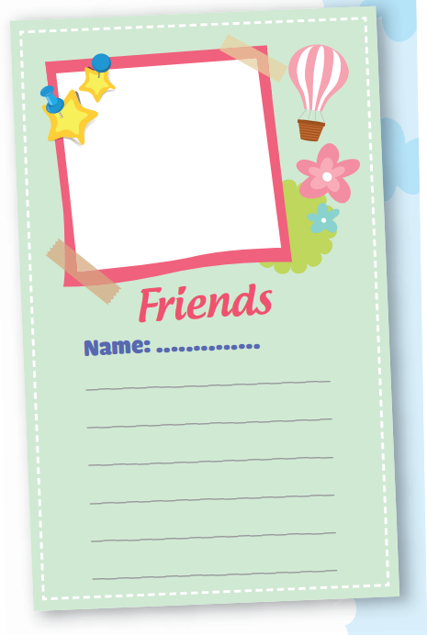  - Teacher sets the context and asks students to bring a photo of his/her friend to class.  - Teacher asks students to write a draft (using the clues)  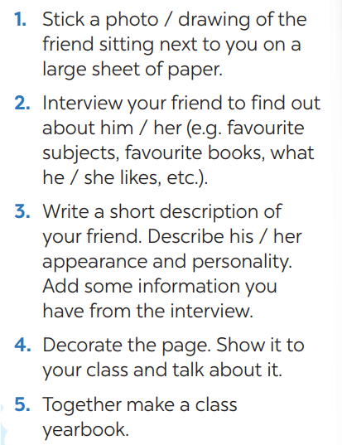  - Teacher checks and sets time for students to make a year-book page.  Teacher gives comments and feedback. | T-Ss
Wrap-up  (3 mins) | To consolidate what students have learnt in the lesson. | Teacher asks students to talk about what they have learnt in the lesson. | T-Ss
Homework  (1 min) | To prepare for the next lesson. | Prepare for the next lesson: Read Review 1. | T-Ss

