Name: …………………………………
ĐỀ CƯƠNG ÔN TẬP KHỐI 3 MÔN TIẾNG ANH
NĂM HỌC 2022 - 2023
A. NỘI DUNG ÔN TẬP
Unit 0: Greetings
I. Vocabulary:  - hi, hello, nice, meet  - how, fine, thanks, thank you, goodbye  - stand up, sit down, look at the board,  come in, don’t talk, go out  - red, blue, black, green, white, orange  - numbers 1-10 |  | II. Grammar:  1) Hello / Hi. I’m + (name)  2) How are you?  I’m fine, thanks / thank you.  - May I go out?  Yes, you can. / No, you can’t.  - What colour is it? It’s + colour.  - How old are you? I’m + number.  I’m + number + years old.
Unit 1: My Family
I. Vocabulary:  - family, brother, mum, dad, sister, cool  - aunt, cousin, grandma, grandpa, uncle, great  - short, tall, old, young, funny |  | II. Grammar:  1) This is my brother  - My brother is Jack.  Jack is my brother  - My mum is short.
Unit 2: My School
I. Vocabulary:  - classroom, lesson, homework, student, teacher  - board, chair, clock, desk  - book, pen, pencil, rubber, ruler |  | II. Grammar:  1) It is a classroom.  He’s a student.  She’s a teacher  - We’re students.  They’re teachers/ desks.  - Are you a student? Yes, I am.  No, I’m not.  - Are they desks? Yes, they are.  No, they aren’t.  (I’m not = I am not, aren’t = are not)
Unit 3: Animals
I. Vocabulary:  - bird, cat, dog, fish, rabbit  - elephant, giraffe, lion, monkey  - shark, sea, turtle, whale | II. Grammar:  1) This is a bird.  That is a rabbit.  - These are monkeys.  Those are giraffes.  - What’s this/ that? It’s an elephant.  - What are these/ those? They’re whales.
Unit 4: My House
I. Vocabulary:  - house, bathroom, living room, kitchen, bedroom  - bed, computer, lamp, toy, TV  - ball, birthday, car, doll, game, teddy bear |  | II. Grammar:  1) There’s a living room.  There are three bedrooms.  - Is there a clock in the bedroom?  Yes, there is.  No, there isn’t.  - Are there books in the living room?  Yes, there are.  No, there aren’t.  - There’s a ball. The ball is red.  - There’s an elephant.  The elephant is young.
Unit 5: My Clothes
I. Vocabulary:  - shoes, skirt, socks, trousers, T-shirt  - boots, coat, dress, hat, warm  - big, small, new, pretty, ugly |  | II. Grammar:  1) I’ve got a T-shirt. My T-shirt is red.  (have got = ‘ve got)  - He’s got a coat. His coat is nice.  (has got = ‘s got)  - They’ve got a new T-shirt.  - It’s got a small hat.

- BÀI TẬP THỰC HÀNH
Question 1: Khoanh tròn đáp án đúng.
1. Hello, my ………………… is Linda.
A. name B. is C. I am
2. What is ………………. name?
A. you B. my C. your
3. How do you …………………. your name? N-A-M
A. What B. is C. spell
4. ……………is that? - That’s Ms. Hoa.
A..
A. Who B. What C. Is
5. Sit ………… ,please.
A. up B. down C. at
6. ………………. are you? - I’m nine years old.
A. How B. How old C. What
7. My mum has got a new coat. _________ coat is warm.
A. Her B. His C. My
8. They are my ……………..
A. student B. students C. teacher
9. This is my ……………..
A. house B. bedrooms C. bathrooms
10. She’s a ___________. She is great.
A. short B. teacher C. rubber
11. This is my ___________. It’s white.
A. lesson B. family C. jug
12. The chairs are ___________.
A. brown B. classroom C. young
13. ___________ is my homework.

A. He B. We C. It
14. How do you ____________ your name? – A-N-N-A.
A. stand B. look C. spell
15. They are chairs. They are ____________.
A. blue B. young C. chair
16. These are turtles____________ the sea.
A. in B. on C. at
17. This is my _______________. She is great.
A. father B. grandpa C. grandma
18. May I ___________out?
A. small B. go C. sea
19. ____________is a school.
A. He B. She C. It
20. There are ________________ on the bed. They’re blue.
A. game B. birthday C. trousers
Question 2 : Tìm từ khác loại.
1. A. bedroom B. garage C. garden D. crocodile
2. A. School B. Hello C. Hi D. Good morning
3. A. elephant B. rubber C. rabbit D. giraffe
4. A. he B. she C. you D. my
5. A. shirt B. ugly C. pretty D. warm
6. A. uncle B. family C. grandpa D. aunt
7. A. white B. cat C. green D. purple
8. A. teachers B. desks C. chairs D. computers
9. A. living room B. bedroom C. kitchen D. classroom
10. A. nine B. fine C. five D. eight
Question 3: Đọc và nối
Example 0. How old are you? | a. My name’s Linda.
1. Hello. I’m Mary. |  | b. Yes, there is.
2. What’s your name? |  | c. That’s Miss Hien.
3. Is there a living room in your house? |  | d. I’m ten years old.
4. Who’s that? |  | e. Hi, Mary. I’m Peter.
Answers: 0 - d, 1 - ….., 2 - ……, 3 - ……, 4 - ……

Question 4. Đọc đoạn văn và khoanh tròn vào câu trả lời đúng
I’m Lisa. I’m seven years old. It’s my birthday. I’m in the living room with my friends. There are both girls and boys. There are toys for everyone. There are four balls, two dolls and two big teddy bears. It’s a great birthday!
1. How old is Lisa?
A. She is six years old.
B. She is seven years old.
C. She is eight years old.
2. Where are Lisa and her friends?
A. They’re at school.
B. They’re in the bedroom.
C. They’re in the living room.
3. Are there girls in her house?
A. Yes, there are.
B. Yes, they are.
C. No, there aren’t.
4. How many toys are there?
A. There are four toys.
B. There are eight toys.
C. There are ten toys.
Question 5: Đọc và sắp xếp câu thành câu hoàn chỉnh.
- that/ Who/ is/ ? Who is that?
1. pencil case. / This / my / is / new
……………………………………………………………………………
2. there / a / lamp / Is / in / room? / the / living
……………………………………………………………………………
3. are / monkeys. / These / are
……………………………………………………………………………
4. pretty / They / T- shirt. / got / have / a
……………………………………………………………………………

5. rulers / in / aren’t / the / classroom. / There
……………………………………………………………………………
6. boys / The / have / black / got / boots.
……………………………………………………………………………
7. go / I / out? / May
……………………………………………………………………………
8. got / aunt / My / a / has / pretty / dress.
……………………………………………………………………………
9. in / There / books / the / are / two / chair.
……………………………………………………………………………
10. that / Is / bedroom? / your
……………………………………………………………………………
Question 6. Nhìn tranh. Nhìn từ. Hoàn thành từ.
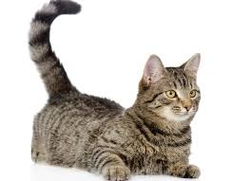  1. t a c ……… | 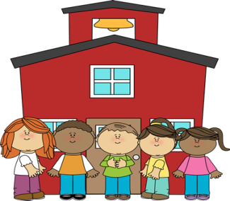  2. l o s h c o ………………
3. r b e u b r …………………. | 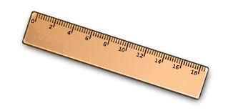  4. r e u l r …………..
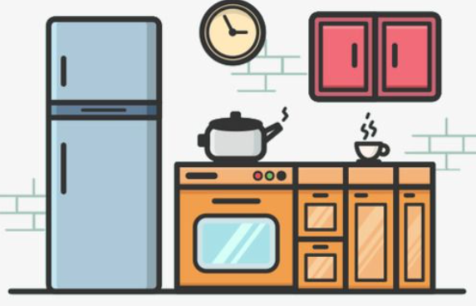  5. i k t n e h c …………………… | 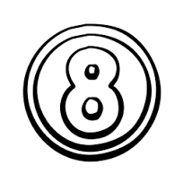  6. t i g e h ………………..

THE END.

