Full name: ……………………………. School: ………………………

- DEFEAT THE GOAL KEEPER:
  - Choose the word that has the underlined part pronounced differently:
    - bus B. but C. put D. cut
  - Let's learn some .
    - much B. many C more D. most
  - I have a motorbike.
    - don't B. doesn't C. am not D. not
  - Choose the word that has the underlined part pronounced differently:
    - do B. mother C. brother D. sometimes
  - Nam is happy _ today is his birthday.
    - so B. but C. and D. because
  - Do you like music? - _
    - Yes, I am B. Yes, I do C. Yes, I don't D. No, I'm not
  - Are your pens in your bag?
    - Yes. It is B. Yes. They are C. No. It isn't D. Yes. It is not
  - I like music because I like
    - swimming B. playing C. singing D. going
  - Choose the word that has the underlined part pronounced differently
    - bag B. bank C. parents D. place
  - How's the weather Hanoi?
    - on B. at C. for D. in
  - Choose the word that has the underlined part pronounced differently
    - five B. sister C. fine D. nine
  - Mary _ to the music now.
    - listens B. listen C. is listening D. listening
  - Stand _, please!
    - on B. in C. up D. of
  - There are clouds.
    - look B. small C. cloudy D. watch
  - Would you like biscuits?
    - some B. an C. a D. Ø
  - She a long hair.
    - have B. does C. has D. do
  - There are students in my class. Twenty boys and twenty girls.
    - forty B. fifty C. twenty D. thirty
  - Her mother works as a at Hue hospital.
    - singer B. farmer C. nurse D. postman
  - How many are there?_ Two. Mary and Jane.
    - girl B. boy C. boys D. girls
  - Is this your school bag? _ Yes, it is. It's .
    - my B. me C. mine D. I

FILL THE BLANK:
- N__SE 21. E AM
- STO__Y 22. MU__EUM
- DA CE 23. __ITHER
- PE CH 24. C__IMB
- H__AD 25. J LY
- T__IN 26. K TCHEN
- DO N 27. SK RT
- NUM__ER 28. W__FE
- PL ASE 29. SOC__
- TRO SERS 30. CA DY
- M Y 31. PI ZA
- BED OOM 32. AL AYS
- E SY 33. VIL AGE
- NUM ER 34. SUM ARY
- COL UR 35. TA LE
- THI D 36. P OR
- D AR 37. AB UT
- CI EMA 38. NU SE
- FU NY 39. RI H
- HREE 40. BO RD
41._ _ _ _ _ is he from? - He's from England.
- Living in Ho Chi Minh City _ _ so boring.

- Bill is 20 and is a doctor. He _
_ _ _
_ in a hospital.

- He gets a lot of gifts _ _ Christmas.
- Vegetables and fruits are good _ _ _ us.
- Linda lives _ _ London.

- Mrs. Jenney is my teacher. She _ _ _
_ _ _
_ me History.

- He's always busy _ _
_ _ _
_ _ he's a businessman.

- The library opens _ _ 7 a.m.
- What meat would you like _ _ _ dinner, Jane?
- In the evening, I am always busy _ _ _ _ my
homework.
- What did your little sister do yesterday? - She v_ _ _ _ _ _ in the museum.
- What's _ _ _ dinner today? Bread or rice?
- We have English on Monday and Sunday. We have it _ _ _ _ _ a week.

- There is a picture _ _ Uncle Ho on the wall.

Full name: ……………………………. School:…………………………

BÀI TẬP 1: DEFEAT THE GOALKEEPER
- How much are your shoes? -
  - They are nice B. It's 70, 000 dong C. They are 70,000 dong D. They are black
- How _books does he have?
  - are B. much C. many D. more
- I have two brothers. names are Minh and Tung.
  - His B. They C. Theirs D. Their
- He is going to the _ to post a letter.
  - post office B. market C. bookshop D. cinema
- Let's to the zoo and see the animals.
  - goes B. to go C. go D. going
- How's the _ in Hanoi? _ It's cold and windy.
  - people B. trees C. life D. weather
- How about to the supermarket?
  - going B. go C. to go D. went
- Hurry ! We'll late for school.
  - in B. of C. up D. down
- You can see lions in the .
  - park B. post office C. police stationD. zoo
- Can you play the guitar? -
  - Yes, I can't B. Yes, I can C. No, I can D. Yes, I am
- We shouldn't ...... a lot in the evening
  - eat B. to eat C. eats D.eating
- What's the matter, Danny? - I'm ......
  - nice B.cold C. big D. tall
- The boy ..... his teacher some beautiful flowers.
  - like to give B. like giving C. likes gives D. would like to give
- ........ about going to Nha Trang?
  - Why B.What C.Where D. When
- We have lots of ...... in the summer.
  - rain B. raining C. rains D. rainy
- There are twelve months in a ......
  - week B. year C. weekend D. daily
- They buy some fruit but ........ vegetables.
  - some B. any C. little D.no
- ......... walk on the grass!
  - No B.Not C. Don't D. Doesn't
- Choose the word that has the underlined part pronounced differently
A. camp | B. table | C. travel | D. match
20. Odd one out
A. dog | B. cow | C. pig | D. string

BÀI TẬP 2: FILL THE BLANK

- I want _ _ have a pen friend from England.
- Please write _ _ me!

3. _
_ _ _
_ do you often go in your free time?

- Which _
_ _ _
_ _ _
_ do you have today? - I have English and Maths.

- In the _
_ _ _
_ _ _
_ _ _
_ lessons, we learn how to use the computer.

- Candies are not good _ _ _ children's teeth.
- How _ _ _ _ _ listening to music?
- Would you like a cup _ _ coffee? - Yes, please.
- Where _ _ _ _ you yesterday? - I was at home.

10. _
_ _ _
_ are three books on the table.

- C_ECK →  - S_IENCE →  - LAN_UAGE →  - S_ISSORS → | - SIC_NESS →  - GLA_S→  - AL_AYS →  - CAPI_AL → | - MU_EUM→  - AC_IVITY→
15.T_OTH → | 24.FU_NY →
16.AI_PORT → | 25.LE_TER →
17.CONN_CT → | 26.MAT_H →
18.CIRC_E → | 27. S_ADIUM →
19.AMUSE _ENT →  BÀI TẬP VÒNG 21 (tiếp) | 28. SI_N →
  - Cool Pair Matching: Match a picture or a Vietnamese word with its English
equivalence.
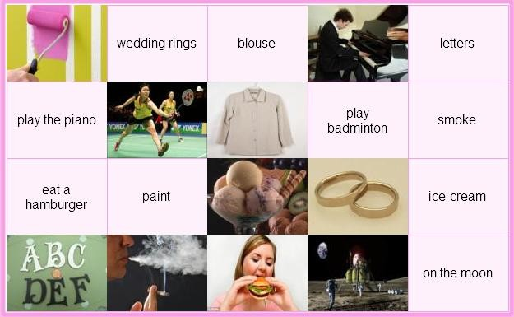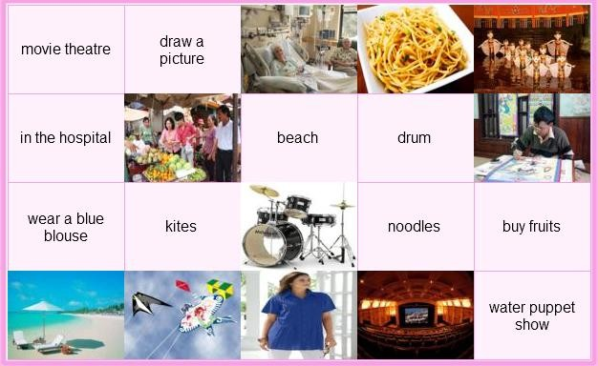
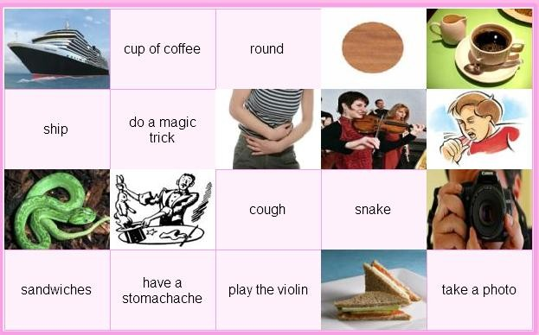
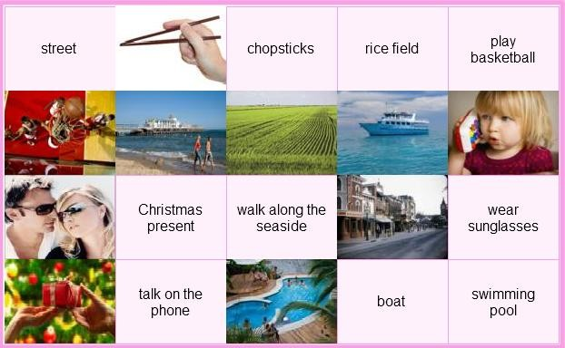

II/ Safe Driving
Answer the question.
    - I am tired because I have to _ _ the housework all day.

    - George eats too much so he's getting _ _ _ .

    - What
_ _ _
_ do you get up? - I get up at 7 a.m.

    - Let's play hide-_ _ _ -seek.

    - We danced, sang and t_ _ _ stories in English.

    - His job is great because he can meet a _ _ _ of people.

    - We had celebrations _ _ the schoolyard.

    - They are rich _ _ they don't have to work.

    - Kate and I are reading books _ _ _ _ _ pets.

    - Are the students _
_ _ _
_ _ _ _
_ to music? No, they're playing volleyball.

    - What's his job?- He's a .......

      - teacher B. engineer C. work D. house work

    - Do you like to ......?
      - hear to music B. listen music C.listen to music D. listen of music
    - Choose the word that has the underlined part pronounced differently
      - bottle B. job C. movie D. chocolate
    - Fish is my favourite ....
      - drink B. food C. fruit D. juice
    - My son often ....... his teeth before going to bed.
      - washes B. brushes C. clean D. gets
    - Choose the word that has the underlined part pronounced differently
      - some B. come C. love D. home
    - Choose the odd one
      - fifteen B. twenty C. one hundred D. time
    - ........ go to the movies tonight? - OK.
A.Let's B. What about C. Why don't we D. How about
    - What are we going to do? - ......
      - Let we go camping B. Why do we go camping?
C. What about going camping? D. What about to go camping?
    - ....... Music lessons, we learn to sing songs
      - On B. Between C. At D. During
    - People often go to the ....... to swim,
      - Stadium B. beach C. mountain D. city
    - My family are going to stay at a ..... house in Nha Trang.
      - friend B. friends C. friend's D. friends'
    - ....... your mother like noodles? - No, she wouldn't.
      - Can B. Would C. Can't D. Does
    - There are ...... hundred students in our school.
      - three B. third C. threeth D. thirth
    - How is your little daughter? - She is fine ........
      - thank B. thank you C. thanks you D. you thank
    - How often does your aunt go to the farm? -
A.One B. Once a week C. Two D. Once time
    - What is your ...... season? - Summer.
A.likes B. interesting C. favourite D. good
    - Xiao Mei is Chinese. She ....... Chinese.
      - says B. talks C. speaks D. tells

    - I don't like living in Sapa because it ........
      - always rain B. always to rain C. rain always D. always rain
    - I'm travelling by bus and ..... a lot of interesting places.
      - visit B. to visit C. visiting D. is visiting
    - My father is an engineer. - My sister is an engineer, ....
      - too B. either C. to D. so
    - The ......... is cold and wet.
      - time B. day C. weather D. season
    - The Bakers are going to visit ...... of interesting places.
      - a much B. a many C. a lot D. a little
    - Choose the word that has the underlined part pronounced differently.
      - all B. always C. ball D. watch
    - What's ....... breakfast, mom? - There's some bread and eggs.
      - on B. of C. for D. in
    - How many ...... are there in a year? Four.
      - months B. days C. seasons D. weeks
    - Choose the odd one
      - carrot B. rice C. noodle D. bread
    - My sister doesn't have ......
      - hair long black B. long black hair C. black long hair D. black hair long
    - I want to go to the ...... to see some tigers.
      - post office B. bookshop C. clothing store D. zoo
    - Mr and.Mrs Pike..... dinner at the moment.
      - is having B. are having C. are eating D. B & C are correct

Bài tập về nhà buổi 2

Full name: ……………………………. School:……………………………

I/ Cool Pair Matching
Match a picture or a Vietnamese word with its English equivalence.

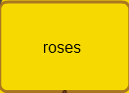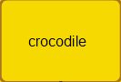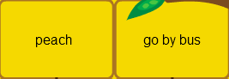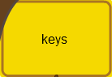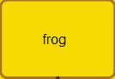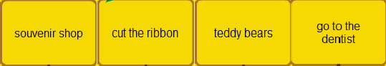

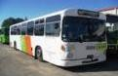

......................... ............................ ............................ ............................. ............................
......................... ............................ ............................ ............................. ............................







......................... ............................ ............................ ............................. ............................
......................... ............................ ............................ ............................. ............................

II/ Safe Driving
Answer the question.
        - ....... you understand all of the new words? - Yes, I do.
          - Is B.Are C.Do D.Does
        - My father works ........ an engineer for his factory.
          - for B.at C.as D.of

        - My class is ...... 7a.m ....... 11 a.m everyday.
          - between/from B.from/in C.from/to D.at/at

        - There are a lot of interesting ...... in the festival.
          - game B.activities C.action D.baseball

        - ...... is your aunt's address? - It's on the table.
A.Where B.How C.When D.Which

        - Mike is playing soccer with his friends. "Soccer" means
          - tennis B.table tennis C.fooball D.badminton

        - Why does your mother go to the food stall? - Because she wants some ........ A.books B.stamps C.hamburgers D.T-shirts

        - Are you free ...... Friday evening?
          - in B.at C.on D.from

        - She is learning ...... to use a computer.
          - what B.when C.where D.how

        - Yesterday they ......... to Ha Long Bay.
          - went B.go C.are going D.to go

Buæi 3
Full name: ……………………………. School:……………………………

I/ LEAVE ME OUT! BÀI TẬP 1

            - HELSP 6. REAOD

            - LISTTEN 7. NIEGHT

            - THROEW 8. SCIENSCE

            - FLOWEAR 9. SKIRET

            - WRITSE 10. WARAM

BÀI TẬP 2

- OSTHER 6. GROSUP

- TELEOVISION 7. PRINST

- BRIANG 8. SEVEAN

- SPRIENG 9. LIGHET

- LIBARARY 10. HEASRT

BÀI TẬP 3

- NATLION 6. MISES

- PICKTURE 7. REPEAST

- BORIN 8. YOFUNG

- PHELP 9. REALDY

- IDEAP 10. PLACKE

BÀI TẬP 4

- HAPPYEN 6. MIAME

- BLEACK 7. STREEST

- SEPTEMBEAR 8. THEAME

- DRAWN 9. CLEASS

- TOBY 10. VISICT

II/ HELP BEAR FIND THE HONEY
- We have English Friday.
- _old are you? - I'm seven years old.
- Thank you _ much
- W is Mary from?
- color is it? - It's red
- _are you? - I'm fine. Thanks.
- There are four people my family.

- time do you go to bed?
- There _ one living room and one kitchen in my house.
- Why do you want to to the bookshop?
- My brother is a factory _ . He works in a factory.
- We like going to the zoo _ much.
- After dinner, my mother checks my homework b bedtime.
- My sister takes vegetables the market.
- Sometimes, I go out my friends.
- I'd like orange, please.
- My father w hard everyday.
- They are farmers. They work o_ a farm.
- The museum _behind the park.
- Let's go out a walk.
- Alan wants to be a taxi d .
- I like play the piano, too.
- Tom _born on October 24th.
- There are people in my family: my parents, my brother and me.
- What _ your father do? - He is a farmer.
- My brother is engineer.
- Nga is a student in class 5A, Quynh Mai P school.
- I want to be a singer b I like to sing.
- The cinema is between the park the post office.
- I don't know how _ dance.

BÀI TẬP VỀ NHÀ (BUỔI 3)
Full name: ……………………………. School:……………………………

BÀI TẬP 1: HELP BEAR FIND THE HONEY
- Choose the odd one:
  - write B. sing C. read D. friend
- Choose the word that has the underlined part pronouced differently
  - pen B. desk C. children D. spell

- Can she play the piano?
  - Yes, I can B. Yes, he can C. Yes, she can D. Yes, we can.
- you understand all of the new words?- Yes, I do.
  - Do B. Are C. Does D. Is
- How many rooms are there in your
  - classroom B. roomates C. apartment D. meeting-room
- is your aunt's address? - It's on the table.
  - Where B. How C. When D. Which
- Do their parents live _ Hue City?
  - in B. at C. on D. from
- Choose the odd one:
  - breakfast B. eat C. dinner D. lunch
- Now, look _your book. Who can answer the third question?
  - up B. for C. in D. at
- I'm going to the to borrow some book.
  - bookshop B. café C. library D. shelf

BÀI TẬP 2: LEAVE ME OUT!

- CHEASS 11. WATEER

- TELERPHONE 12. MABLE

- BIANGO 13. IDEAR

- DOWIN 14. BUSTY

- FINEISH 15. ENODUGH

- FIVELD 16. PLANKE

- NEPAR 17. LESMON

- EXCIATING 18. SABD

- PICANIC 19. CANODLE

- CELEYBRATE 20. BORAT

VÒNG 25 (CẤPTỈNH)_LỚP 5

I/ Safe Driving

Answer the question.

1. What's his job?- He's a .......
A. teacher | B. engineer | C. work | D. house work
- Do you like to ......?  - hear to music | B. listenmusic | C.listen to music | D. listen of music
3. Choose the word that has the underlined part pronounced differently
A. bottle | B. job | C. movie | D. chocolate
- Fish is my favourite ....  - drink | B. food | C. fruit | D. juice

- My son often ....... his teeth before going to bed/
  - washes B. brushes C. clean D. gets

- Choose the word that has the underlined part pronounced differently
A. some | B. come | C. love | D. home
- Choose the odd one  - fifteen | B. twenty | C. one hundred | D. time

- ........ go to the movies tonight? - OK.
A.Let's B. What about C. Why don't we D. How about

- What are we going to do? - ......
  - Let we go camping B. Why do we go camping?
C. What about going camping? D. What about to go camping?

- ....... Music lessons, we learn to sing songs
  - On B. Between C. At D. During

- People often go to the ....... to swim,
  - Stadium B. beach C. mountain D. city

- My family are going to stay at a ..... house in Nha Trang.
  - friend B. friends C. friend's D. friends'

- ....... your mother like noodles? - No, she wouldn't.
  - Can B. Would C. Can't D. Does

- There are ...... hundred students in our school.

  - three B. third C. threeth D. thirth
- How is your little daughter? - She is fine ........
  - thank B. thank you C. thanks you D. you thank

- How often does your aunt go to the farm? -
A.One B. Once a week C. Two D. Once time
- What is your ...... season? - Summer.
A.likes B. interesting C. favourite D. good

- Xiao Mei is Chinese. She ....... Chinese.
  - says B. talks C. speaks D. tells

- I don't like living in Sapa because it ........
  - always rain B. always to rain C. rain always D. always rain

- I'm travelling by bus and ..... a lot of interesting places.
  - visit B. to visit C. visiting D. is visiting

- My father is an engineer. - My sister is an engineer, ....
  - too B. either C. to D. so

- The ......... is cold and wet.
  - time B. day C. weather D. season

- The Bakers are going to visit ...... of interesting places.
  - a much B. a many C. a lot D. a little

- Choose the word that has the underlined part pronounced differently
  - all B. always C. ball D. watch

- What's ....... breakfast, mom? - There'ssome bread and eggs.
  - on B. of C. for D. in

- How many ...... are there in a year? Four.
A. months | B. days | C. seasons | D. weeks
- Choose the odd one  - carrot | B. rice | C. noodle | D. bread

- My sister doesn't have ......
  - hair long black B. long black hair C. black long hair D. black hair long

- I want to go to the ...... to see some tigers.

- post office B. bookshop C. clothing store D. zoo

II/ Fill in the blank
  - _ _ _ _ does he do? - He's a police officer.
  - How _ _ _ _ is a pair of shorts? - It is 90.000 dong.

  - I'm going to the post _
_ _ _ _
_ . I want to buy some stamps.

  - December is the twelfth _
_ _ _
_ of the year.

5. _ _
6. _ _
_ do you like Informatics? - Because it is interesting.
_ is Ann's English teacher? - Mrs. Susan.

- Why are Science lessons interesting _ _ _ her?
- How _ _ _ _ super markets are there in your city?

- My uncle _
_ _ _
_ as a doctor in the hospital.

- My daughter wants to become a teacher _ _ English.
- I have a headache. - You should _ _ _ _ some aspirins.
- What is his _ _ _ ? - He designs houses.
- He plays soccer _ _ _ _ his friends in his free time.
- _ _ _ much homework did you have yesterday?

- My children like bears _
_ _ _
_ _ _ they can jump and climb.

- When I _ _ _ a little girl, I liked candies very much.

- What'sthe weather
_ _ _
_ in winter in England?

- On _ _ _ _ occasion do you wear your favourite clothes?
- It is very cold in winter. There is _ _ sun. There is only snow.
- is your sister eight years _ _ _ ?
- What's the matter _ _ _ _ you?

III/ Cool Pair Matching
Match a picture or a Vietnamese word with its English equivalence.

