Date of preparing: ………………………………….
Date of teaching: ………………………………….
Period 35

UNIT 5: FOOD AND DRINK

Lesson 1: Getting started

I. Objectives
By the end of this lesson, Ss will be able to gain:
1. Knowledge
- An overview about the topic Food and Drink
- Vocabulary to talk about food and drink
2. Core competence
- Develop communication skills and cultural awareness
- Be collaborative and supportive in pair work and teamwork
- Actively join in class activities
3. Personal qualities
- Develop healthy eating habits and awareness of balanced diets
- Be proud of the homeland
II. Materials
- Grade 7 textbook, Unit 5, Getting started
- Computer connected to the Internet
- Projector / TV/ pictures and cards
- sachmem.vn

Language analysis
Form | Pronunciation | Meaning | Vietnamese equivalent
1. roast (v) | /rəʊst/ | to cook something, such as meat, in an oven or over a fire | quay, nướng (thịt..)
2. fry (v) | /fraɪ/ | to cook something in hot fat or oil | rán trong dầu hoặc mỡ
2. shrimp (n) | /ʃrɪmp/ | a small sea creature that you can eat | con tôm
3. lemonade (n) | /ˌleməˈneɪd/ | a drink made from lemons, sugar, and water | nước chanh
4. mineral (n) | /ˈmɪnərəl/ | a natural substance such as iron that is present in some foods and is important for good health | khoáng chất

Assumptions
Anticipated difficulties | Solutions
- Students may not be able to recognise food ingredients and have experience of cooking.  - Students may not know how to work in teams. | - Use pictures/ photos or videos of all food ingredients and ways of cooking to show them in the class.  - Give short, clear instructions and help if necessary.

III. Procedures:
Stage | Stage aim | Procedure | Interaction
Warm-up  (5 mins) | - To activate students’ knowledge on the topic of the unit  - To enhance students’ skills of cooperating with teammates | Edible or inedible  * Teacher gives instructions  ** In pairs, Ss:  - sit facing each other  - take turns to throw a ball of paper to their partner as they say a noun  When their partner catches the ball, say immediately if the noun is edible or inedible, then throw the ball back and repeat the procedure.  Example:  A (throwing) - Egg.  B (catching) - Edible. (throwing) - Book.  A (catching) - Inedible. (throwing) - House …  *** Students share all the words/ phrases about food and drink they have with the others as the class.  **** Teacher checks and corrects if Ss spell or pronounce the words/ phrases incorrectly. | T-S  S-S  S-S  T-S
Presentation  (vocab  Pre-teach)  ( 5 mins) | To help students use key language more appropriately before they read and listen | * T asks Ss to look at the photos and answer the question: What is this?  ** Ss say the words.  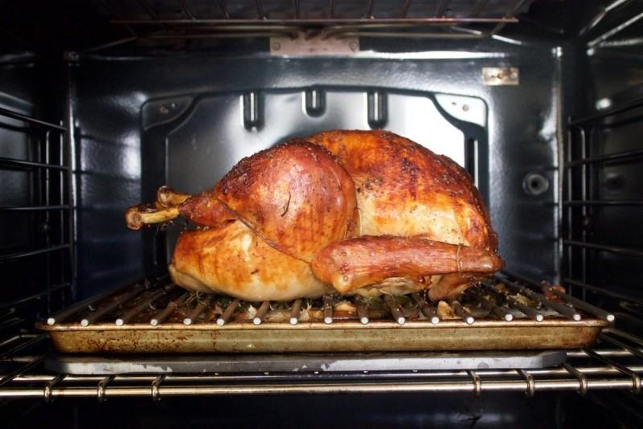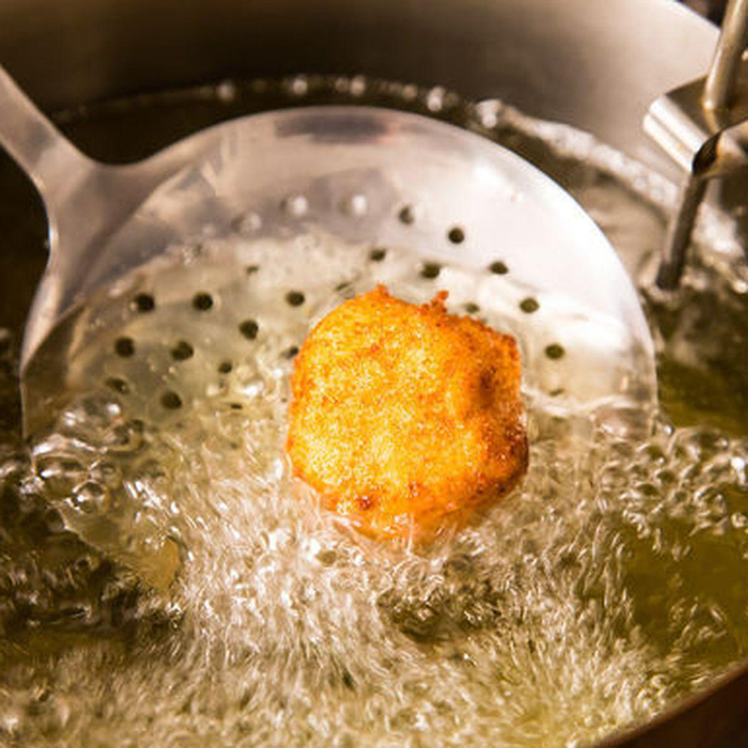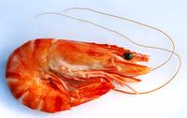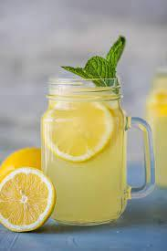  *** Other Ss correct if the previous answers are incorrect.  **** Teacher shows and says the words aloud and asks Ss to repeat them.  * Teacher asks Ss to translate the word “khoáng chất” into English  ** Ss says the word  **** Teacher gives the correct answer "mineral” | T-S  S-S  T-S
Lead-in/  Pre-reading & listening  (3 mins) | - To get students interested in the topic  - To set the context  - To help Ss understand the main idea of the text | TASK 1: ANSWER THE QUESTIONS. (Ex 2, p.51)  * Teacher asks Ss to look at the picture (p.50-51) and answer the questions:  ** Ss ask and answer questions in pairs.  *** Ss share their answers as a whole class.  **** T asks them to read and listen to the conversation and check their answers. | T-S
  + What do your family usually eat for dinner?  + Where does Mark's family eat dinner?  What is Mark's family doing?  A. Ordering food for dinner.  B. Preparing for their dinner.  C. Talking about their favourite food. | 
Practice  (17 mins) | - To practise reading and listening for specific information  - To practise scanning  - To develop Ss' vocabulary for food and drink | TASK 2: FIND THE WORDS AND PHRASES ABOUT FOOD AND DRINK IN THE CONVERSATION AND WRITE THEM IN THE CORRECT COLUMNS. (Ex 3, p.51)  * Teacher asks Ss to work individually to read and listen to the conversation and find the words and phrases and then share their answers with their partners who sit next to them.  ** Ss do exercise 3 individually  *** Ss share and discuss with their partners to write all words/ phrases down on the notebooks.  **** Teacher corrects their answers as a class.  Key: | T-S  S-S  T-S
  Food | Drink
  rice, pork, fish sauce, roast chicken, fried vegetables, fried tofu, spring rolls, canh (soup), shrimp, fish, | juice, lemonade, green tea, mineral water, winter melon juice,
Practice  (17 mins) | - To help Ss deeply understand the text  - To practise scanning and intensive reading | TASK 3: READ THE CONVERSATION AGAIN AND TICK (✓) T TRUE OR (F0 FALSE. (Ex 4, p.51)  * Teacher gives clear instructions.  ** Ss work individually step by step:  - Read the statements carefully and underline key words  Suggested keywords in the statements:  1. Mark's family is at a Vietnamese restaurant.  2. Mark wants fried tofu and beef for dinner.  3. They don't order canh.  4. Mark's mum wants mineral water.  5. His mum doesn't allow her children to drink juice during dinner.  - Scan the conversation to locate the underlined key words  - Read intensively to tick True or False  *** Teacher nominates Ss to read the statements aloud and say which ones are True and False, the others attentively listen to and correct their answers if necessary.  **** Teacher checks and gives the correct answers.  Answer key:  1. T  2. F (Mark wants some fried tofu and spring rolls.)  3. F (Mark's dad thinks they will try some canh)  4. T  5. F (Mineral water for me, green tea for my husband, and juice for my children) | T-S  S  T-S-S  T-S
Production  (10 mins) | - To help Ss be able to talk about favourite food and drink  - To develop teamwork skills  - To give students authentic practice in using target language | TASK 4: WORK IN PAIRS. THINK ABOUT YOUR FAVOURITE FOOD AND DRINK. THEN ASK YOUR PARTNER ABOUT HIS OR HER FAVOURITE FOOD AND DRINK. (Ex 5, p.51)  * Teacher gives Ss clear instructions in order to make sure Ss can role-play effectively.  - Teacher divides Ss into 2 main groups and call them Vietnamese tour guides and French visitors who visit Vietnam for the first time.  + Vietnamese tour guides discuss and list the favourite food in Ha Noi/ Viet Nam, using some suggested questions: What kinds of food are the most popular? What ingredients are there? What is the food like? …  + French visitors think of, discuss and list as many questions to ask about the most favourite Vietnamese food as they can.  - Teacher pairs each tour guide with a French visitor and ask them to role play talking about the most favourite food in Viet Nam.  - T observes Ss while they are role playing, note their language errors  ** Ss do as instructed  **** Teacher gives Ss feedback.  - Choose some useful words/ phrases/ expressions/ word choices Ss have used and suggest other students using them  - Choose some typical errors and correct as a whole class without nominating the students’ names | T-S  T  S-S  T - Ss
Wrap-up  (3 mins) | To help Ss memorise the target language and skills that they have learned | Teacher asks students to talk about what they have learnt in the lesson:  - Vocabulary of Food and Drink  - Reading for specific information and details  - Scanning | T - Ss
Homework  (2 mins) | To review the learned knowledge and prepare for the next lessons | - Talk about your favourite food (for a minute)  - Do the exercises in the workbook  - Project preparation  + Teacher informs student of the final project of the Unit’s project  + Explain the requirements of the project: Design a poster about eating habits in an area or a foreign country you know, including names of main meals and mealtimes; names of common food/ drink for each meal; picture/ photo to illustrate the meals. Students will show their posters and present their ideas in Lesson 7 – Looking back and Project. Explain students  + Teacher explains to students how they can get the information  + Put students into groups and ask them to discuss to assign tasks for each member. Help them set a deadline for each task.  (Teacher should check the progress of students’ preparation after each lesson.) | T - Ss

Date of preparing: ………………………………….
Date of teaching: ………………………………….
Period 36

UNIT 5: FOOD AND DRINK

Lesson 2: A closer look 1

I. Objectives
By the end of this lesson, Ss will be able to:
1. Knowledge
- Use the lexical items related to the topic Food and Drink
- Know how to use the measurement words and phrases often used with food and drink
- Pronounce the sounds /ɒ/ and /ɔ:/ correctly
2. Core competence
- Be collaborative and supportive in pair work and team work
- Access and consolidate information from a variety of sources
- Actively join in class activities
3. Personal qualities
- Promote pride in the values of Vietnamese culture
- Develop love for family
II. Materials
- Grade 7 textbook, Unit 5, A closer look 1
- Computer connected to the Internet
- Projector / TV/ pictures and cards
- sachmem.vn

Language analysis
Form | Pronunciation | Meaning | Vietnamese equivalent
1. kilo (kg) | /ˈkiːləʊ/ | a kilogram | cân (kí lô)
2. teaspoon | /ˈtiːspuːn/ | the amount that a teaspoon can hold | khối lượng đựng trong một thìa nhỏ dùng để quấy trà
3. litre | /ˈliːtə/ | the basic unit for measuring liquid | lít
4. tablespoon | /ˈteɪbəlspuːn/ | the amount that a tablespoon can hold as a unit for measuring liquid | khối lượng đựng trong một thìa canh
5. gram | /ɡræm/ | the basic unit for measuring weight | gờ-ram
6. millimetre | /ˈmɪlɪmiːtə(r)/ | a unit of length that is equal to 0.001 metres | mi-li-mét
7. omelette | /ˈɒmlət/ | eggs mixed together and cooked in hot fat | trứng ốp lết
8. pancake | /ˈpænkeɪk/ | a thin flat round cake made from flour, milk, and eggs | bánh kếp
9. spring rolls | /sprɪŋ rəʊlz/ | food consisting of a piece of thin rolled rice paper filled with vegetables and meat, fried in oil | nem rán
10. onion | /ˈʌnjən/ | a round white vegetable with a brown, red, or white skin and many layers. Onions have a strong taste and smell | hành tây
11. pepper | /ˈpepə/ | a powder that is used to add a hot taste to food | hạt tiêu
12. butter | /ˈbʌtə/ | a solid yellow food made from milk or cream | bơ

Assumptions
Anticipated difficulties | Solutions
1. Students may lack knowledge about food and drink and structures to describe food and drink. | Prepare some photos/posters of food and drink and suggestions on vocabularies and structures to describe food and drink.
2. Students may have underdeveloped listening, speaking and co-operating skills. | - Play the recording many times if any necessary.  - Encourage students to work in pairs, in groups so that they can help each other.  - Provide feedback and help if necessary.

III. Procedures:
Stage | Stage aim | Procedure | Interaction
Warm-up  Lead-in  (4 mins) | - To set in the context of using the lexical items and measurement words/ phrases related to the topic Food and Drink  - To activate students’ knowledge  - To get students interested in the topic | Option 1: Cooking race  * Teacher divides the class into 8 groups and gives instructions.  ** In small groups, Ss write a ten-item shopping list on a piece of paper.  It must include the following things: something salty, something sweet, a tin of something, a jar of something, a kind of meat or fish, a green vegetable, another vegetable, a fruit, a dairy product, two herbs…  *** Ss then swap their lists with another group. Ss discuss and agree on a recipe for a main course using all the ingredients on their list. They can add only salt, pepper and oil and tell what dish they are going to cook in the class.  **** Vote on which dish you would most like to eat.  Option 2: Dictation  * Teacher puts Ss in small groups, explains that they are going to dictate five sets of four words, such as pea, orange, potato, onion. Teacher gives Ss some time to choose an odd one out for each set. More than one answer is possible.  ** Ss listen and write the set. Then they choose the odd one out and circle it.  *** Each group explains their decisions,  e.g. A pea, because it's the only one that's green. / An orange, because it makes terrible soup.  **** T may create his / her own lists or choose from the list below:  1. lemon, grapefruit, grape, lime  2. fridge, cooker, microwave, toaster  3. cow, chicken, sheep, fish  4. bacon, egg, tomato, toast  5. rice, wheat, potato, pasta  6. bread, cake, pie, pizza | T-S  S-S  S-S  S-S  T-S  S-S  S-S  S-S
Vocabulary  (20 mins) | To revise and help Ss understand the measurement words and phrases often used with food and drink | TASK 1: MATCH THE PHRASES WITH THE PICTURES. THEN LISTEN, CHECK, AND REPEAT THE PHRASES. (Ex 1, p.52)  * Teacher gives Ss instruction, lets Ss have time to work individually, in pairs and then supports them if necessary.  - a kilo (kg) of  - a teaspoon (tsp) of  - a litre (l) of  - a tablespoon (tbsp) of  - 200 grams (g) of  - 400 millilitres (ml) of  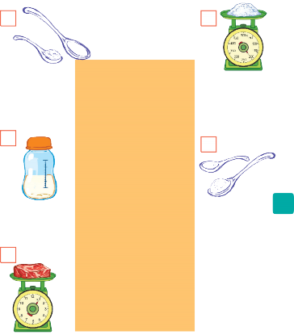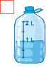  ** Ss quickly match the phrases with the pictures individually.  *** Ss then swap their answers with their partners to check their answers by listening to the recording at the same time.  **** Teacher observes, checks, gives correct answers as well as pauses the recording after each phrase and asks them to repeat chorally and individually.  - Teacher corrects Ss’ pronunciation.  - With weaker classes, teacher may ask for translations to check Ss’ understanding.  Answer key:  1. b 2. f 3. a 4. c 5. d 6. e  Audio script – Track 31:  1. a teaspoon (tsp) of salt  2. 400 millilitres (ml) of milk  3. a kilo (kg) of beef  4. a litre (l) of water  5. a tablespoon (tbsp) of sugar  6. 200 grams (g) of flour | T-S  S  S-S  T-S
 | To help Ss identify new words of dishes and ingredients. | TASK 2: WRITE THE FOLLOWING WORDS AND PHRASES IN THE CORRECT COLUMNS. ADD ANY OTHER DISHES AND INGREDIENTS YOU KNOW. (Ex 2, p. 52)  Activity 1  * Teacher divides the class into 4 groups and gives instructions.  ** Individually, Ss carefully and closely watch in order to write down the words for the items appearing on the screen.  *** Then, Ss discuss the meanings of the words given in groups.  **** T observes and may explain their meanings or even translations.  Activity 2 – Who is faster?  * Teacher sticks 4 group boards on which there are two columns of Dishes and Ingredients, at four corners in the class, hands out four sets of six word cards to each group and explains the rules of the game.  ** Ss receive the signal of the teacher, quickly sort the words and stick them onto the correct columns on their group's board at the corner of the class.  *** The fastest group which has the most appropriate words in the columns will be the winner.  **** Teacher asks Ss to check their answers and share the names of other dishes and ingredients they know with their partners before showing the correct answers.  Key: | T-S  S-S  T-S  T-S  S-S  T-S
  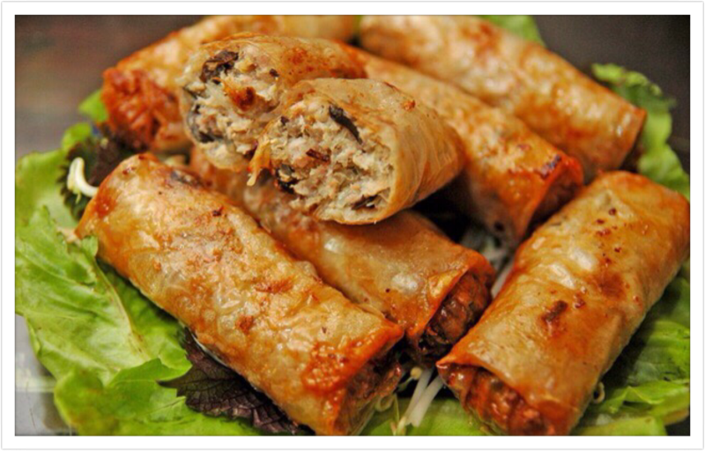  spring rolls |   omelette |   butter
  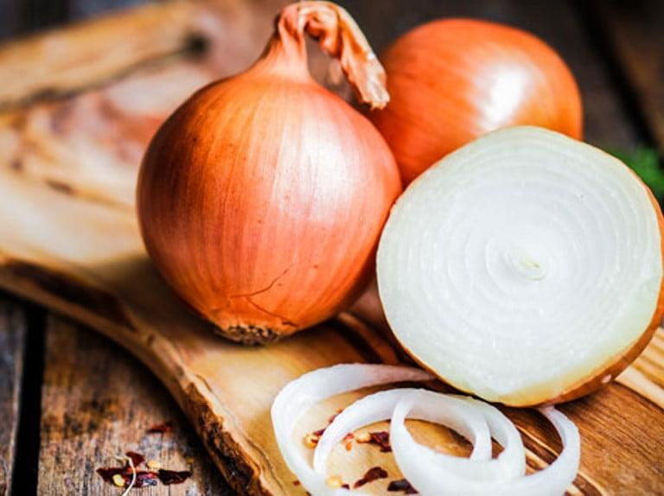  onions |   pancake | 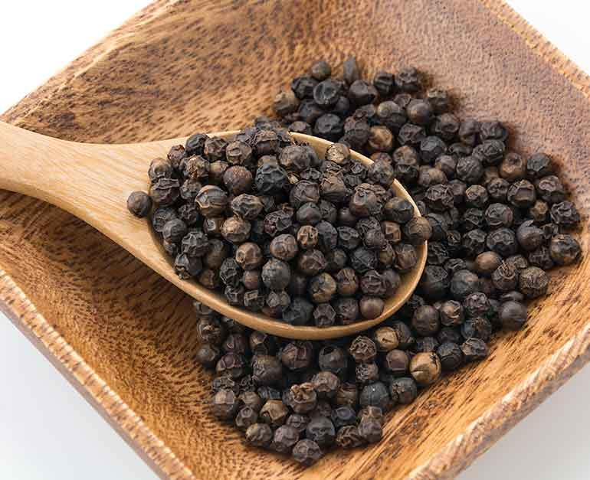  pepper
  Dishes | Ingredients
  spring rolls | butter
  omelette | onions
  pancake | pepper
 | To get Ss to practise asking and answering about the ingredients for a dish using measurement words and phrases they have learnt. | TASK 3: WORK IN PAIRS. ASK AND ANSWER ABOUT THE INGREDIENTS FOR LINH’S APPLE PIE, USING THE QUANTITIES IN THE RECIPE. (Ex 52,  Role-play: "How to make an apple pie?"  ** Ss work in groups and then in pairs to practise.  *** Teacher nominates some pairs of Ss to model this activity in front of the class. The others vote the best pairs they like best.  **** Teacher gives feedback to help students improve their talk later. | T-S  S-S  S-S  T-S
  * Teacher divides the class into two groups named Mums and Daughters/ Sons and assign Mums, only using the information from the table, to prepare ingredients for an apple pie that they are going to instruct their daughters/ sons and daughters/ sons to prepare some questions to ask their Mums how to make the apple pie.  - After that, teacher pairs Ss to make conversation, asking and answering about the quantity of ingredients for an apple pie.  Eg. A: How many apples do we need?  B: We need 12. | 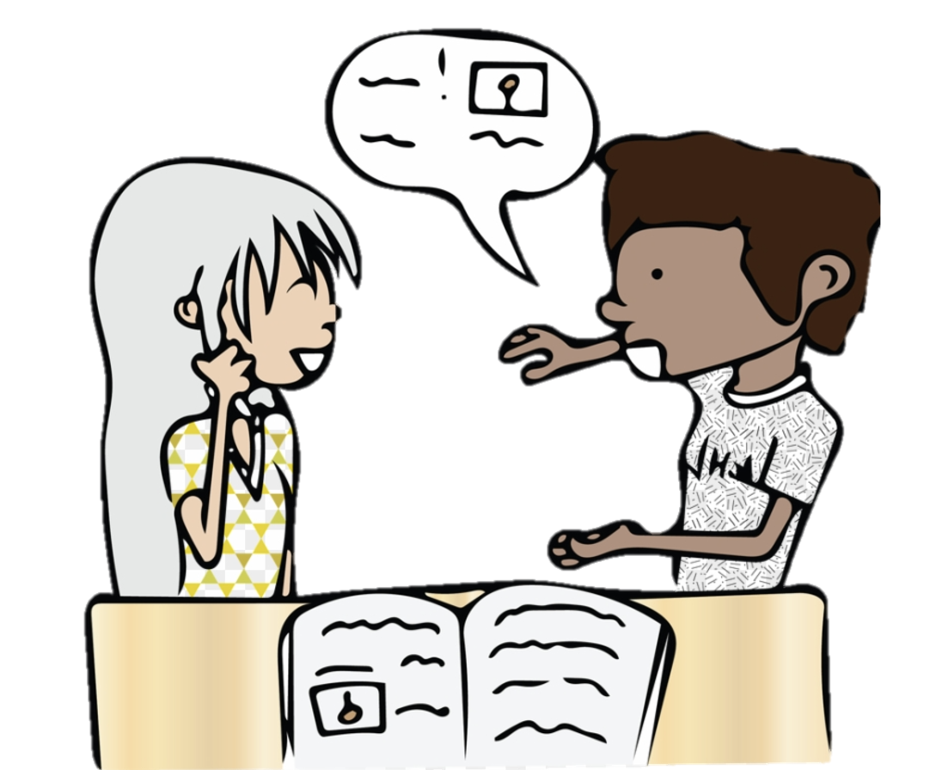
Pronunciation  (16 mins) | To show, model and help Ss how to pronounce the sounds /ɒ/ and /ɔ:/ and practise pronouncing these sounds correctly in words. | TASK 4: LISTEN AND REPEAT THE WORDS. PAY ATTENTION TO THE SOUNDS /ɒ/ AND /ɔ:/. (Ex 4, p.52)  * Teacher plays the video modelling the sounds /ɒ/ and /ɔ:/ first and asks Ss to watch closely to see how the sounds are formed, and then gives them instruction to practise pronouncing the sounds.  ** After watching the video, Ss listen and put the words in the correct columns.  *** Ss swap their notebooks with their partners to share their answers.  **** Teacher plays the recording, show them the correct answers and asks Ss to listen and repeat. Teacher may play the recording as many times as necessary, asking Ss to repeat until they can pronounce the sounds correctly.  Key:  Audio script – Track 32: | T-S  S-S  S-S  T-S
  /ɒ/ | fond, lot, not
  /ɔ:/ | short, call, water, pork, sauce
  fond | short | call | water | pork | sauce | lot | not
Pronunciation  (16 mins) | To help Ss practise pronouncing the sounds /ɒ/ and /ɔ:/ correctly in context. | TASK 5: LISTEN AND REPEAT, PAYING ATTENTION TO THE UNDERLINED WORDS. TICK (✓) THE SENTENCES WITH THE /ɒ/ SOUND. (Ex 5, p.52)  * Teacher asks Ss to listen twice and asks Ss to tick (√) the sentences with the /ɒ/ sound.  ** Ss do as instructed individually  *** Ss share their answers with Ss who sit next to them.  **** Then Teacher plays the recording again, checks and asks Ss to repeat and provides further practice if needed.  Key:  √: 1, 2, 4  Audio script – Track 33:  1. I hate hot dogs.  2. It’s a very big pot.  3. Put the forks here.  4. This soup is very hot.  5. I like pork cooked with vegetables. | T-S  S  S-S  T-S
Wrap-up  (2 mins) | To help students to recall information they’ve learned during class and reflect on gaps in their knowledge | - Teacher asks Ss to summarise what they have learnt in the lesson by asking them some questions.  - What food have we learned to make today?  - What ingredients do we need to make it? How many/ How much of them do we need?  - What sounds do we learn today? | T - Ss
Homework  (2 mins) | To reactivate the knowledge that students have gained. | Teacher asks Ss to make sentences about the quantity of ingredients for a dish using the words and phrases they have learnt in the lesson in their workbook. | T - Ss

Date of preparing: ………………………………….
Date of teaching: ………………………………….
Period 37

UNIT 5: FOOD AND DRINK

Lesson 3: A closer look 2

I. Objectives
By the end of this lesson, Ss will be able to:
1. Knowledge
- Know how to use the measurement words and phrases such as some and a lot of / lots of with countable and uncountable nouns
- Understand and use the How many/ How much to ask and answer about quantities
2. Core competence
- Develop communication skills
- Be collaborative and supportive in pair work and team work
- Actively join in class activities
3. Personal qualities
- Promote pride in the values of Vietnamese culture
- Develop love for family
II. Materials
- Grade 7 textbook, Unit 5, A closer look 2
- Computer connected to the Internet
- Projector / TV/ pictures and cards
- sachmem.vn

Language analysis
Form | Pronunciation | Meaning | Vietnamese equivalent
1. countable (adj) | /ˈkaʊntəbəl/ | a countable noun can be used with "a" or "an" and can be made plural | đếm được
2. quantity (n) | /ˈkwɒntəti/ | the amount or number of something, especially that can be measured | số lượng
3. describe (v) | /dɪˈskraɪb/ | to say or write what someone or something is like | miêu tả
4. popular (adj) | /ˈpɒpjələr/ | liked, enjoyed, or supported by many people | nhiều người biết đến
5. cartoon (n) | /kɑːˈtuːn/ | a drawing, especially in a newspaper or magazine, that tells a joke or makes a humorous political criticism | hoạt hình

Grammar
Form | Meaning | Examples
some/ a lot of/ lots of + both countable/ uncountable nouns | một vài/ nhiều + cả danh từ đếm được và danh từ không đếm được | - I need some apples for this recipe.  - There's some water in the bottle.  - There are a lot of/ lots of people in the room.  - She likes coffee with a lot of/ lots of sugar.
How many + plural countable noun  How much + uncountable noun | Bao nhiêu + danh từ đếm được số nhiều  Bao nhiêu + danh từ không đếm được số ít | - How many pens do you have?  - How much sugar do you need?

Assumptions
Anticipated difficulties | Solutions
1. Students may find confused when to use some/ a lot of/ lots of | - Give short and clear explanations with legible examples for each case.
2. Students may have underdeveloped speaking and  co-operating skills. | - - Give clear instructions, give examples before letting students work in groups.  - Provide feedback and help if necessary.

III. Procedures:
Stage | Stage aim | Procedure | Interaction
Warm-up  Lead-in  (4 mins) | - To activate students’ knowledge using some and a lot of / lots of  - To get students interested in the topic | Mini game: Are these countable and uncountable?  * Teacher put Ss into 2 big teams (named Mango & Orange) and gives instruction.  ** When teacher say the words (apple, carrot, chicken, salt, meal, sugar, star, cucumber, pepper, meat…) aloud:  - Ss of Mango team stand up and shout out if the word is countable.  - Ss of Orange team stand up and shout out if the word is uncountable.  **** Teacher checks and tells Ss the noun is countable or uncountable when they have already reacted. | T-S  T-S-S  T-S
Presentation  (3 mins) | - to help Ss understand and know how to use some, a lot of / lots of | * Teacher shows meanings of the new words in Vietnamese and asks Ss to translate them into English before starting the lesson.  Vocabulary  1. đếm được: countable /ˈkaʊntəbəl/  2. số lượng: quantity /ˈkwɒntəti/  3. miêu tả: describe /dɪˈskraɪb/  4. nhiều người biết đến: popular /ˈpɒpjələr/  5. hoạt hình: cartoon /kɑːˈtuːn/  Grammar  some, a lot of / lots of  - * - Teacher asks Ss to to look at some countable nouns and uncountable nouns she has said and shared on the screen in the mini game, then asks them to tell the difference between countable nouns and uncountable nouns (Don’t forget to remind Ss that they should use a good dictionary to check if a noun is countable or uncountable.)  - - After that, teacher has Ss look at the Remember! box about the use of some, a lot of / lots of and explain how to use some and a lot of / lots of, then show them the examples in the Remember! box.  - Teacher briefly explains that some and a lot of / lots of are all used with both countable nouns and uncountable nouns to talk about quantities. Teacher also explains that SS can use some with plural countable nouns or uncountable nouns to talk about a number or amount of something / somebody when the exact number or amount is not given; Ss can use lot of / lots of with plural countable nouns or uncountable nouns to talk about a large number or amount of something / people. | T-S  T-S
Practice  (23 mins) | - To help Ss practise using some and a lot of / lots of in sentences and in context. | TASK 1: CIRCLE THE CORRECT WORDS OR PHRASES TO COMPLETE THE FOLLOWING SENTENCES. (Ex 1, p.53)  * Teacher asks Ss to read the sentences carefully and choose the best answers on their own, then then swap with their partners.  ** Ss do the exercise as instructed.  *** Ss share their answers and discuss the reasons why they have chosen them.  **** Teacher nominates some Ss to read their answers in front of the whole class, check and correct their answers.  Key: | T-S  S  S-S  T-S
  1. a lot of | 2. lots of | 3. some | 4. a lot of | 5. some
Practice  (23 mins) | - To give Ss further practice on using some and a lot of / lots of in sentences and in context  - T help Ss revise the use of any. | TASK 2: LOOK AT THE PICTURES AND COMPLETE EACH SENTENCE. WRITE SOME, ANY OR A LOT OF/ LOTS OF IN THE BLANKS. (Ex 2, p.53)  * Teacher divides the class into 4 groups, asks them to look at the photos on the screen, write down the words/ phrases to complete the sentences as quickly as they can on their mini boards/ paper sheets and raise the board above their heads, saying "Bingo!"  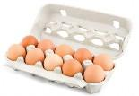  ** The groups having more members who write correct answers the most quickly will get a star.  **** Teacher observes them closely and has one student assist in writing the number of stars each group achieves.  Key: | T-S  S-S  T-S
  1. a lot of/lots of | 2. any | 3. some | 4. a lot of/lots of | 5. a lot of/lots of
Practice  (23 mins) | - To help Ss revise the use of How many and How much to ask about quantities. | TASK 3: FILL IN EACH BLANK WITH HOW MANY OR HOW MUCH. ANSWER THE QUESTIONS, USING THE PICTURES. (Ex 3, p.54)    * Teacher asks Ss to read the sentences carefully and choose the best answers on their own, then then swap with their partners.  ** Ss do the exercise as instructed.  *** Ss share their answers and discuss the reasons why they have chosen them.  **** Teacher nominates some Ss to read their answers in front of the whole class, check and correct their answers.  Key  1. How much – Two litres  2. How many – Two books  3. How many – Two books  4. How many – Three bananas  5. How many – Five spring rolls | T-S  S  S-S  T-S
Practice  (23 mins) | To get Ss to use How much/ How many to ask questions about quantities | TASK 4: WORK IN PAIRS. ASK AND ANSWER, USING THE QUESTIONS IN 3. (Ex 4, p.54)  * - Teacher gives Ss two minutes to think of and write down as many questions using How much and How many as they can.  ** Ss work in pairs to practise.  *** Teacher nominates some pairs of Ss to model this activity in front of the class. The others vote the pairs they like best.  **** Teacher gives feedback to help students improve their talk later. | T-S  S-S  S-S  T-S-S  T-S
  - Teacher pairs them to take turns asking and answering the questions in Task 3 and the questions they have prepared.
  Eg. A: How much water do you drink every day?
  B: Two litres.
Production  (10 mins) | -To get Ss to practise using measurement words and phrases, words of dishes and ingredients, How many and How much in context. | TASK 5: WORK IN PAIRS. TAKE TURNS TO ASK AND ANSWER ABOUT THE RECIPES. (Ex 5, p.54)  * - Teacher chooses some strong Ss in the class and assign the role of culinary teachers to them. The others will be culinary learners.  - Teacher asks them to sit in their groups to discuss and list all the questions and answers to make conversations in a culinary class.  - Teacher then mixes them in groups of a teacher and 3 to 4 students and asks them to make conversations asking and answering how to make pancakes and an omelette in a culinary class.  **/*** Every S in the group needs motivation to take part in the conversations while teacher goes around and observes them talking.  **** Teacher notes all useful measurement expressions and some students' grammatical errors for later comments. | T-S  S - S  T-S-S  T-S
Wrap-up  (5 mins) | To help students to recall information they’ve learned during class and reflect on gaps in their knowledge | Teacher summarises the main points of the lesson:  - How to use some, a lot of/ lots of  - How to ask and answer about food, drinks and cooking recipes using some, a lot of/ lots of, How many, How much | T-S
Homework  (2 mins) | - To reactivate the knowledge that students have gained.  - To prepare for the project. | - Teacher asks Ss to make questions and sentences about quantities, using some, a lot of / lots of, any, How much and How many.  Preparation for Unit 5 project  - Teacher checks what Ss have prepared (the eating habits, pictures or photos they have selected and decided to make a presentation)  - Teacher checks if every member has their own responsibilities and whether they have participated in preparing for the project properly. | T - S

Date of preparing: ………………………………….
Date of teaching: ………………………………….
Period 38

UNIT 5: FOOD AND DRINK

Lesson 4: Communication

I. Objectives
By the end of this lesson, Ss will be able to:
1. Knowledge
- Use lexical items related to the favourite food and drink in everyday life
- Understand and use ways to ask and answer about prices and favourite food and drink in English
2. Core competence
- Develop communication skills
- Be collaborative and supportive in pair work and team work
- Actively join in class activities
3. Personal qualities
- Promote pride in the values of Vietnamese culture
- Develop love for family
II. Materials
- Grade 7 textbook, Unit 5, Communication
- Computer connected to the Internet
- Projector / TV/ pictures and cards
- sachmem.vn

Language analysis
Form | Pronunciation | Meaning | Vietnamese equivalent
1. eel (n) | /iːl/ | a long, thin, snake-like fish, some types of which are eaten | con lươn
2. foreign (adj) | /ˈfɒr.ən/ | belonging or connected to a country that is not your own | ngoại quốc
3. favourite (adj) | /ˈfeɪvərɪt/ | best liked or most enjoyed | ưa thích
4. interview (n) | /ˈɪntəvjuː/ | a meeting in which someone asks you questions to see if you are suitable for a job or course | cuộc phỏng vấn
5. try (v) | /traɪ/ | to attempt to do something | thử làm gì đó

Assumptions
Anticipated difficulties | Solutions
1. Students may have few real life experiences in preparing for or cooking food and drink. | - Prepare some videos/ youtube links and suggestions on vocabularies and structures to describe films.
2. Students may have underdeveloped listening, speaking and co-operating skills. | - Play the recording many times if any necessary.  - Encourage students to work in pairs, in groups so that they can help each other.  - Provide feedback and help if necessary.

III. Procedures:
Stage | Stage aim | Procedure | Interaction
Warm-up  Lead-in  (5 mins) | - To activate students’ knowledge  - To get students interested in the topic | Restaurants  * - Teacher asks Ss to work in small groups.  - Teacher gives each group a different type of restaurant and tells them to create a menu and include starters, main courses, side dishes, desserts and drinks. Don't forget the prices.  - a steakhouse  - a vegetarian café  - an expensive French eatery  - a motorway service station restaurant  - a seafood restaurant  ** Ss quickly write on their own board, raise the board up and say "Bingo"  *** Ss look at others' restaurant menu and say which they want to go to in turns.  **** Teacher gives them a quick feedback. | T-S  S-S  T-S-S
Vocabulary  (5 mins) | To help students use key language more appropriately | 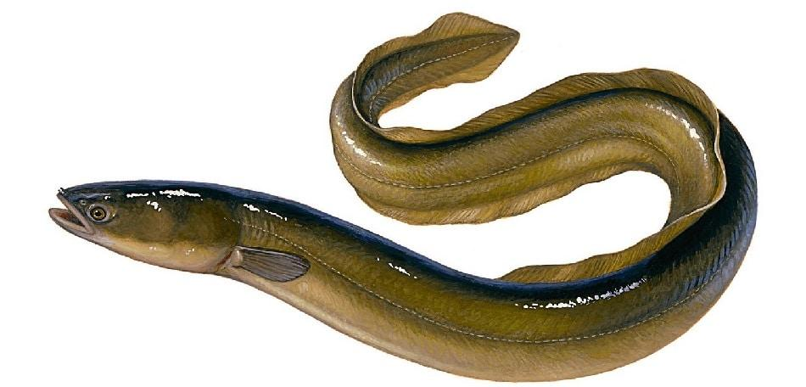  * T asks Ss to look at the photo and answer the question.  What is this?  ** Ss say the word.  *** Other Ss correct if the previous answer is incorrect.  **** Teacher shows and says the word aloud and asks Ss to repeat it.  * Teacher gives some words in Vietnamese and asks Ss to translate into English  ** Ss says the word  **** Teacher gives the correct answers  Vocabulary  1. con lươn: eel /iːl/  2. ngoại quốc: foreign /ˈfɒr.ən/  3. ưa thích: favourite /ˈfeɪvərɪt/  4. cuộc phỏng vấn: interview /ˈɪn.tə.vjuː/  5. thử làm gì đó: try /traɪ/ | T-S  S-S  S-S  T-S
Everyday English  (12 mins) | To introduce ways to ask and answer about prices in English. | TASK 1: LISTEN AND READ THE CONVERSATION. PAY ATTENTION TO THE QUESTIONS AND ANSWERS. (Ex 1, p. 55)  * Teacher gives Ss instructions.  ** Ss listen carefully, watch closely and repeat as a whole class. They pay attention to the questions whenever Teacher pauses and corrects their mistakes.  *** Ss work in pairs to repeat the conversation.  **** Teacher shows the conversation on the screen to make sure they ask the correct questions.  Audio script – Track 34:  Mark: How much is a bottle of mineral water?  Mai: It’s 5,000 dong.  Mark: And how much are two kilos of apples?  Mai: They’re 50,000 dong. | T-S  S-S  S-S  T-S
Everyday English  (12 mins) | To help Ss practise asking and answering about prices. | TASK 2: WORK IN PAIRS. TAKE TURNS TO ASK AND ANSWER ABOUT THE PRICES OF THE FOOD AND DRINK ON THE MENU. (Ex 2, p.55) | T-S  S-S  S-S  T-S
  * Teacher shows the menu on the screen, shows the sample of the conversation, pairs Ss and asks them to play the roles of a waiter and a customer to ask and answer about the prices of the food and drink on the menu.  ** Ss practise for about 3 minutes.  *** Ss work with another partner and change their roles, asking and answering questions about the prices.  ****Teacher goes around, observes, corrects their mistakes and notes some of their typical errors if necessary. | LY'S RESTAURANT  Breakfast
   | Food
   | bowl of beef noodle soup | 30,000 dong
   | bowl off eel soup | 35,000 dong
   | toast | 20,000 dong
   | Drink
   | glass of milk | 9,000 dong
   | bottle of mineral water | 8,000 dong
   | cup of green tea | 5,000 dong
Your favourite food and drink  (17 mins) | - To teach Ss the questions they can ask to interview someone about their favourite food and drink;  - To help Ss revise the vocabulary related to the topic. | TASK 3. LISTEN TO THE CONVERSATION AND ANSWER THE FOLLOWING QUESTIONS. (Ex 3, p.55)  * Teacher gives Ss some time to read the questions in Exercise 3, asks them to pay attention to the key words and predict the answers.  ** Ss do the exercise step by step.  - Ss read and underline key words.  - What's Nam's favourite food?  - What's his favourite drink?  - What foreign food does he like?  - What food does he want to try?  - What food can he cook?  - Ss listen twice, find synonyms and paraphrases of the key words and answer the question.  ***Teacher asks Ss to swap their notebooks with each other, listen to the recording once again and peer check.  ****Teacher gives Ss the correct answers and then asks them to repeat the conversation.  Key:  1. Spring rolls.  2. Lemonade.  3. Apple pie and pancakes.  4. Hu tieu (in Ho Chi Minh City).  5. Omelettes, rice, and spring rolls.  Audio script – Track 35:  Peter: Nam, can you help me with my school project? I need to interview some people about what they like to eat and drink.  Nam: Sure. What questions do you have?  Peter: What’s your favourite food, Nam?  Nam: It’s spring rolls.  Peter: What’s your favourite drink?  Nam: I like lemonade.  Peter: Interesting. What foreign food do you like?  Nam: Mmm, I like apple pie and pancakes.  Peter: How about new food? Is there anything that you’ve never had, but would like to try?  Nam: Certainly. I’d love to try hu tieu in Ho Chi Minh City.  Peter: I’d like to give it a try too. What can you cook?  Nam: Let me think... I cook omelettes, rice, and spring rolls. | T-S  S-S  S-S  T-S
Your favourite food and drink  (17 mins) | - To help Ss practise asking and answering about their friends’ favourite food and drink;  - To help Ss get information to report on their friends’ favourite food and drink;  - To help Ss practise reporting the results of their interviews. | TASK 4: WORK IN GROUPS. INTERVIEW TWO OF YOUR FRIENDS ABOUT THEIR FAVOURITE FOOD AND DRINK. WRITE THEIR ANSWERS IN THE TABLE BELOW. (Ex 4, p.55)  *Teach lets Ss randomly pick the cards to choose their teams. Then, teacher gives the instruction.  **Ss work in groups, practise asking and answering the questions to get information about the others in their groups to complete the table.  ***Ss share the collected information in the class.  ****Teacher listens to them, gives them comments and correct when necessary. | T-S  S-S  S-S  T-S
  Questions | Student 1 | Student 2
  1. What's your favourite food?
  2. What's your favourite drink?
  3. What food or drink do you want to try?
  4. What foreign food or drink do you like?
  5. What can you cook?
Wrap-up  (2 mins) | To help students to recall information they’ve learned during class and reflect on gaps in their knowledge | Teacher has Ss say what they have learnt in the lesson:  - Vocabulary of the favourite food and drink in everyday life  - Ways to ask and answer about prices, and favourite food & drink in English | T - S
Homework  (2 mins) | To reactivate the knowledge that students have gained. | - Teacher asks Ss to make and a conversation, record a video and upload on given drive link. | T - S

Date of preparing: ………………………………….
Date of teaching: ………………………………….
Period 39

UNIT 5: FOOD AND DRINK

Lesson 5: Skills 1

I. Objectives
By the end of this lesson, Ss will be able to:
1. Knowledge
- Develop their reading skill for specific information about food and drink
- Talk about the popular food and drink
2. Core competences
- Develop communication skills and creativity
- Be collaborative and supportive in pair work and team work
- Develop presentation skills
- Actively join in class activities
3. Personal qualities
- Promote pride in the values of Vietnamese culture
- Develop love for family and traditional food and drink
II. Materials
- Grade 7 textbook, Unit 5, Skills 1
- Computer connected to the Internet
- Projector / TV/ pictures and cards
- sachmem.vn

Language analysis
Form | Pronunciation | Meaning | Vietnamese equivalent
1. snack (n) | /snæk/ | a small amount of food that is eaten between main meals/ instead of a meal | đồ ăn vặt
2. taste (n) | /teɪst/ | the feeling that is produced by a particular food or drink | hương vị
3. broth (n) | /brɒθ/ | a thin soup, often with meat bones | nước dùng, canh
4. stewing | /stju:ɪŋ/ | cooking something slowly in liquid for a long time | hầm
5. boneless (adj) | /ˈbəʊnləs/ | boneless meat or fish has had the bones taken out | không xương

Assumptions
Anticipated difficulties | Solutions
1. Students may lack knowledge about some lexical items. | Provide students with the meaning and pronunciation of words.
2. Students may have underdeveloped reading, speaking and co-operating skills. | - - Let students read the text again (if needed).  - - Create a comfortable and encouraging environment for students to speak.  - - Encourage students to work in pairs, in groups so that they can help each other.  - Provide feedback and help if necessary.
3. Some students will excessively talk in the class. | - Define expectation in explicit detail.  - Have excessive talking students practise.  - Continue to define expectations in small chunks (before every activity).

III. Procedures:
Stage | Stage aim | Procedure | Interaction
Warm-up  Lead-in  (5 mins) | - To create an active atmosphere in the class before the lesson | Lunch time  Materials needed: | T-S-S
  Lunchbox, wrapped sandwich, milk container, straw. (Students mime the action as you demonstrate with the props. Point out an area of the room that will be where the students go to get their lunchboxes and another area that will be the lunchroom, or let their own desks be the lunchroom.)  - Look at the clock. It's time for lunch.  - Stand up.  - Get your lunchbox  - Line up.  - Go to the lunchroom.  - Sit down.  - Open your lunchbox.  - Take out a sandwich.  - Unwrap the sandwich.  - Take a bite of the sandwich. Mmmm it's good.  - Open your milk container.  - Put in the straw.  - Drink some milk.  - Eat the rest of your sandwich.  - Drink the rest of the milk  - Wipe your face with your napkin.  - Close your lunchbox.  - Stand up.  - Clean up the table.  - Take the garbage to the garbage can. | 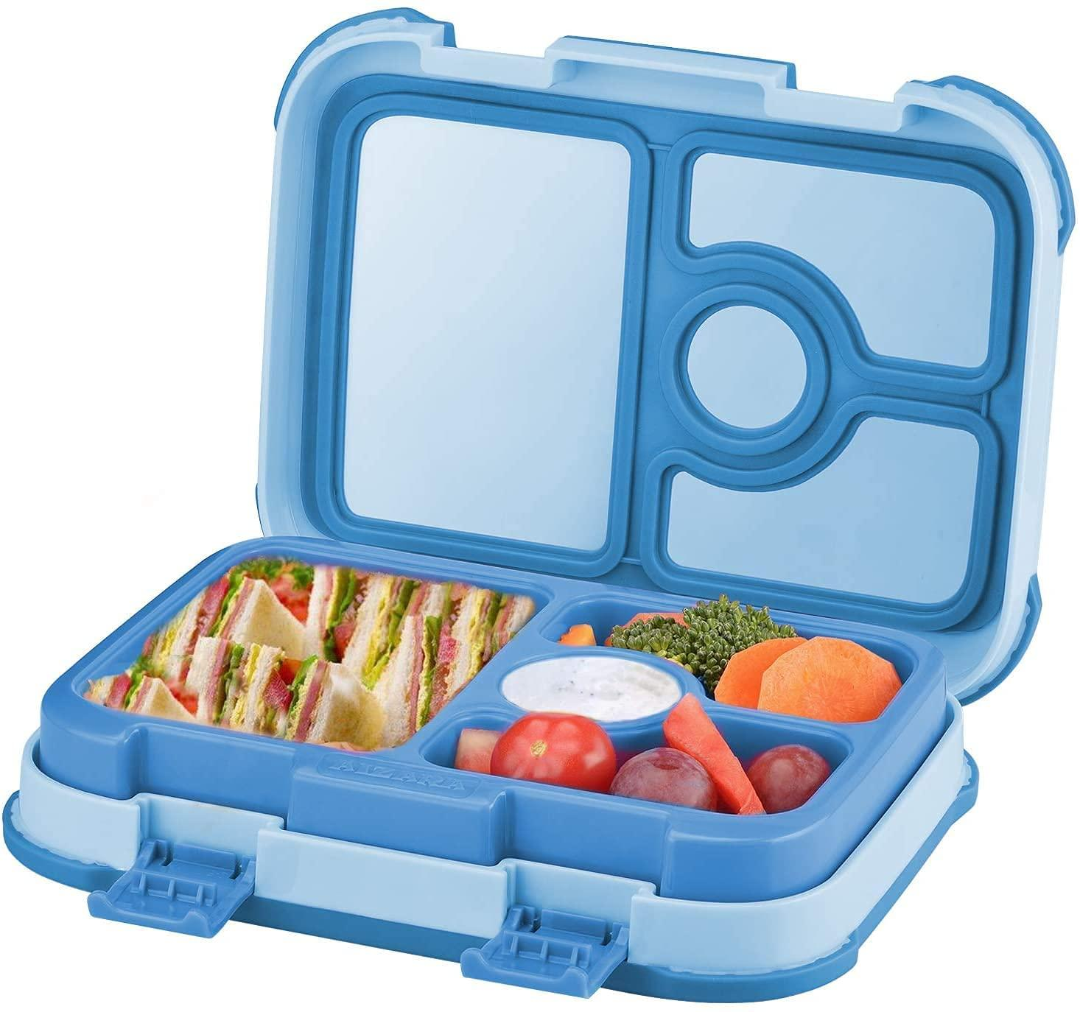  
Pre-reading  (5 mins) | To help Ss understand and activate their knowledge of the topic | TASK 1. WORK IN PAIRS. DISCUSS THE FOLLOWING QUESTIONS. (Ex 1, p.56)  *Teacher pairs Ss, gives them some time to discuss about “Phở”, using suggested questions.  ** Ss discuss as guided.  *** After discussing, Ss talk about pho in front of the class.  **** T listens and may ask some other questions about how to make Phở. | T-S  S-S  S-S  T-S
  1. Is pho popular in your neighbourhood?  2. When can we have pho?  3. What are the main ingredients of pho? | 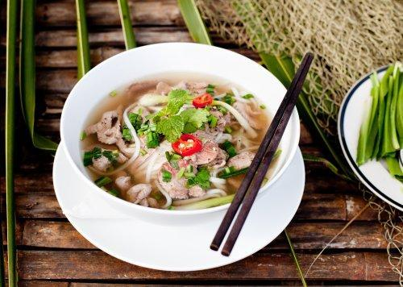
While-reading  (10 mins) | To help students use key language more appropriately | TASK 2. READ PHONG’S BLOG. MATCH THE UNDERLINED WORDS IN THE TEXT WITH THEIR MEANINGS. (Ex 2, p.56)  *Teacher asks Ss to scan the passage to find and work out the meanings of the words (1-5) in the passage and match with their meanings (a-e), using the context.  **Ss quickly locate the words, read with full concentration and complete focus, predict and match them with the provided meanings.  ***Ss swap their answers with each other.  ****Teacher checks the answers as a class, confirms the correct answers.  Or for weak classes, Teacher may ask for translation to check understanding.  Key:  1. d 2. b 3. c 4. a 5. e | T-S  S  S-S  T-S-S
While-reading  (10 mins) | To help Ss develop their reading skill for specific information (scanning). | TASK 3. READ PHONG’S BLOG AGAIN AND CIRCLE THE CORRECT ANSWER A, B OR C. (Ex 3, p. 56)  *Teacher gives instructions.  **Ss work individually to carefully read and underline key words in the given part of the sentences and three options of the other part that fit in.  1. The text is mainly about _______.  A. pho, a popular dish in Viet Nam  B. popular dishes in Viet Nam  C. different ways to cook pho  2. Pho is made mainly with ______.  A. rice noodles and beef or chicken  B. rice, pork, and vegetables  C. fish, shrimp, and noodles  3. We enjoy pho ______.  A. only for breakfast  B. for lunch and dinner  C. at any time of the day  4. To make noodles for pho, we use _____.  A. a variety of sticky rice  B. the best kind of rice  C. eggs and rice flour  5. The broth for pho is made by _____.  A. slowly cooking beef or chicken bones  B. cooking beef or chicken with fish sauce  C. boiling potatoes and chicken bones for a long time  Then, they locate the key words in the text, thoroughly read the text to choose the correct option to complete the sentences. Teacher tells them to underline parts of the passage that help them with the answers and set a strict time limit to ensure Ss read the text quickly for information.  *** Ss share their answers with others to compare their choices in pairs before showing them in the class and to Teacher. Teacher also asks them to give evidence when giving the answers.  ****Teacher nominates some Ss to read the completed sentences aloud, listens and then gives them correct answers.  Key:  1. A 2. A 3. C 4. B 5. A | T-S  S  S-S  T-S-S
Pre-speaking  (10 mins) | To help Ss generate ideas for the speaking activity | TASK 4. MAKE NOTES ABOUT A POPULAR FOOD AND DRINK IN YOUR AREA. THINK ABOUT ITS MAIN INGREDIENTS, HOW OFTEN AND WHEN YOU HAVE IT. (Ex 4, p. 56)  *Teacher asks Ss to brainstorm or use a mind map/ web to make notes about a popular food and drink in their area in groups of 4 or 5 Ss. (Teacher can show them a mind map as a sample)  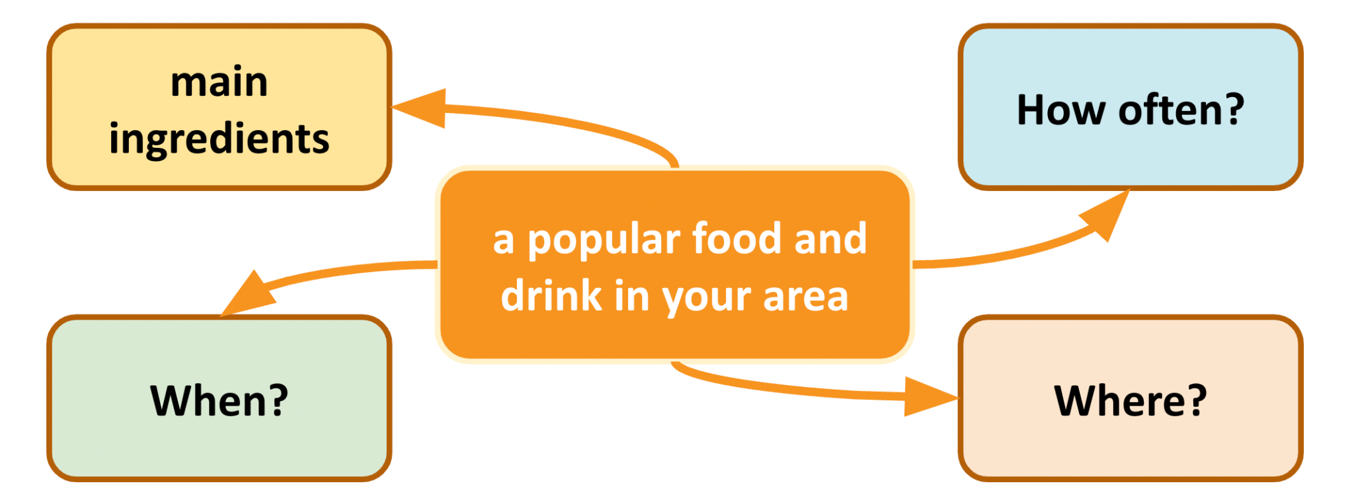  ** Ss think about a popular food or drink in their area, its ingredients and how often and when people in their neighbourhood have it and note down quickly these ideas as instructed during the time limit set by the teacher.  *** Ss share their ideas with other groups.  **** Teacher asks them some extra questions to help Ss if they lack ideas or if they have had too many ones to choose from. | T-S  S-S  T-S
While-speaking  (10 mins) | To provide an opportunity for Ss to practise talking about a popular food or drink. | TASK 5: WORK IN GROUPS OF 3 OR 4. TAKE TURNS TO TALK ABOUT A POPULAR FOOD OR DRINK IN YOUR AREA. (Ex 5, p.56)  * T asks Ss to talk using the notes/ maps/ webs that they have prepared in their own group and then nominates some of them (maybe, strong students) to model this activity in front of the class.  ** Ss practise.  *** Then, Ss listen to their classmates presenting and give positive comments to the others'.  **** Teacher gives feedbacks. | T - S  S - S  T - S
Wrap-up  (4 mins) | To help students to recall information they’ve learned during class and reflect on gaps in their knowledge | - Teacher has Ss summarise what they have learnt in the lesson with the two skills. If there is time, have them draw a mind map to summarise the main points of the lesson.  - Teacher has Ss say what they have learnt in the lesson. | T - S
Homework  (1 min) | To reactivate the knowledge that students have gained. | - Teacher asks Ss to make a conversation, video and upload on given drive link. | T - S

Date of preparing: ………………………………….
Date of teaching: ………………………………….
Period 40

UNIT 5: FOOD AND DRINK

Lesson 6: Skills 2

I. Objectives
By the end of this lesson, Ss will be able to:
1. Knowledge
- Develop their listening skill for specific information about food and drink
- Write a paragraph about eating habits in their area
2. Core competence
- Develop communication skills and creativity
- Be collaborative and supportive in pair work and team work
- Develop presentation skills
- Actively join in class activities
3. Personal qualities
- Promote pride in the values of Vietnamese culture
- Develop love for family and traditional food and drink
II. Materials
- Grade 7 textbook, Unit 5, Skills 2
- Computer connected to the Internet
- Projector / TV/ pictures and cards
- sachmem.vn

Language analysis
Form | Pronunciation | Meaning | Vietnamese equivalent
1. meal | /mɪəl/ | an occasion when food is eaten, or the food that is eaten on such an occasion | bữa ăn
2. breakfast | /ˈbrekfəst/ | a meal eaten in the morning as the first meal of the day | bữa sáng
3. lunch | /lʌntʃ/ | a meal that is eaten in the middle of the day | bữa trưa
4. dinner | /ˈdɪnər/ | the main meal of the day, usually the meal you eat in the evening but sometimes, in Britain, the meal eaten in the middle of the day | bữa tối
5. fabulous | /ˈfæbjələs/ | very good; excellent | tuyệt vời
6. healthy | /ˈhelθi/ | strong and well | khoẻ mạnh

Assumptions
Anticipated difficulties | Solutions
1. Students may lack knowledge about some lexical items. | - Provide students with the meaning and pronunciation of words.
2. Students may have underdeveloped listening, writing and co-operating skills. | - Let students listen to the text again and pause the recording to draw their attention to keywords (if needed).  - Create a comfortable and inspiring environment for students to write.  - Motivate students to work in pairs, in groups so that they can help each other.  - Provide feedback and help if necessary.
3. Some students will excessively talk in the class. | - Define expectation in explicit detail.  - Have excessive talking students’ practise.  - Continue to define expectations in small chunks (before every activity).

III. Procedures:
Stage | Stage aim | Procedure | Interaction
Warm-up  (4 mins) | - To create an active atmosphere in the class before the lesson;  - To lead in the new lesson. | Our eating habits  * Teacher puts Ss in small groups and asks them to tell each other everything they ate and drank the day before.  ** Ss share about what they ate and drank the day before.  *** As a group, Ss then decide who has the healthiest diet. | T-S  S-S
Vocabulary teaching  (4 mins) | To help students use key language more appropriately | * T asks Ss to look at the photos and answer the question “What does it mean in English?” | T-S  S-S  S-S  T-S
  ** Ss say the words.  *** Other Ss correct if the previous answers are incorrect.  **** Teacher shows and says the words aloud and asks Ss to repeat them.  1. meal /mɪəl/: bữa ăn  2. breakfast /ˈbrekfəst/: bữa sáng  3. lunch /lʌntʃ/: bữa trưa  4. dinner /ˈdɪnər/: bữa tối  5. fabulous /ˈfæbjələs/: tuyệt vời  6. healthy /ˈhelθi/: khoẻ mạnh | 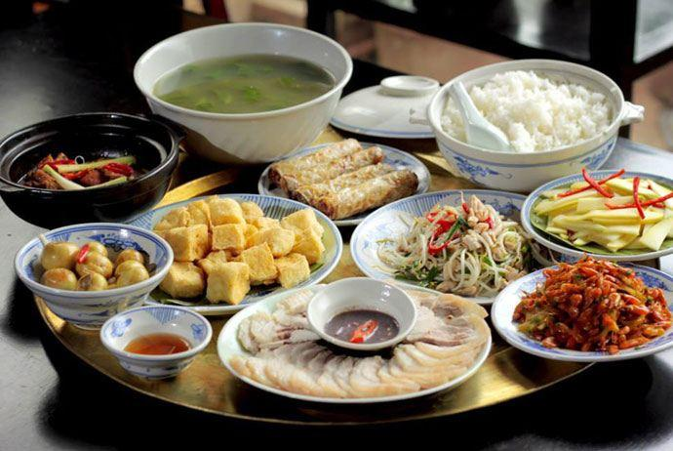 | 
   |  | 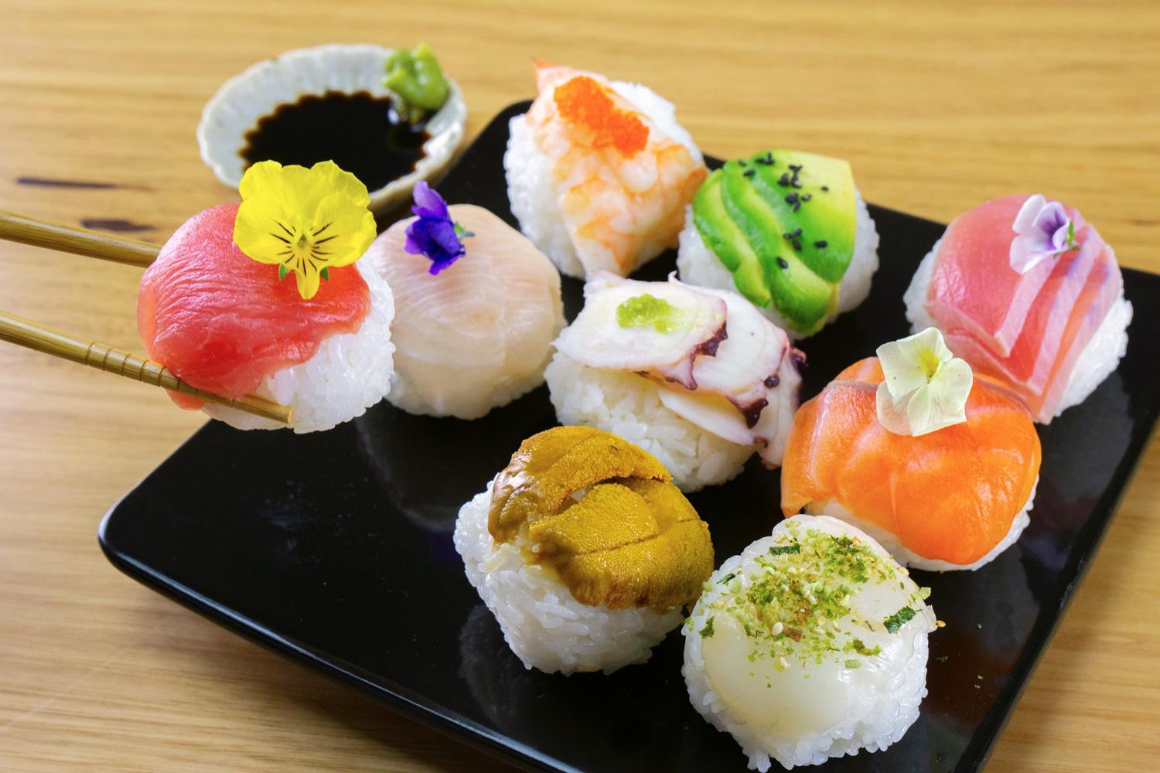
   | 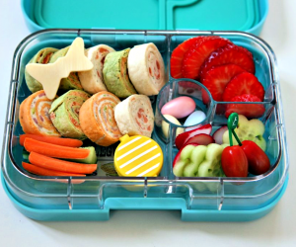 | 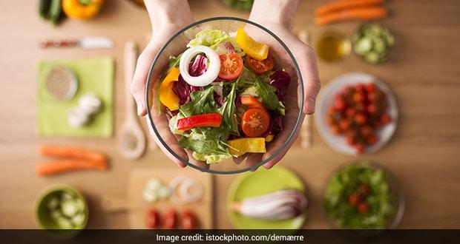
Pre-listening  (4 mins) | To help Ss understand and activate their knowledge of the topic. | TASK 1: WORK IN GROUPS. DISCUSS THE FOLLOWING QUESTIONS. (Ex 1, p. 57)  * Teacher asks Ss to work in groups of 4 or 5 discussing questions about the eating habits of the people in their area.  1. What time do people in your area often have breakfast, lunch, and dinner?  2. What do they often have for breakfast, lunch, and dinner?  ** Ss actively discuss and note down all members' answers.  *** Ss share their groups' answers as the whole class. | T-S  S-S  S-S
While-listening  (10 mins) | - To help Ss understand what the monologue is about;  - To help develop their skill of listening for specific information. | TASK 2: LISTEN TO MINH TALKING ABOUT THE EATING HABITS IN HIS AREAD. CIRCLE THE FOOD AND DRINK YOU HEAR. (Ex 2, p.57)  * Teacher asks Ss to guess which food and drink will appear in the monologue first.  - eel soup  - cakes  - green tea  - coffee  - toast  ** Ss listen to the recording, tick the words or phrases they hear from the monologue.  *** Two or three Ss are nominated to write their answers on the board after the first listening.  **** Teacher plays the recording again for Ss to check the answers. If time is limited, T may only play the monologue once. T may pause at the sentences that include the words or phrases Ss need circle.  Key:  eel soup, green tea | T-S  S - S
While-listening  (10 mins) | To help develop their skill of listening for specific information. | Task 3: LISTEN AGAIN AND TICK (✓) T (True) or F (False).  * Teacher has Ss look at the statements in this activity, asks them how to do it and gives them some strategies to do the exercise. (e.g. reading the sentences, underlining the key words, listening to the text, paying attention to the key words, deciding if each sentence is true or false).  ** Ss individually do exercise as instructed. (For strong classes, Ss can take notes of the information to explain why a sentence is false.)  *** Ss swap their answers with their partners for checking.  **** Teacher nominates Ss to read their answers aloud, checks and gives  them the correct ones.  Key: 1. F 2. T 3. F 4. T 5. T  Audio script - Tracks 36 + 37:  People in my area often have three meals a day: breakfast, lunch and dinner. For breakfast, we usually have pho or eel soup with bread. Sometimes we have instant noodles or xoi (sticky rice). Lunch often starts at 11:30 a.m. Most of us have lunch at home. We often have rice, fish, meat, and vegetables. Dinner is the main meal of the day. It’s also the time when family members gather at home, so it takes a bit longer than the other meals. It often starts at around 7:30 p.m. We usually have rice with a lot of fresh vegetables and seafood or meat. We normally talk about everyday activities during the meal. Then we have some fruit and green tea. I think the food in my area is fabulous. It’s very healthy and delicious. | T-S  S-S  S-S  T-S
Pre-writing  (7 mins) | To help Ss prepare ideas for their writing. | TASK 4: MAKE NOTES ABOUT THE EATING HABITS IN YOUR AREA. (Ex 4, p.57)  * Teacher asks Ss to make notes, brainstorm or cluster ideas to write about the eating habits in their area, using the following questions. (Ss can use the language in the listening exercise.)  + What time do they have breakfast, lunch and dinner?  + What food and drink do they have then?  ** Ss do not have to write full sentences and they can use abbreviations.  *** Then Ss share their notes with their partners.  **** T may ask some strong students to read out the notes to the whole class. | T-S  S-S  S-S  T-S
While-writing  (12 mins) | To help Ss practise writing a paragraph about the eating habits in their area. | TASK 5: WRITE A PARAGRAPH OF ABOUT 70 WORDS ABOUT THE EATING HABIRS IN YOUR AREA. USE THE INFORMATION IN 4 TO HELP YOU. (Ex 5, p.57)  * Teacher suggests Ss think and write, using the notes they have done in Exercise 4.  ** Ss write the first draft individually and listen to their classmates' and Teacher's feedbacks and comments, and then write the final writing.  *** Then, they share their writings with the others, using marking criteria to give each other peer-feedbacks.  Teacher observes Ss, notes some useful expressions and structures the Ss have used and some errors they have made for later comments and correction.  **** T may display all or some of Ss’s final writings on the wall / notice board and mark them. | T-S  S-S  S-S  T-S
Wrap-up  (3 mins) | To help students to recall information they’ve learned during class and reflect on gaps in their knowledge | - Teacher has Ss summarise what they have learnt in the lesson with the two skills.  + Listen for specific information abou food and drink  + Write a paragraph describing eating habits  If there is time, have them draw a mind map to summarise the main points of the lesson. | T-S
Homework  (1 min) | To help students further practise writing about the unit topic. | - Teacher asks Ss to write a paragraph about their favourite food and upload on given drive link. | T - S
Date of preparing: ………………………………….
Date of teaching: ………………………………….
Period 41

UNIT 5: FOOD AND DRINK

Lesson 7: Looking back & Project

I. Objectives
By the end of this lesson, Ss will be able to:
1. Knowledge
- Review the vocabulary and grammar of Unit 5
- Apply what they have learnt (vocabulary and grammar) into practice through a project
2. Core competence
- Develop communication skills and creativity
- Develop presentation skill
- Develop critical thinking skill
- Be collaborative and supportive in pair work and team work
- Actively join in class activities
3. Personal qualities
- Be more creative when doing the project
- Develop self-study skills
II. Materials
- Grade 7 textbook, Unit 5, Looking back & Project
- Computer connected to the internet
- Pictures, A0 paper
- Projector/ TV
- sachmem.vn

Assumptions
Anticipated difficulties | Solutions
1. Ss may have underdeveloped speaking, writing and co-operating skills when doing the project. | - Encourage Ss to work in pairs, in groups so that they can help each other.  - Provide feedback and help if necessary.
2. Some Ss might excessively talk in the class. | - Define expectation in explicit detail.  - Have excessive talking Ss practise.  - Continue to define expectations in small chunks (before every activity).

III. Procedures:

Stage | Stage aim | Procedure | Interaction
Warm-up  Lead-in  (4 mins) | - To create an active atmosphere in the class before the lesson | Game: What can you make?  * Teacher puts Ss in small groups, shows some ingredients on the screen and gives thorough instructions.  ** Ss work in their teams to decide what food they can cook, using the ingredents provided.  *** Students then share their ideas with other groups.  **** Teacher corrects students’ answers if they make any mistakes and suggests some food they can make using the given ingredients. | T-Ss  S-S  S-S  T-Ss
Vocabulary  (8 mins) | To help Ss revise the vocabulary items they have learnt in the unit. | TASK 1: ADD THE WORDS AND PHRASES YOU HAVE LEARNT IN THE CORRECT COLUMNS. (Ex 1, p.58)  * Teacher encourages students to find as many words or phrases as possible to add to the columns individually.  ** Students do the task individually.  *** Ss compare with their partners to find out who has more words and add any words they haven’t had into their tables.  **** Teacher gives feedback as a class discussion. | T-Ss  S-S  S-S  T-Ss
Vocabulary  (8 mins) | To help Ss revise the vocabulary items they have learnt in the unit. | TASK 2: READ THE RECIPE AND WRITE SENTENCES AS IN THE EXAMPLE.  * Teacher has Ss do this activity individually.  ** Ss read the recipe and write about 7 sentences.  *** Ss then compare their answers with their partners. Some strong ones are nominated to read out their answers in front of the class.  **** Teacher gives feedback as a class discussion.  Suggested answers:  We need 5 eggs. We need 2 tomatoes.  We need 2 tablespoons of cold water.  We need 40 grams of butter.  We need 5 grams of onion.  We need 1 teaspoon of salt.  We need 1 teaspoon of pepper. | T-Ss  S-S  S-S  T-Ss
Grammar  (8 mins) | To help Ss revise the use of some, any, much and a lot of / lots of | TASK 3: COMPLETE THE SENTENCES. WRITE SOME, ANY, MUCH, OR A LOT OF/ LOTS OF. (Ex 3, p.58)  * Teacher gives instructions.  ** Ss do the exercise individually first.  *** Then they can swap and check their answers with a partner before discussing the answers as a class. Remind Ss to record their original answers so they can use that information in their Now I can … statement.  **** Teacher gives feedback as a class discussion.  Key:  1. any 2. some 3. a lot of/ lots of 4. a lot of/ lots of 5. any, some | T-Ss  S-S  S-S  T-Ss
 | To help Ss revise the use of How much and How many. | TASK 4: MAKE QUESTIONS WITH HOW MANY/ HOW MUCH FOR THE UNDERLINED WORDS IN THE FOLLOWING SENTENCES. (Ex 4, p. 58)  * Teacher gives instructions.  ** Ss do the exercise individually first.  *** Then they can swap and check their answers with a partner before discussing the answers as a class. Remind Ss to record their original answers so they can use that information in their Now I can … statement.  **** Teacher gives feedback as a class discussion.  Key:  1. How many bottles of juice are there in the fridge?  2. How much butter do you need for your pancakes?  3. How many bottles of fish sauce do you / we have?  4. How many chairs do you / we need (for the party)?  5. How much sugar did she put in her lemonade? | T-Ss  S-S  S-S  T-Ss
Project  (22 mins) | To allow students to apply what they have learnt (vocabulary and grammar) into practice through  a project. | Posters exhibition:  * Teacher has students display all or some of the posters on the wall or notice board and ask each group to present their poster to the whole class. When all groups have presented their posters, T may have the whole class vote for the best poster.  - Choose eating habits in Ha Noi or in another area or country and design a poster for it, including:  - what typical food they eat for the meals  - what ingredients they need to cook  - how they cook  - how they serve the meals  - pictures or photos for illustration  - Organise an exhibition.  - Vote for the best poster.  ** Students do the project in groups before and present during lesson 7  *** Students listen to the others, vote for the best poster and finally complete the self-assessment by completing the statement Now I can … so that they can identify any difficulties and weak areas and provide further practice as the whole groups and individuals.  **** Teacher gives feedback. | T - Ss  S – S  T – Ss
Wrap-up  (2 mins) | To consolidate what students have learnt in the lesson. | Teacher asks students to talk about what they have learnt in the lesson. | T-Ss
Homework  (1 min) | To prepare for the next lesson. | Prepare for the next lesson: Unit 6 – Lesson 1. Getting started. | T-Ss

