Ai Mo B Primary School
SPEAKING TEST FOR ENGLISH 5
Term II (2022 - 2023)
Task 1. Interviewing (1point)
Teacher greets and takes part in the conversation. Teacher can ask 4 of these questions:
- What’s your name?
- How are you today?
- Where do you live?
- What do you like doing in your free time?
- What’s your favourite subject?
- How do you go to school every day?

Task 2. Look and answer (1,5 point)
Teacher shows some cards for Ss to take a card (choose) a topic to talk about.

Topic 1: Health problems
 |  | 
 |  | 

- Look at the picture. What’s the matter with him/her?
- What should he/ she do?
- Should he / she take a rest? / go to school? / eat ice-cream?...
- What should we do to be healthy?

Topic 2: Jobs
 |  | 
 | 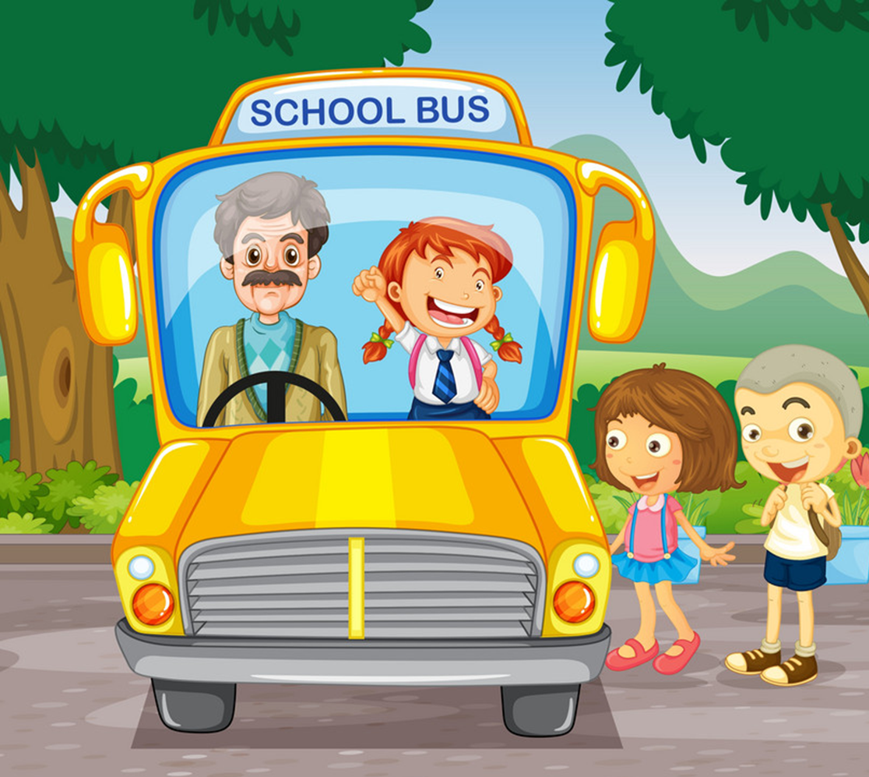 | 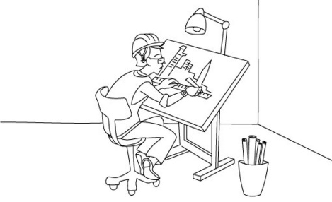

- Look at the picture. What’s the job?
- What would you like to do in the future?
- Why would you like to be a / an ….?

Topic 3: Stories
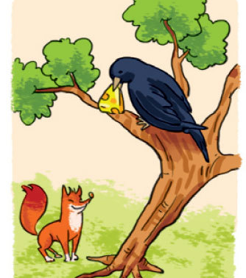 |  | 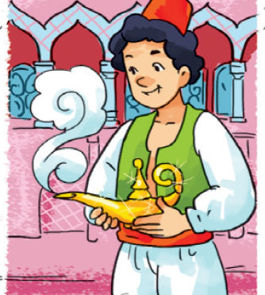
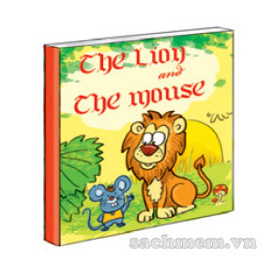 | 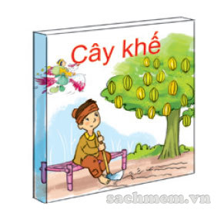 | 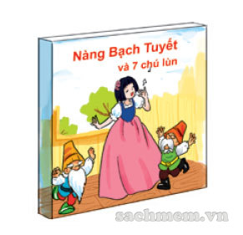

- Do you like reading?
- Look at the picture. What book is this?
- Who is the main character?
- What’s he/ she like?

Topic 4: Places


- Look! What’s this?
- Where is the museum / bus-stop / theatre?
- What’s between the … and the …?
- How can I get to the …?

Topic 5: Food & drink
 |  | 
 |  | 
 |  | 

- What’s your favourite food / drink?
- Do you like bananas / chicken / chocolate…?
- What would you like to eat / drink?
- How much water/ rice/ noodles do you drink every day?
- How many eggs do you eat a week?
Topic 6: Weather
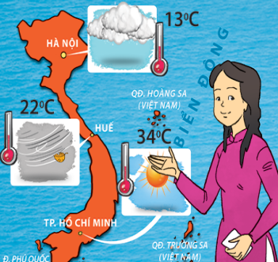 | 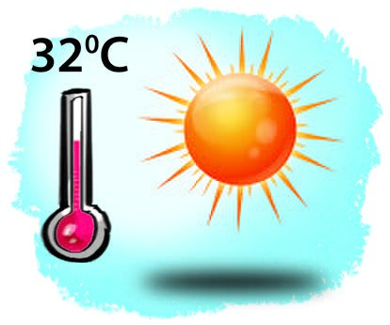 | 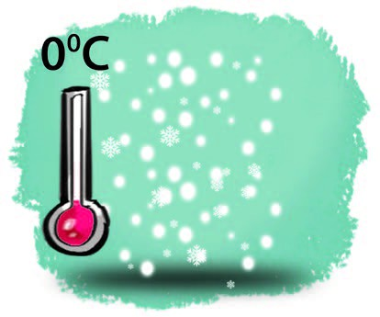
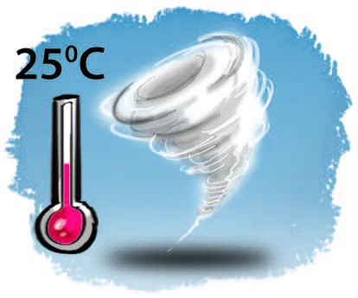 | 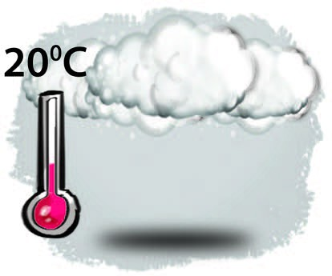 | 

- What’s the weather like to day?
- Look at the picture. What will the weather be like tomorrow?
- How many seasons are there in Hanoi?
- What’s your favourite season?
- What’s the weather like in spring / summer…?

THE END.

