Ai Mo B Primary School
TEST FOR ENGLISH 3
Term II (2022 - 2023)
Time: 40 minutes
Date: ……………………………………. | Written test: … /8
Full name: ………………………………. | Speaking test: … /2
Class: 3A….. | Total: … /10
LISTENING (3.0 points)
PART 1: Listen and number. There is one example. (1.0 point)
 | 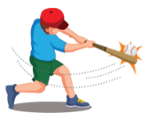 |  |  | 
0
PART 2: Listen and put a tick () in the box. There is one example. (1.0 point)
Ex. | 5. | 6. | 7. | 8.
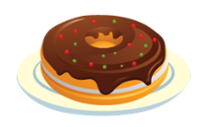 | 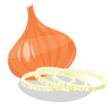 |  |  | 
a. | a. | a. | a. | a.
 |  |  |  | 
b. | b. | b. | b. | b.
PART 3: Listen and write. There is one example. (1.0 point)
Luna’s best friend
Albert
Ex. Name:
9. Favorite sport: ________________________________
10. Favorite toy: ________________________________
11. Favorite food: ________________________________
12. Uniform: white shirt and black __________________

READING (2.5 points)
PART 1: Look, read and draw lines. There is one example. (0.75 point)
eighteen minus three six plus five nineteen minus two seven plus twelve

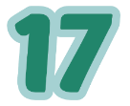
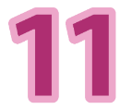
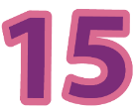
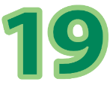

PART 2: Look, read and tick () Yes or No. There is one example. (0.75 point)
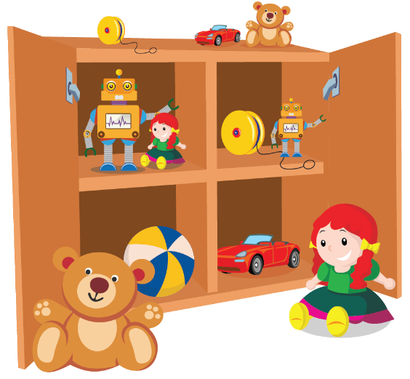

 |  | Yes | No
Ex. | There is one small car
4. | There are two yo-yos.
5. | There is one big doll and one small doll.
6. | There are two big teddy bears.

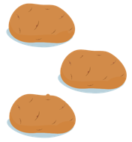
PART 3: Look, read and circle. (1.0 point)
7. | There are some eggs. | 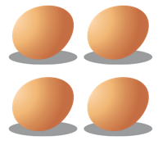  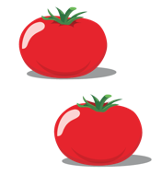
8. | Put the ball under the table. | 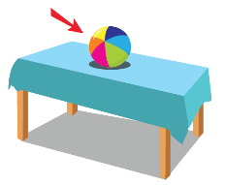  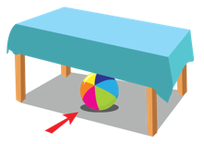  
9. | I can play soccer. | 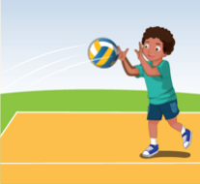  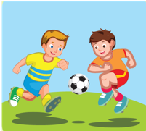  
10. | Let’s play badminton. | 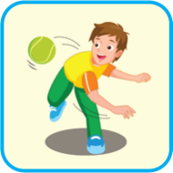  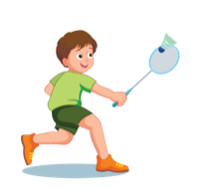

WRITING (2.5 points)
PART 1: Order the letters. (1.0 point)
1. |  | e n i n t s | t ___ ___ ___ ___ ___
2. |  | o a e r b d w r | w __ __ __ __ __ __ __
3. | 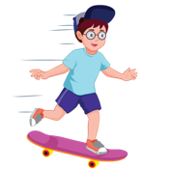 | i g a o r b d n | skate __ __ __ __ __ __ __ __
4. | 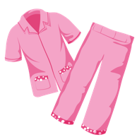 | a a a j m p s | p __ __ __ __ __ __
PART 2: Look and write. (1.0 point)
5. |  | I wear un ___ ___ ___ ___ ___ .
6. | 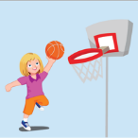 | Let’s play __ __ __ __ __ __ __ __ __ __ .
7. | 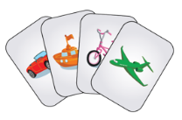 | I have some __ __ __ __ __.
8. | 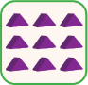 | I learn addition with __ __ __ __ __ __.
PART 3: Reorder the words to make a correct sentence. There is one example. (0.5 point)
Stand
up
please
Ex.
Stand up, please.
in
put
the toy box
I
teddy bears
9.

are
good
at?
What
you
10.

THE END.

