Ai Mo B Primary School
TEST FOR ENGLISH 5
Term I (2022 - 2023)
Time: 40 minutes

Date: ……………………………………. | Written test: … /7,5
Full name: ………………………………. | Speaking test: … /2,5
Class: 5….. | Total: … /10

PART I: LISTENING

Question 1. Listen and tick. There is one example.
Example:   A.  |   B. 
1. 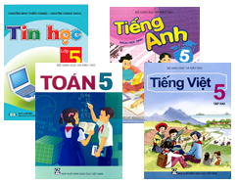  A. | 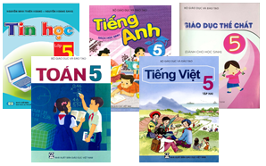  B.
2.   A. | 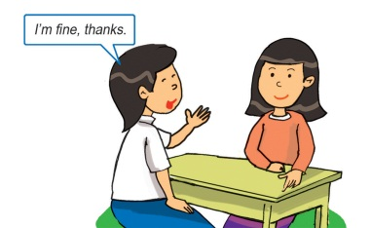  B.
3. 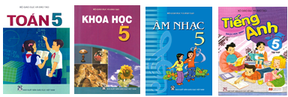  A. | 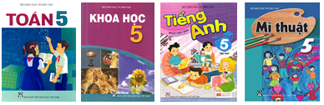  B.
4. 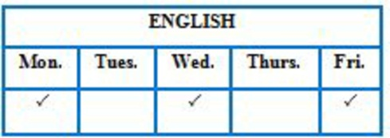  A. | 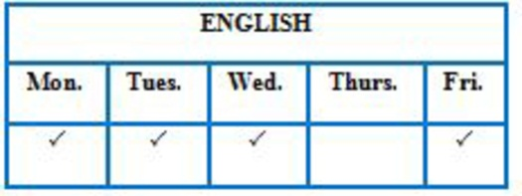  B.

Question 2. Listen and match. There is one example.
-  |  | 0
-  |  | 1
-  |  | 2
- 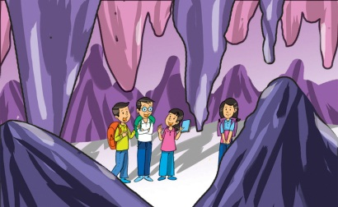 |  | 3
- 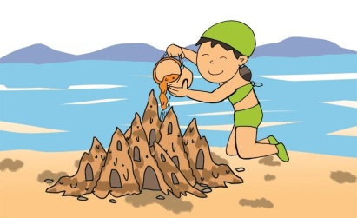 |  | 4

Question 3. Listen and write. There is one example (0,5 point)

- Yesterday. I went to the zoo with my friends.
- At the zoo, I saw some ___________________. They moved beautifully.
- I also saw some ___________________. They were very noisy.
PART II: READING & WRITING
Question 4. Look and write. (1point)

1. 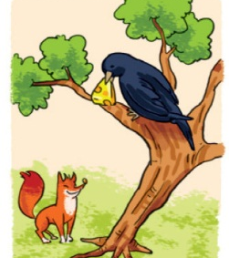 | I’m reading ________________________ .
2. 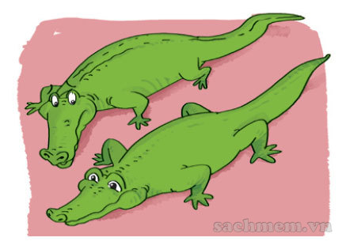 | What did you see at the zoo?  - I saw some____________________.
3.  | Last week, Mai went to see her grandparents by ___________________.
4.  | He practises listening to English by _____________________English cartoons.

Question 5. Read and tick True or False. (1 point)
Vy likes English very much. At school, she has English four times a week. She often speaks English with her classmates. Sometimes, she talks with her foreign friend, Amy. They are happy because they can understand each other. Vy usually reads English comic books in her free time. At home, she practises listening by watching cartoons on TV. Vy wants to learn English well. She thinks English is necessary for her future.
 | True | False
1. Vy has English every day.
2. Amy can understand Vy’s English.
3. Vy usually reads comic books to practise listening.
4. English is necessary for Vy’s future.

Question 6. Circle the best answer (1point)

- I like Snow White __________ she is gentle and kind.
A. so B. and C. but D. because
- What did you do at the party? – We ________ nice food and drink.
A. have B. has C. had D. having
- What will you do at Ha Long Bay? - ____________ swim in the sea.
A. I’ll B. I’ll be C. I will be D. I am
- His grandparents live ____________ a small village in Da Nang.
A. on B. at C. in D. from

Question 7. Read and match the question in column A with the best answer in column B (1 point)

A | B
1. Where will you be this weekend? | a. Twice a week.
2. How often do you have Science? | b. It’s big and noisy.
3. What’s your hometown like? | c. I’ll be in the mountains.
4. What are you reading? | d. The story of Mai An Tiem.

1… 2… 3… 4…
Question 8. Order the words to make sentences (1 point)
- speaking / How / you / do / English / practice /?
…………………………………………………………………………………
- Hoi An / my / went / Last summer, / family / to / coach/ by /.
…………………………………………………………………………………
- How many / you / lessons / have / do / today /?
…………………………………………………………………………………
- watch TV / I / evening / sometimes / in /the /.
…………………………………………………………………………………

--- The end ---

