Ai Mo B Primary School
TEST FOR ENGLISH 4
Term I (2022 - 2023)
Time: 40 minutes

Date: ……………………………………. | Written test: … /8
Full name: ………………………………. | Speaking test: … /2
Class: 4A….. | Total: … /10

PART I: LISTENING
Question 1. Listen and tick. There is one example.
Example: | 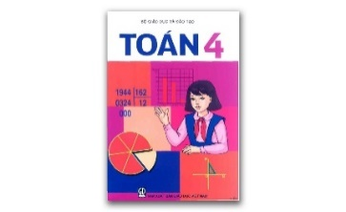 | 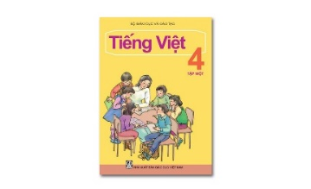
 | A.  | B. 

1.
  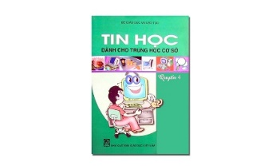 | 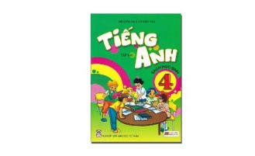
  A. | B.
2.
  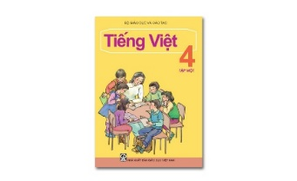 | 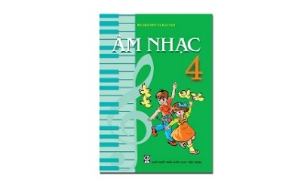
  A. | B.
3.
  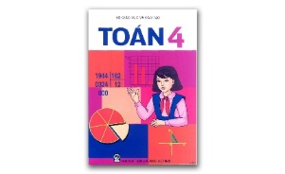 | 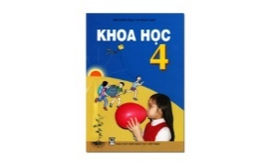
  A. | B.
4.
  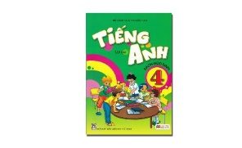 | 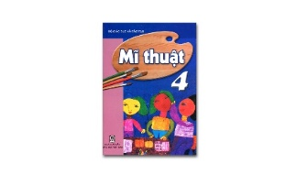
  A. | B.
Question 2. Listen and tick or cross . There are two examples.
Example: | 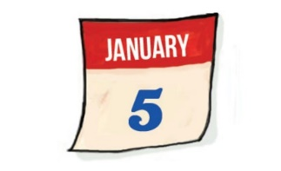 |  |  | 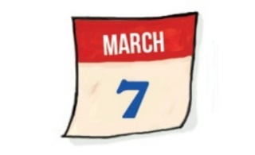
 | A. |  |  | B.
  1.
  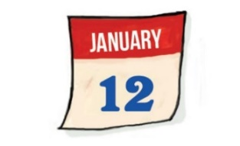
  2.
  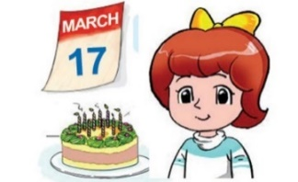
3. |  | 4.
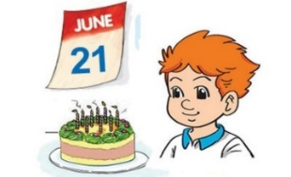 |  | 
PART II: READING AND WRITING
Question 3. Look and write. There is one example.

Example: | avitnem → V i e t N a m | 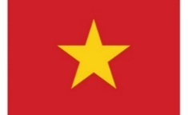

  1. tasrualai  → _ _ _ _ _ _ _ _ _ | 
  2. lmsaayia  → _ _ _ _ _ _ _ _ | 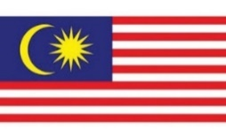
  3. negdaln  → _ _ _ _ _ _ _ | 
  4. eiamrac  → _ _ _ _ _ _ _ | 
Question 4. Read and tick or cross . There are two examples.
 | She is in Class 4A5. | They can’t play chess.
Examples: | 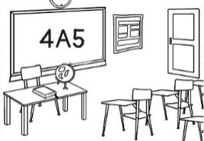 | 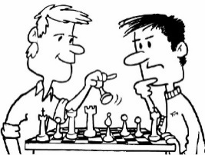
 | A. | B.

  - Our classroom is large.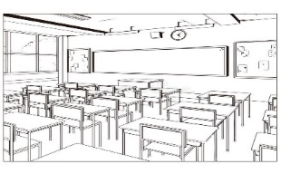
  - I have Art and Music today. | 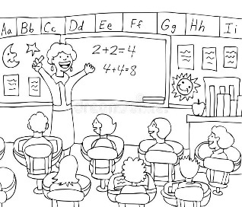
  3.
  She’s in Class 1A3. | 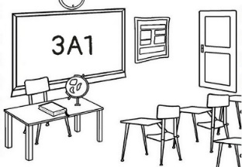
  4.
  She can play piano. | 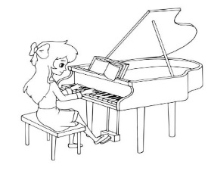
Question 5. Circle the best answer.
- Akiko’s from _________.
A. America B. Japan C. England D. Viet Nam
- _________ day is it today?
A. When B. Who C. Where D. What
- Where’s your school? – It’s in Long Bien _______.
A. zoo B. class C. district D. supermarket
- Can you play guitar? – Yes, _______.
A. I do B. I can C. let’s D. please
Question 6. Read and complete.
volleyball can’t America December
Hello. I’m Vincy. I’m from (1) ______. I’m 11 years old. My birthday is on the twelfth of (2) _______. I can play sports but I (3) ______ play the guitar. I do not go to school at the weekend. I cycle on Saturdays and play (4) ______ on Sundays.
Question 7. Read and match the question in column A with the best answer in column B.

A | B
1. What do you like doing? | a. Nice to see you again, Hoa.
2. Nice to see you again, Mr Loc. | b. It’s on the first of October.
3. When’s your birthday? | c. It’s the fifth of July.
4. What’s the date today? | d. I like cooking.

1… 2… 3… 4…
Question 8. Order the words to make sentences.
1. is / What / hobby? / your /
……………………………………………………………………………………
2. and / Tom / table / Quan / like / tennis. / playing /
……………………………………………………………………………………
3. are / What / doing? / they/
……………………………………………………………………………………
4. is/ writing/ Nam/ dictation/ a/
……………………………………………………………………………………

--- The end ---

