TRƯỜNG THCS GIA QUẤT
TỔ NĂNG KHIẾU
Năm học: 2024 -2025
*****
REVIEW FOR THE FIRST MID-SEMESTER TEST – GRADE 6
UNIT 1-2-3

I/PRONUNCIATION
Mark the letter A, B, C, or D on your answer sheet to indicate the word whose underlined part differs from the other three in pronunciation in each of the following questions.
Question 1. A. computer B. compass C. fun D. month
Question 2. A. card B. farm C. art D. share
Question 3. A. markets B. camps C. schools D. parks
Question 4. A. gardens B. beds C. parents D. halls
Question 5. A. tables B. lights C. villas D. windows
Question 6. A. fun B. study C. compass D. homework
Question 7. A. lessons B. shoes C. cheeks D. friends
Question 8. A. car B. mark C. wardrobe D. start
Mark the letter A, B, C, or D on your answer sheet to indicate the word that differs from the other three in the position of primary stress in each of the following questions.
Question 1. A. rubbish B. dislike C. money D. lucky
Question 2. A. forgot B. early C. physics D. lesson
Question 3. A. delay B. swimming C. money D. compass
Question 4. A. creative B. interview C. equipment D. remember
Question 5. A. overseas B. beautiful C. difficult D. miracle
Question 6. A. backpack B. quiet C. feather D. pollute
Question 7. A. greenhouse B. compass C. surround D. classmate
Question 8. A. boarding B. judo C. pocket D. replace

II/ USE OF LANGUAGE
A.VOCABULARY AND GRAMMAR
Mark the letter A, B, C, or D on your answer sheet to indicate the correct answer to each of the following questions.
Question 1. I have a new _______, but I don’t wear it every day.
A. pencil case B. notebook C. bicycle D. uniform
Question 2. You can borrow books from the school _______.
A. yard B. canteen C. library D. garden
Question 3. My pencil is not sharp any more. I need a pencil _______.
A. sharpener B. case C. eraser D. head
Question 4. What do you usually do _______ break time?
A. on B. in C. at D. about
Question 5. In the afternoon, we learn to draw, swim, or do _______.
A. football B. science C. judo D. lunch
Question 6. My grandpa’s _______ is in a tall building.
A. apartment B. villa C. town house D. stilt house
Question 7. My friends stay in _______ when they go camping.
A. a tent B. a country house C. a cottage D. an apartment
Question 8. Tom is opening the _______ to get some food.
A. wardrobe B. fridge C. chest of drawers D. dishwasher
Question 9. There is a big _______ of my family on the wall.
A. picture B. lamp C. window D. fan
Question 10. Mary wants to buy a big _______ to store all her clothes.
A. fridge B. drawer C. bed D. wardrobe
Question 11. John is _______. He does not live with his parents.
A. boring B. serious C. independent D. helpful
Question 12. Rebecca often talks in class. She is _______.
A. shy B. talkative C. creative D. patient
Question 13. Noriko looks pretty in her new _______ style.
A. hair B. elbow C. neck D. shoulder
Question 14. Jose finishes difficult Maths questions in a short time. He is _______.
A. helpful B. clever C. kind D. confident
Question 15. Sara studies all day. She is a _______ girl.
A. funny B. sporty C. serious D. hard-working
Question 16. Julia has to wear braces _______ her teeth.
A. in front of B. in C. next to D. on
Question 17. I can’t see the screen because of the person _______ me.
A. behind B. in front of C. at D. in
Question 18. Fred is standing _______ the window over there.
A. between B. in C. at D. on
Question 19. The Jeffersons had a picnic _______ the river.
A. on B. in C. under D. next to
Question 20. Every weekend, Jessica goes to music club to _____ the piano.
A. Do B. Play C. Go D. Have
Question 21. Jessica _______ hard-working and serious.
A. has B. is C. are D. have
Question 22. Nam _______ some exercise in the morning.
A. usually do B. usually does C. do usually D. does usually
Question 23. We often _______ lunch at school at about 11 o’clock.
A. are eating B. eats C. is eating D. eat
Question 24. _______ your house have an attic? _______, it does.
A. Do/Yes B. Does/No C. Is/ No D. Does/Yes
Question 25. Be quiet! My younger sister _______ upstairs.
A. is sleeping B. sleeps C. sleep D. are sleeping
Question 26. Eric always gets good marks. He _______ very hard.
A. plays B. has C. studies D. does
Question 27. _______ everyone _______ note of the lesson right now?
A. Is/ taking B. Does/take C. Do/ take D. Are/ taking
Question 28. _______ in any of our group discussions.
A. Never she participates B. She doesn’t never participates
C. She participates never D. She never participates
Question 29. Our teacher _______ strict when he _______ a lesson.
A. is always - has B. is always - have
C. always is - has D. always is - have
Question 30. What does your cousin John Look like?
- He _______very tall, and he _______big eyes with a pair of glasses.
A. isn’t/have B. is/have C. is/ has D. doesn’t/has

B. EVERYDAY ENGLISH
Choose the most suitable response A, B, C, or D to complete each of the following exchanges.
Question 1. Phong introduces his new friend to Nam.
Phong: Nam. This is my new friend. His name is Hai
Nam: ___________________.
A. Hi, Hai. | B.Nice to meet you, Hai. | C.How are you, Hai. | D. Good morning, Hai.
Question 2. Lisa and Ben are talking about their house.
Lisa: “Do you live in a house or an apartment?”
Ben: “____________”.
A. I live near the school. B. I live with my family.
C. I live in an apartment. D. I don’t know.
Question 3. Peter and John are at school now.
Peter: “Let’s go to the cinema with me tonight.” - John: “________.”
A. That’s a great idea. B. You’re welcome.
C. No, I don’t know where it is. D. Thank you
Question 4. Jane’s father gives her a new dress on her birthday.
Jane’s father: “You look really beautiful in this new dress, Kate!”
Jane: “ _________________-”
A. No, I don’t. B. Well done. C. Good job. D. Thank you.
Question 5. You and your friend are redecorating the dining room together.
You: “How about drawing another picture for the dinning room?”
Your friend: “_______”
A. Well done! B. Here you are. C. Oh, sorry. D. Great idea!
Question 6. Martin is asking Amanda about her aunt.
Martin: “What does your aunt look like?”
Amanda: “_____________________. ”
A. She is kind and funny. B. She looks after my uncle in the hospital.
C. She likes reading books. D. She is tall and has big brown eyes.

C. NOTICE COMPLETION:
Read the following instructions and mark the letter A, B, C or D on your answer sheet to indicate the correct option that best fits each of the numbered blanks from 1 to 4.
WHAT TO DO WHEN THE TEACHER IS TALKING
1. (1) __________ down quietly and look at the teacher.
2. Listen (2) __________ every word and don’t talk to your friends.
3. Raise your (3) __________ if you have a question. Don’t shout.
4. Write down important information on your (4) __________.
5. Pay attention to learn something new.

Question 1. A. Sit B. Stand C. Open D. Close
Question 2. A. from B. by C. with D. to
Question 3. A. book B. pen C. hand D. voice
Question 4. A. notebook B. phone C. desk D. computer
Read the following announcement and mark the letter A, B, C or D on your answer sheet to indicate the correct option that best fits each of the numbered blanks from 1 to 4
SCHOOL LIBRARY RULES
● All students must (1)_____________ a library card.
● Computers are for schoolwork only.
● No food or drink (2) ________ the library.
● Be (3) _________ . No running or shouting.
● Mobile phones must be off.
● Students can (4)_________ three books at one time

Question 1: A. do B. study C. have D. play
Question 2: A. on B. in C. under D. between
Question 3: A. quiet B. quietly C. quietness D. quieten
Question 4: A. to borrowing B. to borrow C. borrowing D. borrow

IV. READING
A. SIGNS & NOTICES:
Read the following sign or notice and mark the letter A, B, C or D on your answer sheet to indicate the correct answer to each of the following questions.

Question 1. What does the sign say?
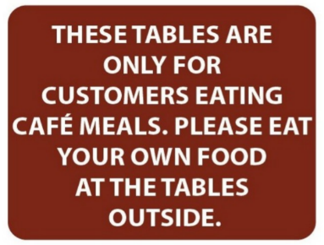 | A. If you want to eat at the tables, you have to bring your own food.  B. You can eat at the café tables if you buy food there.  C. You cannot eat food at the tables outside.  D. The tables outside are for people who don’t eat food
Question 2. What does the notice say?

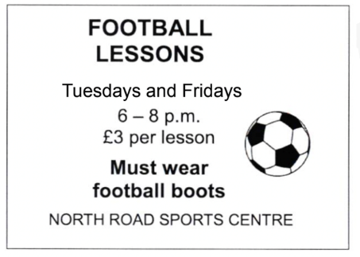 | A. You will have two lessons every week.  B. The football lessons are in the morning  C. The football lessons are free  D. Each lesson last for three hours
 | A. No entering the school.  B. No entry into dangerous areas  C. No fighting at school.  D. No student gatherings allowed.
Question 3. What does the sign say?
Question 4. What does the sign say?
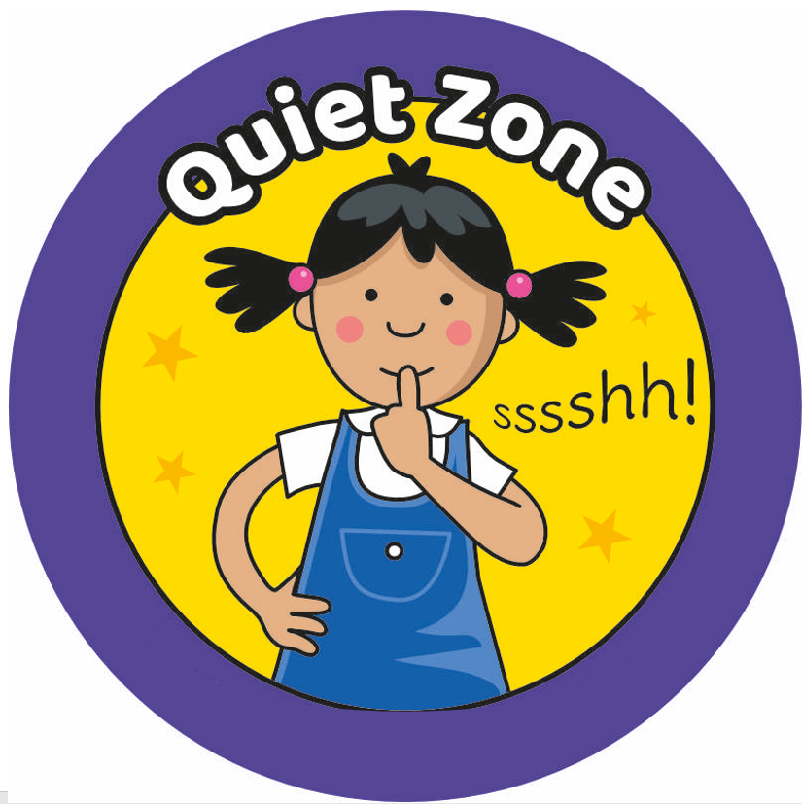 | A. Be loud and talk to your friends.  B. Read aloud to everyone.  C. Be quiet because others are reading.  D. Stop reading and leave the room.
Question 5. What does the sign say?
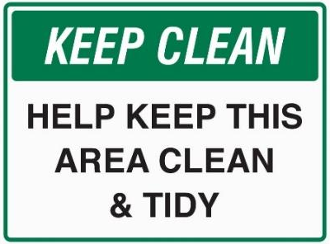 | A. Make the area dirty.  B. Keep the area clean and tidy.  C. Ignore the mess in the area.  D. Throw trash on the ground.

B. CLOZE READING:
Mark the letter A, B, C or D on your answer sheet to indicate the correct option that best fits each of the numbered blanks from 1 to 6.
From: huy@gmail.com
To: harrysmith@gmail.com
Subject: Hi friend!
Hi Harry, Nice to _________ (1)! My name is Huy and I am fifteen years old. I live in Ho Chi Minh City with my parents, and my little sister Hanh. We live in a house on Hung Vuong Street. My house has three bedrooms and a small garden. I live near my school so I walk to school _________(2). I like my school and my ___________ (3) are Math and Science. I also like to work with computers. What about you? What subject do you like at school? My best friends are Nam and Quan and we ______ (4) the same class. After school, I often go to the school canteen with my friends. The canteen has got wi-fi so we can chat with _________ (5) friends while eating or drinking. Then, we usually go home and do our homework. At the weekend, I play sports with my friends. We play football, basketball, and we _______ (6). Write soon and tell me about yourself, your friends and your family.
Best wishes,
Huy
Question 1. A. have you B. see you C. greet you D. meet you
Question 2. A. every day B. often C. always D. usually
Question 3. A. favorite objects B. favored sports C. favorite subjects D. favored objects
Question 4. A. are in B. is on C. are with D. is with
Question 5. A. inline B. offline C. online D. outline
Question 6. A. study Judo B. do Judo C. learn English D. study English

C. MCQS READING:
Read the passage and mark the letter A, B, C or D on your answer sheet to indicate the correct answer to each of the questions below.
SCHOOL CLUBS
We have lots of fun at our school. If you like outdoor activities, the Soccer Club meets at 4 p.m. every Tuesday, with the Tennis Club at the same time on Thursday. For indoor activities, the Board Games Club starts next week. It is popular so please sign up on the noticeboard. The Book Club welcomes anyone who likes reading. You don’t need to sign up but please bring your own copy of The Secret Garden with you to the Library at 4 p.m. on Wednesday. Our Arts and Crafts club is for people who like making things. The cost is $20 per term for materials.
Question 1. What is the main idea of the reading passage?
A. A list of upcoming school exams and events
B. A description of various school clubs and activities
C. A guide to school rules and policies
D. A schedule of sports matches for the school year
Question 2. On which day does the Soccer Club meet?
A. Monday
B. Wednesday
C. Tuesday
D. Thursday
Question 3. The word indoor in the text is OPPOSITE in meaning to _____.
A. inside B. outdoor C. interesting D. boring
Question 4. How much does the Arts and Crafts Club charge for materials per term?
A. $5
B. $15
C. $20
D. $25
Question 5. The word popular in the text is CLOSEST in meaning to _____.
A. new B. well-liked C. boring D. expensive
Question 6. Which of the following types of school clubs is NOT mentioned in the passage?
A. A club focused on physical exercise
B. A club focused on artistic creativity
C. A club for students interested in reading
D. A club for students learning a new language

V.WRITING
A. SENTENCE ORDER:
Four phrases/sentencs have been removed from the text below. Four each question, mark the letter A, B, C or D on your answer sheet to indicate the correct option that best fit each of the numbered blanks from 1 to 4.
Hi, I’m Mary. I’m in the sixth grade. (1)_____________. In the morning, I put on my new uniform and get my new bag.
My best friend and I (2)________________. We are both very nervous and excited. When we get school, we are shown into our classroom with our new teacher. It is quite scary because (3)___________________. Then we go to our first lesson. We have lots of different subjects and the lessons are really fun. My favourite subjects are (4)______________.
I really like my new school, all my teacher are lovely, the lessons are really interesting and I enjoy my first day. I can’t wait to go back tomorrow!
A. walk to school together
B. I don’t know most of the children
C. Today is my first day at secondary school
D. art and English
Question 1.__C__ Question 2. _A__ Question 3._B__ Question 4.__D____
Four phrases/sentences have been removed from the text below. For each question, mark the letter A, B, C, or D on your answer sheet to indicate the correct option that best fits each of the numbered blanks.
Hi, my name is Anna. This is the photo of my family. There are six people in my family: my grandmother, my grandfather, my mother, my father, my elder brother and me. These are my grandparents.(1)___________. They love gardening and doing morning exercise. This is my father. He is forty-one and he is a doctor. He (2) ___________. This is my mother. She is thirty-eight. She is an Art teacher. (3)____________. This is my elder brother. His name is Jack. He is sixteen and he is a high school student. I'm ten and I'm the youngest in my family. Our family lives in a house on Nguyen Hue Street. They are old and (4)_____________. There is a living room, two bedrooms, a bathroom and a kitchen. However, the thing I love most is that the house also has a big garden and a large pond behind it. These are the places where my family likes to relax or fish on weekends.
A. works at a big hospital and helps people
B. The house is small but very nice.
C. enjoy their free time
D. She teaches art to kids at school.
Question 1.___ Question 2.___ Question 3.___ Question 4.___
Keys: 1. C 2. A 3. D 4. B
B. SENTENCE BUILDING:
Mark the letter A, B, C, or D on your answer sheet to indicate the sentence that is made from the given cues in each of the following questions.
Question 1. He / be / do / science / , / and / his children / be / support / him.
A. He be doing science, and his brothers be supporting him.
B. He is doing science, and his children are supporting him.
C. He is doing science, and his children are support him.
D. He are doing science, and his children is supporting him.
Question 2. Everyone / wake / up / the morning / and / walk / school.
A. Everyone wake up in the morning and walk to school
B. Everyone wake up in the morning and walks school
C. Everyone wakes up on the morning and walk to school
D. Everyone wakes up in the morning and walks to school.
Question 3. There/ big/ yard/ front/ our school.
- There is a big yard in front of our school.
B. There are big yards front of our school.
C. There has a big yard in front of our school.
D. There is a big yard front of our school.
Question 4. My English teacher/ smart/ and/ funny/ woman.
- My English teacher is smart and a funny woman.
B. My English teacher is smart and funny woman.
C. My English teacher are a smart and funny woman.
D. My English teacher is a smart and funny woman.
Question 5. Jimmy/ often/ not/ watch/ TV/ evening.
A. Jimmy don’t often watch TV in the evening.
B. Jimmy don’t often watches TV in the evening.
C. Jimmy often doesn’t watch TV in the evening.
D. Jimmy doesn’t often watch TV in the evening.
Question 6. Kate/ read/ books/ at the moment?
A. Kate is reading books at the moment?
B. Does Kate read books at the moment?
C. Is Kate reading books at the moment?
D. Is Kate read books at the moment?
C. SYNONYMOUS SENTENCE:
Choose the correct sentence A, B, C, or D that can be made from the given words.
Question 1. There are about 20 classrooms in my international school.
A. My international school has about 20 classrooms.
B. There are over 20 classrooms in my international school.
C. My international school only has 20 classrooms.
D. My school has many facilities and classrooms.
Question 2. The dishwasher is on the left of the cupboard, and the fridge is on the right.
A. The fridge is under the dishwasher.
B. The cupboard is between the dishwasher and the fridge.
C. The cupboard is on the left of the fridge and the dishwasher.
D. The dishwasher is between the cupboard and the fridge.
Question 3. The room doesn’t have any windows.
A. The room has several windows.
B. There aren’t any windows in the room.
C. The room has one window.
D. There are large windows in the room.
Question 4. His body is strong and sporty.
A. He is not very fit.
B. His body is weak and thin.
C. He has a strong and sporty body.
D. He has a slim figure.
Question 5. She has soft hands and slim fingers.
A. Her hands are rough and thick.
B. She has strong hands and fingers.
C. Her hands are soft, and her fingers are slim.
D. Her fingers are very wide.
Question 6. Let’s clean this messy room.
A. This messy room isn’t clean.
B. How about cleaning this messy room?
C. What about clean this messy room?
D. Why cleaning this messy room?
D. PASSAGE COMPLETION:
Question 1. Put the sentences (a-c) in the correct order, then fill in the blank to make a logical text.
In English, when the school children come to school, they first go to the cloakroom.____.
- Next, when a student is on duty, he comes to school very early.
- He has to open all the windows, water the flowers and clean the blackboard and everything is ready for the first lesson.
- First, they take off their coats and raincoats, their caps and hats, and then go to their classroom.
Question 1. A. b – c – a B. a – c – b C. c – b – a D. c – a – b
Question 2. Choose the sentence that can end the text (in Question 1) most appropriately.
- At seven thirty, the teacher comes into the room and the lesson begins.
- At four o’clock, they come back home.
- I think their school is big.
- They like reading books in the library.

THE END

