UBND QUẬN LONG BIÊN
TRƯỜNG THCS CỰ KHỐI

ĐỀ CƯƠNG ÔN TẬP KIỂM TRA GIỮA KÌ II
Môn: Tiếng Anh – Grade 8
Năm học 2024 – 2025
A. THEORY
Content: From Unit 7 to Unit 9
I. Vocabulary:
- Vocabulary related to the topic of Unit 7: Environmental Protection, Unit 8: Shopping, Unit 9: Natural Disasters.
- Sounds/ stress: /bl/ & /kl/, /sp/ & /st/, stress in words ending in -al and -ous.
II. Grammar:
1. Complex sentences with adverbs clause of time
- Là những mệnh đề bắt đầu bằng các liên từ chỉ thời gian như: when (khi, vào lúc), while, as (trong khi), until, till (cho đến khi), as soon as, once (ngay khi), before (trước khi), after (sau khi), as long as, so long as (chừng nào mà), since (từ khi) …
E.g: As soon as they arrive, we’ll have lunch.
*Lưu ý: Mệnh đề trạng ngữ chỉ thời gian có thể đứng đầu hoặc cuối câu. Nếu mệnh đề trạng ngữ chỉ thời gian đứng ở đầu câu sẽ ngăn cách với mệnh đề chính bằng dấu phẩy.
* Một số từ nối, trang từ trong mệnh đề trạng ngữ chỉ thời gian
a. when
Eg: I was not at home when he came to see me yesterday.
b. while
Eg: is reading a novel while Jack is reading a cartoon.
c. as soon as
Eg: I will clean up the beach as soon as it stops raining.
d. before
Eg: My father taught me how to use the computer before he bought one for me.
e. after
Eg: I went straight to the gym after I left home
f. till/ until
Eg: You can stay here till/ until you find a suitable place to stay.
2. Adverbs of frequency
+ Always /ˈɔːlweɪz/: Luôn luôn  + Usually /ˈjuːʒuəli/: Thường xuyên  + Frequently /ˈfriːkwənsi/: Thường thường  + Often /ˈɒfn/: Thông thường, thường lệ  + Sometimes /ˈsʌmtaɪmz/: Đôi khi, đôi lúc  + Occasionally /əˈkeɪʒnəli/: Thỉnh thoảng  + Seldom /ˈseldəm/: Hiếm khi  + Rarely /ˈreəli/: Hiếm khi  + Never /ˈnevə(r)/: Không bao giờ | 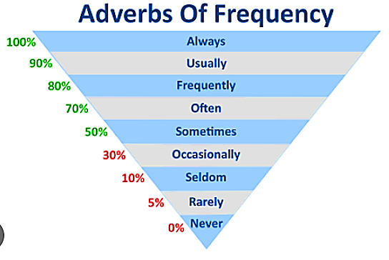

- Trạng từ chỉ tần suất dùng trong câu trả lời câu hỏi “How often…?”

- Vị trí của trạng từ chỉ tần suất khi dùng tiếng Anh:
+ Trạng từ đứng trước động từ thường
Example: My mother often shops at the supermarket. But I don’t go there often.
+ Trạng từ đứng ở sau động từ “tobe”
Example: I am always excited about new things.
3. Present simple for future events
Ngoài cách sử dụng phổ biến, hiện tại đơn còn được sử dụng để diễn tả các sự kiện trong tương lai.
1. Forms
(+) | (-) | (?)
S + V/V-s/es. | S + don’t / doesn’t + V. | Do/Does + S + V?  (+) Yes, S + do / does.  (-) No, S + don’t / doesn’t.
2. Use
Diễn tả sự thật hiển nhiên, chân lý. | The Earth goes around the Sun.
Diễn tả thói quen lặp đi lặp lại. | I get up at 7 a.m. every day.
Diễn tả tương lai khi nói về sự di chuyển của các phương tiện giao thông, lịch trình sự kiện, thời gian biểu rõ ràng. | The trains leave at 5 a.m. tomorrow.
3. Past continuous
a. Cách sử dụng
- Thì quá khứ tiếp diễn dùng để diễn tả 1 hành động đang diễn ra tại một thời điểm xác định trong quá khứ.
E.g. At seven o’clock yesterday, I was studying with my daddy.
- Dùng thì quá khứ tiếp diễn để diễn tả 1 hành động đang diễn ra thì một hành động khác xen vào. Hành động đang diễn ra chúng ta chia ở quá khứ tiếp diễn, hành động xen vào ta chia ở quá khứ đơn. Thường dùng với when/while.
E.g. I was talking to my mom when you called me last night.)
- Thì quá khứ tiếp diễn dùng để diễn tả 2 hành động xảy ra cùng lúc trong quá khứ.
E.g. I was reading my book while my friend was watching TV.
b. Cấu trúc
Khẳng định | S + was/were + V-ing
Phủ định | S + was/ were + not + V-ing
Nghi vấn | Was/ Were + S + V-ing?
E.g. Mark was playing table tennis with his dad at 7 p.m. last night.
Mark wasn’t playing table tennis with his dad at 7 p.m. last night.
Was Mark playing table tennis with his dad at 7 p.m. last night?
c. Dấu hiệu nhận biết
Có thể dễ dàng nhận biết được thì quả khứ tiếp diễn khi trong câu có các trạng từ chỉ thời điểm xác định trong quá khứ.
- At + giờ chính xác + thời gian ở quá khứ (At 8 a.m. yesterday)
- At + this time + thời gian ở quá khứ (At this time three months ago,...)
- In + năm xác định (in 2004, in 2002)
- In the past (trong quá khứ)
B. TYPES OF EXERCISE
1. Listening (Unit 7-Unit 9: Getting started/ Skills 2)
2. Pronunciation – Sound– Stress:
3. Choose the best answer - Vocabulary- Grammar- Everyday English
4. Writing (Structure, grammar)
- Complete the announcement.
- Rearrange sentences to make a complete paragraph.
- Complete the text.
- Choose the correct sentences by using given words.
- Choose similar sentences in meaning
5. Reading
- Read the sign/ notice: 4 sign/ 4 notice
- Read comprehension:
- Match four phrases/sentences to make completed text:
C. PRACTICE
I. PRONUNCIATION
Exercise 1. Mark the letter A, B, C or D to indicate the word whose underlined part differs from the others.
1. A. mud B. numerous C. thunderstorm D. suddenly
2. A. excitement B. item C. expire D. assistant
3. A. earthquake B. breath C. thanks D. breathe
4. A. brand B. advantage C. wander D. access
5. A. consume B. conserve C. resident D. source
Exercise 2. Mark the letter A, B, C or D that differs from the other three in the position of primary stress.
1. A. mission B. protect C. substance D. plastic
2. A. speciality B. economics C. shopaholic D. convenience
3. A. national B. physical C. arrival D. natural
4. A. litter B. mountainous C. worker D. volcanic
5. A. decorate B. volunteer C. customer D. exercise
II. VOCABULARY, GRAMMAR AND COMMUNICATION
Exercise 3. Mark the letter A, B, C, or D to indicate the correct answer to each of the following questions.
1. VOCABULARY
1. Awareness of environmental damage from ______________ bags is growing.
A. simple-use B. single-uses C. single-use D. single-used
2. This forest provides a habitat for hundreds of __________ of plants and animals.
A. styles B. species C. families D. collections
3. The field trip to Con Dao National Park aims to ___________ the awareness of local students about environmental protection.
A. contain B. rise C. cover D. raise
4. My mother is very good at ___________, so she can purchase goods at cheaper prices.
A. talking B. reducing C. bargaining D. selling
5. My father ___________ throws away rubbish in public. He’s very responsible.
A. often B. sometimes C. always D. never
6. Shopping centres attract lots of __________ during the sales season.
A. customers B. habitats C. products D. disasters
7. The flood victims are collecting their personal ___________.
A. thing B. property C. proper D. belonging
8. It would be very hard to ___________ a natural disaster without the help of advanced technology.
A. foretell B. predict C. imagine D. concentrate
9. When she was playing on the beach, she saw the ocean drain away suddenly causing her to think of an imminent __________.
A. tornado B. earthquake C. tsunami D. volcanic eruption
10. The local authorities are providing support and assistance to the victims of the _____disaster.
A. nature B. natural C. naturation D. naturalization
2. GRAMMAR
1. There were bumpy roads ___________ I came back to my hometown.
A. when B. while C. as soon as D. so
2. We should recycle single-use products instead __________ throwing them away.
A. on B. to C. of D. in
3. As soon as Peter gathers enough information about the protection of endangered species, he ___________ doing his wildlife project.
A. started B. start C. starts D. will start
4. The speciality shop is famous for its scented candles, ___________ many foreign tourists often drop by there to get some.
A. because of B. so that C. because D. so
5. Hoa __________ for her mother.
A. rarely cooks B. cooks rarely C. rarely cook D. cook rarely
6. __________ borrow books from the school library?
A. Will you often B. Do often you C. Will often you D. Do you often
7. Listen to the announcement. The train __________ till 12:00.
A. leaves B. left C. won’t leave D. doesn’t leave
8. Nga was watching TV while her sister __________ the piano.
A. is playing B. was playing C. will play D. plays
9. There __________ only a few houses left standing after the tornado hit.
A. was B. is C. were D. be
10. __________ kites in the park at 5 o’clock yesterday afternoon?
A. Were you flying B. Are you flying C. Did you fly D. Will you fly
3. EVERYDAY ENGLISH
1. Julie and Mana are in their class.
Julie: "A big earthquake hit Istanbul yesterday and destroyed many buildings."
Mana: " _________ "
A. That's terrible. You shouldn't go out. B. I'm sorry to hear about your situation.
C. That's awful. I hope everybody there is safe. D. I'm happy to hear about his success.
2. Jack and Khanh are at supermarket.
Jack: “All items in the supermarket have prices on their price tag.” - Khanh: “________”
A. No, I can’t find the item I want. B. Yes, I like bargaining.
C. Can I have a discount for this item? D. Right. It’s convenient for customers.
3. Lam is calling for the shop she ordered.
-Lam: “___________” – Staff: “Well, let me check it. Could you tell me the order number?”
A. I’m calling to ask for the shirt I bought from your store last week.
B. Do you like the shirt I gave you on your birthday?
C. How much did you pay for this beautiful shirt?
D. Do you have a bigger size for this shirt?
4. The foreigner is walking and having a talk with Mai.
- Foreigner: "Can you show me the way to the nearest Internet café?” - Mai:''_____."
A. Yes, it's quite near here. B. Turn left and then turn right.
C. Three kilometers from here. D. It's very far.
5. Linda and Tom are talking in Linda’s kitchen.
Linda: Try our home-made bread, Tom. Tom: “________.”
A. The bread at the bakery is fresh. B. Wow, did you make it yourself?
C. What will you do next? D. Is it fresh?
III. WRITING
Exercise 4. Read the following announcement and mark the letter A, B, C, or D on your answer sheet to indicate the correct option that best fits each of the numbered blanks.
ANNOUNCEMENT 1. What to do after the super typhoon Yagi
1. Don't leave shelters until informed by the authorities or rescue workers.
2. Make sure your loved ones are fine; check to see if there is (1) _____ damage.
3. Be alert for high water in areas where rivers may cause (2)________ due to heavy rains.
4. Check the area around the house. Remove (3)________ trees and plants.
5. Don't try to fix any water-damaged electronics or plug them into a socket.
6. Don't touch the loose and dangling wire (4)________ lamp posts: it may have electric current.
Question 1. A. any B. no C. every D. few
Question 2. A. drought B. storm C. earthquake D. flooding
Question 3. A. break B. breaking C. broken D. breaks
Question 4. A. with B. from C. inside D. under

ANNOUNCEMENT 2. What to do during a school trip to a beach or near water
1. Always stay with your group and do not go into the water alone.
2. Listen to the lifeguard's (1) _____ and obey all warning flags/ signs.
3. If caught in a rip current, swim parallel to the shore to escape, then swim back to the shore at (2)_____ angle.
4. Stay (3)_______ from dangerous areas, like rocks or piers, where the waves can be strong.
5. If you see someone in distress, do not attempt to rescue them - (4) _____ for help from a lifeguard or an adult.
Question 1. A. voices B. instructions C. speeches D. talks
Question 2. A. an B. a C. the D. ∅
Question 3. A. with B. without C. against D. away
Question 4. A. carry B. hand C. call D. find

ANNOUNCEMENT 3. What to do in case of a fire at school
1. Evacuate the building by the nearest or exit if possible. Do not use elevators during an evacuation!
2. (1) ______ calm and listen to the teacher's instructions.
3. Do not stop to collect personal belongings.
4. Stay low to avoid smoke and cover your nose and mouth (2) ______ needed.
5. Do not re-enter the building until you are informed that it is safe to (3) ______ .
6. If your clothes catch fire, stop, drop on the (4) ______, and roll. Keep rolling until the flames are gone.
Question 1. A. Stay B. Stand C. Come D. Wait
Question 2. A. because B. unless C. if D. but
Question 3. A. returning B. returns C. return D. to return
Question 4. A. earth B. soil C. land D. ground
Exercise 5. Mark the letter A, B, C, or D on your answer sheet to indicate the correct answer to each of the following questions.
Set 1.
Question 31. Put the sentences (a - c) in the correct order. Then fill in the blank to make a logical text.
Our trip to the mountains was something we planned for months. Everything went smoothly at first, but then we faced some unexpected problems. ______
a. After finding our way back, we returned, only to find that one of our tents collapsed.
b. While hiking, we accidentally took the wrong trail and ended up far from our campsite.
c. We fixed the tent together, laughing through it all, turning the challenges into cherished memories.
A. c-b-a B. a-b-c C. b-a-c D. a-c-b
Question 2. Choose the sentence that can end the text (in Question 1) most appropriately.
A. In the end, the trip was still an unforgettable experience for all of us.
B. Unfortunately, the whole trip was a disaster, and we had to return early.
C. To begin with; we decided not to return to that place for our next trip.
D. Finally, we gave up trying to enjoy the rest of the trip because we were too disappointed.

Set 2.
Question 1. Put the sentences (a - c) in the correct order. Then fill in the blank to make a logical text.
An avocado starts its life cycle as a seed. When planted, the seed starts to grow in about 4-8 weeks. ______
a. Eventually, the avocado plant produces flowers, and finally fruit after 4-5 years.
b. The seed splits, allowing a root to grow down and a sprout to grow up.
c. As the sprout grows leaves, it becomes a seedling and then continues to grow into an avocado plant.
A. a-b-c B. c-a-b C. a-c-b D. c-b-a
Question 2. Choose the sentence that can end the text (in question 1) most appropriately.
A. Inside each avocado fruit is another seed - ready to start its own life cycle.
B. Children should have a healthy diet with plenty of fruit and vegetables.
C. Avocados are not only delicious but also very healthy for young children.
D. Planting trees is both fun for kids and necessary for the environment.
Set 3.
Question 1. Put the sentences (a - c) in the correct order. Then fill in the blank to make a logical text.
This year, I decided to join the school's photography club. I've always been interested in taking pictures, but I didn't know much about it. _____
a. We even went on a short walk around the school to practice taking photos.
b. At the first meeting, the club members were very welcoming and showed me how to use a professional camera.
c. I was amazed at how much I learned at the end of the session.
A. a-b-c B. b-c-a C. a-c-b D. b-a-c
Question 2. Choose the sentence that can end the text (in question 1) most appropriately.
A. Now I realise that I shouldn't have attended the meeting.
B. The next meeting will be crucial for us to finalise our project details.
C. Now, I can't wait to attend the next meeting and improve my skills even more.
D. I couldn't wait for the meeting to end so I could finally relax and enjoy my evening.

Exercise 6. Mark the letter A, B, C, or D on your answer sheet to indicate the correct option that best fits each of the numbered blanks from
- Paragraph 1.
The most important (1)_________ that influences a person to go shopping is the needs or wants of the individual or people related (2) __________ him/ her. For example, everyone goes to the mall to buy basic necessities like food, clothes, health supplies and others. Irrespective of the age being 16 or 60, the person will have to go to the shop or buy it only. They will ship less if they have (3)__________ mouth to feed and shop more if (4)_____________is less. Secondly, a person cannot purchase anything (5)__________ she has the monetary means to do so. This means that if one has more money, one will spend equally on luxury items and fundamental needs. On the other hand, a person with less (6)__________ will focus more on vital merchandise.
Question 1. A. effect B. factor C. reaction D. person
Question 2. A. to B. with C. about D. within
Question 3. A. less B. more C. much D. many
Question 4. A. a number of dependents B. the of number dependents
C. the number of dependents D. the dependents of number
Question 5. A. when B. if C. unless D. whether
Question 6. A. finance stability B. financial stability
C. financially stability D. stability finance

Paragraph 2.
Have a walk on a beach, listen to the sound of the sea waves, (1)________ suddenly you see a lot of rubbish on the beach. Pollution takes away (2)_________ our beaches. I feel really annoyed when I see plastic bags lying on the sand, cigarette ends buried in the sand, and soda cans floating in the sea.
There are a lot of things that we can do. (3)__________ we see rubbish, we should do our part in the protecting the land by picking it up and throwing it (4)__________ dust bins. Moreover, we can form some kind of organzation that helps (5)___________ the beaches. If everyone does their part, the beaches will be a wonderful and beautiful place. We need to start now (6)_________ the beaches are damaged beyond repair.
Question 1. A. or B. but C. and D. so
Question 2. A. all the beauty B. all the beautiful
C. the beauty all D. the all beautiful
Question 3. A. While B. If C. Unless D. Soon
Question 4. A. on B. in C. forward D. up
Question 5. A. cleaning up B. clean up C. clean of D. clean off
Question 6. A. direct B. direction C. directly D. directing

c. Text 3.
Tornadoes are storms with very (1)_______ turning winds and dark clouds. These winds are perhaps the strongest (2) ______ They reach speeds of 300 miles per hour. The dark clouds are shaped like a funnel - wide at the top and narrow at the bottom. The winds are strongest in (3)________ centre of tunnel. Tornadoes are especially common in the US, but only in certain parts. They (4)_______ in the central.
A hot afternoon in the spring is the most likely time for a tornado. (5)_______ become dark. There is thunder, lightning and rain. A cloud forms a funnel and begins to twist. The funnel moves faster and faster. The faster the winds, the louder the noise. Tornadoes always move in a northeastern (6)_________. They never last longer than eight hours.
Question 1. A. angry B. weak C. cruel D. strong
Question 2. A. in space B. on earth C. underground D. in a planet
Question 3. A. the B. that C. this D. a
Question 4. A. mainly to occur B. mainly occuring C. occur mainly D. occurs main
Question 5. A. sun B. sky C. clouds D. winds
Question 6. A. direct B. direction C. directly D. directing
Exercise 7. Mark the letter A, B, C, or D that is closest in meaning to the original sentence in each of the following questions.
Question 1: If we want to save the environment, we need to stop using so much energy.
A. Using so much energy, we want to save the environment
B. We need to stop using so much energy when we can save the environment
C. We want to save the environment if we need to stop using so much energy
D. We won't save the environment unless we stop using so much energy.
Question 2: It was not until midnight that Mike stopped practising.
A. Mike stopped practising before it was midnight.
B. Mike only stopped practising before midnight.
C. Mike stopped practising after midnight.
D. I wanted Mike to stop practising before midnight.
Question 3: I like spending time with my sister over the weekend to browse instead of buying.
A. I enjoy getting out with my sister on the weekends to browse and buy.
B. I prefer getting out with my sister on the weekends to buy something.
C. I'm interested in spending time with my sister to browse.
D. On the weekends, I like to spend time with my sister browsing instead of making purchases.
Question 4: Due to the supermarket's set prices, I am unable to bargain there.
A. Because the fixed prices at supermarkets. I can never haggle there.
B. Since grocery pricing are set, I can never haggle there.
C. I can never bargain at a supermarket because the prices is fixed.
D. Since grocery pricing are fixed, I never can haggle there.
Question 5: At 8 pm yesterday, I was drawing pictures in my room and Lan was watching her films
A. When I was drawing pictures in my room, Lan watched her films at 8 pm yesterday.
B. While I was drawing pictures in my room, Lan was watching her films at 8 pm yesterday.
C. At 8 pm yesterday, I drew pictures in my room and Lan watched her films.
D. I drew pictures in my room while Lan was watching her films at 8 pm yesterday.
Exercise 8. Mark the letter A, B, C, or D on your answer sheet to indicate the sentence that is made from the given cues in each of the following questions.
Question 1. While she / water / flowers / her garden / start / rain.
A. While she was watering the flowers in her garden, it started to rain.
B. While she watered flowers in her garden, it started to be raining.
C. While she is watering the flowers in her garden, it started to rain.
D. While she watered the flowers in her garden, it was starting to rain.
Question 2. Question 27: They/ often/ spend/ hours/ bargain/ shop/for discounts.
A. They often spend hours to bargain and shopping for discounts
B. They often spend hours bargaining and shopping for discounts
C. They often spend hours to bargain and shop for discounts
D. They often spend hours bargain and shop for discounts.
Question 3. Scientist / can predict / many I the disasters / ahead / time.
A. Scientist can predict many of the disasters ahead of time.
B. Scientists can predict many the disasters ahead of time.
C. Scientists can predict many of the disasters ahead time.
D. Scientists can predict many of the disasters ahead of time.
Question 4: Endangered animals/ wild/face/ risk/ extinction.
A. Endangered animals in the wild face risking of extinction.
B. Endangered animals in the wild are facing a high risk of extinction.
C. Endangered animals in the wild faces risk of extinction.
D. Endangered animals from the wild are facing a risk of extinction.
Question 5: 1/ call/ you/ as soon as/ I/ arrive/ airport.
A. I call you as soon as I arrive at the airport.
B. I will call you as soon as I will arrive at the airport.
C. I will call you as soon as I arrive at the airport.
D. I would call you as soon as I arrive at the airport.
IV. READING.
Exercise 9. Read the following sign or notice and mark the letter A, B, C, or D on your answer sheet to indicate the correct answer to each of the following questions.
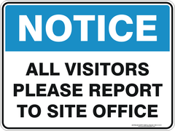 | Question 1: What does the notice say?  A. If you want to visit, you have to inform the school.  B. Visitors must write a report to the school office.  C. Everyone can visit the school office.  D. All visitors are free to come to school office.
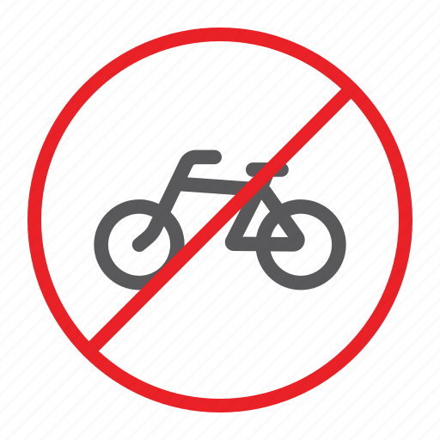 | Question 2. What does the sign say?  A. You can ride your bicycle here.  B. You can ride your bicycle by yourself.  C. Only bicycles can be used here.  D. Riding bicycles is forbidden here.
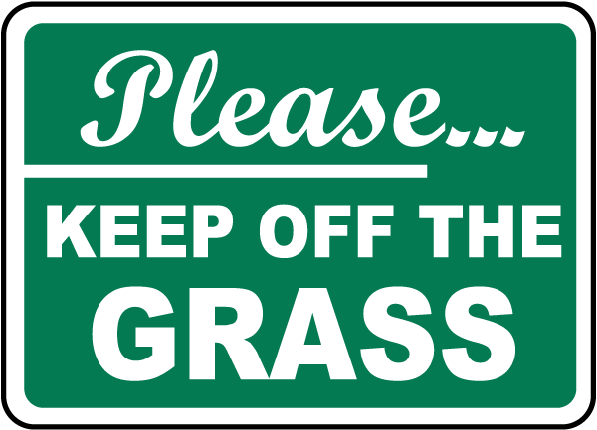 | Question 3: What does the notice say?  A. You must keep walking on the grass.  B. You may walk on the grass.  C. The grass is for you to keep.  D. You can't walk on the grass.
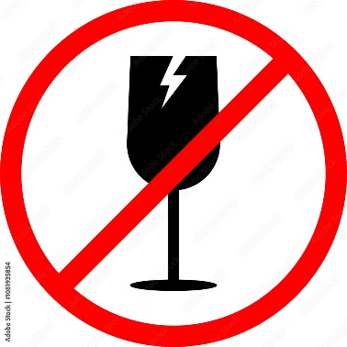 | Question 4. What does the sign say?  A. Glasses for water.  B. Glasses for wine.  C. Easily broken items.  D. Drinking items for sale.
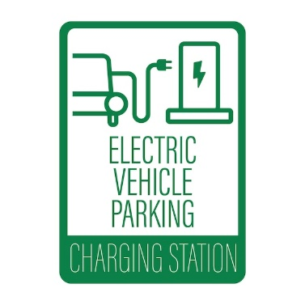 | Question 5: What does the notice say?  A. This car is broken by electricity.  B. There is no electricity for your cars.  C. You can charge your electric cars here.  D. You can't charge your electric cars at home.
The Science Club is open from 2 p.m. to 5 p.m. to students with membership cards. | Question 6: What does the notice say?  A. You can get your membership cards from 2 p.m.to 5 p.m.  B. Only members can visit the Science Club from 2 p.m. to 5 p.m.  C. All students can visit the Science Club from 2 p.m. to 5 p.m.  D. Membership cards are not for all students.
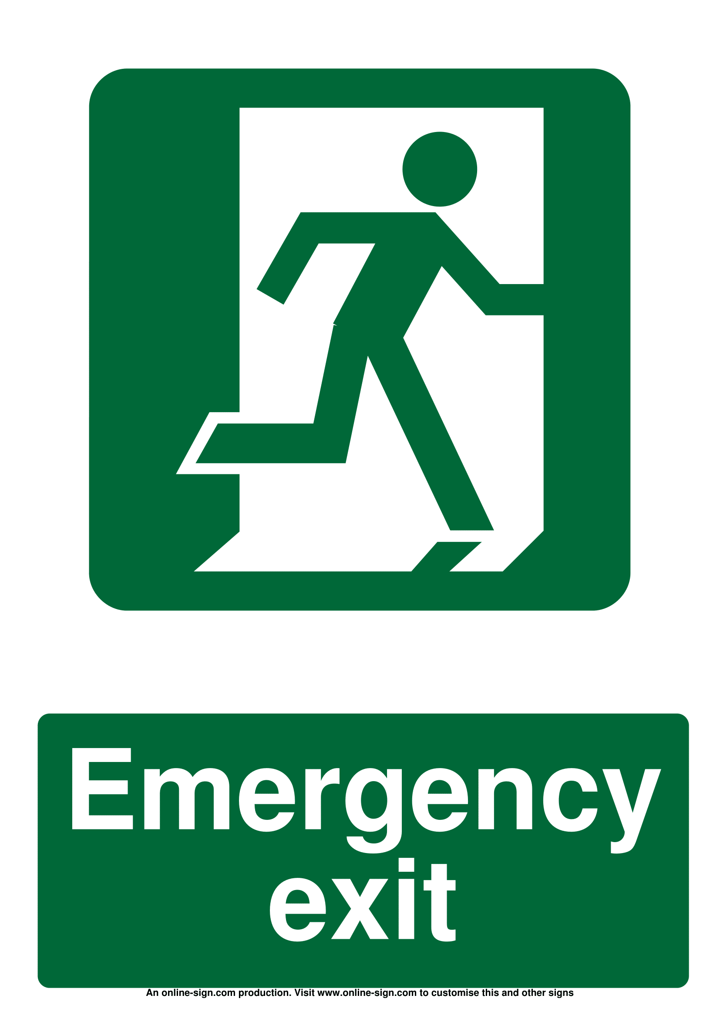 | Question 7. What does the sign say?  A. You can't escape by the exit.  B. Go this way in case of emergency.  C. Don't run through the emergency exit.  D. There is no "Emergency exit" sign.
HOA MAI SCHOOL  cycling and scooter allowed, but students may not use skateboards to get to school | Question 8: What does the notice say?  A. Students are allowed to ride bikes and scooters but not skateboards.  B. Students can use skateboards but must avoid bikes and scooters.  C. All forms of transportation, including skateboards, are allowed.  D. Bicycles, scooters, and skateboards are completely prohibited on campus.

Exercise 10. Read the following passage and mark the letter A, B, C, or D on your answer sheet to indicate the correct answer to each of the following questions.
- Text 1.
Shopping is an enjoyable activity for many people around the world. It involves buying items we need or want, such as food, clothes, and gifts. There are different places to shop, like supermarkets, shopping malls, and local markets. In supermarkets, you can find fresh fruits, vegetables, and everyday items. Shopping malls often have many stores, where you can buy many things such as clothes, shoes, and electronics. Local markets are great for finding unique products and supporting local sellers. Shopping can also be a social activity: friends and family often go together to have fun and share opinions. Many people enjoy looking for good deals and discounts. Nowadays, online shopping is becoming more and more popular, allowing people to buy items from home. You can browse many products and read reviews before making a purchase. However, it is important to be careful when shopping online and to buy from trusted websites. Overall, shopping is not just about buying things; it can also be a way to explore new places and spend time with loved ones.

Question 1. What is the main idea of the reading passage?
A. Shopping is an everyday life activity only for rich people.
B. Shopping is an enjoyable activity involving buying items we need.
C. Shopping is not popular in many countries.
D. Shopping only happens in towns and big cities.
Question 2. The word supporting in the passage is CLOSEST in meaning to _____.
A. involving B. sharing C. helping D. exploring
Question 3. What do people often enjoy while shopping?
A. Buying only expensive items B. Shopping by themselves all the time
C. Looking for good items at low prices D. Looking for good deals and discounts
Question 4. Why is online shopping becoming more and more popular?
A. It allows people to buy items from home. B. The items are always less expensive.
C. It has more products to choose from. D. It doesn't always require a lot of travel.
Question 5. Which of the following statements is true?
A. Online shopping is more popular than shopping in stores.
B. Local markets help support local sellers.
C. Supermarkets generally do not sell food.
D. Shopping malls only sell fresh food and electronics.
Question 6. The word Overall in the last sentence is used to _____.
A. introduce a new idea B. make a comparison
C. give a different view D. include everything in total
b. Text 2.
Our planet is home to some of the most remarkable natural wonders - from towering mountains and green rainforests to unspoiled beaches and serene lakes. These magnificent landscapes not only captivate our senses but also play a crucial role in maintaining the delicate balance of our ecosystems. However, in recent decades, many of these natural treasures have faced increasing threats from human activities, such as pollution, deforestation, and unsustainable development.
It is our responsibility as stewards of the Earth to protect and preserve these natural wonders for generations to come. By adopting eco-friendly practices in our daily lives, we can help reduce our environmental impact and safeguard the habitats that sustain diverse plant and animal species. This can include simple steps like recycling, conserving water, and reducing our carbon footprint.
Moreover, supporting conservation efforts and eco-tourism programmes can also contribute to the protection of these natural landscapes. When we choose to explore and experience these wonders responsibly, we can not only appreciate their beauty but also contribute to their long-term preservation.
Ultimately, the preservation of our natural wonders is not just about protecting the environment; it's about preserving the awe-inspiring beauty that inspires us, connects us to the natural world, and reminds us of the fragility and important of our planet. By taking action and embracing sustainable practices, we can ensure that these natural treasures continue to fascinate and inspire future generations.
Question 1. The word crucial in paragraph 1 is CLOSEST in meaning to _____.
A. beautiful B. peaceful C. natural D. important
Question 2. What are the main threats to natural wonders?
A. Natural disasters and climate change
B. Pollution, deforestation, and unsustainable development
C. Overpopulation and urbanization
D. Lack of government regulations and funding
Question 3. To help preserve the natural wonders, individuals can _____.
A. increase pollution, deforestation, and unsustainable development
B. explore and experience the word's natural wonders
C. recycle, conserve water, and reduce carbon footprint
D. appreciate the beauty of the Earth and connects US to the world
Question 4. What does paragraph 4 imply?
A. Protecting the environment is not the only goal of preservation.
B. Preservation reminds us of the durability and perseverance of our planet.
C. Preservation is an expensive and long-term process.
D. The awe-inspiring beauty of natural wonders inspires us to preserve them.
Question 5. The word fragility in paragraph 4 is OPPOSITE in meaning to _____.
A. weakness B. concern C. strength D. beauty
Question 6. Which is probably the best title for this passage?
A. Natural Wonders of the Earth B. Preserving Our Natural Wonders
C. Threats to Our Natural Wonders D. How We Impact Natural Wonders

c. Text 3.
Two of the most dangerous storms which affect America are hurricanes and tornadoes. They are very much feared by anyone who may live in the path of their destruction.
Every year homes are destroyed by their fury and often lives arc lost. Most people who live near the coast are forced to evacuate their homes and to move to safer areas until the storm passes. Floods are caused along the coast by both the heavy rain and a storm tide that is considerably above normal water level. The high winds, coastal flooding and heavy rains associated with a hurricane cause enormous damage.
Hurricanes usually develop between July and October. Once they hit land, they carry tremendous power with driving rain and wind.
Tornadoes are violent low-pressure storms. These storms occur most often during the summer months and are noticeable by their strong wind and lack of rain. The sky turns black as dust is sucked up into the air. Tornadoes are capable of lifting quite heavy objects from the ground. They can pick up trees and cars right into the air and even uplift heavier objects such as homes and railway cars. Both hurricanes and tornadoes cause millions of dollars worth of damage to life and property every year. Today they can be predicted more easily than in the past, but they cannot be stopped or ignored.
Question 1. What are two of the most dangerous storms which affect America?
A. Hurricanes and tornadoes. B. Typhoons and thunderstorms.
C. Thunderstorms and hurricanes. D. Hurricanes and typhoons.
Question 2. At which part of the year do hurricanes usually develop?
A. July and August only. B. All year round.
C. From the seventh to the ninth month. D. Between July and October.
Question 3. What is the major similarity of both a hurricane and a tornado?
A. They cover only a small area. B. They can cause great damage.
C. They are not accompanied by rain. D. They have either wind or speed.
Question 4. Which of the following is true of tornadoes and hurricanes?
A. They cannot be predicted with accuracy.
B. They are easier to control today than in the past.
C. They can be predicted today with greater accuracy.
D. They cannot be predicted today with greater accuracy.
Question 5. Which of the following was not mentioned in the article?
A. The number of people killed each year by these storms.
B. The tremendous power killed each year by these storms.
C. The damage caused by hurricanes and tornadoes.
D. The time of year when they are most likely to strike.
Exercise 11. Four phrases/sentences have been removed from the text below. For each question, mark the letter A, B, C, or D on your answer sheet to indicate the correct option that best fits each of the numbered blanks.
- Text 1
Pollution is a serious problem that affects our environment and health. It occurs when harmful substances, (1) ______, are released into the air, water, and soil. There are different types of pollution, including air pollution, water pollution, and land pollution.
Air pollution is caused by emissions from factories, vehicles, and burning fossil fuels like coal and oil. (2) ______. Water pollution happens when chemicals, plastics, and waste are dumped into rivers, lakes, and oceans. This can harm fish, plants, and animals that live in the water. Land pollution occurs when trash, chemicals, and industrial waste are dumped on the ground, (3) ______to plants and animals.
Pollution not only affects nature but also harms humans. It can cause health problems such as lung disease, heart disease, and even cancer. (4) ______. Everyone can play a part in keeping our environment clean and safe for future generations.
A. making the soil toxic and harmful
B. like chemicals, smoke, and waste
C. To reduce pollution, we can recycle, use less plastic, drive less, and support clean energy sources
D. It makes the air dirty and can lead to breathing problems
Question 1. ______ Question 2. _____
Question 3. ______ Question 4. _____

- Text 2.
One type of natural disaster that can be mitigated is flooding. Floods often occur after heavy rain or when rivers overflow. To reduce the impact of floods, many countries build levees and dams. (1)______ that help keep water away from homes and roads. Dams are large structures that hold back water in rivers, allowing it to be released slowly. (2) ______. These systems help water flow away quickly from streets and buildings, preventing water from gathering. Communities also prepare for floods (3) ______. These plans tell people what to do and where to go if a flood happens. Education is also key; teaching people about flood risks and safety can save lives. (4) ______. Mitigating the effects of flooding requires cooperation between governments, communities, and individuals to protect lives and property.
A. By using these methods, we can reduce the damage caused by floods and keep people safe
B. Another important measure is creating drainage systems
C. Levees are walls made of earth or concrete
D. by creating emergency plans and warning systems
Question 1. _____ Question 2. ____ Question 3. ____ Question 4. _____

- Text 3.
Shopping can sometimes be a challenging experience, (1)______ Many people choose to give gift vouchers, allowing recipients to shop at their convenience. (2)________ , as it lets them purchase essential or luxury items from home or while on the go. Deliveries are often free, and prices are usually lower than those in physical stores. However, the description or quality of online products may differ from expectations, (3)___________. For in-store shopping, self-service payment machines are commonly used to save time by avoiding long queues, (4)_________.

A - especially when selecting gifts for others on special occasions
B - Online shopping is a popular choice for those with busy schedules
C - but they can cause frustration when technical issues arise and assistance is unavailable
D - leading to disappointment and the need to return items at the customer's expense

Question 1. _____ Question 2 _____ Question 3. _____ Question 4. _____

The end
BGH duyệt Tổ / Nhóm trưởng CM duyệt Người lập

Đỗ Thị Thu Hương Nguyễn Thị Lan Hương Đào Thị Ngọc Bích

