PEOPLE COMMITTEE OF BO DE WARD  AI MO SECONDARY SCHOOL  ------------------  (The test consists of 04 pages) | THE FIRST MID TERM TEST  SUBJECT: ENGLISH 7  School year 2025-2026  (Time allowed: 60 minutes)
Full name: ............................................................................ |  | Class: ............. | CODE 701
Listen and decide whether the statements below are true (T) or false (F)
Question 1. There are four different age groups that play water polo.
A. True B. False
Question 2. Water polo matches are played on Saturdays.
A. True B. False
Question 3. You need to bring a visa to register at the swimming pool.
A. True B. False
Listen again and mark the letter A, B, C, or D to indicate the correct answer to each of the following questions.
Question 4. Tyrone wants to join the under __________ club.
A. 14s B. 20s C. 12s D. 16s
Question 5. The training starts next week on __________.
A. September 2nd B. November 2nd C. September 4th D. October 2nd
Question 6. You need to bring __________ to join the under 18s club.
A. a phone B. a birth certificate
C. a photograph D. a passport

Mark the letter A, B, C, or D in your answer sheet to indicate the sentences that is made from the given cues in each of the following questions.
Question 7. My mother/ keen/ read/ books.
A. My mother keen reading books.
B. My mother is keen on reading books.
C. My mother is keen for reading books.
D. My mother keens reading books.
Question 8. My teeth/ hurt/ make/ appointment/ the dentist/
A. My teeth hurt, so I make an appointment with the dentist.
B. My teeth hurt, so I made an appointment with the dentist
C. My teeth hurt and I made an appointment with the dentist
D. My teeth hurts, but I make an appointment with the dentist.

Read the following passage and mark the letter A, B, C or D on your answer sheet to indicate the correct answer to each of the following questions.
Healthy living is about making good choices every day to keep your body and mind healthy. A balanced diet is important for staying strong and full of energy. This means eating a variety of foods like fruits, vegetables, whole grains, and lean proteins such as chicken, fish, or beans. Drinking enough water is also very important to keep your body hydrated.
Regular exercise is another key part of a healthy lifestyle. Simple activities like walking, jogging, or riding a bike help your body stay fit and keep your heart healthy. It's a good idea to exercise for at least 30 minutes every day.
Getting enough sleep is also very important. Sleep allows your body to rest and recover, so you wake up feeling fresh and ready for the day. Adults should try to get 7-9 hours of sleep each night.
Managing stress is also important for staying healthy. Relaxation activities like meditation, deep breathing, or spending time with family can help reduce stress. Avoiding bad habits like smoking and drinking too much alcohol is key to staying healthy in the long term. By making these simple choices, you can improve your health, feel better, and live a longer, happier life.
Question 9. What type of proteins are recommended in a balanced diet?
A. Lean proteins like chicken and fish B. Sugary snacks
C. Processed meats D. High-fat cheeses
Question 10. What is the main idea of the passage?
A. Healthy living requires daily good choices.
B. Diet is more important than exercise.
C. Stress management is optional.
D. Sleep is the key to happiness.
Question 11. What is the closest meaning of "managing" in the context of stress?
A. Avoiding B. Ignoring C. Increasing D. Controlling
Question 12. How many hours of sleep should adults aim for each night?
A. 4-5 hours B. 10-12 hours C. 5-6 hours D. 7-9 hours

Mark the letter A, B, C, or D in your answer sheet to indicate the sentences that is closest in meaning to the original sentence in each of the following questions.
Question 13. You should go jogging because it makes you strong and reduce stress.
A. It is good to goes jogging because it makes you strong and reduce stress.
B. It is good to go jogging because it makes you strong and reduces stress.
C. It is good to go jogging because it make you strong and reduce stress.
D. It is good to going jogging because it makes you strong and reduce stress.
Question 14. My sister doesn’t have enough money, but she buys a lot of clothes.
A. Although my sister doesn’t have enough money, she buys a lot of clothes.
B. Although my sister don’t have enough money, she buys a lot of clothes.
C. Although my sister has not enough money, she buy a lot of clothes.
D. Although my sister has enough money, she buys a lot of clothes.

Read the following announcement and mark the letter A, B, C or D on your answer sheet to indicate the correct option that best fit each of the numbered blanks.
TRAVEL TIPS
- Be fond (15) ______ planning your trips in advance to avoid last-minute stress.
- Some travelers find reading books (16)______, so bring a good book for long flights.
- Pack light (17)______ carrying too much luggage can make traveling harder.
- Take photos and create memories to share with (18)_______ friends and family.
Question 15. A. in B. of C. on D. at
Question 16. A. to interesting B. was interesting C. is interesting D. interesting
Question 17. A. and B. so C. because D. but
Question 18. A. yourself B. yours C. you D. your

Mark the letter A, B, C or D on your answer sheet to indicate the correct option that best fits each of the numbered blanks.
A Grade 7 student and his friends have an idea of collecting books for homeless children in his town. (19) _____________. Everyone who comes to the party should bring some healthy food, drink, and a book in any kinds: storybook, textbook, notebook, comic, etc. Those who cannot bring books will help with the collecting and sending books to the homeless children. They believe that the healthy food and drink will help them stay healthy and the books will help homeless children with their study.
Question 19. Put the sentence (a-c) in the correct order, then fill in the blank to make a logical text
a. It is just a simple party.
b. Every month they will select a birthday of a friend in his class or a child in his neighborhood to celebrate a special birthday party.
c. They call it the “Book Birthday Party”.
A. a-b-c B. b-a-c C. a-c-b D. c-b-a
Question 20. Choose the sentence that can end the text (in Question 19) most appropriately.
A. Everyone will be happy
B. My grandma says she likes reading books.
C. So, Do you have any special skill?
D. What will you do next year?

Read the following passage and mark the letter A, B, C or D to choose the word or phrase that best fits each of the following questions.
Breakfast is the (21) _____ meal of the day. It (22)____ the nutrients your body needs for good health, the calories it needs for energy and helps to maintain your blood sugar level. Studies have shown that people who don’t have breakfast have a low blood sugar level and are often slow, tired, hungry and unable to concentrate. Surprisingly, breakfast actually plays a part in weight control. It's easier to (23) ____weight if you eat in the morning rather than later in the day. Dividing the day’s calories (24) _____three meals helps take off weight more efficiently than skipping breakfast and having two larger meals a day does.
Question 21. A. the more important B. more important
C. most important D. more importanter
Question 22. A. providing B. providings C. provide D. provides
Question 23. A. gain B. lose C. drop D. put
Question 24. A. into B. for C. up D. in

Mark the letter A, B, C, or D on your answer sheet to indicate the word which differs from the other three in the position of stress in each of the following questions.
Question 25. A. sunburn B. earache C. headache D. disease
Question 26. A. adore B. decide C. believe D. project

Mark the letter A, B, C, or D to indicate the word whose underlined part differs from the others in pronunciation.
Question 27. A. better B. prefer C. brother D. teacher
Question 28. A. washed B. watched C. detested D. passed

Mark the letter A, B, C, or D to indicate the correct answer to each of the following questions.
Question 29. What does the sign say?
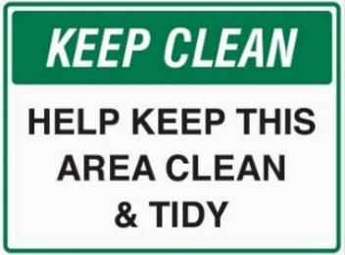 | A. Throw trash on the ground.  B. Ignore the mess in the area.  C. Keep the area clean and tidy.  D. Make the area dirty.
Question 30. Last week, my mother _____________ me to the zoo.
A. is taking B. take C. took D. taking
Question 31. Nga:” My eyes are tired”
My:” _____________”
A. What lovely eyes you have B. You should play more computer game
C. Let’s go to the movie D. You shouldn’t read in dim light
Question 32. I really like __________ - especially in the sea.
A. football B. swimming C. gymnastics D. skating
Question 33. What does the sign say?
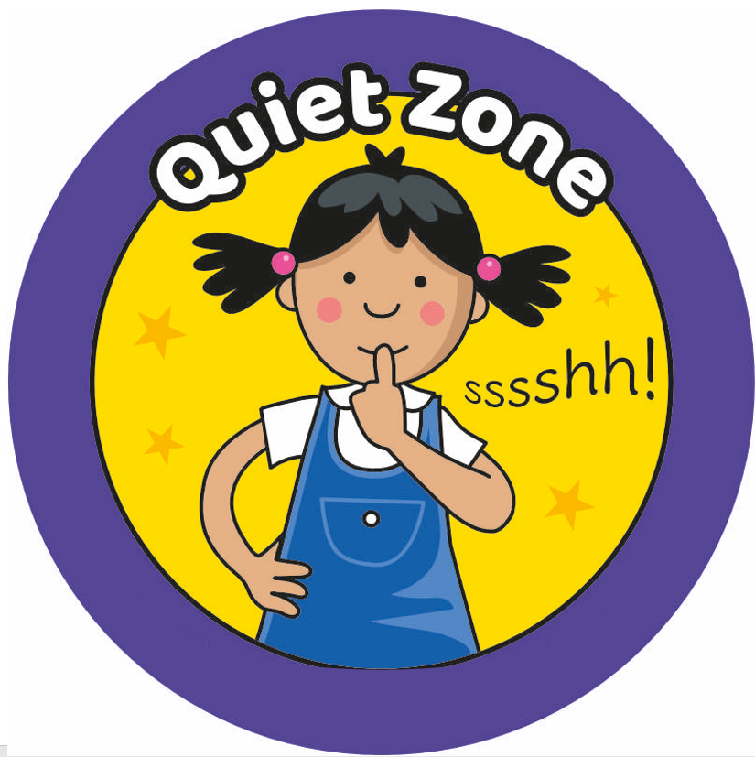 | A. Be loud and talk to your friends.  B. Stop reading and leave the room.  C. Read aloud to everyone.  D. Be quiet because others are reading.
Question 34. Many rich people _____________ money for this volunteer program last year.
A. donated B. donates C. donate D. donating
Question 35. My sister has an _____ to sunflowers, so I don’t arrange them in the house.
A. itchy B. earache C. backache D. allergy
Question 36. You should think of _____ the volunteer activities in your community.
A. taking part in B. making C. taking in D. participating

Four phrases/sentences have been removed from the text below. For each question, mark the letter A, B, C or D on your answer sheet to indicate the correct option that fits each of the numbered blanks from 37 to 40 the most.
- The volunteer work has become popular in Vietnam.
- They were so lovely
- I can’t donate blood, so I often donate books, toys and clothes to street children and homeless people
- Look forward to hearing from you

Dear Mary,
Today I will tell you about my volunteer work.
(37) ____________. Many people have done volunteer work, and I have too. At my age, (38) ____________. I often do this work with my mother. Last Sunday, I donated books and clothes to a charity organization. I met the orphans there. (39) ____________. I played with them, and they were so happy. Some people think that doing volunteer work is waste of time but in my opinion, it helps me relax after school and I feel very happy to bring happiness to them.
What do you think about volunteer work? (40) ____________
Best regards,

Question 37. __________ Question 38. __________
Question 39. __________ Question 40. __________

------ THE END ------

