PEOPLE COMMITTEE OF BO DE WARD  AI MO SECONDARY SCHOOL  School year 2025-2026  ------------------  (The test consists of 03 pages) | THE FIRST MID TERM TEST  SUBJECT: ENGLISH 6  Date: 07/11/2025  (Time allowed: 60 mintues)
Full name: ............................................................................ | Class: ....... | CODE 601
Listen to the recording and mark the letter A, B, C, or D on your answer sheet to indicate the correct answer to each of the following questions.
Question 1. What grade is Janet in?
A. 8 B. 5 C. 6 D. 7
Question 2. What school does Janet go to?
A. Hilltop School B. Sunrise School C. Greenfield School D. Palmer School
Question 3. Who is Janet’s favourite teacher?
A. Mrs. Brown B. Mrs. Smith C. Mr. White D. Mr. Johnson
Question 4. Which subject does Janet study in the library?
A. Maths B. Vietnamese C. Biology D. English
Question 5. What is the main topic of the passage?
A. Janet’s house B. Janet’s family C. Janet’s school D. Janet’s friends
Mark the letter A, B, C or D on your answer sheet to indicate the correct option that best fits each of the numbered blank.
My name's Rose. My best friend is Sarah. She is my classmate and we always (6) ______ to school together. Sarah is 12 years old. She's tall and rather thin. She has short brown and brown eyes. Sarah is (7) ______ and she always makes me laugh. She is also very sporty and plays basketball very well. We (8) ______ basketball at the weekend. She loves music and she plays the guitar. I don't play any instruments but I love music too. Sarah is also very careful. She always (9) _______ what she does.
Question 6. A. go B. are going C. goes D. is going
Question 7. A. hard-working B. active C. funny D. careful
Question 8. A. do B. have C. study D. play
Question 9. A. is good at B. makes friends C. pays attention to D. studies hard
Four phrases/sentences have been removed from the text below. For each question, mark the letter A, B, C, or D on your answer sheet to indicate the correct option that best fits each of the numbered blanks.
“Home is where the heart is” – is a famous quote, and home in a village is more comfortable than a city. (10) ____. There are six members in my family. (11) _______
Everyone helps to keep the house clean and tidy. I can say that my house is comfortable. Here everybody has a separate room, and I have a separate reading room also.
I like my house very much (12) _______ . It has a big kitchen where my mother cooks delicious meals. The backyard is full of flowers and fruit trees, (13)_______ .
In conclusion, my house is more than just a building; it is a place full of love, and happiness.
A - where we often spend our evenings together
B - They are parents, aunts, me, and my younger sister, Ankhi.
C - My house is in a village, and it is made of brick, and wood.
D - because it has everything we need.
Question 10. ___ Question 11. ___ Question 12. ___ Question 13. ___
Read the following instructions and mark the letter A, B, C, or D on your answer sheet to indicate the correct option that best fits each of the numbered blanks.
OUR SCHOOL’S 50th ANNIVERSARY
Please (14) _______ your best clothes and come to the school hall at 5 p.m. There will be (15)__________ party to celebrate our school's 50th anniversary! All students are invited to join. What are you waiting for? There will be many (16) __________activities and games.
Let’s (17) ___________ our best memories together!
Question 14. A. put off B. put on C. put up D. put in
Question 15. A. the B. a C. x D. an
Question 16. A. hard-working B. careful C. caring D. interesting
Question 17. A. come B. read C. share D. listen
Mark the letter A, B, C or D on your answer sheet to indicate the sentence that is closest in meaning to the original sentence in each of the following questions.
Question 18. The red car belongs to Ms. Linh.
A. It is Ms. Linh’s red car.
B. Ms. Linh doesn’t have a car.
C. The red car doesn’t belong to Ms. Linh.
D. It is the red car’s Ms. Linh.
Question 19. My house has two bedrooms, a living room and a kitchen.
A. There have two bedrooms, a living room and a kitchen in my house.
B. There are two bedrooms, a living room and a kitchen.
C. There is two bedrooms, a living room and a kitchen in my house
D. There are two bedrooms, a living room and a kitchen in my house.
Mark the letter A, B, C, or D on your answer sheet to indicate the correct answer to each of the following questions.
Question 20. Look! Those people ________ the mountain so fast.
A. are climbing B. climb C. is climbing D. climbs
Question 21. She kept all her winter clothes neatly folded in the ________ of drawers.
A. table B. shelf C. cabinet D. chest
Question 22. When the weather is good, he ______________ camping in the mountain.
A. is usually going B. going usually C. goes usually D. usually goes
Question 23. Janet lives and studies in a __________ school. She only goes home at weekends.
A. secondary B. private C. international D. boarding
Question 24. The girls ____________ the piano every Mondays.
A. are practicing B. practices C. is practicing D. practice
Question 25. Elena is asking her daughter about her new classmate at school.
“What does your new classmate look like?”- “_________”
A. She’s tall and thin. B. She likes drawing.
C. She lives next door. D. She is clever and kind.
Question 26. The desk is __________ the window and the bed.
A. between B. next C. in D. under
Mark the letter A, B, C, or D on your answer sheet to indicate the sentence that is made from the given cues in each of the following questions.
Question 27. She/ slim/ long blonde hair/ blue eyes.
A. She is slim and have long blonde hair and blue eyes.
B. She is slim, have long blonde hair and blue eyes.
C. She is slim and has long blonde hair with blue eyes.
D. She slim, has long blonde hair and blue eyes.
Question 28. Mai / wake / up / the morning / and / walk / school.
A. Mai wake up in the morning and walk to school.
B. Mai wakes up on the morning and walk to school.
C. Mai wakes up in the morning and walks to school.
D. Mai wake up in the morning and walks school.
Read the passage and mark the letter A, B, C or D on your answer sheet to indicate the correct answer to each of the questions below.
My name is Hoa and my best friend is Thu. She is my classmate. We are both in grade 6 at Nguyen Hue Secondary School. Thu lives next to my house. Every day, my father takes us to school on his motorbike, and we come home on foot in the evening. She is a clever girl. Her favourite subject is Maths, and she is really good at it. Mine is English. We usually help each other with our homework. Whenever I am sad, Thu always tells me stories to make me happy. I feel really lucky to have a best friend like Thu.
Question 29. What is the main idea of the passage?
A. Thu goes to school by motorbike.
B. Hoa wants a new best friend.
C. Hoa and Thu are both good at English.
D. Hoa talks about her close friend.
Question 30. According to the passage, what subject does Hoa like best?
A. English B. Science C. Maths D. History
Question 31. Which of the following is NOT TRUE according to the passage?
A. Thu tells Hoa stories when she is sad.
B. Hoa and Thu study at Nguyen Hue Secondary School.
C. They go to school together on Hoa's father's motorbike.
D. Hoa and Thu live far away from each other.
Question 32. The word “clever” in the passage is CLOSEST in meaning to:
A. confident B. smart C. shy D. creative
Mark the letter A, B, C, or D on your answer sheet to indicate the correct answer to each of the following questions.
Question 33. Put the sentences (a-c) in the correct order, then fill in the blank to make a logical text.
I really enjoy spending time at my school. _______________________
a. Secondly, the library is my favorite place because I love reading books during breaks.
b. Firstly, my teachers are kind and always ready to help me with my homework.
c. Thirdly, we have a big playground where my friends and I play football.
A. b – c – a B. a – b – c C. b – a – c D. c – a – b
Question 34. Choose the sentence that can end the text most appropriately.
A. We often play sports during gym class.
B. And I like studying in the computer room, too.
C. Finally, I’m very happy to be a part of my school.
D. Also, my school has many books.
Read the following sign or notice and mark the letter A, B, C, or D on your answer sheet to indicate the correct answer to each of the following questions.
Question 35. What does the sign say?  A. Birds don’t have to be given food.  B. You can’t bring any birds here.  C. You mustn’t feed the birds.  D. There is no bird here. | 
Question 36. What does the notice say?  A. The football lessons are free.  B. You will have two lessons every week.  C. Each lesson last for three hours.  D. The football lessons are in the morning. | 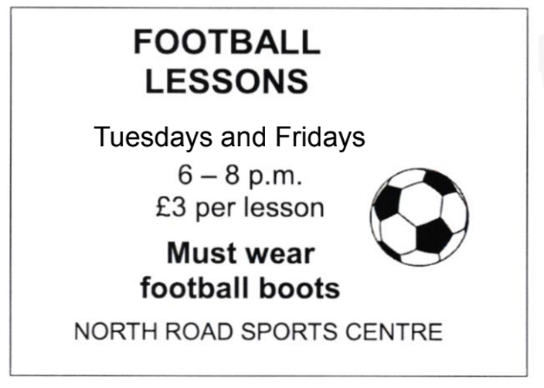

Mark the letter A, B, C or D on your answer sheet to indicate the word whose underlined part differs from the other three in pronunciation in each of the following questions.
Question 37. A. chairs B. lamps C. chests D. sinks
Question 38. A. smart B. father C. classmate D. compass

Mark the letter A, B, C or D on your answer sheet to indicate the word that differs from the other three in the position of primary stress in each of the following questions
Question 39. A. cupboard B. classmate C. between D. wardrobe
Question 40. A. creative B. bathroom C. active D. careful

------ THE END ------

