TEST ENGLISH 9
Mark the letter A, B, C or D on your answer sheet to indicate the word whose underlined part differs from the other three in pronunciation in each of the following questions.
Question 1. A. garbage | B. artisan | C. attraction | D. handicraft
Question 2. A. sculpture | B. preserve | C. past | D. skill

Mark the letter A, B, C or D on your answer sheet to indicate the word that differs from the other three in the position of primary stress in each of the following questions.
Question 3. A. design | B. mention | C. . prefer | D. consist
Question 4. A. delivery | B. environment | C. generation | D. facility

Mark the letter A, B, C or D on your answer sheet to indicate the correct answer to each of the following questions.
Question 5. Sydney has become ______ as there are people here from all over the world.
A. historical B. cultural C. cosmopolitan D. modern
Question 6. Tacos, a kind of Mexican ______, are delicious with seasoned meat and toppings.
A. handicraft B. speciality food C. fast food D. traditional dancing
Question 7. You should take your shoes……………….when you go into the pagoda.
A. on B. up C. off D. in
Question 8. ______ the street becomes, ______ the traffic moves.
A. The more crowded; the slower B. The more crowded; the more slow
C. The most crowded; the slower D. More crowded; more slow
Question 9. I think they will ______ the meeting room with chairs, tables, and a projector for the presentation.
A. take on B. set up C. find out D. look up
Question 10. We are wondering ______ traditional handicrafts as presents for our friends from Germany.
  - if to buy B. whether to buy C. what to buy D. whom to buy
Question 11. Kim is inviting Olivia to watch a film
Kim: “Why don't we go to the cinema to watch The Little Mermaid?” Olivia: “..............”
A. I like the cinema, too. B. I’m afraid I can go.
C. Sure. But please be careful with it. D. That sounds like a good idea.
Question 12: If I tell you a secret,……….you promise not to tell anyone else?
A. would B. did C. will D. have

Read the following announcement and mark the letter A, B, C or D on your answer sheet to indicate the correct option that best fits each numbered blank from 13 to 16.
STAYING HEALTHY AT WORK
To stay healthy while working, try these easy tips:
- Take breaks to stand up and (13) ........... around.
- Drink (14) .......... water all day to stay healthy.
- (15) ........... your desk clean and tidy to feel better.
- If you feel tired, (15) .......... some deep breaths to feel relaxed.
Question 13. A. move | B. come | C. leave | D. look
Question 14. A. many | B. enough | C. little | D. more
Question 15. A. Forget | B. Open | C. Keep | D. Hide
Question 16. A. Take | B. stop | C. wait | D. run

Mark the letter A, B, C or D on your answer sheet to indicate the correct answer to each of the following questions from 17 to 18.
Question 17. Put the sentences (a-c) in the correct order, then fill in the blank to make a logical text.
Basketball is a well-liked game played everywhere. Here’s some basic info about it. ..................
a. The game is played with two teams of five players each, who try to get points by throwing the ball into the other team’s basket.
b. Basketball was created in the late 1800s and has since become a big sport around the world.
c. It needs skills like bouncing the ball, passing, and shooting, and is famous for its fast speed and many points scored.
A. b - a - c | B. a - b - c | C. c - a -b | D. b - c - a
Question 18. Choose the sentence that most appropriately ends the text (in Question 17).
A. Many top players and teams play in famous leagues around the world.
B. Basketball is often played in schools and local centres.
C. The game is also liked in many countries outside the United States.
D. Teams often train for many hours a day to get better.

Read the following sign or notice and mark the letter A, B, C or D on your answer sheet to indicate the correct answer to each of the following questions.
Question 19. What does the sign say?
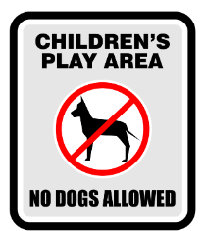 | A. Dogs cannot be taken into this place as it is a children’s play area.  B. Dogs are not allowed to play with children in this area  C. Don’t let your children play here because of the dogs.  D. Dogs are not safe for children in this play area.
Question 20. What does the notice say?
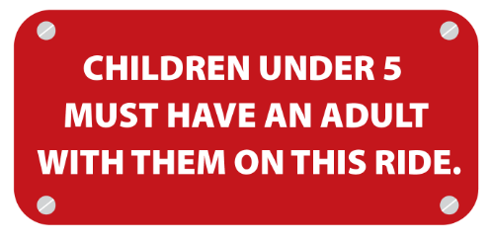 | A. There are no more than 5 adults on this ride.  B. Children in groups of 5 must have an adult with them.  C. Children less than 5 years old cannot go on this ride alone.  D. Adults are not allowed on this ride.

