WEEK
Preparing: / 03 / 2019
Teaching: /03 /2019
UNIT 10: SPACE TRAVEL
LESSON 6: Skills 1

I. OBJECTIVES: By the end of this Unit, students will be able to:
- read for specific information about two famous astronauts' space travel
- talk about space travel history and life on a space station
II . PREPARATION: sub -board, pictures, cassette
III. PROCEDURES:

Teacher’s and students’ activities | Content
Activity 1:  -Have Ss work in pairs. Ask Ss to focus on the photos and try identifying the Vietnamese astronaut (Pham Tuan). Ask if they know anything about Pham Tuan. Pairs can share what they already know about Pham Tuan. After that, have Ss turn the page upside down and read the Quick facts box, then they tell each other some more information about Pham Tuan in full sentences.  Activity 2:  a/ Explain to Ss they are going to read a text about two famous astronauts talking about their space travel experience. Ask Ss to guess what they think the two astronauts will talk about. T may refer back to the information about the ISS that Ss have learnt about in COMMUNICATION.  Have Ss then read the text and do the exercise individually. Discuss the answers with the class but remember to ask Ss to explain their decisions. (Why do you think this quote should go in this paragraph?)  b/ Have Ss work in pairs to complete the exercise. When giving feedback, ask Ss to give further information in the text to back up their answers.  Speaking  Activity 3:  -3 Have Ss work in pairs for this task to discuss the qualities and skills.  First, ask Ss to look at the reading text in 2 again and try to extract the necessary characteristics/qualities/skills for astronauts from the things Pham Tuan and Christer Fuglesang said.  For example: a love for nature, can eat packaged food for a long time, etc.  Then tell Ss they can look at A CLOSER LOOK 1, Activity 2, as well as COMMUNICATION, for more ideas.  Pairs get together to exchange their ideas. Then as a class, Ss build up a list of qualities and skills needed to be an astronaut.  Activity 4:  4 Have Ss work in groups for this role play and solve the problems. There are no wrong answers here.  Encourage Ss to be creative with their ideas.  Once Ss have finished, each group may present their decisions and the class chooses the best solutions. | 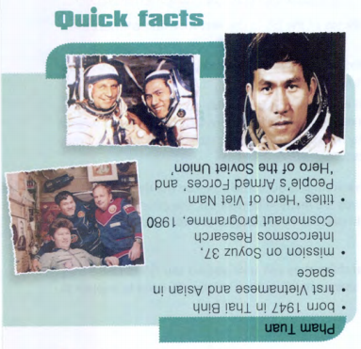  Key:  1. c  2. a  3. b  Key:  1. Pham Tuan is Viet Nam's first astronaut, and Christer Fuglesang is Sweden's first astronaut.  2. He found that the Earth didn't look as big as he thought, and he thought we should cooperate to take care of it.  3. It seemed he didn't enjoy it much since it wasn't fresh.  4. They talked to him when he was in space and that made him happy.  5. They think the chance to fly into space is equal for everyone.  6. He thinks teamwork, social skills, and language skills are important for an astronaut.  Key (suggested):  • One crew member feels extremely homesick: She/ He can make phone calls to family and friends on Earth.  She/.He can exercise, read a book, listen to music, or play some games. Other crew members can talk to her/him, or together they can do something fun in their free time, for example having a ' space party'.  • When looking at the monitoring system you discover a strange object approaching Earth: The crew can contact the Mission Control Centre for help. They can start watching the object, record its movements, and report back to Earth.

IV- HOMEWORK:
-Write new words then learn them by heart.
-Copy the exercise into notebooks.
-Prepare SKILLS 2

Feed back:
………………………………………………………………………………………………………………………………………………………………………………………………

