PHÒNG GD & ĐT QUẬN LONG BIÊN  TRƯỜNG THCS BỒ ĐỀ  Năm học: 2018-2019  Mã đề: 004 | ĐỀ THI HỌC KÌ II  MÔN TIẾNG ANH – LỚP 8  Thời gian: 45 phút  Ngày thi: 02/5/2019
Name: ...........................................
Class: …..…
Mark: | Teacher's comment:

I. Listen and tick True (T) or False (F) (0.8pt)
Statements | T | F
1. Water pollution in the lake has made fish die.
2. Aquatic animals may also die because of the polluted water.
3. There was a factory last year.
4. The air is also dirty.
II. Listen and fill one word or a number in each gap to complete the passage. (1p)
“Good morning. I hope you all had a good sleep. We are now (5)_________________ for Wanaka. We arrive at the first destination, Puzzling World at (6)______________. The first puzzling thing which welcomes you is the Leaning Tower. When you get inside the spacious coffee shop, you will find yourself among many wooden puzzles and games. The (7)______________ Room is a (8)______________ as there’s nothing else like it in the world. Puzzling World is possibly the most photographed (9)_________________ in New Zealand.”
III. Which word has the different stress? (0.4 pt)
10. A. logical B. poisonous C. classical D. pollution
11. A. priority B. waterless C. unkind D. forgetful
IV. Choose the correct answer (1.2 pts)
12. Identify the mistake in the following sentence:
There are about 750 millions English speakers in the world, and this number is increasing fast.
A B C D
13. What is galaxy?
A. a large group of stars and planets in outer space.
B. the sun and the planets that move around it.
C. a large body in space that moces around a planet.
D. a creature that comes from another planet.
14. Choose the sentence which has the closest meaning as the given one:
“Jeft did a research on thermal pollution in 2010.”, Anna said.
A. Anna said that Jeft had done a research on thermal pollution in 2010.
B. Anna said that Jeft did a research on thermal pollution in 2010.
C. Anna said that a research on thermal pollution had been done by Jeft in 2010.
D. Anna said that a research on thermal pollution was done in 2010 by Jeft.
15. Natural disasters can be ________; they can wreak havoc across large areas and cause loss of life.
A. damage B. destructive C. permanent D. uncontrolling
16. Taking survival training courses on diasters management can prevent people_________losing their lives.
A. in B. from C. with D. of
17. - I’ve heard that John has been elected as the president of the school club!. - _________?
A. Congratulation B. Absolutely right C. Really D. Awesome
V. Give the correct form of the words in the brackets to complete the sentences (0.8 pt)
18. They agreed ________________late to complete the task. (work)
19. The history of space ___________________began in 1957 when the Soviet launched the first satellite into space. (explore)
20. Let’s start packing this evening. The plane__________________early tomorrow morning. (leave)
21. When he came back, the manager _______________________writing the report. (already/ finish)
VI. Choose the best heading for each paragraph. (0.8 pt)
B. Direct communication is less popular
A. A common problem of texting

D. Effects on children
C. A new fun way of communicating

22.___________
Texting is a new way of exchanging information, and it is becoming more and more popular among the young. In fact, texting is clearly affecting language. There are no rules for it. We are creating a new aspect of vocabulary and opening up a new kind of playful and direct communication.
23. __________
Naturally, texting is fun but some people are worried about the effects it might have on a child’s ability to read and write. The unofficial language might be used by them and it will probably affect their writing style. An expert says, “Every time a new medium comes along it has an effect on language but this doesn’t destroy the existing language, it adds to it.”
24. _________
In text messages, many words come from shorthand created in emails. After that, they have become popular and accepted somehow. Someone says, “Mostly they are original, but sometimes you get a clash of meanings. For example, LOL can mean both Laugh Out Loud and Lots of Love. That could lead to some misunderstandings.”
25._________
In short, texting is real-time communication but is not in person. It is considered as a reason for the decrease of the face-to-face frequency among people. Everything has both two sides and either it is good or bad, it is up to human.
VII. Read the passage. Whose statement is it? Put a tick into the right column. (1.2 pt)
CHAU: The Internet itself is like any other inventions. Neither good nor bad. It's how it's used that makes the difference. I think the Internet is the greatest technological invention of all time. Before the Internet, the world was a huge place and people on opposite sides of the world could only communicate by snail mail or occasional phone calls as these were too expensive for regular use. The world has become a much smaller place and the places we cannot visit have become alive to us because of it.


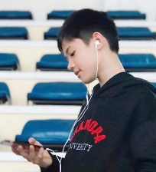
LONG: Internet is a fantastic tool and most businesses rely on it these days and it’s also great for keeping in touch with friends, relatives and doing your shopping. It is so easy to connect with someone far away in seconds. The only downside is that it wasn't regulated correctly from day one and there are some shocking sites and big scams going on. The Internet is now so big that I think it is difficult to get it under control.

Statements | Long | Chau
26. Internet is the best technological invention of all time.
27. The Internet has made the world smaller.
28. The bad sites make the Internet bad.
29. It used to cost a lot of money to communicate to someone far away.
30. Whether Internet is good or bad depends on the use of it.
31. It is probably hard to control the Internet now.
VIII. Rewrite the sentences without changing the meaning with the given word (1 pt)
32. You should spend more time on English. This job requires your efficency in the language.
=> If I………………………………………………………………………………………….…..
33. Although he has prepared carefully, he doesn’t feel confident.
=> Despite having………………………………………………………………………………...
34. “Where were you yesterday?”, she asked.
=> She asked………………………………………………………………………………..………
35. “Avengers: Endgame will be in cinemas soon.” She says.
=> She says (that)…..……………………………………………………….……………………..
36. If Adriana Grande hadn’t cancelled her show in Vietnam, the audience wouldn’t have been so frustrated. (unless)
=> Unless………………………………………………………………………………………………..
IX. Put the following parts in their correct place to make an email. (0.8 pt)
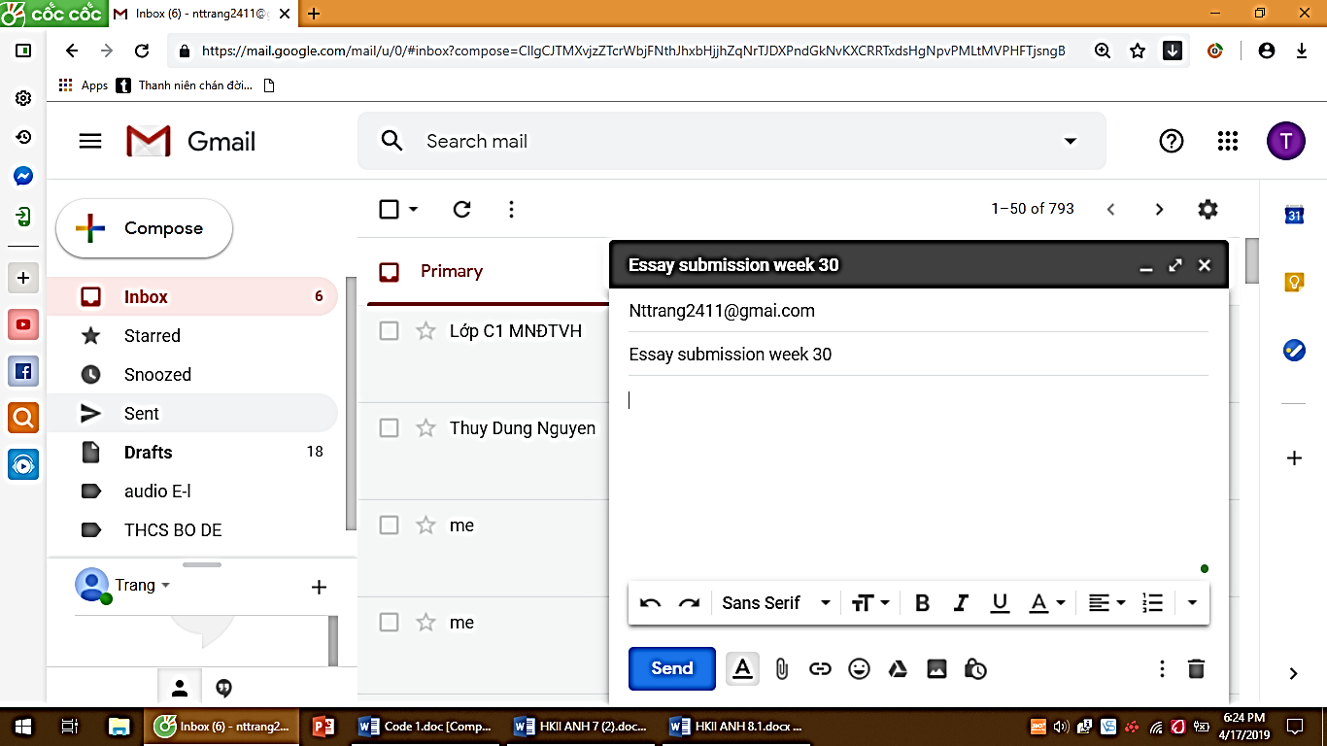
A. Please find my attached essay for week 30.
B. Best regards,
C. Thank you very much.
D. My name is Thor, and I am from class 8A.

Dear Mrs Trang,
(37) . (38) 37…………………………
(39) 38…………………………
(40) 39…………………………
Thor 40…………………………

-------------GOOD LUCK!-------------

ANSWER KEYS – 004
I. Listen and tick True (T) or False (F) (0.8pt)
1. T 2. T 3. F 4. T
*Tapescript: Unit 7: Pollution – Lesson 1: Getting started (students’ book)
II. Listen and fill one word or a number in each gap to complete the passage. (1p)
5. heading 6. 9.30 7. Illusion 8. must-see 9. attraction
*Tapescript: Unit 8: English speaking countries – Lesson 5: Skills 1 (students’ book)
III. Which word has the different stress? (0.4 pt)
10. D. pollution 11. B. waterless
IV. Choose the correct answers (1.2 pts)
12. B. millions 13. A. a large group of stars and planets in outer space.
14. B. Anna said that Jeft did a research on thermal pollution in 2010.
15. B. destructive 16.B. from 17. C. Really
V. Give the correct form of the words in the brackets to complete the sentences (0.8 pt)
18. to work 19. exploration 20. leaves 21. had already finished
VI. Choose the best heading for each paragraph. (0.8 pt)
22. C. A new fun way of communicating 23. D. Effects on children
24. A. A common problem of texting 25. B. Direct communication is less popular
VII. Read the passage. Whose statement is it? Put a tick into the right column. (1.2 pt)
26. Chau 27. Chau 28. Long 29.Chau 30. Chau 31.Long
VIII. Rewrite the sentences without changing the meaning with the given word (1 pt)
32. If I were you, I would spend more time on English.
33. Despite having prepared carefully, he doesn’t feel confident.
34. She asked me where I was the previous day/ the day before.
35.She says that Avengers: Endgame will be in cinemas soon.
36. Unless Adriana Grande had cancelled her show in Vietnam, the audience wouldn’t have been so frustrated.
IX. Put the following parts in their correct place to make an email. (0.8 pt)
37. D. My name is Thor, and I am from class 8A.
38. A. Please find my attached essay for week 30.
39. C. Thank you very much.
40. B. Best regards,

BGH duyệt Nhóm trưởng Người ra đề

Lý Thị Như Hoa Nguyễn Thùy Dung Nguyễn Thùy Trang

