NỘI DUNG ÔN TẬP HÈ K5
MÔN: TIẾNG ANH

PART 1. LANGUAGE FOCUS: From Unit 11 to Unit 19
I. New words
- Review all new words from Unit 11 to Unit 19:
Unit 11: What’s the matter with you? | 16. Where’s the post office?
Unit 12: Don’t ride your bike too fast! | 17. What would you like to eat?
Unit 13: What do you do in your free time? | 18. What will the weather be like tomorrow?
Unit 14: What happened in the story? | 19. Which place would you like to visit?
Unit 15: What would you like to be in the future?
II. Model sentences
- Review all model sentences from Unit 11 to Unit 19.
PART 2. SPEAKING
- What the matter with her/ him ?  (look at the pictures) | - What would you like to eat/ drink?  - How many/ much___________do you eat/ drink every day?  - What kinds of vegetables do you eat every day?  - What kinds of fruits do you eat every day?  - How much rice do you eat every day?
- What do you do in your free time?
- How often do you do it?
- What does your father/ brother/ mother/ sister do in his/ her free time?
- How often does your father/ brother/ mother/ sister do it ?
- What do you think of ____________?  (look at the pictures)  - What kinds of books do you like?  - What is your favourite book?  - Which character do you like best?  - Which character don’t you like?  - Why do you like this book? | - What’s your favourite season?  - What’s the weather like in your favourite season?  - What’s the weather like today?  - What will the weather be like tomorrow?  - What’s________like in your country?  (look at the pictures)
- Where’s the____________? (look at the pictures)  - How can I get to_________? (look at the pictures) | - Where did you go last summer holiday?  - What places did you visit?  - What were they like?  - What do you think you them?  - Which place would you like to visit, ___or ____?
PART 3. EXERCISES
1. Listen and tick. | 8. Read and complete.  9. Read and Tick True or False.
2. Listen and circle. | 8. Read and complete.  9. Read and Tick True or False.
3. Listen and number. | 10. Read and circle the correct answer.
4. Listen and match. | 11. Look at the pictures and the letters.Write the correct words.
5. Listen and write. | 12. Look at the picture and complete the sentence.
6. Read and match. | 13. Reorder the words.
7. Read and write. | 14. Complete the sentences

PART 4. PRACTICE
Task 1. Put the words in order.
1. apples /you / every day? /eat /many /do /How
…………….….
2. The/ supermarket./ next /is /to /post office /the
………...
3. Thong Nhat/ Park. /I /like /would /to /visit
……..
4. think/ Bay? /What /do /of /Ha Long /you
………………….
5. school / Lisa / bad /go/ to /can’t /because/ she/ fever/has/ a/.
…………………………………………………………………………….………………………..
6. She/ heavy /carry /shouldn’t/ things/.
…………………………………………………………………………………………………..….
7. your/ hands/ Wash / having / before / meals./
…………………………………………………………………………………………………..….
8. twice /a day./ Brush / teeth / your
………………………………………………………………………………………………………
9. What’s/ your /the /with /matter /sister/?
………………………………………………………………………………………………………
10. Snow White?/ think of / What/ he /does
……………………………………………………………………………………………………....
11. Thanh Giong / think / I / brave ./ is
……………………………………………………………………………………………………….
12. do / you / Which / like / this / in / fairy tale ?/ characters
……………………………………………………………………………………………………....
Task 2. Choose the best answer.
1. Are you going to do your housework? - Yes,............
A. I am B. I was C. he is D. he was
2. What's the matter............. him? –He has a cold.
A. to B. with C. from D. in
3. How many seasons are............ in England?
A. these B. those C. they D. There
4. Peter doesn’t want ……….. football.
A. play B. to play C. playing D. Played
5. What’s your favourite drink ? ……………………………
A. Chicken B. Orange juice C.Lettuce D. Apple
6. What’s the matter ? I’m very hungry , I’d like some ………………………
A. water B. iced tea C. lemonade D. sandwiches

7. ……………… do you feel ? I feel hungry.
A. Why B. Who C. Which D. How
8. We’re very ……………… now . We don’t want any more food or drink.
A. cold B. hot C. full D. hungry
Task 3. Read and tick True (T) or False (F).
My name is Phong. I live in the centre of Ha Noi. It’s in the north of Viet Nam. I have two friends, Nam and Kim. Nam lives in Can Tho. Kim lives in Da Nang. The weather in our places is not the same. This weekend, it will be cold and dry in Ha Noi, but it will be cool and sunny in the Da Nang and it will be hot and cloudy in Can Tho. The seasons are different, too. There are four seasons in Ha Noi: spring, summer, autumn and winter. But there are only two seasons in Da Nang and Can Tho: the dry season and the rainy season.
 | T | F
1. Phong lives in Ha Noi.  2. The weather is cold and cloudy in Can Tho this weekend.  3. It will be cool and sunny in Da Nang.  4. There are two seasons in Ha Noi. | ………  ............  ............  ............ | ..............  ..............  ..............  ..............
Task 4. Read and write the suitable words in the gaps as example.
life | peaceful sometimes | attractive | spring
Hello. My name’s Thien. It is not easy to answer the question: “ Which one is more exciting, life in the city or (0) life in the countryside? ” but I enjoy living in the countryside very much because life is (1)…………. and the people are friendly. The villages are normally small and quiet. The fields are green, windy and beautiful with flowers in the ( 2)…….……..and the birds singing in the summer. There are not many people, shops and traffic here. I(3) …………..go to Ha Noi with my parents. I see a lot of people there so the streets are always so crowded and noisier, things are more expensive. I think It’s more (4)……………………. and exciting to live in countryside.
Task 5. Look at the picture. Write ONE word for each gap.
 | - I have five lessons on Monday.

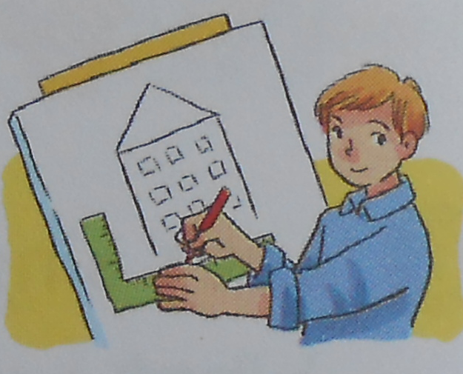 | - I’d like to be an _____________________ because I’d like to design buildings.
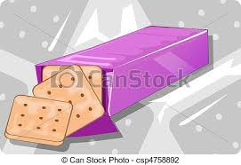 | - I’d like a packet of ___________, please.
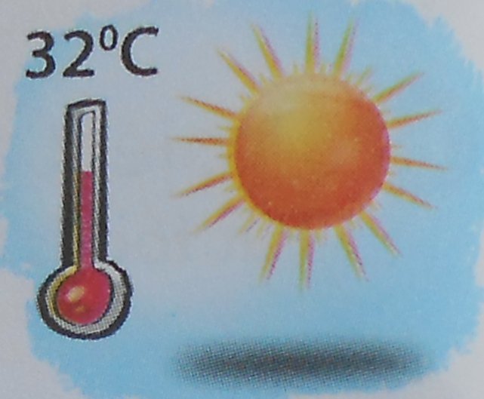 | - It will be ___________ in Hue tomorrow.
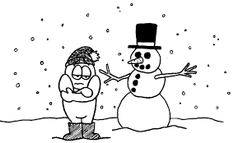 | - It is usually very cold in the ___________.

Task 6. Read and match.
- How much rice do you eat every day ? | - Four bottles.
- What would you like to eat for breakfast ? | - Three bowls.
- How much water do you drink every day ? | - Milk
- What should you drink after dinner ? | - Because they are good for our health.
- Why should you eat a lot of vegetables ? | - Bread with egg.
- What is your favourite fruit ? | - I love watermelons .

Task 7. Read and write the missing letters.
co _ d | s _ _ wy | _ _ nny | _ _ oudy
w_ rm | h _ t | coo _ | fo _ _ y
sp _ _ ng | sum _ _ _ | _ _ tumn | win _ _ r
we _ | d _ y | seas _ _ | sto _ m

Task 8. Look, read and write.
between | next to | opposite

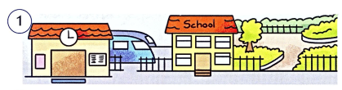 | 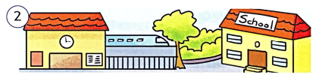
The school is …………………… the station  and the park. | The station is …………………… the school.
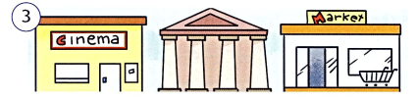 | 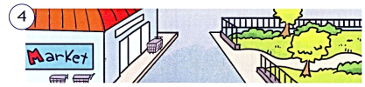
The museum is ……………………the cinema and the supermarket. | The park is ……………………the supermarket.
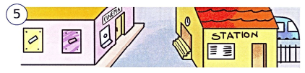 | 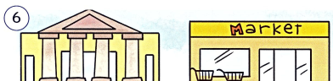
The cinema is ………………… the station. | The museum is ………………… the  supermarket.

Task 9. Look and write.
cinema | stadium | post office | museum | pharmacy | supermarket

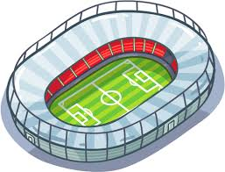 |  | 
 | 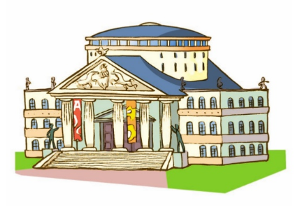 | 

Task 10. Look , read and complete the sentences.
1. What’s spring like in your country , Linda ?  It’s ………………………………………………………….… | 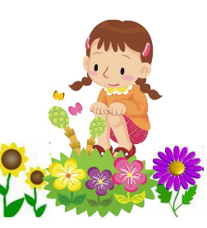
2. What’s winter like in your country , Peter ?  It’s……………………There’s a lot of ………………………. | 
3. What’s the weather like in your favourite season ?  …………………………………………………………………… | 
4. What is your favourite season ?  My favourite season is …………………………………. | 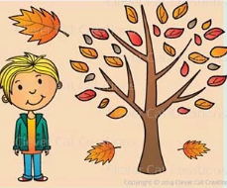

Task 11. Match the jobs with the activities.
- pilot | - drive a car | 1- ……………
- doctor | - draw pictures | 2- ……………
- writer | - work in a field | 3- ……………
- architect | - grow flowers and plant | 4- ……………
- teacher | - teach children | 5- ……………
- astronaut | - write stories | 6- ……………
- gardener | - design building | 7- ……………
- driver | - look after patients | 8- ……………
- artist | - fly a plane | 9- ……………
10) farmer | - fly a spaceship | 10-……………

Task 12. Read and complete the passage with the given words.
drawing | artist | teacher | exciting | doctor

I am Linda. I have two best friends : Anna and Rose. I’ d like to be (1) ………….. in the future. I love children and I want to work in a school near my house. It’s an (2) ……………….. work. Anna would like to be a (3) ………………….when she grows up . She wants to help the poor people. Rose likes (4) …………… pictures. She wants to be an (5) ………….… I hope that one day, our dream will come true.

The end

