NGO GIA TU PRIMARY SCHOOL  School year: 2020-2021 | REVISION FOR THE 2nd SEMESTER TEST  Subject: English 5
PART 1. LANGUAGE FOCUS: From Unit 11 to Unit 19
I. New words
- Review all new words from Unit 11 to Unit 19:
Unit 11: What’s the matter with you? | 16. Where’s the post office?
Unit 12: Don’t ride your bike too fast! | 17. What would you like to eat?
Unit 13: What do you do in your free time? | 18. What will the weather be like tomorrow?
Unit 14: What happened in the story? | 19. Which place would you like to visit?
Unit 15: What would you like to be in the future?
II. Model sentences
- Review all model sentences from Unit 11 to Unit 19.
PART 2. SPEAKING
- What the matter with her/ him ?  (look at the pictures) | - What would you like to eat/ drink?  - How many/ much___________do you eat/ drink every day?  - What kinds of vegetables do you eat every day?  - What kinds of fruits do you eat every day?  - How much rice do you eat every day?
- What do you do in your free time?
- How often do you do it?
- What does your father/ brother/ mother/ sister do in his/ her free time?
- How often does your father/ brother/ mother/ sister do it ?
- What do you think of ____________?  (look at the pictures)  - What kinds of books do you like?  - What is your favourite book?  - Which character do you like best?  - Which character don’t you like?  - Why do you like this book? | - What’s your favourite season?  - What’s the weather like in your favourite season?  - What’s the weather like today?  - What will the weather be like tomorrow?  - What’s________like in your country?  (look at the pictures)
- Where’s the____________? (look at the pictures)  - How can I get to_________? (look at the pictures) | - Where did you go last summer holiday?  - What places did you visit?  - What were they like?  - What do you think you them?  - Which place would you like to visit, ___or ____?
PART 3. EXERCISES
1. Listen and tick. | 8. Read and complete.  9. Read and Tick True or False.
2. Listen and circle. | 8. Read and complete.  9. Read and Tick True or False.
3. Listen and number. | 10. Read and circle the correct answer.
4. Listen and match. | 11. Look at the pictures and the letters.Write the correct words.
5. Listen and write. | 12. Look at the picture and complete the sentence.
6. Read and match. | 13. Reorder the words.
7. Read and write. | 14. Complete the sentences
PART 4. PRACTICE
Task 1. Read and circle the correct answer.
1. What's the matter............. you? -I have a cold.
A. to B. with C. from D. in
2. How many seasons are............ in England?
A. these B. those C. they D. there
3. It's often............... in the rainy season.
A. cold B. warm C. rainy D. sunny
4. What do you do in your free time? – I surf _______.
A. the Internet B. comics C. homework D. flowers
5. You shouldn’t play with the knife because it’s _______.
A. small B. sharp C. tall D. deep
Task 2 . Look and complete.
 |  | 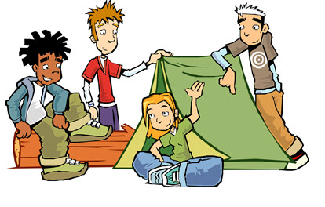
1. Where is the ………………...? | 2. I ’d like to be a ………………..... | 3.They usually go…………… in the forest.
Task 3. Reorder the words.
1. stay / home / you / yesterday / at / Did /?->……………………………………………….…..…
2. like/ the/ in / What/ weather/ summer / is/?->………………………………………………..…. 3. should/ Mr. Tuan/ a/ take /rest/./ ->……………………………………………………………...
4. had/ Quan/ to/ the/ headache/ doctor/ because/ went/ he/ a/.
->………………………………………………………………………………………………….
5. Tam/ gentle./beautiful /and /was/->…………………………………………………………...... Task 4. Read and tick () True or False.
What do English children usually eat nowadays? At lunch, Jim goes to a food stall and buys a sandwich, some chocolate and some milk. Some of his friends buy food at the food stall, too. Some of the sandwiches are healthy, but some aren’t. School meals are healthier, but Jim and his friends never eat at the school canteen. True False
1. At lunch, Jim goes to a book shop.
2. Jim buys some chocolate and some milk.
3. School meals are good.
4. Jim always eats at the school canteen.
Task 5. Look at the pictures and the letters.Write the correct words.

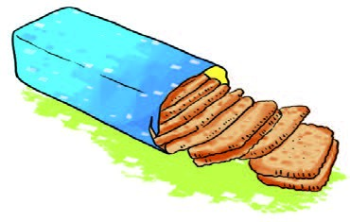 | 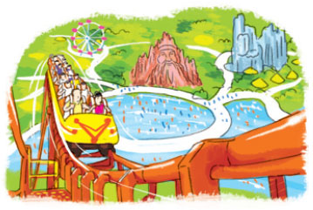 | 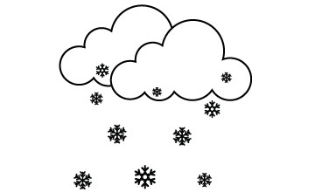
1. B_scuit_ | 2. Dam Sen P_ _ k | 3. s_ ow _

