NGO GIA TU PRIMARY SCHOOL  School year: 2020-2021 | REVISION FOR THE 2nd SEMESTER TEST  Subject: English 4
PART 1. LANGUAGE FOCUS: From Unit 11 to Unit 19
I. New words
- Review all new words from Unit 11 to Unit 19:
Unit 11. What time is it? | Unit 16. Let’s go to the bookshop.
Unit 12. What does your father do? | Unit 17. How much is the T-shirt?
Unit 13. Would you like some milk? | Unit 18. What’s your phone number?
Unit 14. What does he look like? | Unit 19. What animal do you want to see?
Unit 15. When’s Children’s Day?
II. Phonics
- cook, book, noon, school, field, piece, teacher, reading, beef, leaf, fish, dish, this, that, thin, thick, clothes, close, flowers, floor, bookshop, bakery, supermarket, ‘sandals, ‘trousers, ‘jumper, ‘jacket, re’peat, en’joy, in’vite, com’plete, ‘crocodile, ‘elephant, ‘wonderful, ‘beautiful.
III. Model sentences
- Review all model sentences from Unit 11 to Unit 19.
PART 2. SPEAKING
- What time is it ? (look at the pictures)  - What time do you get up?  - What time do you have breakfast / lunch / dinner ?  - What time do you go to school/ go to bed? | - Why do you want to go to the zoo/ cinema/ bakery/ swimming pool/ pharmacy/ supermarket/  sweet shop?
- What do you do?  - What does your father/ mother/ uncle/ brother/ sister do?  - Where does your father/ mother/ uncle/ brother/ sister work?  - Where does a doctor/ a farmer/ a worker/ a clerk work? | - How much is the scarf/ blouse/ jacket/ skirt/ jumper?  (look at the pictures)  - How much are the jeans/ shoes/ trousers/ sandals? (look at the pictures)
- What’s your favourite food/ drink?  - Would you like some bread/ rice/ vegetables/ beef/ pork/ noodles/ chicken/ water/ lemonade/ orange juice/ milk ? | - What’s_______’s phone number?  (look at the pictures)  - Would you like to go for a walk/ go for a picnic/ go fishing/ go skating?
- What does your mother/ father/ brother/ sister look like?  - Who’s slimmer, your mother or your sister?  - Who’s stronger, your father or your brother? | - What animal do you want to see?  - Why do you like tigers/ crocodiles/ bears/ elephants/ zebras/ kangaroos?
- When is New Year/ Children’s Day/ Teachers’Day/ Christmas?
- What do you do at ………………………….?
PART 3. EXERCISES
1. Listen and tick. | 8. Read and complete.
2. Listen and circle. | 9. Read and Tick True or False.
3. Listen and number. | 10. Read and circle the correct answer.
4. Listen and match. | 11. Look at the pictures and the letters.Write the correct words.
5. Listen and write. | 12. Look at the picture and complete the sentence.
6. Read and match. | 13. Reorder the words.
7. Read and write. | 14. Complete the sentences
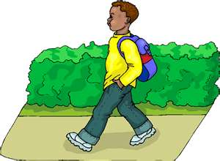
PART 4. PRACTICE
Task 1. Complete the sentences.
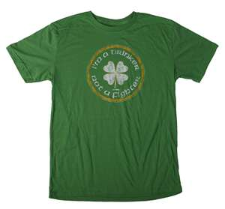
- He _______________________at 7 o’clock.

- I have a green _____________________.
- He is a __________________.
Task 2. Read and write.
Li Li, Mai and Linda want to go shopping. First, they go to the bookshop because they want to buy some books. Next, they go to the supermarket because they want to buy some food. Then, they go to the post office because Li Li wants to buy some stamps. Finally, they go to the food stall because they are hungry.
 | True | False
- Mai, Li Li and Linda want to go shopping.
- First, they go to the bookshop.
- Next, they go to the post office.
- They are hungry so they go to the food stall.
Task 3. Look at the pictures and the letters.Write the correct words.
 | 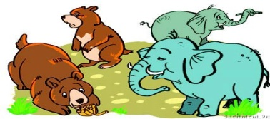 | 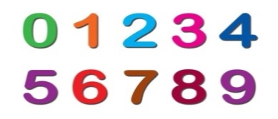
1. hcrsitams→ _____________ | 2. mansial→ _____________ | 3. munerb → ___________
Task 4. Reorder the words.
1. like/ I’d/ to/ noodles/ eat/./ ->…………………………………………………………………..
2. to/ go/ Why/?/ do/ you/ want/ to/ the/ bakery ->……………………………………………......
3. you/ Do/ want/ shopping/ ?/ to/ go ->…………………………………………………………..
4. fish/ My/ favourite/ food/ is/./ ->……………………………………………………………….
5. I/ want/ Because/ some/ bread / buy / to/./ ->…………………………………………………..
6. school/ I/ at/ go/ to/ o’clock/ seven /./ ->……………………………………………………….
7. much/ are/ shoes/ How/ these /?/ ->………………………………………………………….…
Task 5. Read and circle the correct answer.
1. I love animals. Let’s go to the.....................
A. post office B. supermarket C. circus
2. Why do you like tigers? Because they can…………
A. sing B. swing C. jump
3. What ............. are your shoes? They are brown.
A. colour B. time C. would
4. Chicken is my favourite .............
A. drink B. food C. interesting

