NỘI DUNG ÔN TẬP HÈ K4
MÔN: TIẾNG ANH

PART 1. LANGUAGE FOCUS: From Unit 11 to Unit 19
I. New words
- Review all new words from Unit 11 to Unit 19:
Unit 11. What time is it? | Unit 16. Let’s go to the bookshop.
Unit 12. What does your father do? | Unit 17. How much is the T-shirt?
Unit 13. Would you like some milk? | Unit 18. What’s your phone number?
Unit 14. What does he look like? | Unit 19. What animal do you want to see?
Unit 15. When’s Children’s Day?
II. Phonics
- cook, book, noon, school, field, piece, teacher, reading, beef, leaf, fish, dish, this, that, thin, thick, clothes, close, flowers, floor, bookshop, bakery, supermarket, ‘sandals, ‘trousers, ‘jumper, ‘jacket, re’peat, en’joy, in’vite, com’plete, ‘crocodile, ‘elephant, ‘wonderful, ‘beautiful.
III. Model sentences
- Review all model sentences from Unit 11 to Unit 19.
PART 2. SPEAKING
- What time is it ? (look at the pictures)  - What time do you get up?  - What time do you have breakfast / lunch / dinner ?  - What time do you go to school/ go to bed? | - Why do you want to go to the zoo/ cinema/ bakery/ swimming pool/ pharmacy/ supermarket/  sweet shop?
- What do you do?  - What does your father/ mother/ uncle/ brother/ sister do?  - Where does your father/ mother/ uncle/ brother/ sister work?  - Where does a doctor/ a farmer/ a worker/ a clerk work? | - How much is the scarf/ blouse/ jacket/ skirt/ jumper?  (look at the pictures)  - How much are the jeans/ shoes/ trousers/ sandals? (look at the pictures)
- What’s your favourite food/ drink?  - Would you like some bread/ rice/ vegetables/ beef/ pork/ noodles/ chicken/ water/ lemonade/ orange juice/ milk ? | - What’s_______’s phone number?  (look at the pictures)  - Would you like to go for a walk/ go for a picnic/ go fishing/ go skating?
- What does your mother/ father/ brother/ sister look like?  - Who’s slimmer, your mother or your sister?  - Who’s stronger, your father or your brother? | - What animal do you want to see?  - Why do you like tigers/ crocodiles/ bears/ elephants/ zebras/ kangaroos?
- When is New Year/ Children’s Day/ Teachers’Day/ Christmas?
- What do you do at ………………………….?
PART 3. EXERCISES
1. Listen and tick. | 8. Read and complete.
2. Listen and circle. | 9. Read and Tick True or False.
3. Listen and number. | 10. Read and circle the correct answer.
4. Listen and match. | 11. Look at the pictures and the letters.Write the correct words.
5. Listen and write. | 12. Look at the picture and complete the sentence.
6. Read and match. | 13. Reorder the words.
7. Read and write. | 14. Complete the sentences
PART 4. PRACTICE
Task 1. Read and circle the correct words.
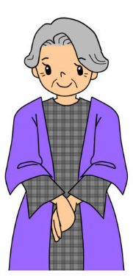 |  | 
1.What does she look like ?  She is old / young . | 2.What does he look like?  He is big /slim. | 3.What does he look like?  He is small/big
 | 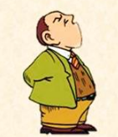 | 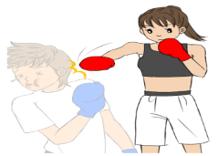
4. What does she look like ?  She is big /slim. | 5.What does he look like ?  He is short / tall. | 6.What does she look like ?  She is strong /weak.
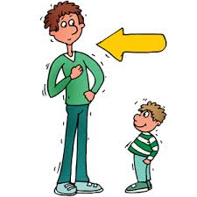 | 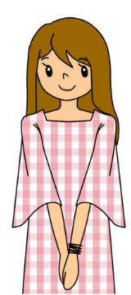 | 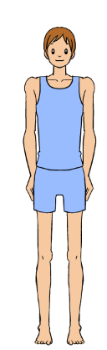
7.What does he look like ?  He is short /tall. | 8. What does she look like ?  She is young /old. | 9. What does he look like ?  He is old/thin.
Task 2. Look and answer these questions.
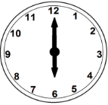 | 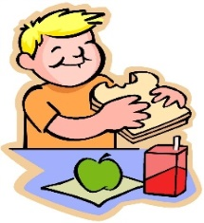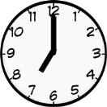 | 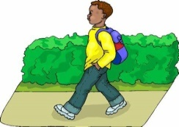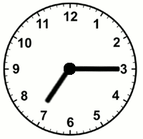
1. What time does he get up ? | 2. What time does he have  breakfast ? | 3. What time does he go to  school ?
He gets up at six o’clock.
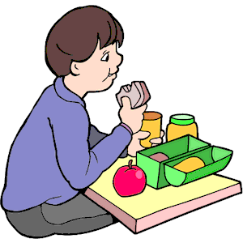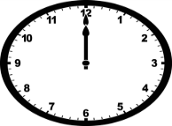 | 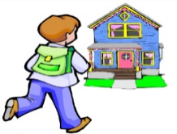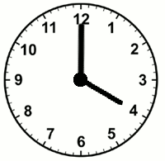 | 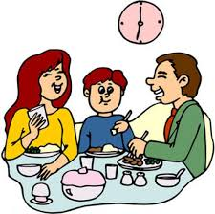
4. What time does he have  lunch ? | 5. What time does he go  home ? | 6. What time do they have  dinner ?
Task 3. Put the words in correct order.
- like ?/ father / What/ your/ does/ look
.............................................................................................................................................
- me/ brother/ is/ older/ My/ than/.
............................................................................................................................................
- is / She/tall/ and / thin.
...........................................................................................................................................
4. father/ My/ is/ brother/ than/ taller/ my/.
............................................................................................................................................
5. my mother / fatter / is/ My sister / than
..........................................................................................................................................
6. She/ to / bed /goes /at /10 / o’clock/.
.........................................................................................................................................
7. Let’s/ swimming / go / to / the /pool/.
..........................................................................................................................................
8. some/ to / books/ want/ I / buy/.
..........................................................................................................................................
9. Why/ you/ go/ the / to/ cinema/ do/ want/?
........................................................................................................................................
10. She/ to / buy/ wants/ some/medicine/.
.........................................................................................................................................
11. There/ a/ is /supermarket/ near / my home/.
.........................................................................................................................................
12. they/ Because/ want/ to/ play football/ and/ badminton/.
.........................................................................................................................................
13. is / The/ yellow / jacket /very/ nice/.
.........................................................................................................................................
14. the/ How/ much/ are/ jeans/ ?
.........................................................................................................................................
15. like / Would / you/to / go/ swimming pool/?
.........................................................................................................................................
16. What's /phone / his /number?
.........................................................................................................................................
Task 4. Circle a , b, or c.
1. When is Children’s Day ? It is _____________________the first of June.
A. in B. on C. at D. of
2. I'd like ........... apple, please.
A. a B. four C. an D. and
3. His book are ................. the table
A. at B.between C. down D. on
4. How ......................... books on the table? There are 3 books.
A. much B. very C. many D. on
5. .................... pens are there in your bag? There are 2 pens.
A. How old B. When C. How D. How many
6. They live .................... England.
A. on B. in C. under D. for
7. What's ................... name? - He's Tommy.
A. my B. his C. she D. he
8. I would like an apple. - Here you ..............................
A. is B. are C. a D. an
9. Peter can ................ a bike.
A. ride B. play C. stay D. drink
10. ........................... you like a candy? No, thanks.
A. Who B. When C. Would D. How
Task 5. Read and tick () T(True ) or F(False).
Children’s Day is the most interesting festival for children. It’s on the first of June .On this day , children do not study at school .They have a party at school or at home. They have a lot of fun .they get presents from their parents. They sing, dance, play games, eat cakes and candies at the party. Children are happy on Children’s Day.
 | T | F
1. Children’s Day is on the 1st Of July
2. It is the most interesting festival for children.
3. On this day , children study at school.
4. They get presents from their parents.
5. They like this festival very much.

Task 6. Read and match.
- What color is the skirt ? | - It’s one hundred thousand dong.
- Where does your father work ? | - I’m going to the bookshop.
- How much are these socks ? | - Because I want to buy something to eat.
- Why do you want to go to the supermarket? | - They’re thirty thousand dong.
- What color are those jeans ? | - The skirt is pink.
- Would you like some noodles ? | - My father works in a hospital.
- How much is the T shirt ? | - Yes, please. I love noodles.
- Do you like this skirt ? | - Thank you.
- Oh, your T – shirt is very nice. | - Yes, I do.
- Let’s go to the zoo, Linda. | 10) I’m going to the bookshop.
- Where are you going ? | 11) Sorry, I can’t.
- What does your sister look like ? | 12) His favorite food is beef.
- What did you do last Sunday ? | 13) My sister is young and tall.
- What is his favorite food ? | 14) I visited my grandparents last Sunday.
Task 7. Read and complete.
hospital | teacher | 4B | works | four

My name is Ben. There are (1)…………………….people in my family : my parents, my brother and me. My dad is a (2)………………….. he works in New Scotland Hill Primary School. My mother is a nurse. She works in Wellington (3) ……………………My brother is a worker. He (4)………………in a car factory. And as you know, I am a pupil in Class (5)……….. I love my family and I am happy at my school.
Task 8. Look at the picture and answer the questions.
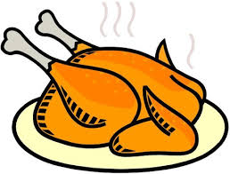 | 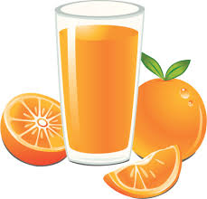
1. What’s his favourite food ? | 2. What’s her favourite drink ?
His favourite food is chicken.
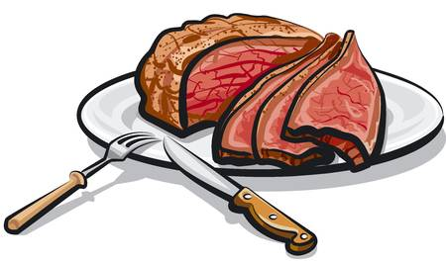 | 
3. What's your favourite food? | 4. What’s his favourite drink ?
 | 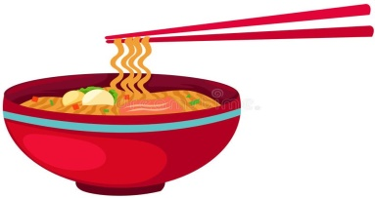
5. Do you like vegetables? | 6. What’s her favourite food ?
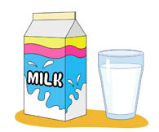 | 
7. Does she like milk ? | 8. Does he like rice ?
Task 9. Look and write.

1. rusen → _ _ _ _ _ | 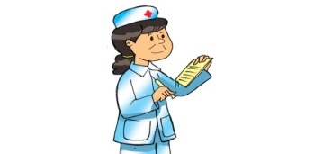
2. codretae → _ _ _ _ _ _ _ _the house | 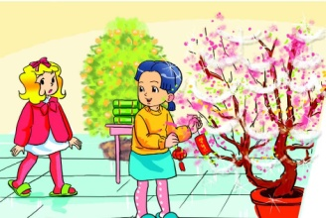
3. tiesvfla → _ _ _ _ _ _ _ _ for children | 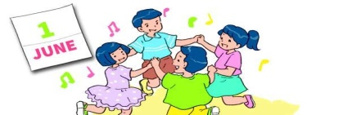
4. kybera → _ _ _ _ _ _ | 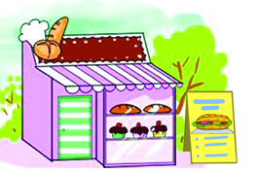
5. enicam →_ _ _ _ _ _ | 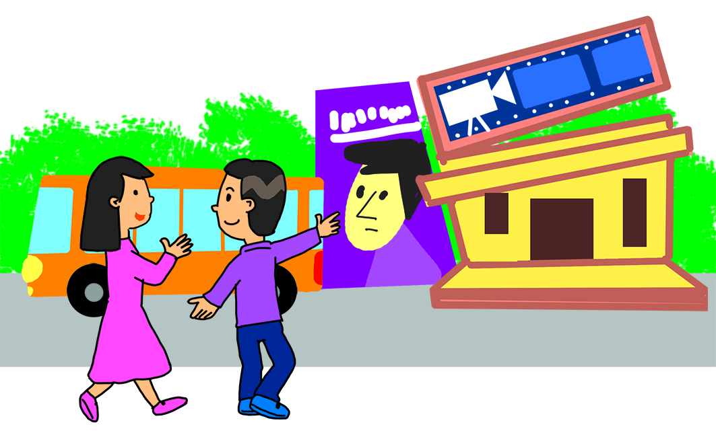

Task 10. Look at the picture and answer the questions
No | Question - Answer | Picture
 | What animal is that ?  …………………………………………………… | 
 | What colour is the panda ?  …………………………………………………… | 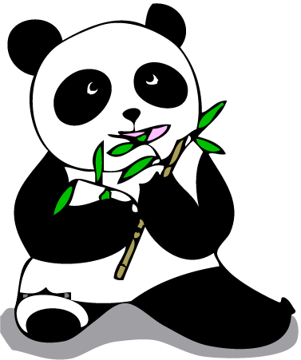
 | Is that an elephant?  No , ………………………………………. | 
 | What is the horse doing ?  ……………………………………………. | 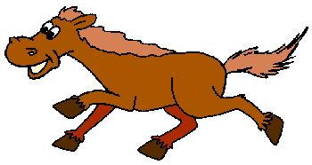

The end

