REVISION - UNIT 7- TELEVISION
Exercise 1: Divide the words into two columns according to pronunciation of the underlined part.
thief teeth leather thing mouth
they father this health smooth
than thirsty there other through
three cloth thigh those either
month three breath width strength
another author together with breathe
/θ/ | /ð/
................................. .................................  ................................. .................................  ................................. .................................  ................................. .................................  ................................. .................................  ................................. ................................. | ................................. .................................  ................................. .................................  ................................. .................................  ................................. .................................  ................................. .................................  ................................. .................................
Exercise 2: Use the given words to complete the second part of each phrase.
programme | show | control
television | button | activity
1. local_____________. 2. news_____________. 3. volume____________.
4. game_____________. 5. remote____________. 6. outdoor____________.
Exercise 3: Look at the picture and tell who/ what they are.
viewer | newsreader | sport program | cartoon
remote control | newspaper | weatherman | MC
 |  | 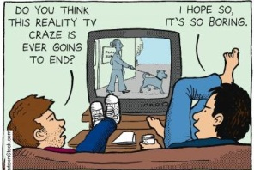 | 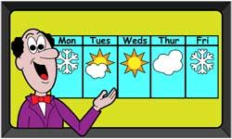
1. ______________ | 2. ______________ | 3. ______________ | 4. ______________
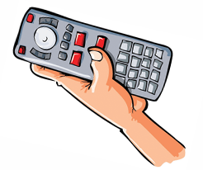 |  | 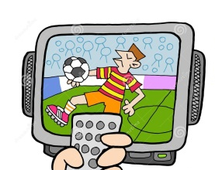 | 
5. ______________ | 6. ______________ | 7. ______________ | 8. ______________
Exercise 4: Read the definitions and complete the blanks with given words.
entertain |  | channel | comedian | viewer |  | newspaper
schedule |  | weatherman | cartoon | remote control |  | broadcast
No. | Definitions |  |  |  | Word
1. | A band of radio waves used for broadcasting television or radio programmes |  |  |  | _____________________
2. | A film/movie made by photographing a series of gradually changing drawings or models, so that they look as if they are moving |  |  |  | _____________________
3. | A set of large printed sheets of paper containing news, articles, advertisements, etc. and published every day or every week |  |  |  | _____________________
4. | A list of the television and radio programmes that are on a particular channel and the times that they start |  |  |  | _____________________
5. | An entertainer who makes people laugh by telling jokes or funny stories |  |  |  | _____________________
6. | To send out programmes on television or radio |  |  |  | _____________________
7. | To interest and amuse somebody in order to please them |  |  |  | _____________________
8. | A person watching television |  |  |  | _____________________
9. | A man on radio or television whose job is describing the weather and telling people what it is going to be like |  |  |  | _____________________
10. | A device that allows you to operate a television, etc. from a distance |  |  |  | _____________________
Exercise 5: Complete the sentences with and, but, so, because, although.
1. I want to work as an interpreter in the future, ___________ I am studying Russian.
2. When she got the news from her family, she couldn’t do anything ___________ cry.
3. ___________ we live in the same building, we have hardly seen each other.
4. I went to buy a Rolling Stones CD, ___________ the shop didn’t have it.
5. Anna needs some money, ___________ she took a part time job.
6. Julie has a guitar ___________ she plays it really well.
7. The concert was cancelled ___________ we went to watch a movie instead.
8. ___________ my sister had not written a note for me, my fingers were injured.
9. This is an expensive ___________ useful book.
10. I don’t like him, ___________ I agree that he has good manners.
Exercise 6: Decide if each sentence is true or false and correct wrong sentences.
1. He is only sixteen, so he is not allowed to drive a car.
2. Maria tried to read a novel in French, and the book was too difficult for her to understand.
3. To get from Vancouver to Victoria, you can fly, or you can ride the ferry.
4. I bought a bottle of wine and we drank it together.
5. The waiter was not very nice, or the food was delicious.
6. Although he worked very hard, he still cannot earn enough money to support his family.
7. I wanted to give him some money after he helped me with the car although he absolutely refused to accept it.
8. Everyone is ready for the discussion in spite of him.
9. In spite of I was tired, I managed to finish the work.
10. Is her child a boy or a girl?
11. I forgot to bring the map, or I got lost.
12. He failed the examination because of he didn’t study hard enough.
13. Lien won the match although she was injured.
14. My new classmate is quite friendly and sociable.
15. I don’t like watching films on TV and I like watching them at the cinema.
Exercise 7: Complete the questions with question words.
1. _________ did she go to the doctor? - Because she had a splitting headache.
2. _________ does he teach in the high school? – English.
3. _________ did Nam leave home yesterday? – At 7 o’clock.
4. _________ does she often do exercises? – After she finishes her homework.
5. _________ roses do they plant in the garden? – I don’t know, just some.
6. _________ does she learn about in computer science class? – Computer.
7. _________ is your mother doing in the kitchen? – She is cooking.
8. _________ sports does Mai like playing after school? – Badminton.
9. _________ do you go to the movies? – Twice a week.
10. _________ do they stay? – In a hotel on Apple street.
Exercise 8. Join each pair of sentences, using the word in brackets.
1. Nathan missed the bus. He was late for school. (because)

2. Keep the food covered. The flies will contaminate it. (or)

3. Julie has a guitar. She plays it very well. (and)

4. I need to study hard. I can get a good score on the test. (so)

5. He seemed a friendly person. I didn’t like him. (although)

6. The food looks delicious. It tastes horrible. (but)

7. Mason fell. The floor was wet. (because)

8. Anna took a part-time job. She needed some money. (so)

Exercise 9. Choose the correct answers.
1. Fruit tastes good _________ it’s healthy for your body.
A. but B. and C. so D. or
2. I want to buy a new jacket, _________ I don’t have enough money.
A. and B. so C. but D. because
3. Linda is going to make a cake, _________ she needs some eggs and flour.
A. so B. but C. and D. or
4. We went for a walk _________ it was raining heavily.
A. because B. although C. therefore D. however
5. We can go to the pool _________ we can go horse-riding, whichever you prefer?
A. or B. but C. and D. so
6. John likes funny movies _________ he doesn’t like scary movies.
A. and B. or C. so D. but
7. I’d like to see that Korean band _________ their music is pretty cool.
A. although B. so C. because D. but
8. I still cry at the end _________ I’ve seen this movie several times.
A. and B. although C. because D. so
9. You must hurry _________ you will miss your train.
A. so B. but C. and D. or
10. His chocolate was too hot, _________ he put some cold milk in it.
A. so B. but C. because D. although
11. Mickey and Donald are two famous ________ in America and over the world.
A. comedian B. cartoon characters C. main character D. channel
12. A person who reads the news on television or radio is a ________.
A. MC B. newsreader C. weatherman D. weathergirl
13. “Life in the water” is a ________ about the colourful living world in the Pacific.
A. comedian B. game show C. channel D. documentary
14. This channel has a lot of interesting programmes. Do you want to check its _______?
A. schedule B. series C. volume button D. channel
15. “The Face” is a famous ________ in Vietnam where models compete with each other to be the winner.
A. game show B. documentary C. cartoon D. comedy
16. Do you know what time the film is ________?
A. announce B. broadcast C. watch D. entertain
Exercise 10. Write questions to the underlined words.
1.
My father watches the News every night.
2.
Tom Hank is my favourite actor.
3.
We usually watch TV in the evening.
4.
Tim is watching a game show now.
5.
I like music programme best.
6.
The game show Are you smarter than a 5th grader? is on 8 p.m.
7.
Many children like cartoons because they are funny.
8.
The Red Spotted Squirrel lasts twenty-five minutes.
9.
They watch TV two or three hours every day.
10.
The Old Town of Inca is in Peru.
Exercise 11: Read and answer the questions.
Television enables us to see things in distant places. It is indeed one of the most wonderful things that man has ever invented.
Television not only entertains people but also teaches people a variety of important things. Through this wonderful invention we learn about people and events thousands of miles away. Pictures taken in all parts of the world are also shown on television for entertainment as well as for instruction. Short films based on popular stories are often shown which entertain millions of people all over the world.
In some countries television is used to teach pupils and students many useful lessons. Students who cannot go to school because of transport or other problems are taught all their lessons at home through television.
As television appeals to the eye instead of the ear, people enjoy watching more than listening to the radio. Listening requires knowledge of many things, but what we see with our eyes explains that itself.
For all these reasons, there is no doubt that television will continue to be popular for a long time.
1. What is television considered as?
.
2. What do we learn through television?
.
4. What do people prefer, watching or listening?
.
5. How can students obtain knowledge if they cannot go to school?
.
6. What is the difference between listening and watching?
.
REVISION - UNIT 8- SPORTS AND GAMES
Exercise 1: Choose the word that has the underlined part pronounced differently.
1. A. clear B. prepare C. real D. fear
2. A. bare B. care C. tear D. air
3. A. dare B. career C. deer D. area
4. A. invariable B. chair C. square D. engineer
5. A. beard B. vegetarian C. cheer D. gear
6. A. upstairs B. swear C. carrier D. stare
7. A. heir B. shear C. sphere D. theater
8. A. various B. librarian C. wear D. dreary
9. A. near B. pair C. dear D. rear
10. A. beer B. bear C. fare D. dairy
Exercise 2: Look at the pictures and write the name of sports/ games.
 | 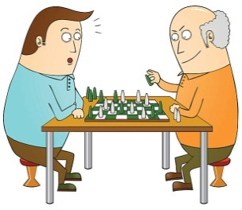 | 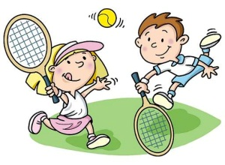 | 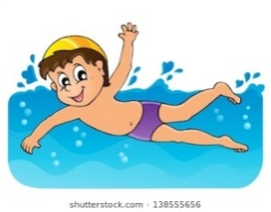
1. ______________ | 2. ______________ | 3. ______________ | 4. ______________
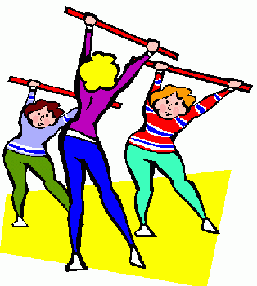 | 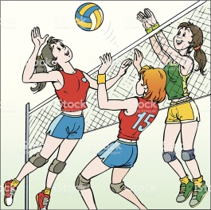 |  | 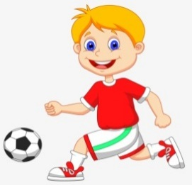
5. ______________ | 6. ______________ | 7. ______________ | 8. ______________
Exercise 3: Which sports/ games are used with go/ play/ do.
swimming volleyball cycling football jogging
boxing tennis aerobics karate
 | ....................... |  | ....................... |  | .......................
go | ....................... | play | ....................... | do | .......................
 | ....................... |  | ....................... |  | .......................
Exercise 4: Change the verbs into simple past form.
No. | Present form | Past form | No. | Present form | Past form
1. | be | _________________ | 9. | read | _________________
2. | play | _________________ | 10. | listen | _________________
3. | build | _________________ | 11. | learn | _________________
4. | do | _________________ | 12. | drink | _________________
5. | bring | _________________ | 13. | work | _________________
6. | feel | _________________ | 14. | forget | _________________
7. | find | _________________ | 15. | have | _________________
8. | give | _________________ | 16. | eat | _________________
Exercise 5. Turn the sentences into negative and interrogative forms.
1. They were in Rio last summer.

2. We did our exercise this morning.

3. My parents came to visit me last July.

4. The hotel was very expensive.

5. I had a bicycle when I was young

6. The children went to the zoo yesterday.

7. Ernie ate the last doughnut.

8. They bought a new house last month.

Exercise 6. Fill in the sentences with the correct form (past simple) of the verbs in brackets.
1. I ____________ (see) the film last night but I ____________ (not like) it.
2. ____________ (Marco/ win) the golf competition?
3. They ____________ (not play) very well yesterday. They ____________ (lose) the match.
4. How many goals _________________ (your team/ score) in the first half?
5. I ____________ (be) very tired, so I ____________ (go) to bed early last night.
6. ____________ (you/ go) swimming this morning?
7. The children ____________, (not be) hungry, so they ____________ (not eat) anything.
8. Susan and her friends ____________ (come) to Japan three months ago.
9. I ____________ (have) a wonderful holiday with my family last July.
10. Jane ________ (not be) at the party last Sunday, so she ________ (not know)what happened.
Exercise 7: Choose the words in the box to complete the sentences using past simple tense.
teach | cook | want | spend | ring
be | sleep | study | go | write
1. She ___________ out with her boyfriend last night.
2. Laura ___________ a meal yesterday afternoon.
3. Mozart ___________ more than 600 pieces of music.
4. I ___________ tired when I came home.
5. The bed was very comfortable so they ___________ very well.
6. Jamie passed the exam because he ___________ very hard.
7. My father ___________ the teenagers to drive when he was alive.
8. Dave ___________ to make a fire but there was no wood.
9. The little boy ___________ hours in his room making his toys.
10. The telephone ___________ several times and then stopped before I could answer it.
Exercise 8: Choose the best options to complete the following sentences.
1. I often practice ________ in the gym four times a week.
A. boxing B. fishing C. driving
2. It’s snowy outside. We can go ________.
A. tennis B. skiing C. football
3. He sometimes goes ________ with his father at weekends.
A. badminton B. table tennis C. swimming
4. The ________ has attracted many famous athletes this year.
A. sports competition B. Game Show C. music event
5. I like playing ________. It makes me more intelligent.
A. aerobics B. gym C. chess
6. In a ________ match, players will try to kick the ball to the other team’s goal to score.
A. basketball B. football C. volleyball
7. Why don’t you do ________? It can help you protect yourself.
A. cycling B. karate C. skateboarding
8. Boys often play ________ in the schoolyard at break time.
A. aerobics B. cycling c. marbles
Exercise 9: Read and answer the questions.
My last Sports Day occurred on the 8th of September in 2016. On that day, the school was beautifully decorated with colorful flags. Parents were invited to watch their children participate in many events.
In the morning, our class was divided into four groups and they competed against one another. The children used balls, hoops, skipping-ropes and bags in the competition. The parents cheered them very much.
In the afternoon, we had more interesting events. The Upper Primary students competed in many sports such as hurdles, relay races, short distance races, high jump and long jump. Every participant tried their best to win as many trophies as possible for their team.
The prize-giving ceremony marked the end of the exciting day. The winners were cheered and carried on their classmates’ shoulders. Though we were very tired, we had enjoyed ourselves very much.
1. When did her last Sports Day take place?

2. What was the school decorated with?

3. Who were invited to watch her children participate in many events?

4. What did the children use in the competition?

5. What sports did the Upper Primary student compete in?

6. Why did the participants try their best?

Exercise 10: Write the question for the underlined part in each sentence
1. It took her three hours to finish the composition.
.
2. The homework was very difficult yesterday.
.
3. I made it from a piece of wood.
.
4. She bought it at the shop over there.
.
5. It took her three hours to finish the composition.
.
6. Her neighbor gave her a nice dress.
.
7. They returned to America two weeks ago.
.
8. He travelled to Nha Trang by coach.
.

KEYS
REVISION - UNIT 7- TELEVISION
Exercise 1: Divide the words into two columns according to pronunciation of the underlined part.
/θ/ | /ð/
thief teeth  author thing  mouth three  thirsty thigh  health through  month cloth  breath width  strength | they father  this other  smooth than  those there  another either  together leather  breathe with
Exercise 2: Use the given words to complete the second part of each phrase.
1. television 2. programme 3. button
4. show 5. control 6. activity
Exercise 3: Look at the picture and tell who/ what they are.
1. newspaper 2. MC 3. viewer 4. weatherman
5. remote control 6. newsreader 7. sport program 8. cartoon
Exercise 4: Read the definitions and complete the blanks with given words.
1. channel 2. cartoon 3. newspaper 4. schedule 5. comedian
6. broadcast 7. entertain 8. viewer 9. weatherman 10. remote control
Exercise 5: Complete the sentences with and, but, so, because, although.
1. so 2. but 3. Although 4. but 5. so
6. and 7. so 8. Because 9. but 10. but
Exercise 6: Decide if each sentence is true or false and correct wrong sentences.
1. 6. cannot couldn’t 11. or so
2. and but 7. although but 12. because of because
3. 8. in spite of but 13.
4. 9. In spite of Although 14.
5. or but 10. 15. and but
Exercise 7: Complete the questions with question words.
1. Why 2. What 3. What time 4. When 5. How many
6. What 7. What 8. What 9. How often 10. Where
Exercise 8. Join each pair of sentences, using the word in brackets.
1. Nathan was late for school because he missed the bus.
2. Keep the food covered, or the flies will contaminate it.
3. Julie has a guitar and she plays it very well.
4. I need to study hard, so I can get a good score on the test.
5. Although he seemed a friendly person, I didn’t like him.
6. The food looks delicious, but it tastes horrible.
7. Mason fell because the floor was wet.
8. Anna needed some money, so she took a part-time job.
Exercise 9. Choose the correct answers.
1. B 2. C 3. A 4. B 5. A 6. D 7. C 8. B
9. D 10. A 11. B 12. B 13. D 14. A 15. A 16. B
Exercise 10. Write questions to the underlined words.
1. How often does your father watch the News?
2. Who is your favourite actor?
3. When do you usually watch TV?
4. What is Tim doing now?
5. What programme do you like best?
6. What time is the game show Are you smarter than a 5th grader? on?
7. Why do many children like cartoons?
8. How long does The Red Spotted Squirrel last?
9. How many hours do they watch TV every day?
10. Where is The Old Town of Inca?
Exercise 11: Read and answer the questions.
1. It is considered to be one of the most wonderful things that man has ever invented.
2. We learn about people and events thousands of miles away.
3. They are based on popular stories.
4. They prefer watching.
5. They are taught all their lessons at home through television.
6. Listening requires knowledge of many things, but what we see with our eyes explains that itself.

REVISION - UNIT 8- SPORTS AND GAMES
Exercise 1: Choose the word that has the underlined part pronounced differently.
1. B 2. C 3. A 4. D 5. B
6. C 7. A 8. D 9. B 10. A
Exercise 2: Look at the pictures and write the name of sports/ games.
1. boxing 2. chess 3. tennis 4. swimming
5. aerobics 6. volleyball 7. skateboarding 8. football
Exercise 3: Which sports/ games are used with go/ play/ do.
 | swimming |  | volleyball |  | boxing
go | cycling | play | tennis | do | aerobics
 | jogging |  | football |  | karate
Exercise 4: Change the verbs into simple past form.
1. was 6. felt 11. learnt
2. played 7. found 12. drank
3. built 8. gave 13. worked
4. did 9. read 14. forgot
5. brought 10. listened 15. Had
Exercise 5. Turn the sentences into negative and interrogative forms.
1.They weren’t in Rio last summer.
Were they in Rio last summer?
2.We didn’t do our exercise this morning.
Did you do your exercise this morning?
3.My parents didn’t come to visit me last July.
Did your parents come to visit you last July?
4.The hotel wasn’t very expensive.
Was the hotel very expensive?
5.I didn’t have a bicycle when I was young.
Did you have a bicycle when you were young?
6.The children didn’t go to the zoo yesterday.
Did the children go to the zoo yesterday?
7.Ernie didn’t eat the last doughnut.
Did Ernie eat the last doughnut?
8. They didn’t buy a new house last month.
Did they buy a new house last month?
Exercise 6. Fill in the sentences with the correct form (past simple) of the verbs in brackets.
1.saw-didn t like 2. Did Marco win 3. didn’t play - lost 4. did your team score
5. was – went 6. Did you go 7. weren’t - didn’t eat 8. came
9. had 10. wasn’t – didn’t know
Exercise 7: Choose the words in the box to complete the sentences using past simple tense.
1. went 2. cooked 3. wrote 4. was 5. slept
6. studied 7. taught 8. wanted 9. spent 10. rang
Exercise 8: Choose the best options to complete the following sentences.
1. A | 2. B | 3. C | 4. A
5. C | 6. B | 7. B | 8. C
Exercise 9: Read and answer the questions.
1. It took place on September 8th, 2016.
2. It was decorated with colorful flags.
3. Parents were.
4. They used balls, hoops, skipping ropes and bags in the competition.
5. Hurdles, relay races, short distance races, high jump and long jump.
6. They tried their best to win as many trophies as possible for their team.
Exercise 10: Write the question for the underlined part in each sentence.
1. How long did it take her to finish the composition?
2. How was the homework yesterday?
3. What did you make it from?
4. Where did she buy it?
5. How long did it take her to finish the composition?
6. Who/Whom did the neighbor give a nice dress to?
7. When did they return to America?
8. How did he travel to NhaTrang?

^{BGH DUYỆT}  ^{Nguyễn Thị Minh Ngọc} |  | ^{NGƯỜI RA NỘI DUNG}  ^{Phạm Thị Thúy Nga}

