ĐỀ CƯƠNG ÔN TẬP- MÔN TIẾNG ANH 6
Full name: _________________________________________________________
WEEK 21
Exercise 1: Divide the words into two columns according to pronunciation of the underlined part.
thief teeth leather thing mouth
they father this health smooth
than thirsty there other through
three cloth thigh those either
month three breath width strength
another author together with breathe
/θ/ | /ð/
................................. .................................  ................................. .................................  ................................. .................................  ................................. .................................  ................................. .................................  ................................. ................................. | ................................. .................................  ................................. .................................  ................................. .................................  ................................. .................................  ................................. .................................  ................................. .................................
Exercise 2: Use the given words to complete the second part of each phrase.
programme | show | control
television | button | activity
1. local_____________. 2. news_____________. 3. volume____________.
4. game_____________. 5. remote____________. 6. outdoor____________.
Exercise 3: Look at the picture and tell who/ what they are.
viewer | newsreader | sport program | cartoon
remote control | newspaper | weatherman | MC
 |  | 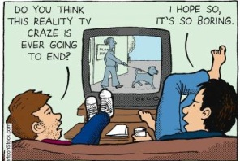 | 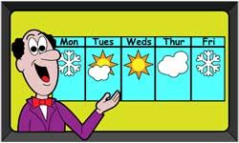
1. ______________ | 2. ______________ | 3. ______________ | 4. ______________
 |  | 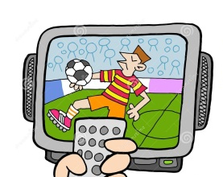 | 
5. ______________ | 6. ______________ | 7. ______________ | 8. ______________
Exercise 4: Read the definitions and complete the blanks with given words.
entertain |  | channel | comedian | viewer |  | newspaper
schedule |  | weatherman | cartoon | remote control |  | broadcast
No. | Definitions |  |  |  | Word
1. | A band of radio waves used for broadcasting television or radio programmes |  |  |  | _____________________
2. | A film/movie made by photographing a series of gradually changing drawings or models, so that they look as if they are moving |  |  |  | _____________________
3. | A set of large printed sheets of paper containing news, articles, advertisements, etc. and published every day or every week |  |  |  | _____________________
4. | A list of the television and radio programmes that are on a particular channel and the times that they start |  |  |  | _____________________
5. | An entertainer who makes people laugh by telling jokes or funny stories |  |  |  | _____________________
6. | To send out programmes on television or radio |  |  |  | _____________________
7. | To interest and amuse somebody in order to please them |  |  |  | _____________________
8. | A person watching television |  |  |  | _____________________
9. | A man on radio or television whose job is describing the weather and telling people what it is going to be like |  |  |  | _____________________
10. | A device that allows you to operate a television, etc. from a distance |  |  |  | _____________________
Exercise 5. Choose the correct answers.
1. Mickey and Donald are two famous ________ in America and over the world.
A. comedian B. cartoon characters C. main character D. channel
2. A person who reads the news on television or radio is a ________.
A. MC B. newsreader C. weatherman D. weathergirl
3. “Life in the water” is a ________ about the colourful living world in the Pacific.
A. comedian B. game show C. channel D. documentary
4. This channel has a lot of interesting programmes. Do you want to check its _______?
A. schedule B. series C. volume button D. channel
5. “The Face” is a famous ________ in Vietnam where models compete with each other to be the winner.
A. game show B. documentary C. cartoon D. comedy
6. Do you know what time the film is ________?
A. announce B. broadcast C. watch D. entertain

WEEK 22
Exercise 1 . Choose the correct answers.
1. Fruit tastes good _________ it’s healthy for your body.
A. but B. and C. so D. or
2. I want to buy a new jacket, _________ I don’t have enough money.
A. and B. so C. but D. because
3. Linda is going to make a cake, _________ she needs some eggs and flour.
A. so B. but C. and D. or
4. We went for a walk _________ it was raining heavily.
A. because B. although C. therefore D. however
5. We can go to the pool _________ we can go horse-riding, whichever you prefer?
A. or B. but C. and D. so
6. John likes funny movies _________ he doesn’t like scary movies.
A. and B. or C. so D. but
7. I’d like to see that Korean band _________ their music is pretty cool.
A. although B. so C. because D. but
8. I still cry at the end _________ I’ve seen this movie several times.
A. and B. although C. because D. so
9. You must hurry _________ you will miss your train.
A. so B. but C. and D. or
10. His chocolate was too hot, _________ he put some cold milk in it.
A. so B. but C. because D. although
Exercise 2: Complete the sentences with and, but, so, because, although.
1. I want to work as an interpreter in the future, ___________ I am studying Russian.
2. When she got the news from her family, she couldn’t do anything ___________ cry.
3. ___________ we live in the same building, we have hardly seen each other.
4. I went to buy a Rolling Stones CD, ___________ the shop didn’t have it.
5. Anna needs some money, ___________ she took a part time job.
6. Julie has a guitar ___________ she plays it really well.
7. The concert was cancelled ___________ we went to watch a movie instead.
8. ___________ my sister had not written a note for me, my fingers were injured.
9. This is an expensive ___________ useful book.
10. I don’t like him, ___________ I agree that he has good manners.
Exercise 3: Complete the questions with question words.
1. _________ did she go to the doctor? - Because she had a splitting headache.
2. _________ does he teach in the high school? – English.
3. _________ did Nam leave home yesterday? – At 7 o’clock.
4. _________ does she often do exercises? – After she finishes her homework.
5. _________ roses do they plant in the garden? – I don’t know, just some.
6. _________ does she learn about in computer science class? – Computer.
7. _________ is your mother doing in the kitchen? – She is cooking.
8. _________ sports does Mai like playing after school? – Badminton.
9. _________ do you go to the movies? – Twice a week.
10. _________ do they stay? – In a hotel on Apple street.
Exercise 4. Join each pair of sentences, using the word in brackets.
1. Nathan missed the bus. He was late for school. (because)

2. Keep the food covered. The flies will contaminate it. (or)

3. Julie has a guitar. She plays it very well. (and)

4. I need to study hard. I can get a good score on the test. (so)

5. He seemed a friendly person. I didn’t like him. (although)

6. The food looks delicious. It tastes horrible. (but)

7. Mason fell. The floor was wet. (because)

8. Anna took a part-time job. She needed some money. (so)

Exercise 5. Write questions to the underlined words.
1.
My father watches the News every night.
2.
Tom Hank is my favourite actor.
3.
We usually watch TV in the evening.
4.
Tim is watching a game show now.
5.
I like music programme best.
6.
The game show Are you smarter than a 5th grader? is on 8 p.m.
7.
Many children like cartoons because they are funny.
8.
The Red Spotted Squirrel lasts twenty-five minutes.
9.
They watch TV two or three hours every day.
10.
The Old Town of Inca is in Peru.

WEEK 23
Exercise 1: Choose the word that has the underlined part pronounced differently.
1. A. clear B. prepare C. real D. fear
2. A. bare B. care C. tear D. air
3. A. dare B. career C. deer D. area
4. A. invariable B. chair C. square D. engineer
5. A. beard B. vegetarian C. cheer D. gear
6. A. upstairs B. swear C. carrier D. stare
7. A. heir B. shear C. sphere D. theater
8. A. various B. librarian C. wear D. dreary
9. A. near B. pair C. dear D. rear
10. A. beer B. bear C. fare D. dairy
Exercise 2: Look at the pictures and write the name of sports/ games.
 | 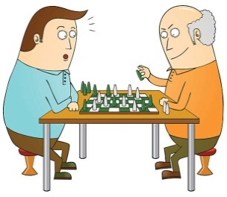 | 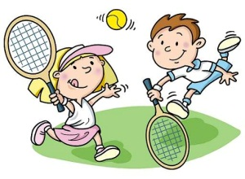 | 
1. ______________ | 2. ______________ | 3. ______________ | 4. ______________
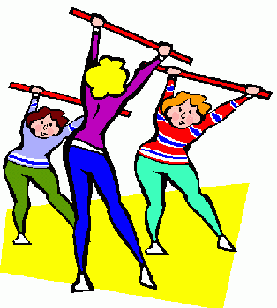 | 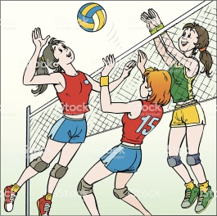 |  | 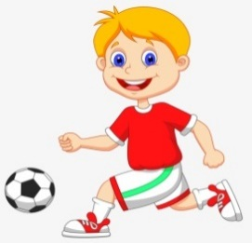
5. ______________ | 6. ______________ | 7. ______________ | 8. ______________
Exercise 3: Which sports/ games are used with go/ play/ do.
swimming volleyball cycling football jogging
boxing tennis aerobics karate
 | ....................... |  | ....................... |  | .......................
go | ....................... | play | ....................... | do | .......................
 | ....................... |  | ....................... |  | .......................
Exercise 4: Choose the best options to complete the following sentences.
1. I often practice ________ in the gym four times a week.
A. boxing B. fishing C. driving
2. It’s snowy outside. We can go ________.
A. tennis B. skiing C. football
3. He sometimes goes ________ with his father at weekends.
A. badminton B. table tennis C. swimming
4. The ________ has attracted many famous athletes this year.
A. sports competition B. Game Show C. music event
5. I like playing ________. It makes me more intelligent.
A. aerobics B. gym C. chess
6. In a ________ match, players will try to kick the ball to the other team’s goal to score.
A. basketball B. football C. volleyball
7. Why don’t you do ________? It can help you protect yourself.
A. cycling B. karate C. skateboarding
8. Boys often play ________ in the schoolyard at break time.
A. aerobics B. cycling c. marbles

WEEK 24
Exercise 1: Change the verbs into simple past form.
No. | Present form | Past form | No. | Present form | Past form
1. | be | _________________ | 9. | read | _________________
2. | play | _________________ | 10. | listen | _________________
3. | build | _________________ | 11. | learn | _________________
4. | do | _________________ | 12. | drink | _________________
5. | bring | _________________ | 13. | work | _________________
6. | feel | _________________ | 14. | forget | _________________
7. | find | _________________ | 15. | have | _________________
8. | give | _________________ | 16. | eat | _________________
Exercise 2. Turn the sentences into negative and interrogative forms.
1. They were in Rio last summer.

2. We did our exercise this morning.

3. My parents came to visit me last July.

4. The hotel was very expensive.

5. I had a bicycle when I was young

6. The children went to the zoo yesterday.

7. Ernie ate the last doughnut.

8. They bought a new house last month.

Exercise 3. Fill in the sentences with the correct form (past simple) of the verbs in brackets.
1. I ____________ (see) the film last night but I ____________ (not like) it.
2. ____________ (Marco/ win) the golf competition?
3. They ____________ (not play) very well yesterday. They ____________ (lose) the match.
4. How many goals _________________ (your team/ score) in the first half?
5. I ____________ (be) very tired, so I ____________ (go) to bed early last night.
6. ____________ (you/ go) swimming this morning?
7. The children ____________, (not be) hungry, so they ____________ (not eat) anything.
8. Susan and her friends ____________ (come) to Japan three months ago.
9. I ____________ (have) a wonderful holiday with my family last July.
10. Jane ________ (not be) at the party last Sunday, so she ________ (not know)what happened.
Exercise 4: Choose the words in the box to complete the sentences using past simple tense.
teach | cook | want | spend | ring
be | sleep | study | go | write
1. She ___________ out with her boyfriend last night.
2. Laura ___________ a meal yesterday afternoon.
3. Mozart ___________ more than 600 pieces of music.
4. I ___________ tired when I came home.
5. The bed was very comfortable so they ___________ very well.
6. Jamie passed the exam because he ___________ very hard.
7. My father ___________ the teenagers to drive when he was alive.
8. Dave ___________ to make a fire but there was no wood.
9. The little boy ___________ hours in his room making his toys.
10. The telephone ___________ several times and then stopped before I could answer it.
Exercise 5: Write the question for the underlined part in each sentence
1. It took her three hours to finish the composition.
.
2. The homework was very difficult yesterday.
.
3. I made it from a piece of wood.
.
4. She bought it at the shop over there.
.
5. It took her three hours to finish the composition.
.
6. Her neighbor gave her a nice dress.
.
7. They returned to America two weeks ago.
.
8. He travelled to Nha Trang by coach.
.

KEYS
WEEK 21
Exercise 1: Divide the words into two columns according to pronunciation of the underlined part.
/θ/ | /ð/
thief teeth  author thing  mouth three  thirsty thigh  health through  month cloth  breath width  strength | they father  this other  smooth than  those there  another either  together leather  breathe with
Exercise 2: Use the given words to complete the second part of each phrase.
1. television 2. programme 3. button
4. show 5. control 6. activity
Exercise 3: Look at the picture and tell who/ what they are.
1. newspaper 2. MC 3. viewer 4. weatherman
5. remote control 6. newsreader 7. sport program 8. cartoon
Exercise 4: Read the definitions and complete the blanks with given words.
1. channel 2. cartoon 3. newspaper 4. schedule 5. comedian
6. broadcast 7. entertain 8. viewer 9. weatherman 10. remote control
Exercise 5. Choose the correct answers.
1. B 2. C 3. A 4. B 5. A 6. D

WEEK 22

Exercise 1 . Choose the correct answers.
1. C 2. B 3. D 4. A 5. B 6. B 7. D 8. A 9. A 10. B

Exercise 2: Complete the sentences with and, but, so, because, although.
1. so 2. but 3. Although 4. but 5. so
6. and 7. so 8. Because 9. but 10. but
Exercise 3: Complete the questions with question words.
1. Why 2. What 3. What time 4. When 5. How many
6. What 7. What 8. What 9. How often 10. Where
Exercise 4. Join each pair of sentences, using the word in brackets.
1. Nathan was late for school because he missed the bus.
2. Keep the food covered, or the flies will contaminate it.
3. Julie has a guitar and she plays it very well.
4. I need to study hard, so I can get a good score on the test.
5. Although he seemed a friendly person, I didn’t like him.
6. The food looks delicious, but it tastes horrible.
7. Mason fell because the floor was wet.
8. Anna needed some money, so she took a part-time job.
Exercise 5. Write questions to the underlined words.
1. How often does your father watch the News?
2. Who is your favourite actor?
3. When do you usually watch TV?
4. What is Tim doing now?
5. What programme do you like best?
6. What time is the game show Are you smarter than a 5th grader? on?
7. Why do many children like cartoons?
8. How long does The Red Spotted Squirrel last?
9. How many hours do they watch TV every day?
10. Where is The Old Town of Inca?

WEEK 23
Exercise 1: Choose the word that has the underlined part pronounced differently.
1. B 2. C 3. A 4. D 5. B
6. C 7. A 8. D 9. B 10. A
Exercise 2: Look at the pictures and write the name of sports/ games.
1. boxing 2. chess 3. tennis 4. swimming
5. aerobics 6. volleyball 7. skateboarding 8. football
Exercise 3: Which sports/ games are used with go/ play/ do.
 | swimming |  | volleyball |  | boxing
go | cycling | play | tennis | do | aerobics
 | jogging |  | football |  | karate
Exercise 4: Choose the best options to complete the following sentences.
1. A | 2. B | 3. C | 4. A
5. C | 6. B | 7. B | 8. C

WEEK 24
Exercise 1: Change the verbs into simple past form.
1. was 6. felt 11. learnt
2. played 7. found 12. drank
3. built 8. gave 13. worked
4. did 9. read 14. forgot
5. brought 10. listened 15. Had

Exercise 2. Turn the sentences into negative and interrogative forms.
1.They weren’t in Rio last summer.
Were they in Rio last summer?
2.We didn’t do our exercise this morning.
Did you do your exercise this morning?
3.My parents didn’t come to visit me last July.
Did your parents come to visit you last July?
4.The hotel wasn’t very expensive.
Was the hotel very expensive?
5.I didn’t have a bicycle when I was young.
Did you have a bicycle when you were young?
6.The children didn’t go to the zoo yesterday.
Did the children go to the zoo yesterday?
7.Ernie didn’t eat the last doughnut.
Did Ernie eat the last doughnut?
8. They didn’t buy a new house last month.
Did they buy a new house last month?
Exercise 3. Fill in the sentences with the correct form (past simple) of the verbs in brackets.
1.saw-didn t like 2. Did Marco win 3. didn’t play - lost 4. did your team score
5. was – went 6. Did you go 7. weren’t - didn’t eat 8. came
9. had 10. wasn’t – didn’t know
Exercise 4: Choose the words in the box to complete the sentences using past simple tense.
1. went 2. cooked 3. wrote 4. was 5. slept
6. studied 7. taught 8. wanted 9. spent 10. rang
Exercise 5: Write the question for the underlined part in each sentence.
1. How long did it take her to finish the composition?
2. How was the homework yesterday?
3. What did you make it from?
4. Where did she buy it?
5. How long did it take her to finish the composition?
6. Who/Whom did the neighbor give a nice dress to?
7. When did they return to America?
8. How did he travel to NhaTrang?

^{BGH DUYỆT}  ^{Nguyễn Thị Minh Ngọc} |  | ^{NGƯỜI RA NỘI DUNG}  ^{Phạm Thị Thúy Nga}

