ĐỀ CƯƠNG ÔN TẬP- MÔN TIẾNG ANH 8
Full name: _________________________________________________________
WEEK 21
Exercise 1: Choose the word which has different stress position.
1. A. alphabetic B. dynamic C. systematic D. electronic
2. A. relic B. critic C. classic D. magnetic
3. A. electric B. linguistic C. magic D. acetic
4. A. kinetic B. realistic C. toxic D. political
5. A. economic B. botanic C. cosmetic D. specific
Exercise 2: Look at the picture and put the correct types of pollution under it.
light pollution | soil pollution
radioactive pollution | air pollution
noise pollution | thermal pollution

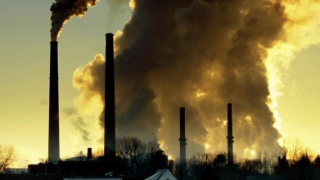 | 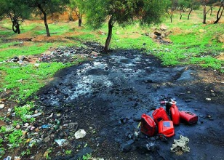
1. ..................................................... | 2. .....................................................
 | 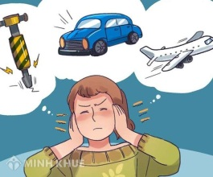
3. ..................................................... | 4. .....................................................
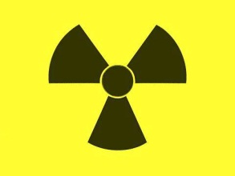 | 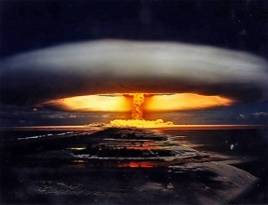
5. ..................................................... | 6. .....................................................
Exercise 3: Put the verbs in brackets: Conditional sentence type I or type II.
1. If you come with me, I (do) ............................ the shopping with you.
2. Jimmy (help) ............................ his mother in the garden if she reads him a story this evening.
3. If it (ran) ............................, I will stay at home.
4. Our teacher will be happy if we (learn) ............................ the poem by heart.
5. If they had enough money, they (buy) ............................ a new car.
6. We (pass) ............................ the exam if we studied harder.
7. If Pat (repair) ............................ his bike, he could go on a bicycle tour with us.
8. She would get 100 pounds if she (sell) ............................ this old shelf.
9. If I were you, I (invite) ............................Jack to the party.
10. If the weather (be) ............................ fine, the children can walk to school.
Exercise 4: Choose the correct answers.
1. Do you think there would be less conflict in the world if all people ............. the same language?
A. spoke B. speak C. had spoken D. will speak
2. If you can give me one good reason for your acting like this, ............this incident again.
A. I will never mention B. I never mention
C. will I never mention D. I don’t mention
3. Unless you .................all of my questions, I can’t do anything to help you.
A. answered B. answer C. would answer D. are answering
4. If someone .................into the store, smile and say, “May I help you?”
A. comes B. came C. would come D. could come
5. “Here’s my phone number”.
“Thanks. I’ll give you a call if I .................some help tomorrow”
A. will need B. need C. would need D. needed
Exercise 9: Choose the incorrect part. (1)
1. If we meet at 9:30, we would have plenty of time.
A B C D
2. If you find a skeleton in the cellar, not to mention it to anyone.
A B C D
3. If you passes your examination, we will have a celebration.
A B C D
4. Lisa would find the milk if she look for it in the fridge.
A B C D
5. What would happen if I press this button?
A B C D

WEEK 22
Exercise 1: Choose the correct answers.
1. If I had enough money, I .................abroad to improve my English.
A. will go B. would go
C. should go D. should have go to
2. The bench would collapse if they .................on it.
A. stood B. stand C. standing D. stands
3. If it .................convenient, let’s go out for a drink tonight.
A. be B. is C. was D. were
4. If you .................time, please write to me.
A. have B. had C. have had D. has
5. I wouldn’t go there at night if I .................you.
A. am B. was C. be D. were
Exercise 2: Choose the incorrect part.
1. If the milkman conies, tell him to be leave two pints.
A B C D
2. I will call the office if I were you.
A B C D
3. Someone will sits on your glasses if you leave them there.
A B C D
4. You would hear my explanation if you did not talked so much.
A B C D
5. Which will I do if I hear the burglar alarm?
A B C D
Exercise 3: Rewrite each sentence, beginning as shown.
1. I didn’t have an umbrella with me so I got wet.
I wouldn’t
2. I’ll call the police if you don’t leave me alone.
Unless
3. In the snowy weather we don’t go to school.
If
4. Without Jack’s help, I wouldn’t have been able to move this table.
If
5. You drink too much coffee, that’s why you can’t sleep.
If you
6. Make me some coffee, and I’ll give you some sweets.
If
7. If you hadn’t told me about Sue’s hair, I wouldn’t have noticed her.
Unless
8. If you see Peter, tell him he should be here at 8 00.
Should
Exercise 4: Rewrite the following sentences starting with if.
1. He can’t go out because he has to study for his exam.
If
2. She is lazy so she can’t pass the exam.
If
3. He will pay me tonight; I will have enough money to buy a car.
If
4. He smokes too much; that’s why he can’t get rid of his cough.
If
5. She is very shy, so she doesn’t enjoy the party.
If
6. He doesn’t take any exercises. He is so unhealthy.
If
7. Study hard or you won’t pass the exam.
If
8. Don’t be impatient or you will make mistakes.
If

WEEK 23
Exercise 1: Mark the stress position of the words in the box.
Words | Words
1. Taiwanese  2. Chinese  3. Portuguese  4. Lebanese  5. Nepalese | 6. Examinee  7. Interviewee  8. Lessee  9. Designee  10. Degree
Exercise 2: Look at the picture and put the correct word under it.
monument | raincoat | summer camp
tour guide | waterfall | trolley
koala | cattle station | kangaroo

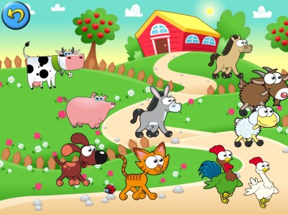 |  | 
1. ...................................... | 2. ...................................... | 3. ......................................
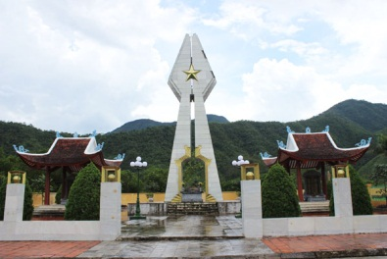 |  | 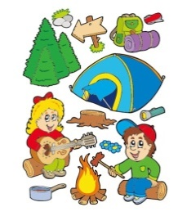
4. ..................................... | 5. ...................................... | 6. ......................................
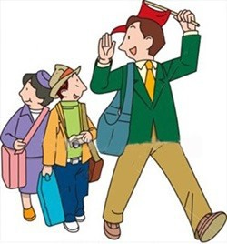 | 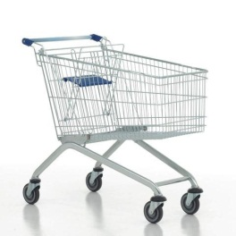 | 
7. ...................................... | 8. ...................................... | 9. ......................................

Exercise 3: Match the word/ phrase with the correct definition.
No. | Term | Opt. | Definition
1. | century | A | a piece of clothing
2 | debate | B | the language that you first learn to speak when you are a child
3 | entertainment | C | a period of 100 years
4 | exhibition | D | land that is under the control of a particular country or ruler
5 | garment | E | a collection of things, for example works of art, that are shown to the public
6 | ghost | F | a small symbol on a computer or smart phone screen that represents a program or a file
7 | icon | G | films/movies, music, etc. used to entertain people; an example of this
8 | mother tongue | H | the spirit of a dead person that a living person believes they can see or hear
9 | puzzle | I | a formal discussion of an issue at a public meeting. In this, there are two or more speakers express opposing views and then there is often a vote on the issue.
10 | territory | J | a game, etc. that you have to think about carefully in order to answer it or do it
Your answer:
1______ 2______ 3______ 4______ 5 ______
6______ 7______ 8______ 9______ 10______
Exercise 4: Put the verbs in brackets. Present simple or present continuous.
1. I (not/belong) ............................... to this particular government committee.
2. Hurry? The bus (come) ............................... (not/want) ................................ to miss it.
3. Martha is a vegetarian. She (not/eat) ............................... meat.
4. I (look) ............................... for the manager. I can’t find him anywhere.
5. We are successful because we (take) .................................... the time to talk to our customers.
6. John (deaf) ............................... with all the enquiries about sales.
7. At the moment we (make) ............................... a training video for Siemens.
8. (you/know) ............................... what Mr. Brown is doing? He is not in his office.
WEEK 24
Exercise 1: Put the verbs in brackets: Present perfect
1. How long (you/ know) .........................................Gerry?
2. You look dirty. What (you/ do) .........................................all day?
3. How many times (Charles/ visit) .........................................New York?
4. She (learn) .........................................French words for hours, but she still doesn’t remember all of them.
5. The children (watch) .........................................videos for two hours.
6. (he/ study) .........................................hard today?
7. Sorry, I’m late, (you/ wait) .........................................for long?
8. We (not/ see) .........................................Lisa recently.
9. He (write) .........................................his essay all day, but he hasn’t finished yet.
10. How long (he/ wait) .........................................for her?
11. You took tired. (you/study) .........................................hard?
12. Is Mr. Brown here? How long (he/work) ...............................................for the company?
13. (you/hear) ...................................the bad news? Simon (break) .............................his leg!
14. John (write) ...................................his novel since last year.
15. What (you/do) ................................? I (wait) ........................................for you for an hour.
Exercise 2: Choose the best option to complete the sentence.
1. She can’t come to the phone now because she ..................... tomorrow’s test.
A. studies B. is studying
C. has studied D. has been studying
2. They must be at the sports ground now. They usually ...................basketball on Fridays.
A. play B. are playing
C. have played D. have been playing
3. I ..................... my work already. I’m ready to go for a walk with you.
A. finish B. am finishing
C. have finished D. have been finishing
4. I ..................... breakfast right now. Can you call a tittle later?
A. cook B. am cooking
C. have cooked D. have been cooking
5. I ..................... this book. Can I borrow it tor a week or so?
A. don’t read B. am not reading
C. haven’t read D. haven’t been reading
6. Maria is good at languages. She .....................French, Spanish and German.
A. speaks B. is speaking
C. has spoken D. has been speaking
7. So far, he ..................... five stories for children.
A. writes B. is writing
C. has written D. has writing
8. We ..................... for their answer for two months already
A. wait B. are waiting
C. have been waited D. have been waiting
9. She ..................... since Monday.
A. is sick B. is being sick
C. has been sick D. has been being sick
10. She ..................... since noon. Should we wake her up?
A. sleeps B. is sleeping
C. has been sleep D. has been sleeping
Exercise 3: Put the verbs in brackets in the correct form.
1. She always (remember) ...................................my birthday.
2. Look! It (snow)...................................
3. How long (know) ...................................Simon?
4. Can you hear those girls? What (they/ talk) ...................................this exam?
5. How many times (you/ take) ...................................this exam?
6. He (eat) ...................................six bars of chocolate today!
7. When I’m in Paris I (usually/stay) ...................................in the Hotel du Pont, but this time I (stay) ...................................in the more expensive Hotel Notre Dame.
8. (they/ arrive) ...................................already?
9. My father (be) ............................an engineer, but he (not/work) ............................... now.
10. My parents (live) ...................................in Sydney. Where (your parents/ live) ...................................?

KEY
WEEK 21
Exercise 1: Choose the word which has different stress positron.
1. B 2. D 3. C 4. B 5. A
Exercise 2: Look at the picture and put the correct types of pollution under it.
1. air pollution 5. radioactive pollution
2. soil pollution 6. thermal pollution
3. light pollution
4. noise pollution

Exercise 3: Put the verbs in brackets. Conditional sentences type I or type II.

1. will do 2. will help 3. rains 4. learn 5. would buy

6. would pass 7. repaired 8. sold 9. would invite 10. is
Exercise 4: Choose the correct answers.
1. A 2. A 3. B 4. A 5. B
Exercise 5: Choose the incorrect part.
1. C 2. C 3. A 4. D 5. B

WEEK 22
Exercise 1: Choose the correct answers.
1. B 2. A 3. A 4. A 5. A
Exercise 2: Look at the picture and put the correct types of pollution under it.
1. D 2. A 3. B 4. D 5. A
Exercise 3: Rewrite each sentence, beginning as shown.
1. I wouldn’t have got wet if I had had an umbrella with me.
2. Unless you leave me alone, I’ll call the police.
3. If the weather is snowy, we don’t go to school.
4. If Jack hadn’t helped me, I wouldn’t have been able to move this table.
5. If you didn’t drink too much coffee, you could sleep.
6. If you make me some coffee, I’ll give you some sweets.
7. Unless you had told me about Sue’s hair, l wouldn’t have noticed her.
8. Should you see Peter, tell him he should be here at 8:00.
Exercise 4: Rewrite the following sentences starting with if.

1. If he didn’t have to study for his exam, he could go out.

2. If she weren’t lazy, she could pass the exam.

3. If he pays me tonight, I will have enough money to buy a car.

4. If he didn’t smoke too much, he could get rid of his cough.
5. If she weren’t shy, she would enjoy the party.
6. If he took some exercises, he wouldn’t be so unhealthy.
7. If you don’t study hard, you won’t pass the exam.
8. If you are impatient, you will make mistakes.

WEEK 23
Exercise 1: Mark the stress position of the words in the box.
1. Taiwaˈnese 2. Chiˈnese 3. Portuˈguese
4. Lebaˈnese 5. Nepaˈlese 6. Examiˈnee
7. Interviewˈee 8. Leˈssee 9. Desigˈnee
10. Deˈgree
Exercise 2: Look at the picture and put the correct word under it.
1. cattle station 2. kangaroo 3. koala
4. monument 5. raincoat 6. summer camp
7. tour guide 8. trolley 9. waterfall
Exercise 3: Match the word/ phrase with the correct definition.
1. C 2. I 3. G 4. E 5. A
6. H 7. F 8. B 9. J 10. D
Exercise 4: Put the verbs in brackets. Present simple or present continuous.
1. don’t belong 2. is coming; don’t want 3. doesn’t eat
4. am looking 5. take 6. deals
7. are making 8. Do you know

WEEK 24
Exercise 1: Put the verbs in brackets: Present perfect.

1. have you known
2. have you done
3. has Charles visited
4. has learned
5. have watched
6. Has he studied
7. Have you waited
8. haven’t seen
9. has written
10. has he waited
11. Have you studied
12. has he worked
13. Have you heard; has broken
14. has written
15. have you; have waited

Exercise 2: Choose the best option to complete the sentence.
1. B 2. A 3. C 4. B 5. C
6. A 7. C 8. D 9. C 10. D
Exercise 3: Put the verbs in brackets in the correct form.
1. remembers 6. has eaten
2. is snowing 7. usually stay; am staying
3. have you known 8. Have they arrived
4. are they talking 9. is; is not working
5. have you taken 10. live; do your parents live

